C:\Users\NSales\AppData\Local\Microsoft\Windows\Temporary Internet Files\Content.IE5\BQMQVTLA\MC900303569[1].wmf

for Agricultural Research

C:\Users\NSales\AppData\Local\Microsoft\Windows\Temporary Internet Files\Content.IE5\BQMQVTLA\MC900303569[1].wmf

Statistical Tool

C:\Users\NSales\AppData\Local\Microsoft\Windows\Temporary Internet Files\Content.IE5\BQMQVTLA\MC900303569[1].wmf

for Agricultural Research

C:\Users\NSales\AppData\Local\Microsoft\Windows\Temporary Internet Files\Content.IE5\BQMQVTLA\MC900303569[1].wmf

Statistical Tool

C:\Users\NSales\AppData\Local\Microsoft\Windows\Temporary Internet Files\Content.IE5\BQMQVTLA\MC900303569[1].wmf

USER’S MANUAL

C:\Users\NSales\AppData\Local\Microsoft\Windows\Temporary Internet Files\Content.IE5\BQMQVTLA\MC900303569[1].wmf

Statistical Tool for Agricultural Research

Version 2.0

November 2013

A NOTE TO THE READER:

An electronic copy of this user’s manual comes with the STAR installer. The STAR User’s Manual may be printed/copied and distributed to any number of users. STAR is a freeware developed for non-profit use. Hence, selling of either the software or the user’s manual is prohibited.

Biometrics and Breeding Informatics

Plant Breeding, Genetics and Biotechnology Division

INTERNATIONAL RICE RESEARCH INSTITUTE

Contents

[Introduction 1](#_Toc373491475)

[Featured Modules 1](#_Toc373491476)

[New Features in STAR 2.0 1](#_Toc373491477)

[About the User’s Manual 2](#_Toc373491478)

[Citing the Software 2](#_Toc373491479)

[Getting Started 3](#_Toc373491480)

[Installation 3](#_Toc373491481)

[Launching STAR 10](#_Toc373491482)

[Project Explorer Panel 11](#_Toc373491483)

[Editor Panel 12](#_Toc373491484)

[Menu Bar 13](#_Toc373491485)

[Data Viewer 15](#_Toc373491486)

[Result Viewer 16](#_Toc373491487)

[Project and File Management 19](#_Toc373491488)

[Creating New Project 19](#_Toc373491489)

[Open Existing Project 21](#_Toc373491490)

[Renaming Project 21](#_Toc373491491)

[Exporting Project 23](#_Toc373491492)

[Deleting Project 24](#_Toc373491493)

[Importing Project 26](#_Toc373491494)

[Importing Data from External Source 27](#_Toc373491495)

[Importing Data from Other Project 29](#_Toc373491496)

[Importing Data from Package 31](#_Toc373491497)

[Creating New Folder 32](#_Toc373491498)

[Copying File/Folder 34](#_Toc373491499)

[Renaming File/Folder 36](#_Toc373491500)

[Moving File/Folder 38](#_Toc373491501)

[Deleting File/Folder 40](#_Toc373491502)

[Switching Workspace 41](#_Toc373491503)

[Data Handling and Manipulation 45](#_Toc373491504)

[Representing Missing Value(s) 45](#_Toc373491505)

[Insert Row(s) 45](#_Toc373491506)

[Delete Row(s) 47](#_Toc373491507)

[Inserting Column(s) 48](#_Toc373491508)

[Deleting Column(s) 50](#_Toc373491509)

[Create New Variables 51](#_Toc373491510)

[Editing Variable Information 55](#_Toc373491511)

[Sorting 57](#_Toc373491512)

[Merging Datasets 60](#_Toc373491513)

[Appending Datasets 63](#_Toc373491514)

[Creating Data Subset 65](#_Toc373491515)

[Reshaping 68](#_Toc373491516)

[Reshaping Data from Long (Serial) to Wide (Parallel) Format 68](#_Toc373491517)

[Reshaping Data from Wide (Parallel) to Long (Serial) Format 71](#_Toc373491518)

[Aggregating Data 75](#_Toc373491519)

[Randomization and Layout 81](#_Toc373491520)

[Completely Randomized Design 81](#_Toc373491521)

[Randomized Complete Block Design 85](#_Toc373491522)

[Latin Square Design 91](#_Toc373491523)

[Split Plot Design 94](#_Toc373491524)

[Strip Plot Design 102](#_Toc373491525)

[Split-Split Plot Design 106](#_Toc373491526)

[Strip-Split Plot Design 112](#_Toc373491527)

[Split-Split-Split Plot Design 117](#_Toc373491528)

[Strip-Split-Split Plot Design 122](#_Toc373491529)

[Balanced Incomplete Block Design 127](#_Toc373491530)

[Graphs 133](#_Toc373491531)

[Bar Graph 133](#_Toc373491532)

[Box Plot 140](#_Toc373491533)

[Histogram 146](#_Toc373491534)

[Line Graph 151](#_Toc373491535)

[Pie Chart 157](#_Toc373491536)

[Scatter Plot 162](#_Toc373491537)

[Descriptive Statistics 169](#_Toc373491538)

[Cross Tabulation 175](#_Toc373491539)

[Normality Test 179](#_Toc373491540)

[Homogeneity of Variances 187](#_Toc373491541)

[Fitting Distributions 195](#_Toc373491542)

[t-Test 201](#_Toc373491543)

[One Sample *t*-test 201](#_Toc373491544)

[Paired Sample *t*-tests 205](#_Toc373491545)

[Independent Sample *t*-tests 209](#_Toc373491546)

[Chi-Square Test 215](#_Toc373491547)

[Goodness of fit Test 215](#_Toc373491548)

[Test of Independence 217](#_Toc373491549)

[Test on Proportion 223](#_Toc373491550)

[Analysis of Variance 227](#_Toc373491551)

[Completely Randomized Design 228](#_Toc373491552)

[Randomized Complete Block Design 235](#_Toc373491553)

[Latin Square Design 240](#_Toc373491554)

[Split Plot Design 246](#_Toc373491555)

[Strip Plot Design 253](#_Toc373491556)

[Split-Split Plot Design 260](#_Toc373491557)

[Strip-Split Plot Design 267](#_Toc373491558)

[Split-Split-Split Plot Design 274](#_Toc373491559)

[Strip-Split-Split Plot Design 276](#_Toc373491560)

[Balanced Incomplete Block Design 278](#_Toc373491561)

[Pairwise Mean Comparison 284](#_Toc373491562)

[Partitioning Sum of Squares 290](#_Toc373491563)

[Group Comparison 290](#_Toc373491564)

[Trend Comparison 294](#_Toc373491565)

[Correlation Analysis 297](#_Toc373491566)

[Regression Analysis 305](#_Toc373491567)

[Linear Regression 305](#_Toc373491568)

[Non-Linear Regression 312](#_Toc373491569)

[Nonparametric Tests 321](#_Toc373491570)

[One Sample 321](#_Toc373491571)

[Two Related Samples 324](#_Toc373491572)

[Two Independent Samples 326](#_Toc373491573)

[Test for Several Related Samples 328](#_Toc373491574)

[Test for Several Independent Samples 331](#_Toc373491575)

[Multivariate Analysis 336](#_Toc373491576)

[Principal Component Analysis 336](#_Toc373491577)

[Cluster Analysis 343](#_Toc373491578)

[Multivariate Analysis of Variance 351](#_Toc373491579)

[Multidimensional Scaling 357](#_Toc373491580)

[Discriminant Analysis 362](#_Toc373491581)

[Appendix 370](#_Toc373491582)

[Data from STAR Package 370](#_Toc373491583)

[AgroData1 370](#_Toc373491584)

[AgroData2 370](#_Toc373491585)

[CarbonStock 371](#_Toc373491586)

[AugLS 371](#_Toc373491587)

[AugRCB 372](#_Toc373491588)

[CochranBIB 372](#_Toc373491589)

[Corr 373](#_Toc373491590)

[CropStatRCBDOverSite 373](#_Toc373491591)

[Dule\_AlphaGxE 374](#_Toc373491592)

[Dune 375](#_Toc373491593)

[Fertilizer 376](#_Toc373491594)

[fishData 377](#_Toc373491595)

[GeneticDistMatrix 377](#_Toc373491596)

[Gerua 377](#_Toc373491597)

[GomezMaizeCross 378](#_Toc373491598)

[GomezMaizeCrossSummary 379](#_Toc373491599)

[GomezSplitRCBD 380](#_Toc373491600)

[GomezSplit2RCBD 380](#_Toc373491601)

[GomezStrip 381](#_Toc373491602)

[GomezStripSplit 382](#_Toc373491603)

[GomezTenureStatus 383](#_Toc373491604)

[GomezTwoCropSeasonRCB 383](#_Toc373491605)

[grp\_pss 384](#_Toc373491606)

[IASRICorrReg 384](#_Toc373491607)

[IASRILSD 385](#_Toc373491608)

[IASRITomar 386](#_Toc373491609)

[IASRITomar2 387](#_Toc373491610)

[InjuryProfile 387](#_Toc373491611)

[Inoculation 388](#_Toc373491612)

[Insecticides 389](#_Toc373491613)

[JohnAlpha 389](#_Toc373491614)

[KemptonRowCol 390](#_Toc373491615)

[KijojiDS2010Cluster 391](#_Toc373491616)

[Maize 391](#_Toc373491617)

[ManovaData1 392](#_Toc373491618)

[Nurul2012 392](#_Toc373491619)

[OP\_pss 393](#_Toc373491620)

[PGTYPIC 394](#_Toc373491621)

[SeedingRate 394](#_Toc373491622)

[Sensors 395](#_Toc373491623)

[Sevilla2012Cluster 395](#_Toc373491624)

[soil\_redox 396](#_Toc373491625)

[soil\_var 397](#_Toc373491626)

[Survival 397](#_Toc373491627)

[tf\_rcb 398](#_Toc373491628)

[upland 398](#_Toc373491629)

[White\_heads 399](#_Toc373491630)

[Year 399](#_Toc373491631)

[Yield94 399](#_Toc373491632)

# Introduction

Statistical Tool for Agricultural Research (STAR) is a computer program for data management and basic statistical analysis of experimental data. It has a user-friendly graphical interface where items are accessible via drop-down menus. Its graphical interface was created using the Eclipse Rich Client Platform (RCP) and uses the R language and environment for statistical computing and graphics. The programs uses functions in R that are specifically written for the development of this computer program and those that are available in the following R packages: ade4, agricolae, dae, DiGGer, doBy, fields, fitdstrplus, gdata, gplots, Hmisc, leaps, lme4, lmerTest, MASS, multcomp, mvtnorm, numDeriv, pastecs, permute, plyr, qtl, R.methodsS3, R.oo, rJava, spam, stringr and vegan.

STAR has been developed primarily for the analysis of data from agricultural field trials, but many of the features can be used for analysis of data from other sources.

## Featured Modules

STAR has the following modules:

* Data management with a spreadsheet view
* Randomization for commonly used experimental design
* Graphics
* Descriptive statistics
* Analysis of variance for experimental designs
* Correlation and linear regression analysis
* Multivariate Analysis
* Non-parametric data analysis

## New Features in STAR 2.0

The following are the revisions made and modules added in the latest version of STAR:

* Analysis for Balanced Incomplete Block design using fixed model
* Variable selection method under the Liner Regression Analysis
* Non-Linear Regression Analysis
* Principal Component Analysis
* Cluster Analysis
* Multivariate Analysis of Variance
* Multi-Dimensional Scaling
* Discriminant Analysis

While the following module has been deleted in this version of STAR:

* Randomization and layout for Alpha-Lattice designs, Lattice design, Augmented RCB design and Augmented Latin Square design
* Analysis for Alpha-Lattice designs, Augmented RCB design and Augmented Latin Square design

## About the User’s Manual

The STAR user’s manual provides step-by-step instructions on how to perform certain tasks of interest to users. Tasks are discussed using sample datasets that are included when STAR is installed. In most tasks, dialog boxes are displayed and the user has to specify required fields and additional options as desired. Descriptions and limitations of these fields and options are also provided. Screen images are also included for additional references.

This manual is written using the following format:

* Menu items, names of dialogs and form controls are in **bold** letters
* Project names, filenames, variable names and directories are *italicized*
* Menus appear in the form **Project | New Project**, which means “choose **New Project** from the **Project** menu”

## Citing the Software

The suggested citation of STAR in publication is as follows:

STAR, version 2.0 2013. Biometrics and Breeding Informatics, PBGB Division, International Rice Research Institute, Los Baños, Laguna.

# Getting Started

## Installation

The installer of STAR 2.0 and its required R packages can be downloaded from *bbi.irri.org*. To download the installers, click the links labeled as *STAR 2.0* and *R-Packages 1.2* at the right-hand side of the page.



User need to install *R-Packages* first before installing *STAR*. The steps to install the required R packages are as follows:

* Double-click the installer icon  to launch the setup. A dialog as shown below is displayed. Click the **OK** button.

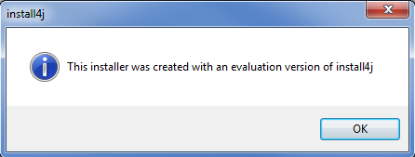

* The next step is the preparation of the wizard. A dialog with progress bar is displayed. Wait until the preparation is completed.

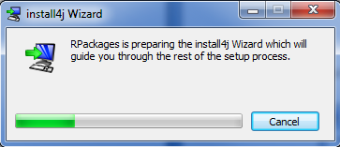

* When installing R Packages for the first time, the **Welcome** dialog as shown below is displayed. Click the **Next** button.

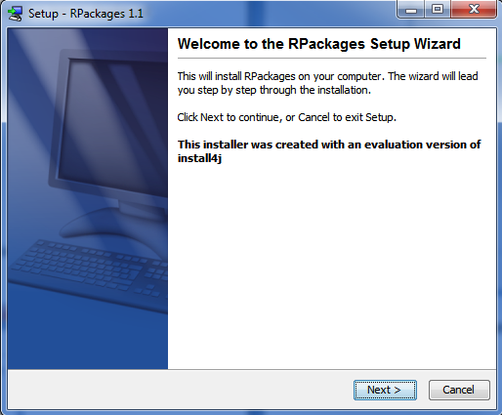

* Select the destination folder, preferably not in **C:\Program Files** as problems were encountered when RPackages is installed in this location. Click the **Next** button.

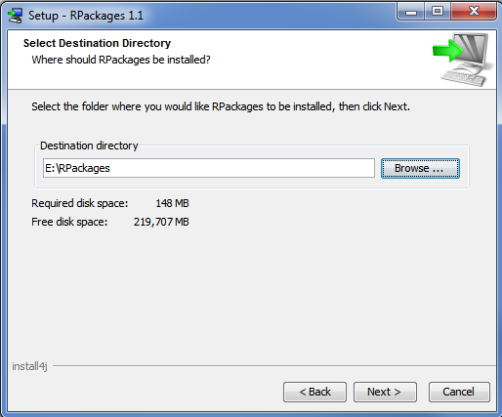

* Wait until the installation is completed.

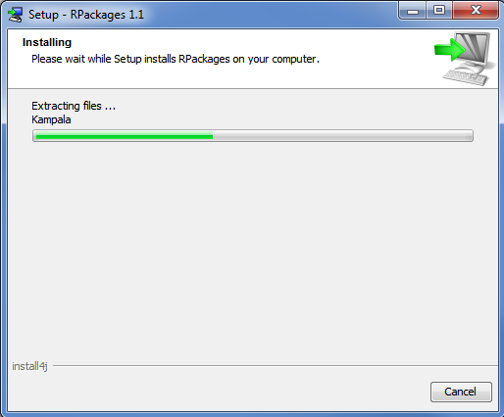

* Click the **Finish** button to exit Setup.

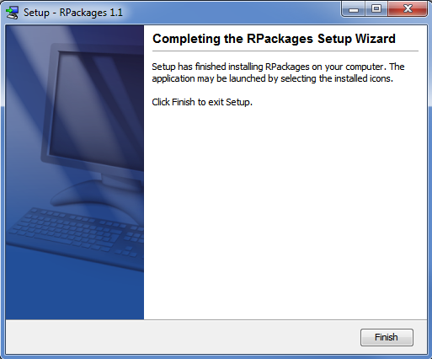

The steps to install STAR are as follows:

* Double-click the installer icon 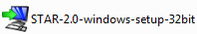 to launch the setup. A dialog as shown below is displayed. Click the **OK** button.

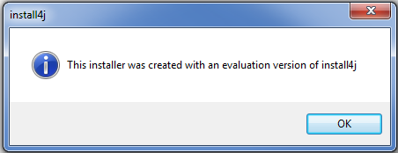

* The next step is the preparation of the wizard. A dialog with progress bar is displayed. Wait until the preparation is completed.

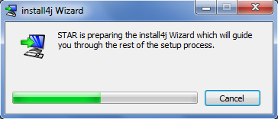

* When installing STAR for the first time, the **Welcome** dialog as shown below is displayed. Click the **Next** button.

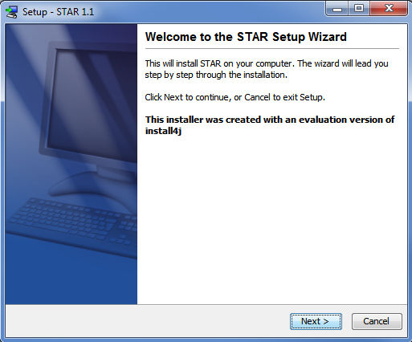

* Select the destination folder, preferably not in **C:\Program Files** as problems were encountered when STAR is installed in this location. Click the **Next** button.

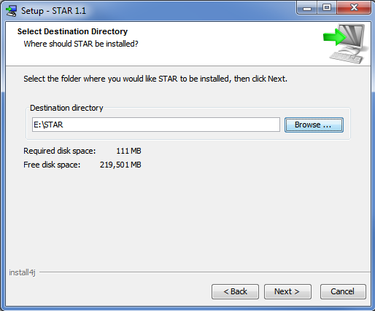

* Select which start menu folder you want to place the STAR icons in and click the **Next** button.

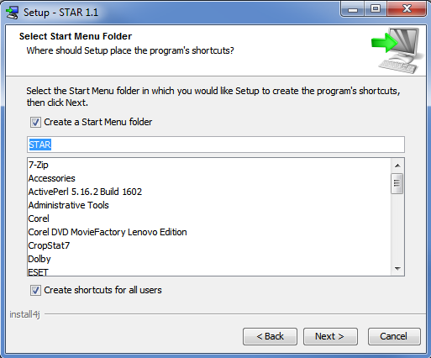

* Wait until the installation is completed.

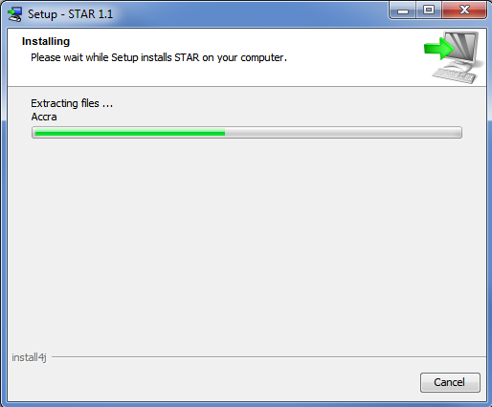

* Finally, specify if you want to create a desktop icon and run STAR. Click the **Finish** button.

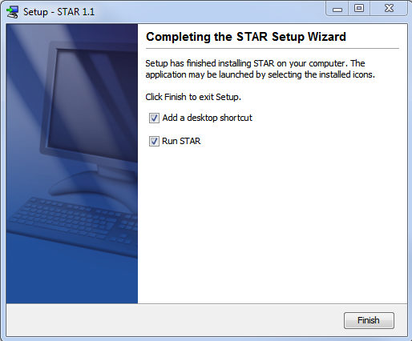

## Launching STAR

To launch STAR, double-click the STAR shortcut icon on the desktop (if there is one) or click **Start** on the Windows task bar, choose **All Programs**, then click on the *STAR* folder and click the STAR icon.

Upon launching, the splash image will appear.

****

When STAR is launched for the first time, the **Select Workspace** dialog is displayed. A default workspace folder is indicated in the **Workspace** entry box**.** To indicate a different workspace folder, click the **Browse** button and select the new workspace folder. By default, the checkbox **Import Sample Project** is selected. Then click the **OK** button.

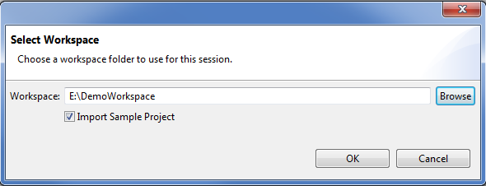

The main window of STAR will appear.

**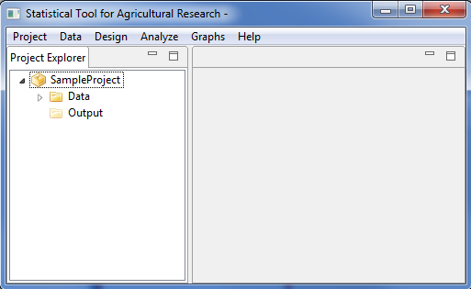**

STAR main window has a menu bar and is divided into two panels, the **Project Explorer** panel located on the left-hand side and the **Editor Panel** on the right-hand side.

## Project Explorer Panel

Project Explorer can be seen at the left-hand side of the main window. It serves as a file manager of the active project, where data and results of the analysis are displayed in a tree. It displays the last opened project from the previous STAR session. When the “Import Sample Project” option is selected in the **Select Workspace** dialog, a default project named *SampleProject* is displayed with *Data* folder and *Output* folder inside it. The *Data* folder contains some sample datasets that will be used in this manual. The *Output* folder, on the other hand, will contain all output files that will be created when an analysis is performed.



## Editor Panel

Editor panel is located at the right-hand side of the main window. It consists of **Data Viewer** tab and the **Result Viewer** tab. By default, the editor panel is empty.



**Editor Panel**

## Menu Bar

Most of the tasks that you perform in STAR start with menu selections. There are six drop-down menus available and this are:



**Project** Menu contains functions for creating and managing project. This menu can also be used to quit or terminate sessions in STAR. It contains the following submenu items:

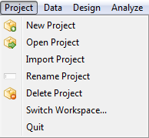

**Data** Menu contains functions for reading, managing and manipulating datasets. Items under this menu can be used only when a data in CSV format is displayed in the active tab of the editor panel. It contains the following submenu items:

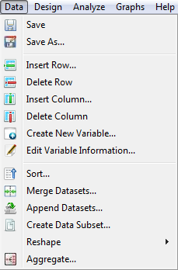

**Design** Menu contains functions for generating random assignment of factor levels for commonly used experimental design. It contains the following submenu items:

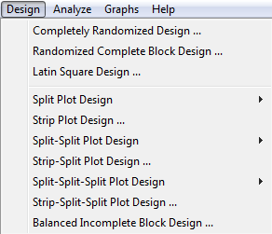

**Analyze** Menu contains functions to perform statistical analysis. Items under this menu can be used only when a data in CSV format is displayed in the active tab of the editor panel. It contains the following submenu items:

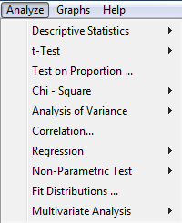

**Graph** Menu contains functions for creating the basic graphs. It contains the following submenu items:

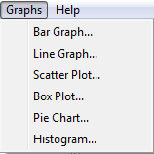

**Help** Menu used to access STAR’s Help System or User’s Manual. It contains the following submenu items:

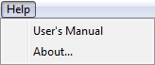

## Data Viewer

The **Data Viewer** tab is displayed in the editor panel when a data in CSV format is double-clicked from the **Project Explorer** tree. It is used for viewing data in spread-sheet format, editing data values and performing data management. Several **Data Viewer** tabs can be opened simultaneously inside the **Editor Panel** but only one is considered to be the active tab. Each **Data Viewer** tab contains toolbars which can be used for managing the data. The toolbars have the same functionalities as the options under the **Data** menu.

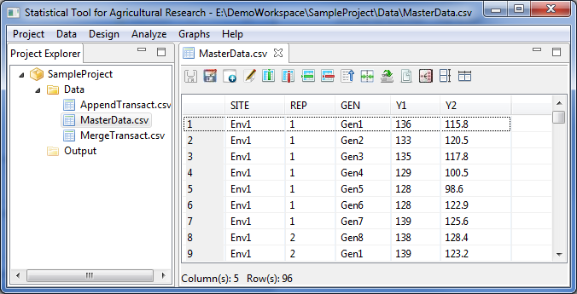

The name of the tab indicates the name of the dataset. When an asterisk appears in the tab name 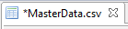, it indicates that there has been modification made in the data. If data manipulation or analysis is performed on the data on the active tab, STAR captures all information in the active tab (even unsaved modifications) and submit it for manipulation, graph creation or analysis. If a **Data Viewer** with unsaved changes is closed, the user will be prompted to save the changes.

## Result Viewer

The **Results Viewer** tab is displayed in the editor panel when an analysis is performed or by double-clicking a results folder inside the *Output* folder. Depending on the contents of the results folder, the Result Viewer may have an *Output* page and/or the *Graph* page.

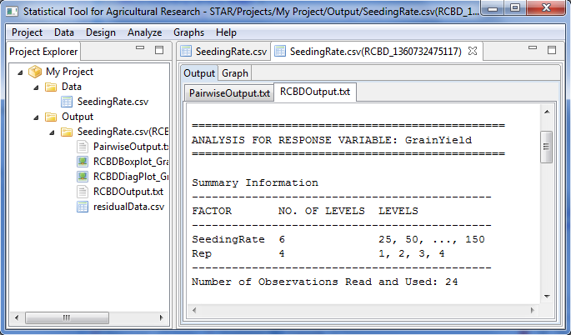

All outputs in *txt* format are displayed in the *Output* page while all graphical outputs in *png* format are displayed in the *Graph* page. The *Graph* page has toolbars that can be used to minimize, maximize, and view the graph to normal size and to export graph to external sources. To view other graphs in the page, the left and right arrow keys can be used.

*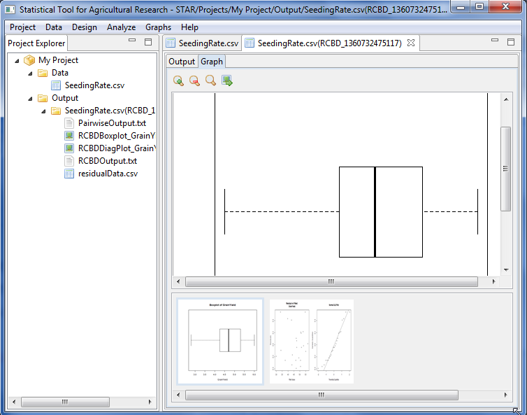*

# Project and File Management

## Creating New Project

Several projects can be created in STAR. However, only one project can be considered as the active project and is visible in the Project Explorer panel. The steps for creating new project are listed below.

* Select **Project | New Project** from the main menu.



* The **Create New Project** dialog box will appear. In the **Project Name** field, specify a name of the new project.

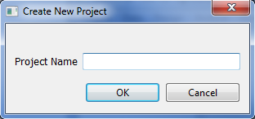

In naming a project, the following rules apply:

* + The name must start with a letter. The remaining characters can be any letter, any digit, a period, underscore, blank or dash.
  + The last character of the name should not be a period, underscore, blank or dash
  + The length of the name should not be less than 4 characters.
  + The name must be different from the existing project names.
  + The name is not case sensitive.

For the example, type *DemoProject*. The completed dialog box will appear as shown below:

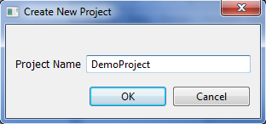

* Click the **OK** button. The new project named *DemoProject*, will now be displayed in the **Project Explorer** panel. By default, two empty folders under the project name will be automatically created, the *Data* and *Output* folders. Note that these folders cannot be deleted, rename or move to another location.

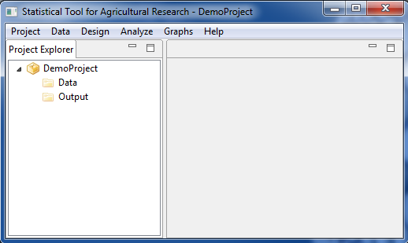

Note: As part of the examples, create another folder named *MyProject*.

## Open Existing Project

The steps for opening existing project inside the STAR workspace are listed below.

* Select **Project | Open Project** from the main menu.
* The **Open Existing Project from the Workspace** dialog box will appear. The list of all existing projects in the workspace can be seen.

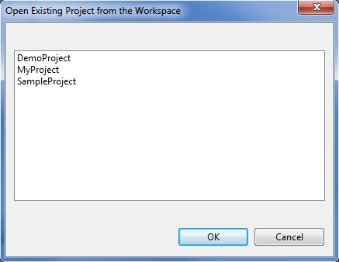

For the example, select the project named *DemoProject*. Click the **OK** button. *Demo* *Project* should now be the active project in the **Project Explorer**.

## Renaming Project

The steps for renaming the active project are listed below.

* Right-click on the active project, say *DemoProject*, then select **Rename Project** or select **Project | Rename Project** from the main menu.

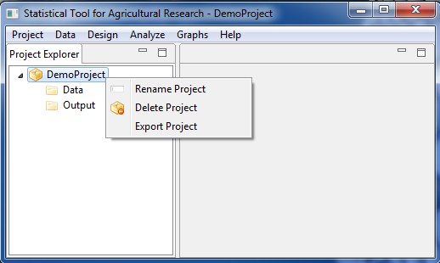

* The **Rename Project** dialog box will appear. In the **New Project Name** field, specify a new project name, say *Trial Project*. Click the **OK** button.

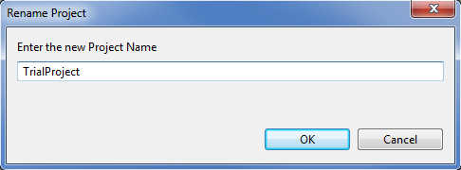

* The project should be displayed in the **Project Explorer** with the new name.

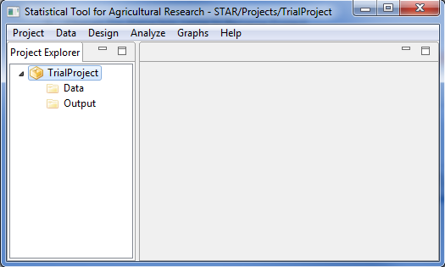

## Exporting Project

If the user wants to save the active project to a different directory, the export project feature can be used. The steps are listed below.

* Right-click on the active project, say *TrialProject*, then select **Export Project**.

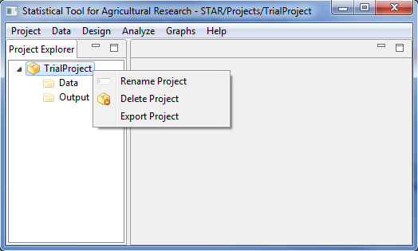

* The **Export Project** dialog box will appear. Select the directory where the active project will be saved. For the example, choose *Desktop*. Click the **OK** button.

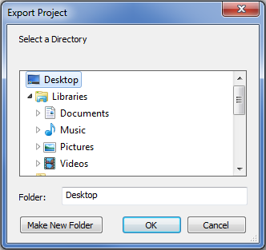

* The *TrialProject* folder is now on the desktop.

## Deleting Project

The steps for deleting an existing project inside the STAR workspace are listed below.

* Right-click on the active project, say *TrialProject* then select **Delete Project** or select **Project | Delete Project** from the main menu.



* Another dialog will be displayed. Click on the check box labeled **I want to delete multiple projects** if multiple projects are to be deleted. Then select from the list the projects to be deleted. For the example, delete only *TrialProject* by clicking the **OK** button.

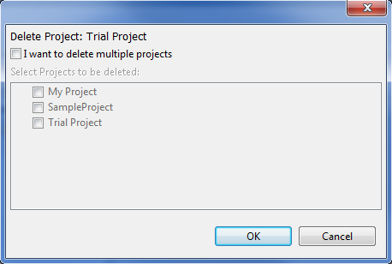

* Since *TrialProject* is now deleted from the STAR workspace, there is no active project displayed in the Project Explorer as shown below.

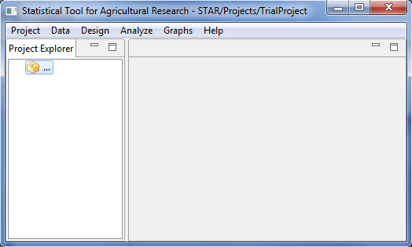

## Importing Project

Projects, as long as it is a valid STAR project, can be saved inside the STAR workspace by using the import project feature. The steps are listed below.

* Click **Project | Import Project** from the main menu.

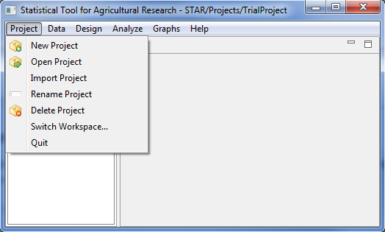

* Select the project folder that will be imported.

For the example, select *TrialProject* folder on the desktop. Click the **OK** button.

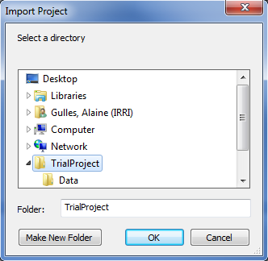

* The *TrialProject* is now the active project in the **Project Explorer**.

## Importing Data from External Source

There are three file formats that STAR accepts to import from external source namely:

1. R datasets. These are datasets that were saved in the R environment and have an extension .rda, .Rda, .RDA, or .Rdata;
2. text files. These are datasets with extension .txt whose file delimiter can be a tab, space, comma or a semi-colon; and
3. comma-separated value files. These are datasets with extension .csv.

The general steps for importing data from external source are listed below:

* On the **Project Explorer** panel, right-click the *Data* folder of the project named *TrialProject*. A pop-up menu will appear. Choose **Import Data**.

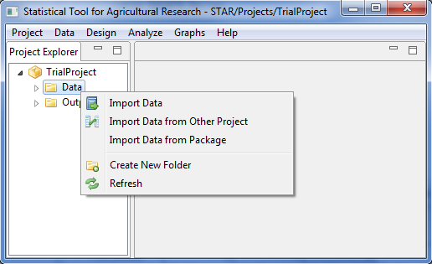

* The **Import** dialog box will appear. Choose the appropriate file type to be imported in the File of Types drop-down box. The default file type is **\*.csv**. Go to the directory where the file to be imported is located. Select the file or type the file name on the **File name** text box.

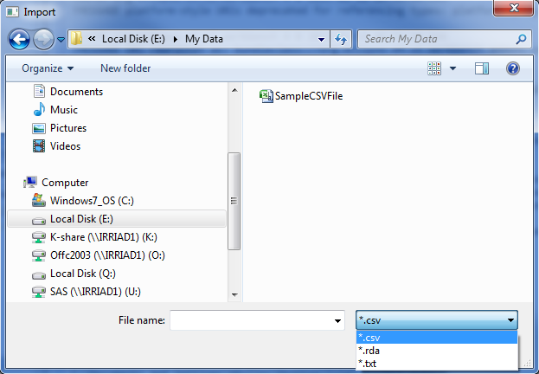

* Click the **Open** button.

If the **\*.txt** or the **\*.rda** file type is chosen, a message dialog box will appear indicating that the text or r data files will be automatically converted to a csv file. Click the **OK** button.

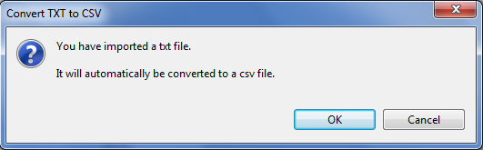

Further, if the **\*.txt** file type is chosen, the **Specify Delimiter** dialog box will appear. Choose the appropriate delimiter of the text file to be open then click the **OK** button.

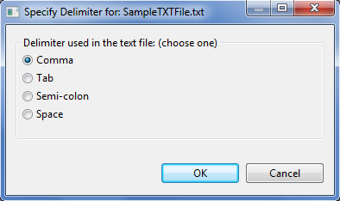

* The newly imported data will now be displayed inside the *Data* folder of the active project in the **Project Explorer**. To view the data in a spreadsheet format, double-click the icon of the data file.

## Importing Data from Other Project

The steps for importing data from other project are listed below:

* On the **Project Explorer** panel, right-click the *Data* folder of the project named *TrialProject*. A pop-up menu will appear. Choose **Import Data from Other Project**.



* The **Import from Other Project** dialog box will appear. This dialog box contains all existing projects in STAR. Select one or several project folders, one or several folders within projects or one or several data files. Choose the data files to be imported.

For the example, choose *MasterData.csv* from *Projects | SampleProject | Data*.

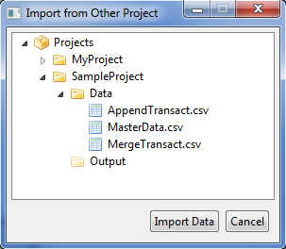

* Click the **Import Data** button. The new imported data file will now be displayed inside the *Data* folder of the active project in the **Project Explorer** panel. To view the data in a spreadsheet format, double-click the icon of the data file.

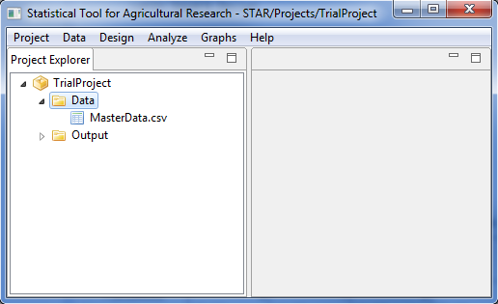

## Importing Data from Package

Datasets in STAR package of R can be imported. The steps to import data from R package are listed below:

* On the **Project Explorer** panel, right-click the *Data* folder of the project named *TrialProject*. A pop-up menu will appear. Choose **Import Data from Package**.



* The **Import Data from R** dialog box will appear. This dialog box contains all existing data file in STAR R package. Select one or several data files. Choose the data files to be imported.

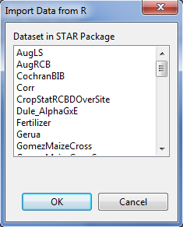

For the example, choose *SeedingRate*.

* Click the **OK** button. The new imported data file will now be displayed inside the *Data* folder of the active project in the **Project Explorer** panel. To view the data in a spreadsheet format, double-click the icon of the data file.

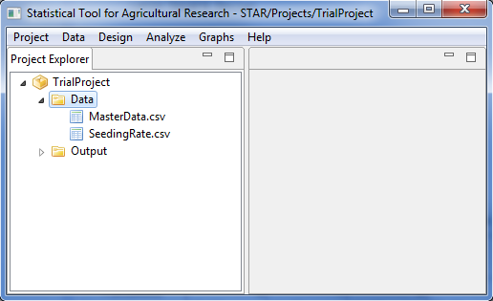

## Creating New Folder

To organize the data files imported in a project or results of an analysis, user may want to create a sub folder inside the *Data* folder or inside the *Output* folder.

The steps in creating a sub folder are listed below:

* On the **Project Explorer** panel, right-click the folder where you want to create the sub folder. A pop-up menu will appear. Choose **Create New Folder.**

For the example, right-click the *Data* folder of the project named *TrialProject*.



* The **New Folder** dialog box will appear**.** In the **Enter the new folder name** field, specify the name for the new folder. If the sub folder will be created within the *Data* folder, the default folder name is *Data*. If the sub folder will be created within the *Output* folder, the default folder name is *Output*.

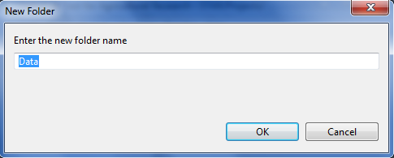

In naming a folder, the following rules apply:

* + The name must start with a letter. The remaining characters can be any letter, any digit, a period, underscore, blank or dash.
  + The last character of the name should not be a period, underscore, blank or dash.
  + The length of the name should not be less than 4 characters.
  + The name must be different from the existing folder names inside a parent folder.
  + The name is not case sensitive.

For the example, type *Lecture Data* as the new folder name.

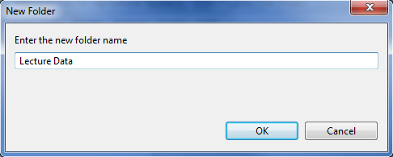

* A new sub-folder inside *Data* folder is now created and can be seen in the Project Explorer.

**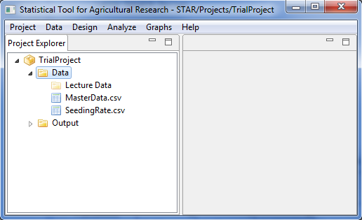**

The user can create several sub folders within the *Data* folder or *Output* folder. If the sub folders are created within the Data folder, user can import data set to the sub folder, rename, copy, delete and move the sub folder.

## Copying File/Folder

The steps to copy data files to other location are listed below:

* On the **Project Explorer** panel, right-click the file you want to copy. A pop-up menu will appear. Choose **Copy**.

For the example, right-click *SeedingRate.csv* inside the *Data* folder of the project named *TrialProject*.

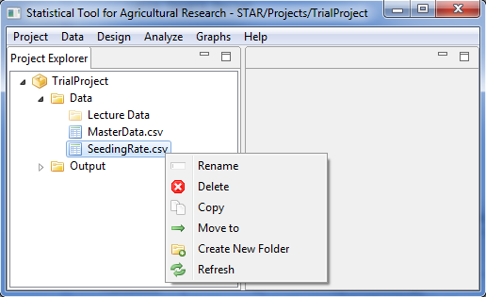

* Go to the desired destination folder, which can be within or outside STAR workspace, then right-click then choose **Paste.**

For the example, right-click on the *Lecture Data* folder then chose **Paste.**

**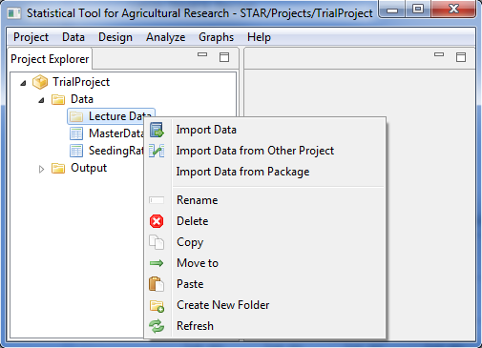**

* The file is now copied inside the destination folder.

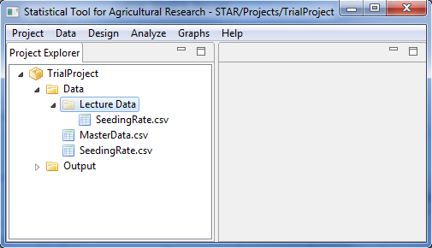

These steps also apply when copying the sub- folders within the *Data* and *Output* folders.

## Renaming File/Folder

The steps to rename files are listed below:

* On the **Project Explorer** panel, right click the file to rename. A pop-up menu will appear. Choose **Rename**.

For the example, right-click *SeedingRate.csv* inside the *Data* folder of the project named *TrialProject*.

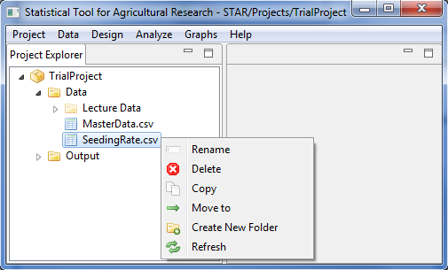

* The **Rename File** dialog box will appear. In the **Enter the new file name** field, specify the new filename.

For the example, set the new filename to *SeedingRate\_old.csv*. The completed dialog box should appear as shown below:

*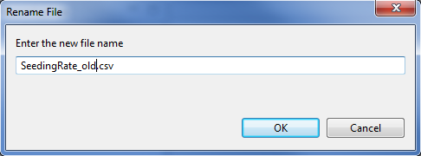*

* Click the **OK** button. The renamed data file should appear in the **Project Explorer** panel.

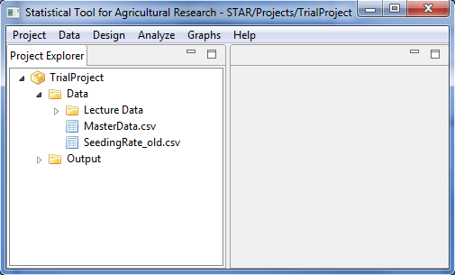

These steps also apply when renaming the sub- folders within the *Data* and *Output* folders.

## Moving File/Folder

The steps to move data files to other location in the STAR workspace are listed below:

* On the **Project Explorer** panel, right click the file to you want to move. A pop-up menu will appear. Choose **Move to**.

For the example, right-click *SeedingRate\_old.csv* inside the *Data* folder of the project named *TrialProject*.

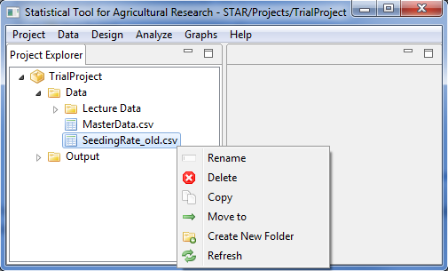

* The **Move to** dialog box will appear. Select the destination folder.

For the example, choose the *Lecture Data* folder inside the *Data* folder.

*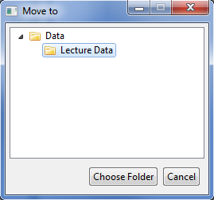*

* Click the **Choose Folder** button. The file is now moved to the destination folder.

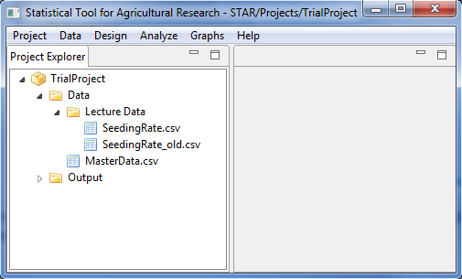

These steps also apply when moving the sub-folders within the *Data* and *Output* folder.

## Deleting File/Folder

Files to be deleted must be close before following the steps listed below. However, if a user wants to delete a folder, all items inside the folder to be deleted must be close before deleting the folder. Note that the default folders created (*Data* folder and *Output* folder) cannot be deleted.

The steps to delete data files are listed below:

* On the **Project Explorer** panel, right click the file to you want to delete. A pop-up menu will appear. Choose **Delete**.

For the example, right-click *SeedingRate\_old.csv* inside the *Lecture Data* of the *Data* folder of the project named *TrialProject*.

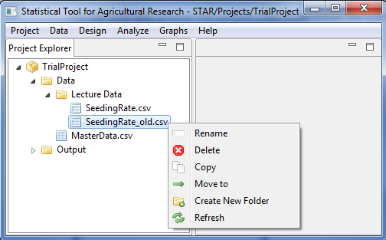

* The **Confirm Delete** message box will appear.

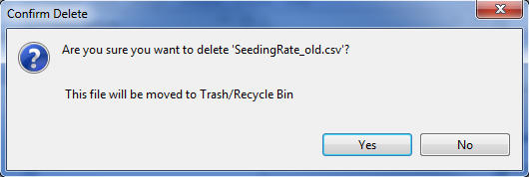

* Click the **Yes** button to delete.

These steps also apply when deleting the sub-folders within the *Data* and *Output* folder.

## Switching Workspace

Workspace is a location where projects, data and output during the session will be saved.

The steps to switch to a different workspace are listed below:

* Click **Project | Switch Workspace…**. The **Select Workspace** dialog box will appear. Click the **Browse** button to change the current workspace. The **Workspace** dialog box will appear.

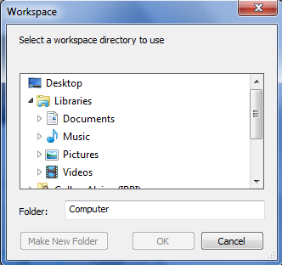

* Choose the new workspace or create a new workspace by clicking the **Make New Folder** button. Then click the **OK** button.

For the example, the completed dialog box should appear as shown below:

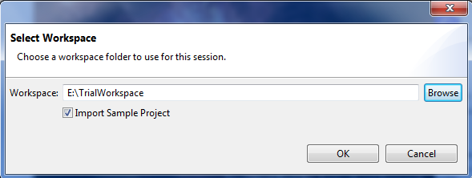

If the **Import Sample Project** is selected, the main window appears with *SampleProject* as the active project.

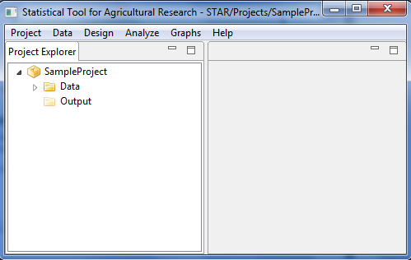

Otherwise, the main window appears with no active project.

**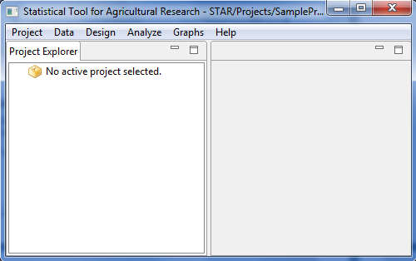**

# Data Handling and Manipulation

## Representing Missing Value(s)

In STAR, missing values can be represented by using any of the following: *NA*, space, period or blank. Using other symbol, say asterisk (\*), to represent missing values will affect how STAR identifies the attributes of the columns of the dataset. A column with numeric values but contains asterisks will be classified as a factor column. This misclassification may cause problems later when the data is subjected to manipulation or analysis.

## Insert Row(s)

The steps to insert row(s) are listed below:

* On the **Project Explorer** panel, double-click the file where new row(s) will be inserted to open it and view it in the Data Viewer tab.

For the example, using the project named *MyProject*, import the data *MasterData.csv* from the *Data* folder of the project named *SampleProject*. To import data from the *SampleProject*, see *Importing Data from Other Project* sectionof this user’s manual.

* Select any row(s) or any cell in the row(s) where new row(s) are to be inserted above it. To select several cells/rows, click any cell/row, then hold the **Ctrl** key and click on another cell/row. The number of selected rows is the number of row that will be inserted.

For the example, select the 4th row.

* Click **Data** | **Insert Row…** from the menu bar of the main window or click on the Insert Row icon  in the **Data Viewer** toolbar.

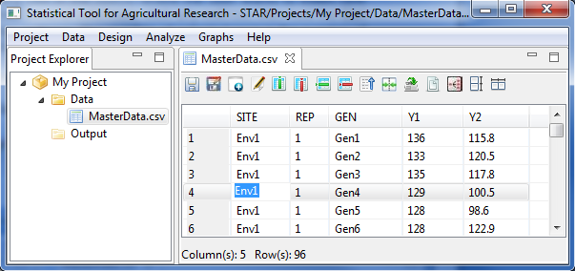

* The data now contains the newly inserted row.

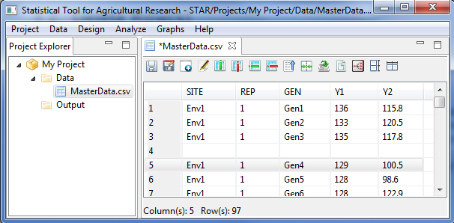

If there is no row selected before executing the Insert Row function, the user will be prompted if the user wants to insert a row after the last row of the data or not.

## Delete Row(s)

The steps to delete row(s) are listed below:

* On the **Project Explorer** panel, double-click the file where rows will be deleted to open it and view it in the Data Viewer tab.

For the example, use the modified and unsaved *MasterData.csv* in the project named *MyProject* created from the previous section that is displayed in the Data Viewer.

* Select any row(s) or any cell in the row(s) that will be deleted. To select several cells/rows, click any cell/row, then hold the Ctrl key and click on another cell/row. The number of selected rows is the number of row that will be deleted.

For the example, select the 4th row.

* Click **Data | Delete Row** from the menu bar of the main window or click on the Delete Row icon  in the Data Viewer tool bar.



* The **Delete Row** dialog box will appear. Confirm that the row deletion is desired by clicking the **Yes** button.
* The changes made should be reflected in the Data Viewer tab.

For the example, close the modified *MasterData.csv* and do not save the changes.

## Inserting Column(s)

The steps to delete row(s) are listed below:

* On the **Project Explorer** panel, double-click the file where new columns will be inserted to open it and view it in the Data Viewer tab.

For the example, using the project named *MyProject*, import the data *MasterData.csv* from the *Data* folder of the project named *SampleProject*. To import data from the *SampleProject*, see *Importing Data from Other Project* sectionof this user’s manual.

* Select a column where the new column will be inserted before it by clicking on the column name. A check icon will appear on the column header.

For the example, select the column named *Y1*.

* Click **Data | Insert Column…** from the menu bar of the main window or click on the Insert Column icon  in the Data Viewer tool bar.

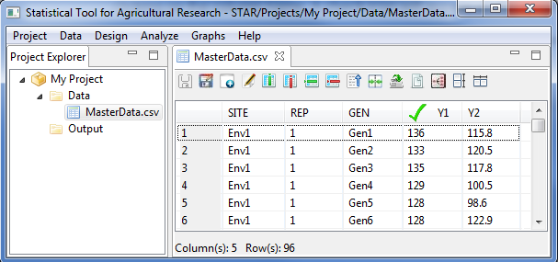

* The **Insert Column** dialog box will appear. In the **Insert New Column Name** field, specify a new name for the inserted column. The default new column name is *NewColumn*.

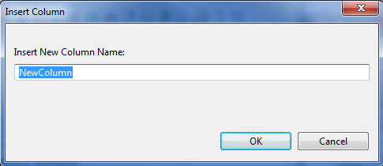

In naming the column, the following rules apply:

* The name must start with a letter while the remaining characters can be any letter, any digit, a period or underscore.
* The name must be different from the existing column names in the data.
* The name is case sensitive.

For the example, type *Plot*. The completed dialog box will appear as shown below:

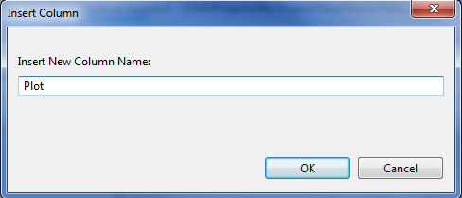

* Click the **OK** button.

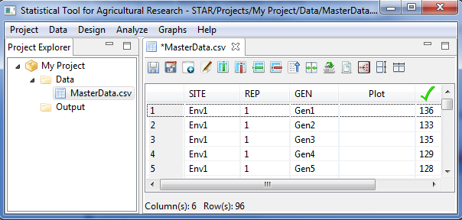

* The data now contains the newly inserted column named *Plot.*

## Deleting Column(s)

The steps to delete row(s) are listed below:

* On the **Project Explorer** panel, double-click the file where columns will be deleted to open it and view it in the Data Viewer tab.

For the example, use the modified and unsaved *MasterData.csv* in the project named *MyProject* created from the previous section that is displayed in the Data Viewer tab.

* Select the column or one of the columns to be deleted by clicking on the column name. A check icon will appear on the column header.

For the example, select the column named *Plot*.

* Click **Data | Delete Column…** from the main window or click on the Insert Column icon  in the Data Viewer tool bar.
* Click the **OK** button.

## Create New Variables

New variables can be created in the active data set by transforming existing variables or collapsing categories of two or more existing variables.

For transformations, there are six available functions, namely: logarithm, natural logarithm, square root, power, exponential and standardized. For logarithm, natural logarithm, square root and power transformation, the variables to be transformed should not contain negative values. For logarithm and natural logarithm transformation, values of the variable to be transformed will be incremented by 1 if it contains values equal to 0. For square root and power transformation, values of the variable will be incremented by 0.5 if it contains values equal to 0.

The steps to create new variables are listed below:

* On the **Project Explorer** panel, double-click the file to be used to open it and view it in the Data Viewer tab.

For the example, using the project named *MyProject*, import the data *MasterData.csv* from the *Data* folder of the project named *SampleProject*. To import data from the *SampleProject*, see *Importing Data from Other Project* sectionof this user’s manual.

* To create new variables, click **Data | Create New Variable** from the main window or click on the Create New Variable icon  in the Data Viewer toolbar.

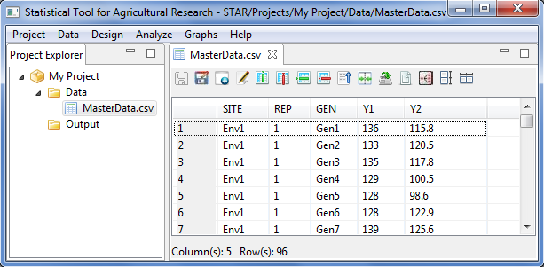

The **Create New Variable** dialog box will appear.

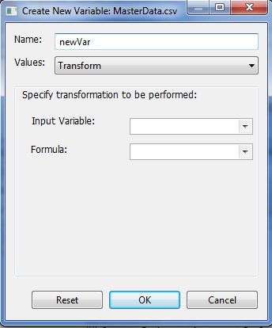

* Specify the required fields and appropriate options.

**Name**

This is the name of the new variable to be created. The default variable name is *newVar*. In naming the column, the following rules apply:

* The name must start with a letter while the remaining characters can be any letter, any digit, a period or underscore.
* Each column name must be unique; duplication is not allowed.
* Column name is case sensitive

**Values**

There are two options to determine the values of the new variable. The user can either transform any existing numeric variables or concatenate the values of any variables in the data set. The default is *Transform*.

**Input Variable**

If *transformation* is selected in the **Value** drop-down box, this drop-down box will be visible. This box pertains to the variable where the transformation will be performed. All numeric variables of the active data will be displayed in the drop-down box.

**Formula**

If *transformation* is selected in the **Value** drop-down box, this drop-down box will be visible. This box pertains to the formula that will be used when the value in the **Input Variable** is transformed. Transformation options available are logarithm, natural logarithm, square root, power, exponential and standardized.

**Checkbox Table**

If *Concatenate Columns* is selected in the **Value** drop-down box, this table will be visible. This table lets the user specify the columns to concatenate by ticking at least two column names. All columns of the active data will be displayed in the table.

For the example, suppose we want to standardized the variable *Y1*. The completed dialog box should appear as shown below:

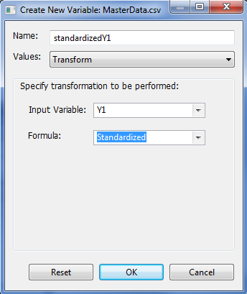

* Click the **OK** button. The data set with the transformed variable is displayed in the Data Viewer tab.

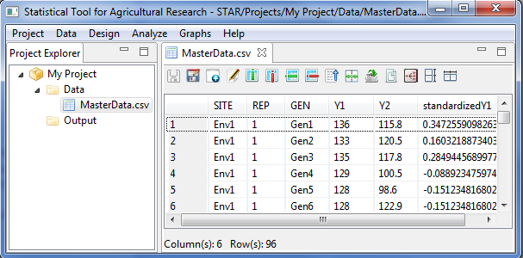

Suppose we want to create a new variable by concatenating the values of two variables. The completed dialog box should appear as shown below:

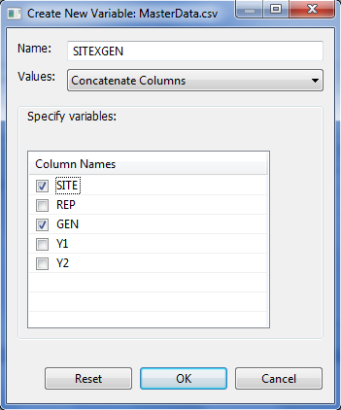

* Click the **OK** button. The transform variable is displayed in the Data Viewer tab.

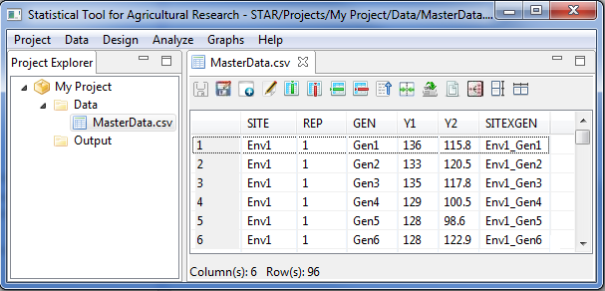

## Editing Variable Information

The steps to edit the variable information are listed below:

* On the **Project Explorer** panel, double-click the file to be used to open it and view it in the Data Viewer tab.

For the example, using the project named *MyProject*, import the data *MasterData.csv* from the *Data* folder of the project named *SampleProject*. To import data from the *SampleProject*, see *Importing Data from Other Project* sectionof this user’s manual.

* To edit variable information, click **Data | Edit Variable Information** from the main window of STAR or click on the Edit Variable Information icon  in the Data Viewer toolbar.



* The **Edit Variable Information** dialog box will appear. The variables in the active data set are classified as either a factor or numeric variable. The user can modify the variable type of the variables in the data set.

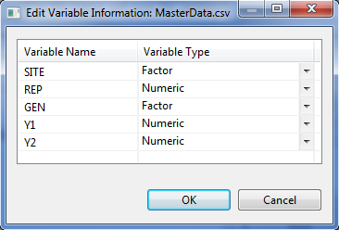

For the example, change the Variable Type of *REP* from Numeric to Factor. The complete dialog box should appear as shown below:

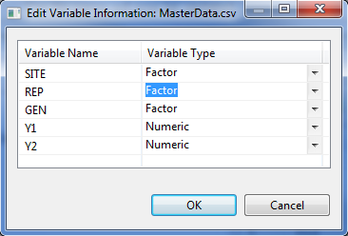

* Click the **OK** button.

## Sorting

Re-arranging or sorting the rows or cases of the data file is often useful and sometimes necessary for certain types of analysis. The **Sort Cases Menu** can be used to sort rows based on the value of one or more sorting variables.

The steps to re-arrange the data set based on the value of one or more sorting variables are listed below:

* On the **Project Explorer** panel, double-click the file to be used to open it and view it in the Data Viewer tab.

For the example, using the project named *MyProject*, import the data *MasterData.csv* from the *Data* folder of the project named *SampleProject*. The data file is arranged by *SITE*, *REP* then by *GEN*.

To import data from the *SampleProject*, see *Importing Data from Other Project* sectionof this user’s manual.

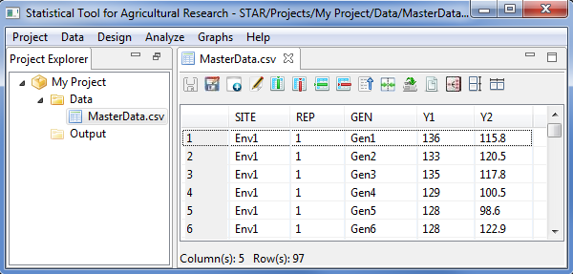

* Choose **Data** | **Sort…** from the main window or click on the Sort icon  in the Data Viewer tool bar. The **Sort** dialog box will appear.

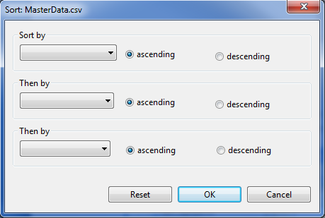

* Specify up to three variables as the basis for sorting and the order of sorting. Click the drop-down list box to identify the sorting variables. The rows can be re-arranged or sorted in ascending or descending order, with ascending order as the default option. If two or three variables are selected, rows are sorted for each variable within categories of the preceding variables. For character variables, uppercase letters precede their lowercase counterparts.

For the example, suppose we want to re-arrange the content of the data *MasterData.csv*, by ascending order of the variable *GEN* then by descending order of the variable *SITE*. The completed dialog box should appear as shown below:

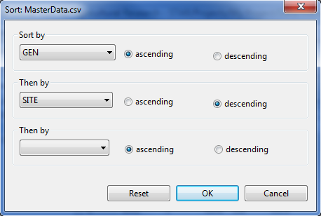

* Click the **OK** button to sort the active data. The **Sort** dialog box is closed and the sorted data is saved in the parent folder of the active data and displayed in the Data Viewer tab.

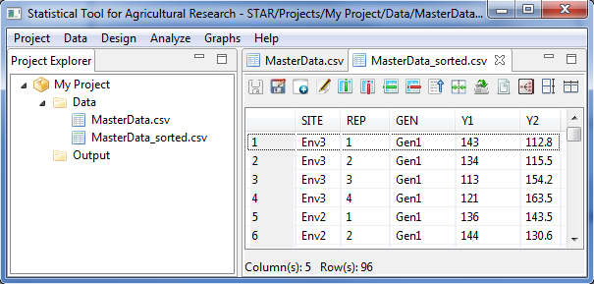

## Merging Datasets

The **Merge submenu** can be used to combine the active data file (known as the master data) with another data file (referred as the transaction data) that contains the same cases or rows but different variables.

The steps to merge datasets are listed below:

* On the **Project Explorer** panel, using the project named *MyProject*, import the data files *MasterData.csv* and *MergeTransact.csv* from the *Data* folder of the project named *SampleProject*. Double-click the file *MasterData.csv* to open it and view it in the Data Viewer.

To import data from the *SampleProject*, see *Importing Data from Other Project* sectionof this user’s manual.

* Choose **Data | Merge Datasets…** or click on the MergeDatasets icon  in the Data Viewer toolbar. The **Merge Data** dialog box will appear.

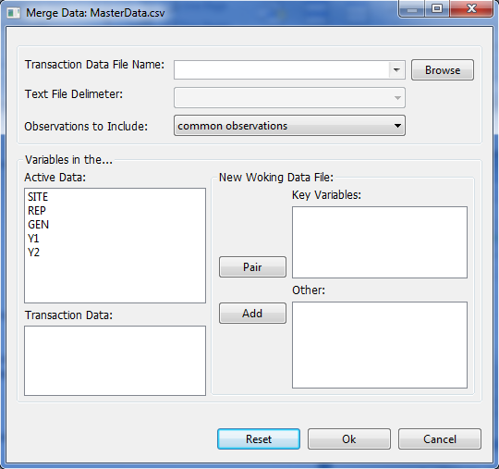

* Specify the required fields and appropriate options.

**Transaction File Name**

Specify this file by selecting a file using the drop-down combo box or by locating it using the **Browse** button. The files included in the drop-down combo box are files inside the *Data* folder not in its sub-folder. Only *.txt* and *.csv* data file format can be selected as the transaction file.

**Text File Delimeter**

If the transaction file selected is a text file, the delimeter should be specified. Four delimeters are available, namely: comma, space, tab and semi-colon.

**Observations to Include**

This option pertains to how rows or cases will be included in the new merged data file. The options available are to include common observations (default value), all observations in the active data, all observations in the transaction data and all observations.

**Key Variables**

These are pair(s) of variables that are present in the active and transaction files and will be the basis for the merging. Variables can be paired by clicking one variable in the active data and clicking one variable in the transaction data then clicking the **Pair** button. If the pair of variables has different column names, the new merged data file that will be created will use the column name of the active data.

**Other**

These are the other variables the user wants to include in the merged data file. Variables can be added by selecting at least one variable in the active data and/or in the transaction data then clicking the **Add** button. If columns in this list have the same name, **.1** will be appended to the column name coming from the active data and **.2** to the one from the transaction data.

For the example, select *MergeTransact.csv* file as the transaction data file from the drop-down combo box. The completed dialog box should appear as shown below:

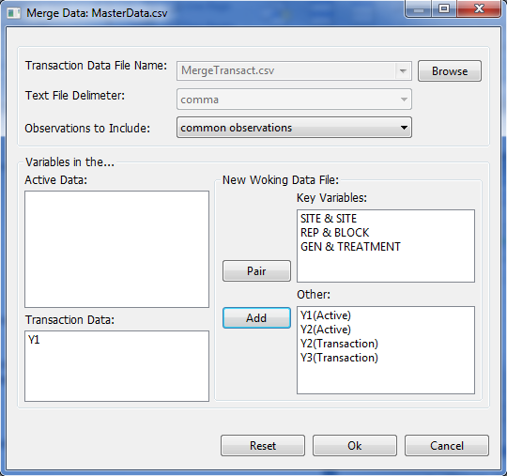

* Click the **OK** button. The merged data is saved in the parent folder of the active data and displayed in the Data Viewer tab. The default filename of the merged data set follows the format *<activeDataFilename>\_<TransactionDataFilename>\_merge.csv*.

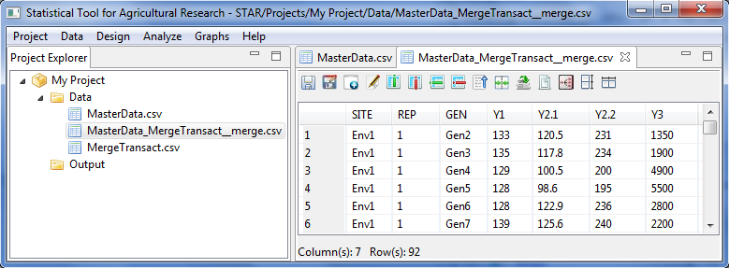

## Appending Datasets

The Append submenu can be used combine two data files with the same variables but different cases.

* On the **Project Explorer** panel, using the project named *MyProject*, import the data files *MasterData.csv* and *AppendTransact.csv* from the *Data* folder of the project named *SampleProject*. Double-click the file *MasterData.csv* to open it and view it in the Data Viewer.

To import data from the *SampleProject*, see *Importing Data from Other Project* sectionof this user’s manual.

* Choose **Data | Append Datasets…** or click on the AppendDatasets icon  in the Data Viewer toolbar. The Append Data dialog box will appear.

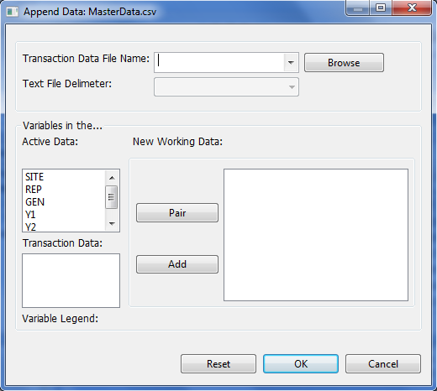

* Specify the required fields and appropriate options.

**Transaction File Name**

Specify this file by selecting a file using the drop-down combo box or by locating it using the **Browse** button. The files included in the drop-down combo box are files inside the *Data* folder not in its sub-folder. Only *.txt* and *.csv* data file format can be selected as the transaction file.

**Text File Delimeter**

If the transaction file selected is a text file, the delimeter should be specified. Four delimeters are available, namely: comma, space, tab and semi-colon

**New Working Data**

This is the list of variables or paired variables that will be included in the new data set. Variables can be paired by clicking one variable in the active data and clicking one variable in the transaction data then clicking the **Pair** button. Other variables can be added to this list by clicking the variable then clicking the **Add** button. For paired variables in this list, the appended data file that will be created will use the column name of the active data. For non-paired variables, **.1** will be appended to the column name coming from the active data and **.2** to the one from the transaction data.

For the example, select *AppendTransact.csv* file as the transaction data file from the drop-down combo box. The completed dialog box should appear as illustrated below:

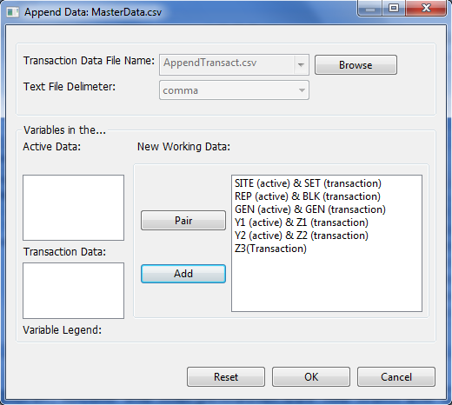

* Click the **OK** button. The appended data is saved in the parent folder of the active data and displayed in the Data Viewer tab. The appended data will contain an additional column named *Source* which indicates where the data came from. The default filename of the appended data set follows the format *<activeDataFilename>\_<TransactionDataFilename>\_merge.csv*.

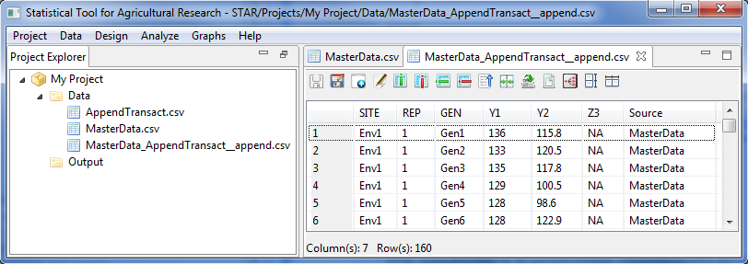

## Creating Data Subset

The steps in creating a subset of a dataset are listed below:

* On the **Project Explorer** panel, using the project named *My Project*, import the data file *MasterData.csv* from the *Data* folder of the project named *SampleProject*. Double-click the file to open it and view it in the Data Viewer.

To import data from the *SampleProject*, see *Importing Data from Other Project* sectionof this user manual.

* Choose **Data | Create Data Subset…** or click on the Create Data Subset icon  in the Data Viewer toolbar. The **Create Data Subset** dialog box will appear.

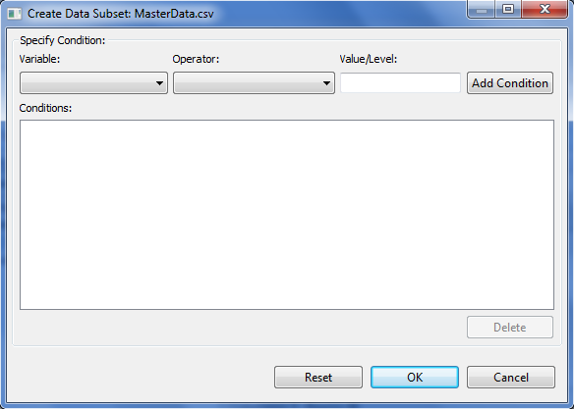

* Specify the required fields and appropriate options.

**Variable**

This drop-down list box lists all the variables in the active data set. User can specify the variable by clicking the drop-down list box and selecting the variable of interest.

**Operator**

This drop-down list box lists the available relational operators that can be used. The seven available operators that can be used are: equal (==), not equal (!=), at least (>=), at most (<=), greater than (>), less than (<) and within the range. User can specify the variable by clicking the drop-down list box and selecting the operator of interest.

**Value/Level**

Specify the level or value of the variable specified. If the operator specified is *within range*, user must specify two values separated by comma. Otherwise, user should specify only one value/level.

**Add Condition**

After specifying the conditional expression, user needs to click this button for the expression to be included in the **Conditions** list box.

**Conditions**

All the conditional expressions specified in this list box will be used when sub setting the active data set.

For the example, the completed dialog box should appear as shown below:

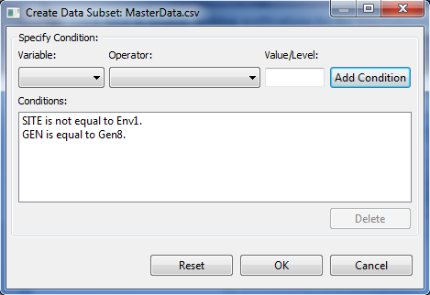

* Click the **OK** button. The new data is saved in the parent folder of the active data and displayed in the Data Viewer tab. The default filename of the new data set follows the format *<activeDataFilename>\_subset.csv*

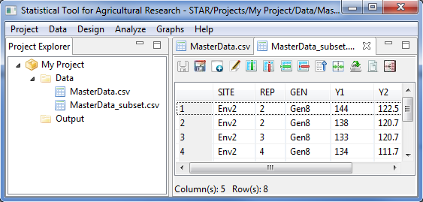

## Reshaping

The **Reshape** submenu can be used to restructure or reshape your active data set to follow the structure of the data set appropriate for the STAR procedure you want to use.

### Reshaping Data from Long (Serial) to Wide (Parallel) Format

Reshaping data from long (serial) to wide (parallel) involves re-arranging a data file, such that, repeated measurements are in separate columns.

The steps for reshaping the data from long to wide format are listed below:

* On the **Project Explorer**, double-click the file to be reshaped to open and view it in the Data Viewer tab.

For the example, import the data file *Year* from the package. To import data from the package, see *Importing Data from Package* sectionof this user manual.

* Click **Data** **| Reshape | Long (Serial) to Wide (Parallel) …** from the main window or click on the Reshape to Wide icon  in the Data Viewer tool bar.

**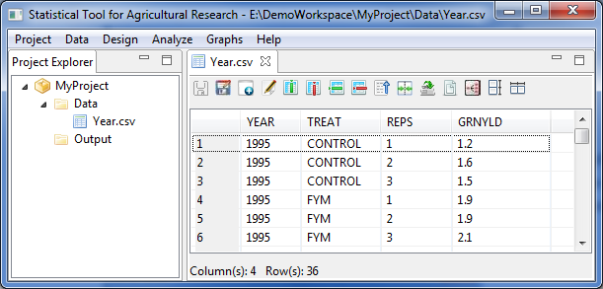**

* The **Reshape Data (Long to Wide)** dialog boxwill automatically appear.

**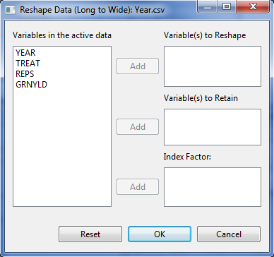**

* Specify the required fields and appropriate options.

**Variables to be Reshape**

This is the list of variable(s) whose values are to be divided into two or more columns and saved to different variables in terms of the levels of the index factor.

**Variables to be Retained**

This is the list of variable(s) which will be retained to describe the individual cases or observations.

**Index Factor**

This pertains to variable(s) which will determine the groupings of the values of the variable(s) to be transposed

For the example, the completed **Reshape Data (Long to Wide)** dialog box should appear as illustrated below:

**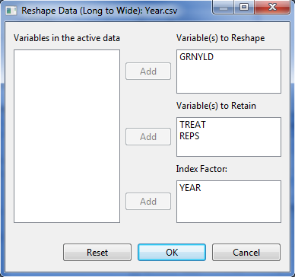**

* Click the **Ok** button. The restructured data set is saved in the parent folder of the active data and displayed in the **Data Viewer** tab. The default filename of the restructured data set follows the format *<activeDataFilename>\_ReshapeToWide.csv*.

**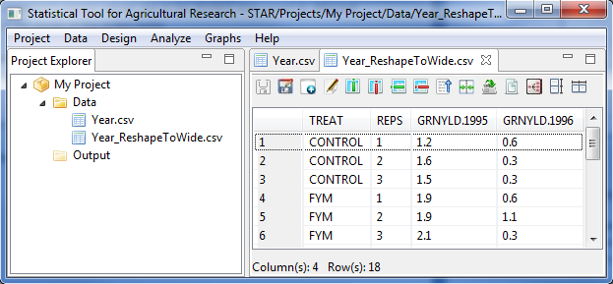**

### Reshaping Data from Wide (Parallel) to Long (Serial) Format

Manipulating data from wide (parallel) to long (serial) refers to re-arranging a multivariate into a univariate data. For instance, different columns representing measurements taken for a response variable over a period of time can be combined to form a single column, with the time variable used as an additional identifier variable.

The steps for reshaping the data from wide to long format are listed below:

* On the **Project Explorer**, double-click the file to be reshaped to open and view it in the Data Viewer tab.

For the example, locate the *Year\_ReshapeToWide.csv* file from the *Data* folder of the project named *MyProject*. Thisfile was generated from the section *Reshape Data from Long to Wide Format* of this user’s manual.

* Click **Data** **| Reshape | From Wide (Parallel) to Long (Serial) …** from the main window or click on the Reshape to Long icon  in the Data Viewer tool bar.

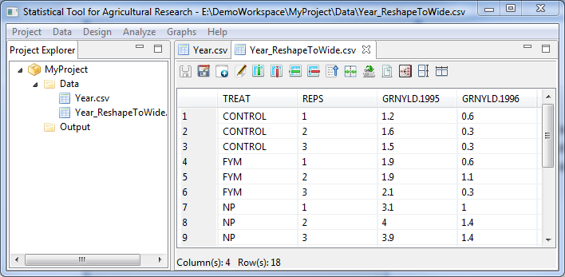

* The **Reshape Data (Wide to Long)** dialog box will appear.

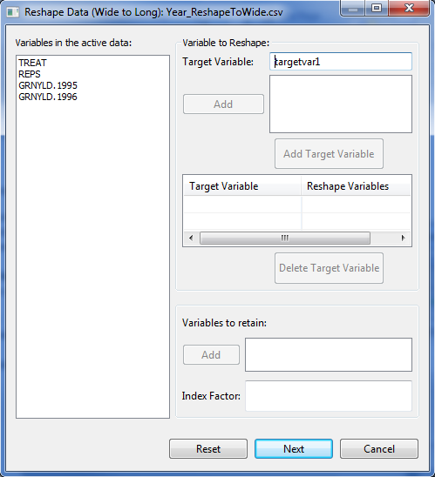

* Specify the required fields and appropriate options:

**Variable to be Reshape**

These are the variables that will be combined to form one variable. Click the variables in the list of variables in the active data while holding the Ctrl key then click the **Add** button. Moreover, the user should specify as the target variable the name of the variable to be created. The default target variable name is *targetvar1*.Then click the **Add Target Variable**. In specifying the name of the target variable, the following rules apply:

* The name must start with a letter. The remaining characters can be any letter, any digit, a period or underscore.
* Each column name must be unique; duplication is not allowed.
* Column name is case sensitive

User can create at least one target variable. This target variable should be unique and the length of the *Reshape Variables* should be the equal for all target variables to be created.

**Variables to be Retained**

These are the variables that will be included in the restructured data set and pertains to variables that describe the individual cases.

**Index Factor**

This is the name of the grouping variables that will be created.

For the *example*, the completed dialog box should appear as shown below:

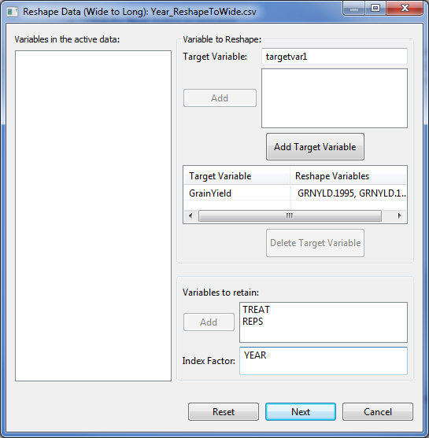

* Click the **Next** button to proceed.
* The **Define Levels** dialog box will appear.

**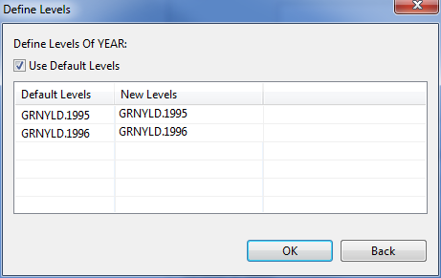**

* Specify the required fields. To specify the levels of the Index Factor that will be created, the user can use the default values or type the desired levels in the column labeled ‘New Levels’. For now, STAR only accepts non-numeric values for the levels.

For the example, the completed dialog box should appear as shown below:

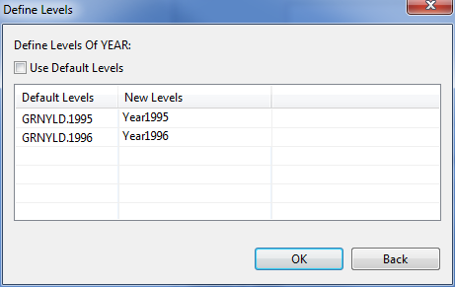

* Click the **OK** button. The restructured data set is saved in the parent folder of the active data and displayed in the Data Viewer tab. The default filename of the restructured data set follows the format *<activeDataFilename>\_ReshapeToLong.csv*.

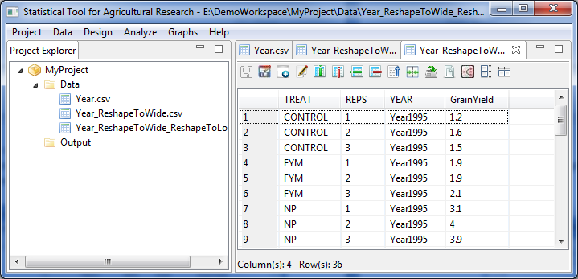

## Aggregating Data

This feature aggregates group of observations into single observation and creates a new, aggregated data file or creates new columns in the active data file that contain the aggregated data. Observations are aggregated based on the value of one or more grouping variables.

The steps for aggregating the data are listed below:

* On the **Project Explorer**, double-click the file to be used to open and view it in the Data Viewer tab.

For the example, using the project named *MyProject*, import the data file *MasterData.csv* from the *Data* folder of the project named *SampleProject*. To import data from the *SampleProject*, see *Importing Data from Other Project* sectionof this user’s manual.

Opening the data for the first time, *REP* field is regarded by STAR as numerical variable. To change its type, go to **Data | Edit Variable Information** and change the *Variable Type* of *REP* from *Numeric* to *Factor*.

* Choose **Data | Aggregate…** or click on the Aggregate Data icon  in the **Data Viewer** tool bar.

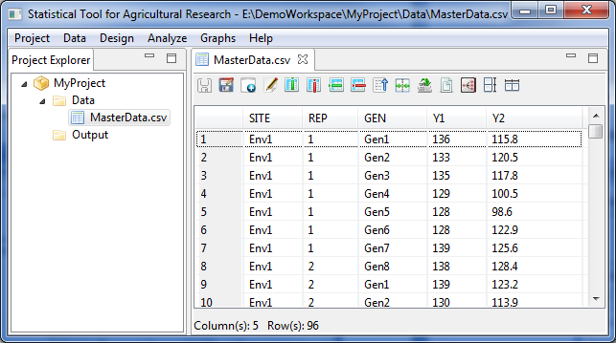

* The **Aggregate Data** dialog box will appear.

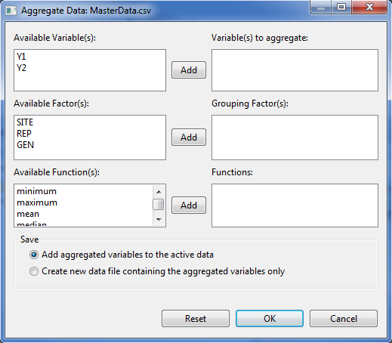

* Specify the required fields and appropriate options.

**Variable(s) to Aggregrate**

This is the list of variables whose values will be summarized using the selected functions. At least one entry is needed and should come from the **Available Variable(s)** list box.

**Grouping Factor(s)**

This field is optional. If specified, it will summarize the values per category of the grouping factor. Entries should come from the **Available Factor(s)** list box.

**Functions**

At least one function should be specified. Available functions are minimum, maximum, mean, median, sum, variance and standard deviation.

**Save**

Specify how the aggregated data will be saved. User can either add aggregated variables to the active data (default options) or create a new data file containing the aggregated variables only. If user chooses the default option, the resulting data file is not aggregated. Each observations with the save value(s) of the grouping variable(s) will receive the same values of the new aggregated variables. If user chooses the option create a new data file containing the aggregated variables only, the new data files contains one observation for each category of the grouping variables.

For the *example*, suppose we want to compute the mean of the variables *Y1* and *Y2* for each level of *REP*. The completed dialog box should appear as shown below:

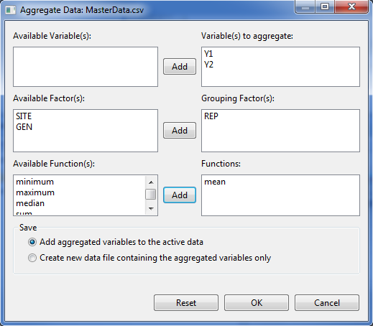

* Click the **OK** button.

If the user chooses the save option: *add aggregated variables to the active data* (default option), the active data is saved with the additional column(s) and displayed in the Data Viewer. The default column name(s) which contain the aggregate data follows the format *<Function>.< Variable to aggregate >*.

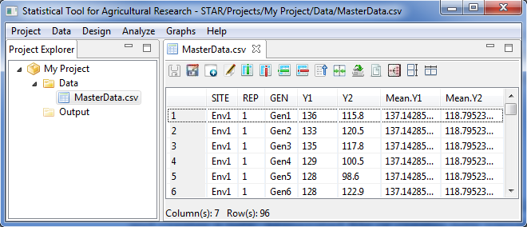

If the user chooses the save option: *create a new data file containing the aggregated variables only*, the aggregated data file is saved in the parent folder of the active data and displayed in the Data Viewer. The default column name(s) which contain the aggregate data follows the format *<Function>.<Variable name to aggregate>* and the default filename of the aggregated data set follows the format *<activeDataFilename>\_aggregate.csv*.

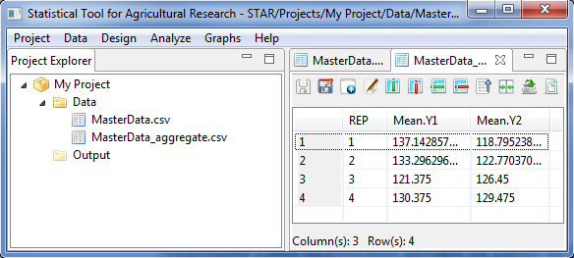

# Randomization and Layout

The **Design Menu** allows user to generate randomization and layout for single- and multi-factor designs. If the menu is used for the first-time in the active project, a *Randomization* folder will be created inside the *Output* folder. Sub-folders will be created inside the *Randomization* folder where the generated field book in *csv* format and a text file will be saved. The default sub-folder name follows the format *<design>\_<time stamp>*.

## Completely Randomized Design

The randomization that will be generated is for balanced design. Equal number of replicates will be generated for each level of the factor or treatment combination.

The steps to generate randomization are listed below:

* To perform randomization, click **Design | Completely Randomized Design…**. The **Randomization and Layout** dialog box will appear.
* Specify the required fields and appropriate options.

**Number of Factors**

Define the number of factors to be generated with default and minimum value equal to 1 and maximum value equal to 10. The number of factors specified will define the number of rows of the table inside the **Factor Definition** frame. To change the default value, user can either type a value inside the spin box or click the up-arrow key of the spin box to increase the value, down-arrow key, otherwise.

**Factor Definition Frame**

**Name**

Contain the default name for each factor which can be change. In specifying the factor name, the following rules apply:

* name should not contain any space;
* must begin with a letter or a period (.);
* succeeding characters can be a combination of letters, numbers, period (.) and underscore (\_); and
* name must be different from other factor names already specified.

**Factor ID**

Contain the default code for each factor. User can change the factor ID by typing the desired factor ID. Factor ID should consist of 1 to 4 letters only and should be unique.

**Levels**

Contain the level for each factor. User can change the level of the factor by either typing a value inside the spin box or clicking the up-arrow key of the spin box to increase the value, down-arrow key, otherwise. The default and minimum value of the levels is equal to 2 while the maximum value of the levels is 500.

**Number of Replicates**

Define the number of replicates to be generated for each level of the factor or for each treatment combination. The default and minimum value is equal to 2.

**Number of Field Rows**

Define the number of rows in the field layout for each trial. The default and minimum value is equal to one.

**Number of Trial**

Define the number of trials to be generated. The default and minimum value is equal to one.

**Field Book Filename**

This field is required and it specifies the file name where the result of the randomization will be saved. The default filename is *fieldbookCRD*.

**Field Book Order**

Define how the plot number will be arranged. There are two options available: *Plot Order* (default value)and *Serpentine*.

For the example, suppose we want to generate a randomization and layout for an experiment whose aim is to compare the effects of seven different foliar and granular insecticides on the grain yield of a certain rice variety. The experiment will be conducted in completely randomized design with four replicates. The completed dialog box should appear as shown below:

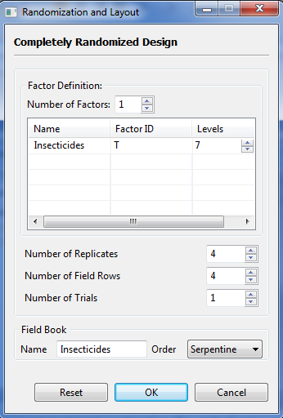

* Click the **OK** button to generate the randomization. The **Randomization** dialog box will be minimized and STAR will automatically display the *csv* data file and the *txt* file created in the Data Viewer tab.

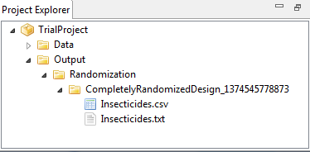

Sample *txt* file displayed in the Data Viewer tab is shown below:

DESIGN PROPERTIES:

Single Factor

Completely Randomized Design

DESIGN PARAMETERS:

Number of Trials = 1

Number of Replicates = 4

Treatment Name = Insecticides

Treatment Levels = T1, T2, T3, ..., T7

Layout for Completely Randomized Design

Trial = 1

+----+----+----+----+----+----+----+

| 1| 2| 3| 4| 5| 6| 7|

|T2 |T7 |T3 |T6 |T4 |T5 |T1 |

+----+----+----+----+----+----+----+

| 8| 9| 10| 11| 12| 13| 14|

|T2 |T1 |T1 |T3 |T2 |T1 |T5 |

+----+----+----+----+----+----+----+

| 15| 16| 17| 18| 19| 20| 21|

|T6 |T5 |T7 |T5 |T2 |T6 |T4 |

+----+----+----+----+----+----+----+

| 22| 23| 24| 25| 26| 27| 28|

|T3 |T6 |T4 |T4 |T7 |T7 |T3 |

+----+----+----+----+----+----+----+

\*\*Note: Cells contain plot numbers on top, treatments/entries below

Sample *csv* data file displayed in the Data Viewer tab is shown below:

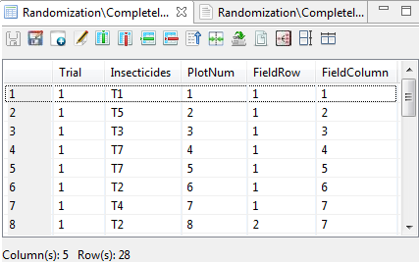

## Randomized Complete Block Design

The steps to generate randomization in are listed below:

* To perform randomization, click **Design | Randomized Complete Block Design** **…**. The **Randomization and Layout** dialog box will appear.
* Specify the required fields and appropriate options.

**Number of Factors**

Define the number of factors to be generated with default and minimum value equal to 1 and maximum value equal to 10. The number of factors specified will define the number of rows of the table inside the **Factor Definition** frame. To change the default value, user can either type a value inside the spin box or click the up-arrow key of the spin box to increase the value, down-arrow key, otherwise.

**Factor Definition Frame**

**Name**

Contain the default name for each factor which can be change. In specifying the factor name, the following rules apply:

* name should not contain any space;
* must begin with a letter or a period (.);
* succeeding characters can be a combination of letters, numbers, period (.) and underscore (\_); and
* name must be different from other factor names already specified.

**Factor ID**

Contain the default code for each factor. User can change the factor ID by typing the desired factor ID. Factor ID should consist of 1 to 4 letters only and should be unique.

**Levels**

Contain the level for each factor. User can change the level of the factor by either typing a value inside the spin box or clicking the up-arrow key of the spin box to increase the value, down-arrow key, otherwise. The default and minimum value of the levels is equal to 2 while the maximum value of the levels is 500.

**Number of Blocks**

Define the number of blocks to be generated. The default and minimum value is equal to 2.

**Number of Rows per Block**

Define the number of rows per block. The default and minimum value is equal to 1.

**Number of Field Rows**

Define the number of rows in the field layout for each trial. The default and minimum value is equal to one.

**Number of Trial**

Define the number of trials to be generated. The default and minimum value is equal to one.

**Field Book Filename**

This field is required and it specifies the file name where the result of the randomization will be saved. The default filename is *fieldbookRCBD*.

**Field Book Order**

Define how the plot number will be arranged. There are two options available: *Plot Order* (default value)and *Serpentine*.

For the example, suppose we want to generate a randomization and layout for an experiment whose aim is to compare the effects of five seeding densities on the on grain yield of three rice varieties. The experiment will be conducted in randomized complete block design with four blocks in one trial. The planned field layout is shown below:

|  |  |  |  |
| --- | --- | --- | --- |
|  | Field Column 1 | Field Column 2 | Field Column 3 |
| Field Row 1 |  |  |  |
| Field Row 2 |  |  |  |
| Field Row 3 |  |  | Block 1 |
| Field Row 4 |  |  |  |
| Field Row 5 |  |  |  |
| Field Row 6 |  |  |  |
| Field Row 7 |  |  | Block 2 |
| Field Row 8 |  |  |  |
| Field Row 9 |  |  |  |
| Field Row 10 |  |  |  |
| Field Row 11 |  |  |  |
| Field Row 12 |  |  | Block 3 |
| Field Row 13 |  |  |  |
| Field Row 14 |  |  |  |
| Field Row 15 |  |  |  |
| Field Row 16 |  |  |  |
| Field Row 17 |  |  |  |
| Field Row 18 |  |  | Block 4 |
| Field Row 19 |  |  |  |
| Field Row 20 |  |  |  |

The completed dialog box should appear as shown below:

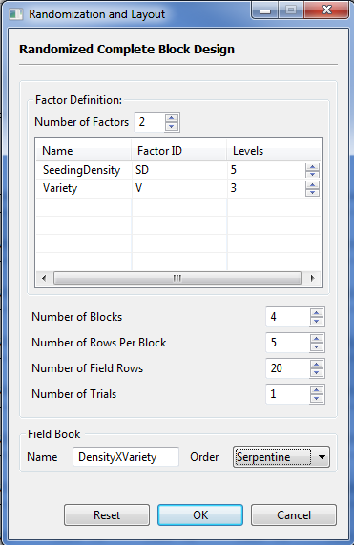

* Click the **OK** button to generate the randomization. The **Randomization and Layout** dialog box will be minimized and STAR will automatically display the *csv* data file and the *txt* file created in the Data Viewer tab.

Sample *txt* file displayed in the Data Viewer tab is shown below:

DESIGN PROPERTIES:

Factorial Design

Randomized Complete Block Design

DESIGN PARAMETERS:

Number of Trials = 1

Number of Blocks = 4

Factor 1 = SeedingDensity

Levels = SD1, SD2, SD3, SD4, SD5

Factor 2 = Variety

Levels = V1, V2, V3

Number of Field Row = 20

Number of Field Column = 3

Layout for Randomized Complete Block Design

Trial = 1

FieldCol1 FieldCol2 FieldCol3

+-----------+-----------+-----------+

FieldRow1 | 101| 102| 103|

|SD4 V1 |SD5 V2 |SD2 V1 |

+-----------+-----------+-----------+

FieldRow2 | 104| 105| 106|

|SD4 V2 |SD1 V3 |SD5 V1 |

+-----------+-----------+-----------+

FieldRow3 | 107| 108| 109|

|SD5 V3 |SD4 V3 |SD1 V1 |

+-----------+-----------+-----------+

FieldRow4 | 110| 111| 112|

|SD1 V2 |SD2 V3 |SD3 V2 |

+-----------+-----------+-----------+

FieldRow5 | 113| 114| 115|

|SD3 V3 |SD2 V2 |SD3 V1 |

+-----------+-----------+-----------+

FieldRow6 | 201| 202| 203|

|SD1 V1 |SD4 V1 |SD5 V1 |

+-----------+-----------+-----------+

FieldRow7 | 204| 205| 206|

|SD1 V2 |SD4 V2 |SD3 V1 |

+-----------+-----------+-----------+

FieldRow8 | 207| 208| 209|

|SD1 V3 |SD3 V3 |SD2 V1 |

+-----------+-----------+-----------+

FieldRow9 | 210| 211| 212|

|SD2 V3 |SD3 V2 |SD2 V2 |

+-----------+-----------+-----------+

FieldRow10 | 213| 214| 215|

|SD5 V2 |SD4 V3 |SD5 V3 |

+-----------+-----------+-----------+

FieldRow11 | 301| 302| 303|

|SD5 V3 |SD4 V2 |SD2 V1 |

+-----------+-----------+-----------+

FieldRow12 | 304| 305| 306|

|SD5 V1 |SD5 V2 |SD2 V2 |

+-----------+-----------+-----------+

FieldRow13 | 307| 308| 309|

|SD3 V2 |SD1 V1 |SD1 V3 |

+-----------+-----------+-----------+

FieldRow14 | 310| 311| 312|

|SD3 V3 |SD3 V1 |SD4 V3 |

+-----------+-----------+-----------+

FieldRow15 | 313| 314| 315|

|SD1 V2 |SD4 V1 |SD2 V3 |

+-----------+-----------+-----------+

FieldRow16 | 401| 402| 403|

|SD4 V2 |SD5 V3 |SD2 V3 |

+-----------+-----------+-----------+

FieldRow17 | 404| 405| 406|

|SD3 V1 |SD4 V1 |SD1 V3 |

+-----------+-----------+-----------+

FieldRow18 | 407| 408| 409|

|SD5 V2 |SD4 V3 |SD2 V1 |

+-----------+-----------+-----------+

FieldRow19 | 410| 411| 412|

|SD3 V2 |SD1 V1 |SD5 V1 |

+-----------+-----------+-----------+

FieldRow20 | 413| 414| 415|

|SD3 V3 |SD2 V2 |SD1 V2 |

+-----------+-----------+-----------+

\*\*Note: Cells contain plot numbers on top, treatments/entries below

Sample *csv* data file displayed in the Data Viewer tab is shown below:

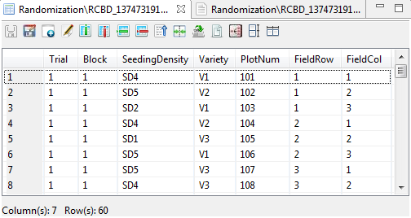

## Latin Square Design

The steps to generate randomization are listed below:

* To perform randomization, click **Design | Latin Square Design…**. The **Randomization and Layout** dialog box will appear.
* Specify the required fields and appropriate options.

**Number of Factors**

Define the number of factors to be generated with default and minimum value equal to 1 and maximum value equal to 10. The number of factors specified will define the number of rows of the table inside the **Factor Definition** frame. To change the default value, user can either type a value inside the spin box or click the up-arrow key of the spin box to increase the value, down-arrow key, otherwise.

**Factor Definition Frame**

**Name**

Contain the default name for each factor which can be change. In specifying the factor name, the following rules apply:

* name should not contain any space;
* must begin with a letter or a period (.);
* succeeding characters can be a combination of letters, numbers, period (.) and underscore (\_); and
* name must be different from other factor names already specified.

**Factor ID**

Contain the default code for each factor. User can change the factor ID by typing the desired factor ID. Factor ID should consist of 1 to 4 letters only and should be unique.

**Levels**

Contain the level for each factor. User can change the level of the factor by either typing a value inside the spin box or clicking the up-arrow key of the spin box to increase the value, down-arrow key, otherwise. The default and minimum value of the levels is equal to 2. The maximum levels of the factor or treatment combination should be equal to 11.

**Number of Trial**

Define the number of trials to be generated. The default value and minimum value is equal to one.

**Field Book Filename**

This field is required and it specifies the file name where the result of the randomization will be saved. The default filename is *fieldbookLSD*.

**Field Book Order**

Define how the plot number will be arranged. There are two options available: *Plot Order* (default value)and *Serpentine*.

For the example, suppose we want to generate a randomization and layout for an experiment to be laid out in Latin Square design whose aim is to compare the grain yield of five promising maize hybrids and a check variety. The completed dialog box should appear as shown below:

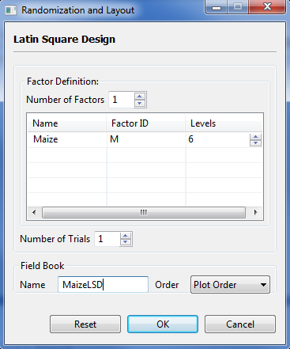

* Click the **OK** button to generate the randomization. The **Randomization and Layout** dialog box will be minimized and STAR will automatically display the *csv* data file and the *txt* file created in the Data Viewer tab.

Sample *txt* file displayed in the Data Viewer is shown below:

DESIGN PROPERTIES:

Single Factor

Latin Square Design

DESIGN PARAMETERS:

Number of Trials = 1

Treatment Name = Maize

Treatment Levels = M1, M2, M3, ..., M6

Layout for Latin Square Design

Trial = 1

+----+----+----+----+----+----+

| 1| 2| 3| 4| 5| 6|

|M6 |M3 |M2 |M4 |M1 |M5 |

+----+----+----+----+----+----+

| 7| 8| 9| 10| 11| 12|

|M5 |M2 |M1 |M3 |M6 |M4 |

+----+----+----+----+----+----+

| 13| 14| 15| 16| 17| 18|

|M1 |M4 |M3 |M5 |M2 |M6 |

+----+----+----+----+----+----+

| 19| 20| 21| 22| 23| 24|

|M2 |M5 |M4 |M6 |M3 |M1 |

+----+----+----+----+----+----+

| 25| 26| 27| 28| 29| 30|

|M3 |M6 |M5 |M1 |M4 |M2 |

+----+----+----+----+----+----+

| 31| 32| 33| 34| 35| 36|

|M4 |M1 |M6 |M2 |M5 |M3 |

+----+----+----+----+----+----+

\*\*Note: Cells contain plot numbers on top, treatments/entries below

Sample *csv* data file displayed in the Data Viewer is shown below:

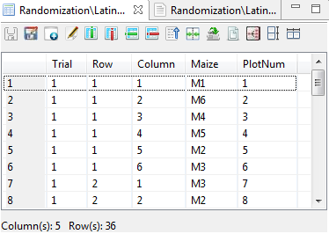

## Split Plot Design

This design can be generated for experiments where the main plot is arranged in completely randomized design, randomized complete block design and Latin square design.

The steps to generate randomization are listed below:

* Click **Design | Split Plot Design** from the main window. Choose the appropriate design for the main plot.
* The **Randomization and Layout** dialog box will appear.

When the main plot is arranged in completely randomized design, the default **Randomization and Layout** dialog box is shown below:

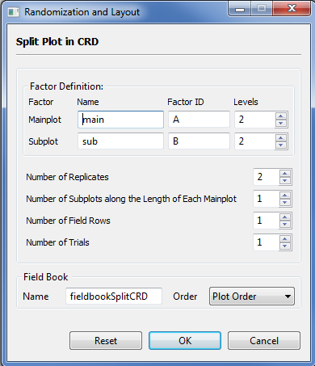

When the main plot is arranged in randomized complete block design, the default **Randomization and Layout** dialog box is shown below:

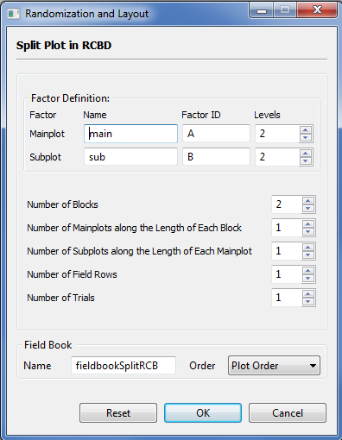

When the main plot is arranged in Latin Square design, the default **Randomization and Layout** dialog box is shown below:

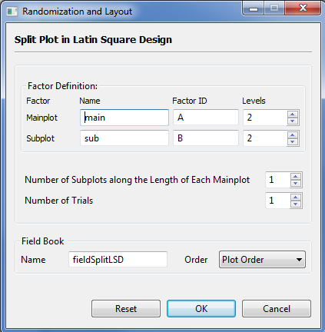

* Specify the required field and appropriate options.

**Factor Definition Frame**

**Name**

Contain the default name for each factor which can be change. In specifying the factor name, the following rules apply:

* name should not contain any space;
* must begin with a letter or a period (.);
* succeeding characters can be a combination of letters, numbers, period (.) and underscore (\_); and
* name must be different from other factor names already specified.

**Factor ID**

Contain the default code for each factor. User can change the factor ID by typing the desired factor ID. Factor ID should consist of 1 to 4 letters only and should be unique.

**Levels**

Contain the level for each factor. User can change the level of the factor by either typing a value inside the spin box or clicking the up-arrow key of the spin box to increase the value, down-arrow key, otherwise. The default and minimum value of the levels is equal to 2 while the maximum value of the levels is 500. When the main plot is arranged in Latin Square design, the maximum value of the levels of the main plot factor is 11.

**Number of Replicates**

Applicable only if completely randomized design is chosen. These define the number of replicates to be generated per trial. The default and minimum value is equal to 2.

**Number of Blocks**

Applicable only if randomized complete block design is chosen. These define the number of blocks to be generated. The default value and minimum value is equal to 2.

**Number of Mainplots along the Length of Each Block**

Applicable only if randomized complete block design is chosen. This is defined as the number of mainplots along the length of each block. The default and minimum value is equal to one.

This is defined as the number of rows in each block that would receive the levels of the mainplot factor

**Number of Subplots along the Length of Each Mainplot**

These define the number of subplots along the length of each mainplot. The default and minimum value is equal to one.

**Number of Field Rows**

Applicable only if completely randomized or randomized complete block design is chosen. Define the total number of rows in the field layout for each trial. The default and minimum value is equal to one.

**Number of Trial**

Define the number of trials to be generated. The default value and minimum value is equal to one.

**Field Book Filename**

This field is required and it specifies the file name where the result of the randomization will be saved.

**Field Book Order**

Define how the plot number will be arranged. There are two options available: *Plot Order* (default value)and *Serpentine*.

For this example, suppose we want to generate a randomization and layout for an experiment whose aim is to compare the effects of four nitrogen rates on grain yield of five rice varieties. The experiment will be conducted using Split Plot with four blocks. Nitrogen rates will be assigned as the mainplot factor and will be laid out in randomized complete block design; and the varieties as the subplot factor. The planned field layout is shown below:

|  |  |  |  |  |
| --- | --- | --- | --- | --- |
|  | Field  Column 1 | Field  Column 2 | Field  Column 3 | Field  Column 4 |
| Field Row 1 |  |  |  | Block 1 |
| Field Row 2 |  |  |  |  |
| Field Row 3 |  |  |  | Block 2 |
| Field Row 4 |  |  |  |  |
| Field Row 5 |  |  |  | Block 3 |
| Field Row 6 |  |  |  |  |
| Field Row 7 |  |  |  | Block 4 |
| Field Row 8 |  |  |  |  |

The completed dialog box should appear as below:

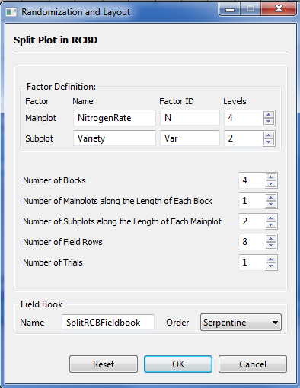

* Click the **OK** button to generate the randomization. The **Randomization and Layout** dialog box will be minimized and STAR will automatically display the *csv* data file and the *txt* file created in the Data Viewer tab.

Sample *txt* displayed in the Data Viewer is shown below:

DESIGN PROPERTIES:

Split Plot Design

Randomized Complete Block Design

DESIGN PARAMETERS:

Number of Trials = 1

Number of Blocks = 4

Mainplot Factor = NitrogenRate

Levels = N1, N2, N3, N4

Subplot Factor = Variety

Levels = Var1, Var2

Layout for Split Plot in Randomized Complete Block Design:

Trial = 1

FieldCol1 FieldCol2 FieldCol3 FieldCol4

+-----------+-----------+-----------+-----------+

FieldRow1 | 11| 12| 13| 14|

|N4 Var2 |N2 Var2 |N3 Var2 |N1 Var2 |

+-----------+-----------+-----------+-----------+

FieldRow2 | 18| 17| 16| 15|

|N4 Var1 |N2 Var1 |N3 Var1 |N1 Var1 |

+-----------+-----------+-----------+-----------+

FieldRow3 | 21| 22| 23| 24|

|N3 Var2 |N4 Var2 |N2 Var1 |N1 Var2 |

+-----------+-----------+-----------+-----------+

FieldRow4 | 28| 27| 26| 25|

|N3 Var1 |N4 Var1 |N2 Var2 |N1 Var1 |

+-----------+-----------+-----------+-----------+

FieldRow5 | 31| 32| 33| 34|

|N4 Var1 |N2 Var2 |N1 Var2 |N3 Var2 |

+-----------+-----------+-----------+-----------+

FieldRow6 | 38| 37| 36| 35|

|N4 Var2 |N2 Var1 |N1 Var1 |N3 Var1 |

+-----------+-----------+-----------+-----------+

FieldRow7 | 41| 42| 43| 44|

|N2 Var1 |N3 Var1 |N4 Var2 |N1 Var2 |

+-----------+-----------+-----------+-----------+

FieldRow8 | 48| 47| 46| 45|

|N2 Var2 |N3 Var2 |N4 Var1 |N1 Var1 |

+-----------+-----------+-----------+-----------+

\*\*Note: Cells contain plot numbers on top, treatments/entries below

Sample *csv* data file displayed in the Data Viewer is shown below:

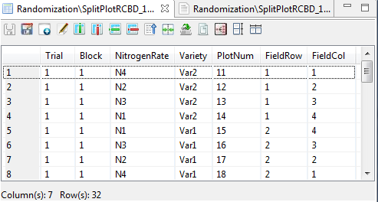

## Strip Plot Design

The steps to generate randomization are listed below:

* Choose **Design | Strip Plot Design**… from the main window. The **Randomization and Layout** dialog box will appear.
* Specify the required fields and appropriate options.

**Factor Definition Frame**

**Name**

Contain the default name for each factor which can be change. In specifying the factor name, the following rules apply:

* name should not contain any space;
* must begin with a letter or a period (.);
* succeeding characters can be a combination of letters, numbers, period (.) and underscore (\_); and
* name must be different from other factor names already specified.

**Factor ID**

Contain the default code for each factor. User can change the factor ID by typing the desired factor ID. Factor ID should consist of 1 to 4 letters only and should be unique.

**Levels**

Contain the level for each factor. User can change the level of the factor by either typing a value inside the spin box or clicking the up-arrow key of the spin box to increase the value, down-arrow key, otherwise. The default and minimum value of the levels is equal to 2 while the maximum value of the levels is 500.

**Number of Blocks**

These define the number of blocks to be generated. The default value and minimum value is equal to 2.

**Number of Field Rows**

Define the total number of rows in the field layout for each trial. The default and minimum value is equal to 2.

**Number of Trial**

Define the number of trials to be generated. The default value and minimum value is equal to one.

**Field Book Filename**

This field is required and it specifies the file name where the result of the randomization will be saved. The default filename is *fieldbookStrip*.

**Field Book Order**

Define how the plot number will be arranged. There are two options available: *Plot Order* (default value)and *Serpentine*.

For this example, suppose we want to generate a randomization and layout for an experiment to be conducted using Strip Plot, with land preparation (with 3 levels) as the horizontal factor and water stress (with four levels) as the vertical factor. Three blocks will be used. The planned field layout is shown below:

|  |  |  |  |  |
| --- | --- | --- | --- | --- |
|  | Field  Column 1 | Field  Column 2 | Field  Column 3 | Field  Column 4 |
| Field Row 1 |  |  |  | Block 1 |
| Field Row 2 |  |  |  |  |
| Field Row 3 |  |  |  | Block 2 |
| Field Row 4 |  |  |  |  |
| Field Row 5 |  |  |  | Block 3 |
| Field Row 6 |  |  |  |  |
| Field Row 7 |  |  |  |  |
| Field Row 8 |  |  |  |  |
| Field Row 9 |  |  |  |  |

The completed dialog box should appear as shown below:

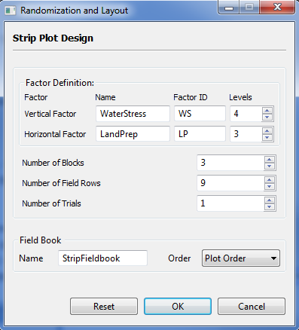

* Click the **OK** button to generate the randomization. The **Randomization and Layout** dialog box will be minimized and STAR will automatically display the *csv* data file and *txt* file created in the Data Viewer tab.

Sample *txt* file displayed in the Data Viewer is shown below:

DESIGN PROPERTIES:

Strip Plot Design

DESIGN PARAMETERS:

Number of Trials = 1

Number of Blocks = 3

Vertical Factor = WaterStress

Levels = WS1, WS2, WS3, WS4

Horizontal Factor = LandPrep

Levels = LP1, LP2, LP3

Layout for Strip Plot:

Trial = 1

FieldCol1 FieldCol2 FieldCol3 FieldCol4

+-----------+-----------+-----------+-----------+

FieldRow1 | 101| 102| 103| 104|

|WS3 LP1 |WS2 LP1 |WS4 LP1 |WS1 LP1 |

+-----------+-----------+-----------+-----------+

FieldRow2 | 105| 106| 107| 108|

|WS3 LP3 |WS2 LP3 |WS4 LP3 |WS1 LP3 |

+-----------+-----------+-----------+-----------+

FieldRow3 | 109| 110| 111| 112|

|WS3 LP2 |WS2 LP2 |WS4 LP2 |WS1 LP2 |

+-----------+-----------+-----------+-----------+

FieldRow4 | 201| 202| 203| 204|

|WS4 LP3 |WS1 LP3 |WS3 LP3 |WS2 LP3 |

+-----------+-----------+-----------+-----------+

FieldRow5 | 205| 206| 207| 208|

|WS4 LP1 |WS1 LP1 |WS3 LP1 |WS2 LP1 |

+-----------+-----------+-----------+-----------+

FieldRow6 | 209| 210| 211| 212|

|WS4 LP2 |WS1 LP2 |WS3 LP2 |WS2 LP2 |

+-----------+-----------+-----------+-----------+

FieldRow7 | 301| 302| 303| 304|

|WS3 LP1 |WS1 LP1 |WS4 LP1 |WS2 LP1 |

+-----------+-----------+-----------+-----------+

FieldRow8 | 305| 306| 307| 308|

|WS3 LP3 |WS1 LP3 |WS4 LP3 |WS2 LP3 |

+-----------+-----------+-----------+-----------+

FieldRow9 | 309| 310| 311| 312|

|WS3 LP2 |WS1 LP2 |WS4 LP2 |WS2 LP2 |

+-----------+-----------+-----------+-----------+

\*\*Note: Cells contain plot numbers on top, treatments/entries below

Sample *csv* data file displayed in the Data Viewer is shown below:

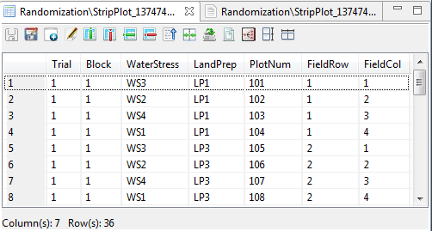

## Split-Split Plot Design

This design can be generated for experiments where the main plot is arranged in completely randomized design, randomized complete block design and Latin square design.

The steps to generate randomization are listed below:

* Click **Design | Split-Split Plot Design** from the main window. Choose the appropriate design for the main plot.
* The appropriate **Randomization and Layout** dialog box will appear depending on how the main plot will be arranged.
* Specify the required field and appropriate options.

**Factor Definition Frame**

**Name**

Contain the default name for each factor which can be change. In specifying the factor name, the following rules apply:

* name should not contain any space;
* must begin with a letter or a period (.);
* succeeding characters can be a combination of letters, numbers, period (.) and underscore (\_); and
* name must be different from other factor names already specified.

**Factor ID**

Contain the default code for each factor. User can change the factor ID by typing the desired factor ID. Factor ID should consist of 1 to 4 letters only and should be unique.

**Levels**

Contain the level for each factor. User can change the level of the factor by either typing a value inside the spin box or clicking the up-arrow key of the spin box to increase the value, down-arrow key, otherwise. The default and minimum value of the levels is equal to 2 while the maximum value of the levels is 500. When the main plot is arranged in Latin Square design, the maximum value of the levels of the main plot factor is 11.

**Number of Replicates**

Applicable only if completely randomized design is chosen. These define the number of replicates to be generated. The default and minimum value is equal to 2.

**Number of Blocks**

Applicable only if randomized complete block design is chosen. These define the number of blocks to be generated. The default and minimum value is equal to 2.

**Number of Mainplots along the Length of Each Block**

Applicable only if randomized complete block design is chosen. These define the number of main plots along the length of each block. The default and minimum value is equal to one.

**Number of Subplots along the Length of Each Mainplot**

Define the number of subplots along the length of each mainplot. The default and minimum value is equal to one.

**Number of Sub-subplots along the Length of Each Subplot**

Define the number of sub-subplots along the length of each subplot. The default and minimum value is equal to one.

**Number of Field Rows**

Applicable only if completely randomized or randomized complete block design is chosen. Define the total number of rows in the field layout for each trial. The default and minimum value is equal to one.

**Number of Trial**

Define the number of trials to be generated. The default value and minimum value is equal to one.

**Field Book Filename**

This field is required and it specifies the file name where the result of the randomization will be saved.

**Field Book Order**

Define how the plot number will be arranged. There are two options available: *Plot Order* (default value)and *Serpentine*.

For this example, suppose we want to generate a randomization and layout for an experiment whose aim is to compare the effects of five nitrogen rates and three management practices on the grain yield of three rice varieties which will be conducted using Split-Split Plot with three blocks. Nitrogen rates will be assigned as the mainplot factor and will be arranged in randomized complete block design, management practices as the subplot factor and varieties as the sub-subplot factor. The planned field layout is shown below:

|  |  |  |  |  |
| --- | --- | --- | --- | --- |
|  | Field  Column 1 | Field  Column 2 | Field  Column 3 | Field  Column 4 |
| Field Row 1 |  |  |  | Block 1 |
| Field Row 2 |  |  |  |  |
| Field Row 3 |  |  |  | Block 2 |
| Field Row 4 |  |  |  |  |
| Field Row 5 |  |  |  | Block 3 |
| Field Row 6 |  |  |  |  |
| Field Row 7 |  |  |  | Block 4 |
| Field Row 8 |  |  |  |  |

The completed dialog box should appear as shown below:

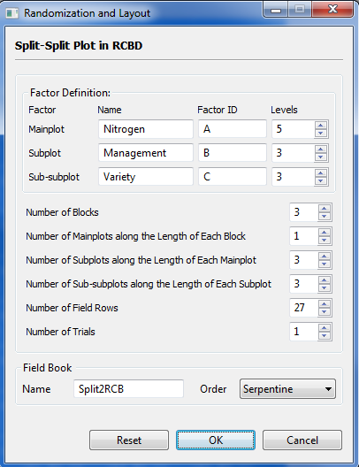

* Click the **OK** button to generate the randomization. The **Randomization and Layout** dialog box will be minimized and STAR will automatically display the *csv* data file created in the Data Viewer.

Sample *txt* data file displayed in the Data Viewer is shown below:

DESIGN PROPERTIES:

Split-Split Plot Design

Randomized Complete Block Design

DESIGN PARAMETERS:

Number of Trials = 1

Number of Blocks = 3

Mainplot Factor = Nitrogen

Levels = A1, A2, A3, A4, A5

Subplot Factor = Management

Levels = B1, B2, B3

Sub-subplot Factor = Variety

Levels = C1, C2, C3

Layout for Split-Split Plot in Randomized Complete Block Design:

Trial = 1

FieldCol1 FieldCol2 FieldCol3 FieldCol4 FieldCol5

+-----------+-----------+-----------+-----------+-----------+

FieldRow1 | 101| 102| 103| 104| 105|

|A3 B3 C3 |A4 B2 C2 |A5 B3 C2 |A2 B3 C1 |A1 B3 C1 |

+-----------+-----------+-----------+-----------+-----------+

FieldRow2 | 110| 109| 108| 107| 106|

|A3 B3 C2 |A4 B2 C1 |A5 B3 C1 |A2 B3 C2 |A1 B3 C3 |

+-----------+-----------+-----------+-----------+-----------+

FieldRow3 | 111| 112| 113| 114| 115|

|A3 B3 C1 |A4 B2 C3 |A5 B3 C3 |A2 B3 C3 |A1 B3 C2 |

+-----------+-----------+-----------+-----------+-----------+

FieldRow4 | 120| 119| 118| 117| 116|

|A3 B2 C2 |A4 B3 C2 |A5 B2 C2 |A2 B1 C3 |A1 B1 C3 |

+-----------+-----------+-----------+-----------+-----------+

FieldRow5 | 121| 122| 123| 124| 125|

|A3 B2 C1 |A4 B3 C1 |A5 B2 C3 |A2 B1 C1 |A1 B1 C1 |

+-----------+-----------+-----------+-----------+-----------+

FieldRow6 | 130| 129| 128| 127| 126|

|A3 B2 C3 |A4 B3 C3 |A5 B2 C1 |A2 B1 C2 |A1 B1 C2 |

+-----------+-----------+-----------+-----------+-----------+

FieldRow7 | 131| 132| 133| 134| 135|

|A3 B1 C2 |A4 B1 C3 |A5 B1 C2 |A2 B2 C3 |A1 B2 C3 |

+-----------+-----------+-----------+-----------+-----------+

FieldRow8 | 140| 139| 138| 137| 136|

|A3 B1 C1 |A4 B1 C2 |A5 B1 C3 |A2 B2 C2 |A1 B2 C2 |

+-----------+-----------+-----------+-----------+-----------+

FieldRow9 | 141| 142| 143| 144| 145|

|A3 B1 C3 |A4 B1 C1 |A5 B1 C1 |A2 B2 C1 |A1 B2 C1 |

+-----------+-----------+-----------+-----------+-----------+

FieldRow10 | 201| 202| 203| 204| 205|

|A1 B1 C1 |A3 B2 C3 |A5 B2 C2 |A2 B2 C3 |A4 B1 C1 |

+-----------+-----------+-----------+-----------+-----------+

FieldRow11 | 210| 209| 208| 207| 206|

|A1 B1 C3 |A3 B2 C2 |A5 B2 C1 |A2 B2 C1 |A4 B1 C2 |

+-----------+-----------+-----------+-----------+-----------+

FieldRow12 | 211| 212| 213| 214| 215|

|A1 B1 C2 |A3 B2 C1 |A5 B2 C3 |A2 B2 C2 |A4 B1 C3 |

+-----------+-----------+-----------+-----------+-----------+

FieldRow13 | 220| 219| 218| 217| 216|

|A1 B2 C3 |A3 B3 C1 |A5 B1 C3 |A2 B3 C1 |A4 B2 C2 |

+-----------+-----------+-----------+-----------+-----------+

FieldRow14 | 221| 222| 223| 224| 225|

|A1 B2 C1 |A3 B3 C2 |A5 B1 C1 |A2 B3 C3 |A4 B2 C3 |

+-----------+-----------+-----------+-----------+-----------+

FieldRow15 | 230| 229| 228| 227| 226|

|A1 B2 C2 |A3 B3 C3 |A5 B1 C2 |A2 B3 C2 |A4 B2 C1 |

+-----------+-----------+-----------+-----------+-----------+

FieldRow16 | 231| 232| 233| 234| 235|

|A1 B3 C3 |A3 B1 C3 |A5 B3 C3 |A2 B1 C2 |A4 B3 C3 |

+-----------+-----------+-----------+-----------+-----------+

FieldRow17 | 240| 239| 238| 237| 236|

|A1 B3 C2 |A3 B1 C2 |A5 B3 C2 |A2 B1 C3 |A4 B3 C2 |

+-----------+-----------+-----------+-----------+-----------+

FieldRow18 | 241| 242| 243| 244| 245|

|A1 B3 C1 |A3 B1 C1 |A5 B3 C1 |A2 B1 C1 |A4 B3 C1 |

+-----------+-----------+-----------+-----------+-----------+

FieldRow19 | 301| 302| 303| 304| 305|

|A2 B3 C3 |A4 B1 C2 |A1 B3 C1 |A3 B2 C2 |A5 B2 C3 |

+-----------+-----------+-----------+-----------+-----------+

FieldRow20 | 310| 309| 308| 307| 306|

|A2 B3 C1 |A4 B1 C3 |A1 B3 C2 |A3 B2 C3 |A5 B2 C2 |

+-----------+-----------+-----------+-----------+-----------+

FieldRow21 | 311| 312| 313| 314| 315|

|A2 B3 C2 |A4 B1 C1 |A1 B3 C3 |A3 B2 C1 |A5 B2 C1 |

+-----------+-----------+-----------+-----------+-----------+

FieldRow22 | 320| 319| 318| 317| 316|

|A2 B2 C1 |A4 B2 C1 |A1 B2 C1 |A3 B1 C3 |A5 B3 C3 |

+-----------+-----------+-----------+-----------+-----------+

FieldRow23 | 321| 322| 323| 324| 325|

|A2 B2 C2 |A4 B2 C3 |A1 B2 C2 |A3 B1 C1 |A5 B3 C1 |

+-----------+-----------+-----------+-----------+-----------+

FieldRow24 | 330| 329| 328| 327| 326|

|A2 B2 C3 |A4 B2 C2 |A1 B2 C3 |A3 B1 C2 |A5 B3 C2 |

+-----------+-----------+-----------+-----------+-----------+

FieldRow25 | 331| 332| 333| 334| 335|

|A2 B1 C1 |A4 B3 C2 |A1 B1 C3 |A3 B3 C1 |A5 B1 C2 |

+-----------+-----------+-----------+-----------+-----------+

FieldRow26 | 340| 339| 338| 337| 336|

|A2 B1 C3 |A4 B3 C1 |A1 B1 C2 |A3 B3 C3 |A5 B1 C3 |

+-----------+-----------+-----------+-----------+-----------+

FieldRow27 | 341| 342| 343| 344| 345|

|A2 B1 C2 |A4 B3 C3 |A1 B1 C1 |A3 B3 C2 |A5 B1 C1 |

+-----------+-----------+-----------+-----------+-----------+

\*\*Note: Cells contain plot numbers on top, treatments/entries below

Sample *csv* data file displayed in the Data Viewer is shown below:

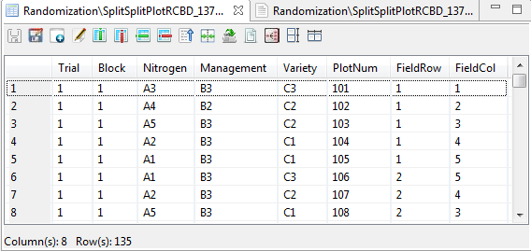

## Strip-Split Plot Design

The steps to generate randomization are listed below:

* Choose **Design | Strip-Split Plot Design…** from the main window. The **Randomization** dialog box will appear.
* Specify the required fields and appropriate options.

**Factor Definition**

**Name**

Contain the default name for each factor. User can change the factor name by typing the desired factor name. In specifying the factor name, the following rules apply:

* name should not contain any space;
* must begin with a letter or a period (.);
* succeeding characters can be a combination of letters, numbers, period (.) and underscore (\_); and
* name must be different from other factor names already specified.

**Factor ID**

Contain the default code for each factor. User can change the factor ID by typing the desired factor ID. Factor ID should consist of 1 to 4 letters only and should be unique.

**Levels**

Contain the level for each factor. User can change the level of the factor by either typing a value inside the spin box or clicking the up-arrow key of the spin box to increase the value, down-arrow key, otherwise. The default and minimum value of the levels is equal to 2 while the maximum value of the levels is 500.

**Number of Blocks**

Define the number of blocks to be generated. The default value and minimum value is equal to 2.

**Number of Subplots along the Length of Each VxH plot**

These define the number of subplots along the length of VxH plot. The default and minimum value is equal to one.

**Number of Field Rows**

Define the total number of rows in the field layout for each trial. The default and minimum value is equal to 2.

**Number of Trial**

Define the number of trials to be generated. The default value and minimum value is equal to one.

**Field Book Filename**

This field is required and it specifies the file name where the result of the randomization will be saved. The default filename is *fieldbookStripSplit*.

**Field Book Order**

Define how the plot number will be arranged. There are two options available: *Plot Order* (default value)and *Serpentine*.

For this example, suppose we want to generate a randomization for an experiment to be conducted using Strip-Split Plot, with planting methods (with 2 levels) as vertical factor, nitrogen rates (with 3 levels) as the horizontal factor and rice variety (with 6 levels) as the subplot factor. Three blocks will be used. The planned field layout is shown below:

|  |  |  |  |  |
| --- | --- | --- | --- | --- |
|  | Field  Column 1 | Field  Column 2 | Field  Column 3 | Field  Column 4 |
| Field Row 1 |  |  |  | Block 1 |
| Field Row 2 |  |  |  |  |
| Field Row 3 |  |  |  | Block 2 |
| Field Row 4 |  |  |  |  |
| Field Row 5 |  |  |  | Block 3 |
| Field Row 6 |  |  |  |  |
| Field Row 7 |  |  |  | Block 4 |
| Field Row 8 |  |  |  |  |

The completed dialog box should appear as shown below:

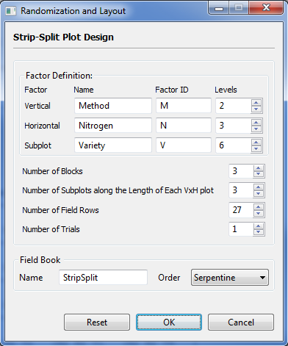

* Click the **OK** button to generate the randomization. The **Randomization and Layout** dialog box will be minimized and STAR will automatically display the *csv* data file and the *txt* file created in the Data Viewer.

Sample *txt* file displayed in the Data Viewer is shown below:

DESIGN PROPERTIES:

Strip-Split Plot Design

DESIGN PARAMETERS:

Number of Trials = 1

Number of Blocks = 3

Vertical Factor = Method

Levels = M1, M2

Horizontal Factor = Nitrogen

Levels = N1, N2, N3

Subplot Factor = Variety

Levels = V1, V2, V3, ..., V6

Layout for Strip-Split Plot

Trial = 1

FieldCol1 FieldCol2 FieldCol3 FieldCol4

+-----------+-----------+-----------+-----------+

FieldRow1 | 101| 102| 103| 104|

|M2 N1 V1 |M2 N1 V3 |M1 N1 V6 |M1 N1 V4 |

+-----------+-----------+-----------+-----------+

FieldRow2 | 108| 107| 106| 105|

|M2 N1 V2 |M2 N1 V4 |M1 N1 V2 |M1 N1 V1 |

+-----------+-----------+-----------+-----------+

FieldRow3 | 109| 110| 111| 112|

|M2 N1 V6 |M2 N1 V5 |M1 N1 V5 |M1 N1 V3 |

+-----------+-----------+-----------+-----------+

FieldRow4 | 116| 115| 114| 113|

|M2 N3 V2 |M2 N3 V3 |M1 N3 V6 |M1 N3 V1 |

+-----------+-----------+-----------+-----------+

FieldRow5 | 117| 118| 119| 120|

|M2 N3 V6 |M2 N3 V5 |M1 N3 V3 |M1 N3 V5 |

+-----------+-----------+-----------+-----------+

FieldRow6 | 124| 123| 122| 121|

|M2 N3 V1 |M2 N3 V4 |M1 N3 V4 |M1 N3 V2 |

+-----------+-----------+-----------+-----------+

FieldRow7 | 125| 126| 127| 128|

|M2 N2 V2 |M2 N2 V5 |M1 N2 V1 |M1 N2 V3 |

+-----------+-----------+-----------+-----------+

FieldRow8 | 132| 131| 130| 129|

|M2 N2 V3 |M2 N2 V4 |M1 N2 V6 |M1 N2 V4 |

+-----------+-----------+-----------+-----------+

FieldRow9 | 133| 134| 135| 136|

|M2 N2 V1 |M2 N2 V6 |M1 N2 V2 |M1 N2 V5 |

+-----------+-----------+-----------+-----------+

FieldRow10 | 201| 202| 203| 204|

|M1 N3 V1 |M1 N3 V2 |M2 N3 V6 |M2 N3 V3 |

+-----------+-----------+-----------+-----------+

FieldRow11 | 208| 207| 206| 205|

|M1 N3 V4 |M1 N3 V5 |M2 N3 V2 |M2 N3 V4 |

+-----------+-----------+-----------+-----------+

FieldRow12 | 209| 210| 211| 212|

|M1 N3 V6 |M1 N3 V3 |M2 N3 V1 |M2 N3 V5 |

+-----------+-----------+-----------+-----------+

FieldRow13 | 216| 215| 214| 213|

|M1 N1 V2 |M1 N1 V1 |M2 N1 V6 |M2 N1 V2 |

+-----------+-----------+-----------+-----------+

FieldRow14 | 217| 218| 219| 220|

|M1 N1 V3 |M1 N1 V5 |M2 N1 V5 |M2 N1 V3 |

+-----------+-----------+-----------+-----------+

FieldRow15 | 224| 223| 222| 221|

|M1 N1 V4 |M1 N1 V6 |M2 N1 V4 |M2 N1 V1 |

+-----------+-----------+-----------+-----------+

FieldRow16 | 225| 226| 227| 228|

|M1 N2 V4 |M1 N2 V2 |M2 N2 V3 |M2 N2 V4 |

+-----------+-----------+-----------+-----------+

FieldRow17 | 232| 231| 230| 229|

|M1 N2 V3 |M1 N2 V6 |M2 N2 V1 |M2 N2 V5 |

+-----------+-----------+-----------+-----------+

FieldRow18 | 233| 234| 235| 236|

|M1 N2 V5 |M1 N2 V1 |M2 N2 V6 |M2 N2 V2 |

+-----------+-----------+-----------+-----------+

FieldRow19 | 301| 302| 303| 304|

|M1 N1 V5 |M1 N1 V3 |M2 N1 V6 |M2 N1 V2 |

+-----------+-----------+-----------+-----------+

FieldRow20 | 308| 307| 306| 305|

|M1 N1 V4 |M1 N1 V1 |M2 N1 V4 |M2 N1 V3 |

+-----------+-----------+-----------+-----------+

FieldRow21 | 309| 310| 311| 312|

|M1 N1 V2 |M1 N1 V6 |M2 N1 V1 |M2 N1 V5 |

+-----------+-----------+-----------+-----------+

FieldRow22 | 316| 315| 314| 313|

|M1 N2 V1 |M1 N2 V2 |M2 N2 V2 |M2 N2 V5 |

+-----------+-----------+-----------+-----------+

FieldRow23 | 317| 318| 319| 320|

|M1 N2 V5 |M1 N2 V6 |M2 N2 V1 |M2 N2 V6 |

+-----------+-----------+-----------+-----------+

FieldRow24 | 324| 323| 322| 321|

|M1 N2 V3 |M1 N2 V4 |M2 N2 V3 |M2 N2 V4 |

+-----------+-----------+-----------+-----------+

FieldRow25 | 325| 326| 327| 328|

|M1 N3 V6 |M1 N3 V2 |M2 N3 V2 |M2 N3 V4 |

+-----------+-----------+-----------+-----------+

FieldRow26 | 332| 331| 330| 329|

|M1 N3 V1 |M1 N3 V4 |M2 N3 V3 |M2 N3 V1 |

+-----------+-----------+-----------+-----------+

FieldRow27 | 333| 334| 335| 336|

|M1 N3 V3 |M1 N3 V5 |M2 N3 V5 |M2 N3 V6 |

+-----------+-----------+-----------+-----------+

\*\*Note: Cells contain plot numbers on top, treatments/entries below

Sample *csv* data file displayed in the Data Viewer is shown below:

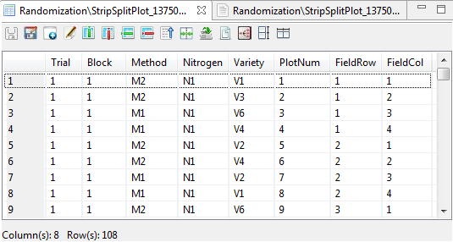

## Split-Split-Split Plot Design

This design can be generated for experiments where the main plot is arranged in completely randomized, randomized complete block and Latin square design.

The steps to generate randomization are listed below:

* Click **Design | Split-Split-Split Plot Design** from the main window. Choose the appropriate design for the main plot.
* The appropriate **Randomization and Layout** dialog box will appear depending on how the main plot will be arranged.
* Specify the required field and appropriate options.

**Factor Definition Frame**

**Name**

Contain the default name for each factor which can be change. In specifying the factor name, the following rules apply:

* name should not contain any space;
* must begin with a letter or a period (.);
* succeeding characters can be a combination of letters, numbers, period (.) and underscore (\_); and
* name must be different from other factor names already specified.

**Factor ID**

Contain the default code for each factor. User can change the factor ID by typing the desired factor ID. Factor ID should consist of 1 to 4 letters only and should be unique.

**Levels**

Contain the level for each factor. User can change the level of the factor by either typing a value inside the spin box or clicking the up-arrow key of the spin box to increase the value, down-arrow key, otherwise. The default and minimum value of the levels is equal to 2 while the maximum value of the levels is 500. When the main plot is arranged in Latin Square design, the maximum value of the levels of the main plot factor is 11.

**Number of Replicates**

Applicable only if completely randomized design is chosen. These define the number of replicates to be generated. The default and minimum value is equal to 2.

**Number of Blocks**

Applicable only if randomized complete block design is chosen. These define the number of blocks to be generated. The default and minimum value is equal to 2.

**Number of Mainplots along the Length of Each Block**

Applicable only if randomized complete block design is chosen. These define the number of main plots along the length of each block. The default and minimum value is equal to one.

**Number of Subplots along the Length of Each Mainplot**

Define the number of subplots along the length of each main plot. The default and minimum value is equal to one.

**Number of Sub-subplots along the Length of Each Subplot**

Define the number of sub-subplots along the length of each subplot. The default and minimum value is equal to one.

**Number of Sub-sub-subplots along the Length of Each Sub-subplot**

Define the number of sub-sub-subplots along the length of each sub-subplot. The default and minimum value is equal to one.

**Number of Field Rows**

Applicable only if completely randomized or randomized complete block design is chosen. Define the total number of rows in the field layout for each trial. The default and minimum value is equal to one.

**Number of Trial**

Define the number of trials to be generated. The default value and minimum value is equal to one.

**Field Book Filename**

This field is required and it specifies the file name where the result of the randomization will be saved.

**Field Book Order**

Define how the plot number will be arranged. There are two options available: *Plot Order* (default value)and *Serpentine*.

For this example, suppose we want to generate a randomization for an experiment whose aim is to compare the effects of two nitrogen rates, two management practices and two seeding rate on the grain yield of two rice varieties which will be conducted using Split-Split-Split Plot with four blocks. Nitrogen rates will be assigned as the mainplot factor and will be arranged in randomized complete block design, management practices as the subplot factor, varieties as the sub-subplot factor and seeding rate as the sub-sub-subplot factor. The planned field layout is shown below:

|  |  |  |  |  |
| --- | --- | --- | --- | --- |
|  | Field  Column 1 | Field  Column 2 | Field  Column 3 | Field  Column 4 |
| Field Row 1 |  |  |  | Block 1 |
| Field Row 2 |  |  |  |  |
| Field Row 3 |  |  |  | Block 2 |
| Field Row 4 |  |  |  |  |
| Field Row 5 |  |  |  | Block 3 |
| Field Row 6 |  |  |  |  |
| Field Row 7 |  |  |  | Block 4 |
| Field Row 8 |  |  |  |  |

The completed dialog box should appear as shown below:

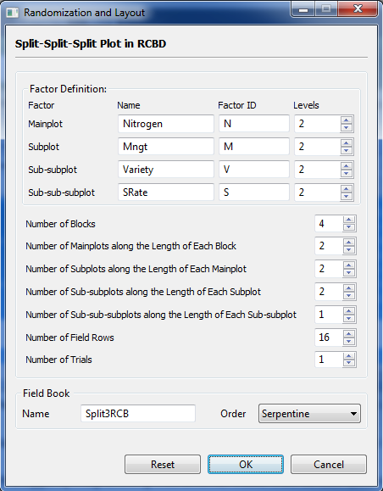

* Click the **OK** button to generate the randomization. The **Randomization and Layout** dialog box will be minimized and STAR will automatically display the *csv* data file and the *txt* file created in the Data Viewer tab.

Sample *txt* file displayed in the Data Viewer is shown below:

DESIGN PROPERTIES:

Split-Split-Split Plot Design

Randomized Complete Block Design

DESIGN PARAMETERS:

Number of Trials = 1

Number of Blocks = 4

Mainplot Factor = Nitrogen

Levels = N1, N2

Subplot Factor = Mngt

Levels = M1, M2

Sub-subplot Factor = Variety

Levels = V1, V2

Sub-sub-subplot Factor = SRate

Levels = S1, S2

Layout for Split-Split-Split Plot in Randomized Complete Block Design:

Trial = 1

FieldCol1 FieldCol2 FieldCol3 FieldCol4

+-------------+-------------+-------------+-------------+

FieldRow1 | 101| 102| 201| 202|

|N2 M2 V2 S1 |N2 M2 V2 S2 |N1 M1 V1 S1 |N1 M1 V1 S2 |

+-------------+-------------+-------------+-------------+

FieldRow2 | 104| 103| 204| 203|

|N2 M2 V1 S1 |N2 M2 V1 S2 |N1 M1 V2 S2 |N1 M1 V2 S1 |

+-------------+-------------+-------------+-------------+

FieldRow3 | 105| 106| 205| 206|

|N2 M1 V1 S2 |N2 M1 V1 S1 |N1 M2 V1 S2 |N1 M2 V1 S1 |

+-------------+-------------+-------------+-------------+

FieldRow4 | 108| 107| 208| 207|

|N2 M1 V2 S1 |N2 M1 V2 S2 |N1 M2 V2 S2 |N1 M2 V2 S1 |

+-------------+-------------+-------------+-------------+

FieldRow5 | 109| 110| 209| 210|

|N1 M2 V2 S2 |N1 M2 V2 S1 |N2 M1 V2 S1 |N2 M1 V2 S2 |

+-------------+-------------+-------------+-------------+

FieldRow6 | 112| 111| 212| 211|

|N1 M2 V1 S2 |N1 M2 V1 S1 |N2 M1 V1 S1 |N2 M1 V1 S2 |

+-------------+-------------+-------------+-------------+

FieldRow7 | 113| 114| 213| 214|

|N1 M1 V1 S2 |N1 M1 V1 S1 |N2 M2 V2 S1 |N2 M2 V2 S2 |

+-------------+-------------+-------------+-------------+

FieldRow8 | 116| 115| 216| 215|

|N1 M1 V2 S1 |N1 M1 V2 S2 |N2 M2 V1 S2 |N2 M2 V1 S1 |

+-------------+-------------+-------------+-------------+

FieldRow9 | 301| 302| 401| 402|

|N1 M2 V2 S2 |N1 M2 V2 S1 |N2 M2 V2 S1 |N2 M2 V2 S2 |

+-------------+-------------+-------------+-------------+

FieldRow10 | 304| 303| 404| 403|

|N1 M2 V1 S2 |N1 M2 V1 S1 |N2 M2 V1 S1 |N2 M2 V1 S2 |

+-------------+-------------+-------------+-------------+

FieldRow11 | 305| 306| 405| 406|

|N1 M1 V2 S1 |N1 M1 V2 S2 |N2 M1 V1 S1 |N2 M1 V1 S2 |

+-------------+-------------+-------------+-------------+

FieldRow12 | 308| 307| 408| 407|

|N1 M1 V1 S1 |N1 M1 V1 S2 |N2 M1 V2 S2 |N2 M1 V2 S1 |

+-------------+-------------+-------------+-------------+

FieldRow13 | 309| 310| 409| 410|

|N2 M1 V2 S2 |N2 M1 V2 S1 |N1 M1 V1 S1 |N1 M1 V1 S2 |

+-------------+-------------+-------------+-------------+

FieldRow14 | 312| 311| 412| 411|

|N2 M1 V1 S2 |N2 M1 V1 S1 |N1 M1 V2 S1 |N1 M1 V2 S2 |

+-------------+-------------+-------------+-------------+

FieldRow15 | 313| 314| 413| 414|

|N2 M2 V1 S2 |N2 M2 V1 S1 |N1 M2 V1 S1 |N1 M2 V1 S2 |

+-------------+-------------+-------------+-------------+

FieldRow16 | 316| 315| 416| 415|

|N2 M2 V2 S2 |N2 M2 V2 S1 |N1 M2 V2 S1 |N1 M2 V2 S2 |

+-------------+-------------+-------------+-------------+

\*\*Note: Cells contain plot numbers on top, treatments/entries below

Sample *csv* data file displayed in the Data Viewer is shown below:

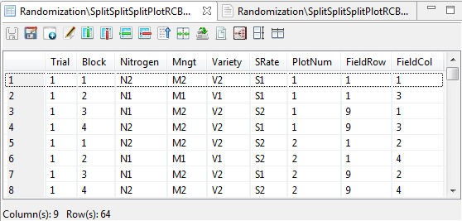

## Strip-Split-Split Plot Design

The steps to generate randomization are listed below:

* Choose **Design | Strip-Split-Split Plot Desig**n from the main window. The **Randomization and Layout** dialog box will appear.
* Specify the required fields and appropriate options.

**Factor Definition**

**Name**

Contain the default name for each factor. User can change the factor name by typing the desired factor name. In specifying the factor name, the following rules apply:

* name should not contain any space;
* must begin with a letter or a period (.);
* succeeding characters can be a combination of letters, numbers, period (.) and underscore (\_); and
* name must be different from other factor names already specified.

**Factor ID**

Contain the default code for each factor. User can change the factor ID by typing the desired factor ID. Factor ID should consist of 1 to 4 letters only and should be unique.

**Levels**

Contain the level for each factor. User can change the level of the factor by either typing a value inside the spin box or clicking the up-arrow key of the spin box to increase the value, down-arrow key, otherwise. The default and minimum value of the levels is equal to 2 while the maximum value of the levels is 500.

**Number of Blocks**

Define the number of blocks to be generated. The default value and minimum value is equal to 2.

**Number of Subplots along the Length of Each VxH plot**

These define the number of subplots along the length of VxH plot. The default and minimum value is equal to one.

**Number of Sub-subplots along the Length of Each Subplot**

These define the number of sub-subplots along the length of subplot. The default and minimum value is equal to one.

**Number of Field Rows**

Define the total number of rows in the field layout for each trial. The default and minimum value is equal to 2.

**Number of Trial**

Define the number of trials to be generated. The default value and minimum value is equal to one.

**Field Book Filename**

This field is required and it specifies the file name where the result of the randomization will be saved. The default filename is *fieldbookStripSplit2*.

**Field Book Order**

Define how the plot number will be arranged. There are two options available: *Plot Order* (default value)and *Serpentine*.

For this example, suppose we want to generate a randomization for an experiment to be conducted using Strip-Split-Split Plot, with planting methods (with 2 levels) as vertical factor, nitrogen rates (with 2 levels) as the horizontal factor, rice variety (with 2 levels) as the subplot factor and weeding method (with and without as levels) as sub-subplot. Four blocks will be used. The planned field layout is shown below:

|  |  |  |  |  |
| --- | --- | --- | --- | --- |
|  | Field  Column 1 | Field  Column 2 | Field  Column 3 | Field  Column 4 |
| Field Row 1 |  |  |  | Block 1 |
| Field Row 2 |  |  |  |  |
| Field Row 3 |  |  |  | Block 2 |
| Field Row 4 |  |  |  |  |
| Field Row 5 |  |  |  | Block 3 |
| Field Row 6 |  |  |  |  |
| Field Row 7 |  |  |  | Block 4 |
| Field Row 8 |  |  |  |  |

The completed dialog box should appear as shown below:

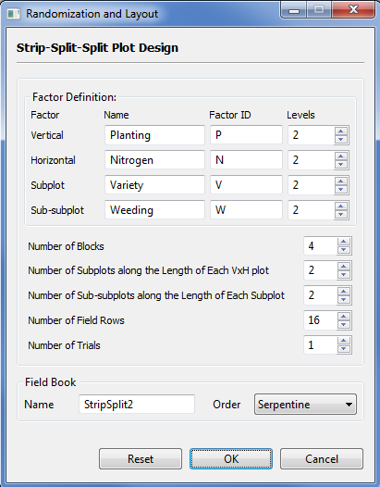

* Click the **OK** button to generate the randomization. The **Randomization and Layout** dialog box will be minimized and STAR will automatically display the *csv* data file and the *txt* file created in the Data Viewer tab.

Sample *txt* file displayed in the Data Viewer is shown below:

DESIGN PROPERTIES:

Strip-Split-Split Plot Design

DESIGN PARAMETERS:

Number of Trials = 1

Number of Blocks = 4

Vertical Factor = Planting

Levels = P1, P2

Horizontal Factor = Nitrogen

Levels = N1, N2

Subplot Factor = Variety

Levels = V1, V2

Sub-subplot Factor = Weeding

Levels = W1, W2

Layout for Strip-Split-Split Plot:

Trial = 1

FieldCol1 FieldCol2 FieldCol3 FieldCol4

+-------------+-------------+-------------+-------------+

FieldRow1 | 101| 102| 201| 202|

|P2 N2 V2 W2 |P1 N2 V1 W2 |P2 N1 V2 W1 |P1 N1 V2 W1 |

+-------------+-------------+-------------+-------------+

FieldRow2 | 104| 103| 204| 203|

|P2 N2 V2 W1 |P1 N2 V1 W1 |P2 N1 V2 W2 |P1 N1 V2 W2 |

+-------------+-------------+-------------+-------------+

FieldRow3 | 105| 106| 205| 206|

|P2 N2 V1 W1 |P1 N2 V2 W1 |P2 N1 V1 W1 |P1 N1 V1 W2 |

+-------------+-------------+-------------+-------------+

FieldRow4 | 108| 107| 208| 207|

|P2 N2 V1 W2 |P1 N2 V2 W2 |P2 N1 V1 W2 |P1 N1 V1 W1 |

+-------------+-------------+-------------+-------------+

FieldRow5 | 109| 110| 209| 210|

|P2 N1 V1 W2 |P1 N1 V1 W2 |P2 N2 V1 W1 |P1 N2 V2 W2 |

+-------------+-------------+-------------+-------------+

FieldRow6 | 112| 111| 212| 211|

|P2 N1 V1 W1 |P1 N1 V1 W1 |P2 N2 V1 W2 |P1 N2 V2 W1 |

+-------------+-------------+-------------+-------------+

FieldRow7 | 113| 114| 213| 214|

|P2 N1 V2 W2 |P1 N1 V2 W2 |P2 N2 V2 W2 |P1 N2 V1 W2 |

+-------------+-------------+-------------+-------------+

FieldRow8 | 116| 115| 216| 215|

|P2 N1 V2 W1 |P1 N1 V2 W1 |P2 N2 V2 W1 |P1 N2 V1 W1 |

+-------------+-------------+-------------+-------------+

FieldRow9 | 301| 302| 401| 402|

|P2 N2 V1 W1 |P1 N2 V2 W1 |P2 N2 V2 W1 |P1 N2 V1 W2 |

+-------------+-------------+-------------+-------------+

FieldRow10 | 304| 303| 404| 403|

|P2 N2 V1 W2 |P1 N2 V2 W2 |P2 N2 V2 W2 |P1 N2 V1 W1 |

+-------------+-------------+-------------+-------------+

FieldRow11 | 305| 306| 405| 406|

|P2 N2 V2 W2 |P1 N2 V1 W2 |P2 N2 V1 W1 |P1 N2 V2 W2 |

+-------------+-------------+-------------+-------------+

FieldRow12 | 308| 307| 408| 407|

|P2 N2 V2 W1 |P1 N2 V1 W1 |P2 N2 V1 W2 |P1 N2 V2 W1 |

+-------------+-------------+-------------+-------------+

FieldRow13 | 309| 310| 409| 410|

|P2 N1 V1 W2 |P1 N1 V2 W1 |P2 N1 V1 W2 |P1 N1 V2 W1 |

+-------------+-------------+-------------+-------------+

FieldRow14 | 312| 311| 412| 411|

|P2 N1 V1 W1 |P1 N1 V2 W2 |P2 N1 V1 W1 |P1 N1 V2 W2 |

+-------------+-------------+-------------+-------------+

FieldRow15 | 313| 314| 413| 414|

|P2 N1 V2 W1 |P1 N1 V1 W1 |P2 N1 V2 W2 |P1 N1 V1 W2 |

+-------------+-------------+-------------+-------------+

FieldRow16 | 316| 315| 416| 415|

|P2 N1 V2 W2 |P1 N1 V1 W2 |P2 N1 V2 W1 |P1 N1 V1 W1 |

+-------------+-------------+-------------+-------------+

\*\*Note: Cells contain plot numbers on top, treatments/entries below

Sample *csv* data file displayed in the Data Viewer is shown below:

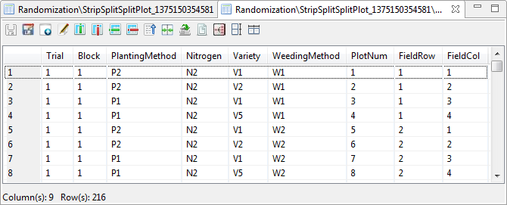

## Balanced Incomplete Block Design

The steps to generate randomization for Balanced Incomplete Block Design are listed below:

* Click **Design | Balanced Incomplete Block…** from the main window. The **Randomization and Layout** dialog box will appear.

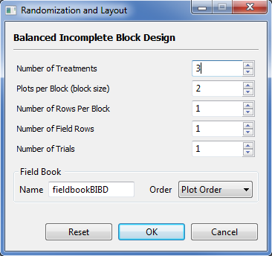

* Specify the required field and appropriate options.

**Number of Treatments**

Define the number of treatments (trmt) to be included in the randomization. The default and minimum value is 3. The entry should be a greater than the entry for the plots per block.

**Plots per Block (block size)**

Define the number of replicates to be generated. The default value and minimum value is equal to 2. The entry should be less than the number of treatments.

**Number of Rows Per Block**

Define the number of rows per block. The default and minimum value is equal to 1.

**Number of Field Rows**

Define the number of rows in the field layout for each trial. The default and minimum value is equal to one.

**Number of Trial**

Define the number of trials to be generated. The default value and minimum value is equal to one.

**Field Book Filename**

This field is required and it specifies the file name where the result of the randomization will be saved. The default filename is *fieldbookBIBD*.

**Field Book Order**

Define how the plot number will be arranged. There are two options available: *Plot Order* (default value)and *Serpentine*.

For this example, suppose we want to generate a randomization for an experiment with 5 treatment levels and 5 blocks. Each block can accommodate only 4 treatment levels. The planned field layout is shown below:

|  |  |  |  |  |  |
| --- | --- | --- | --- | --- | --- |
|  | Field  Column 1 | Field  Column 2 | Field  Column 3 | Field  Column 4 |  |
| Field Row 1 |  |  |  |  | Block 1 |
| Field Row 2 |  |  |  |  | Block 2 |
| Field Row 3 |  |  |  |  | Block 3 |
| Field Row 4 |  |  |  |  | Block 4 |
| Field Row 5 |  |  |  |  | Block 5 |

For the example, the completed dialog box should appear as below:

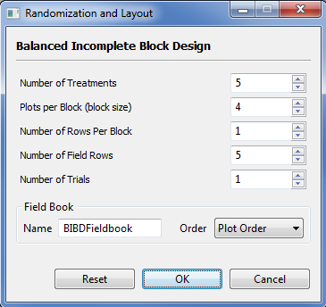

* Click the **OK** button to generate the randomization. The **Randomization and Layout** dialog box will be minimized and STAR will automatically display the *csv* data file created in the Data Viewer tab.

Sample *txt* file displayed in the Data Viewer is shown below:

DESIGN PROPERTIES:

Balanced Incomplete Block Design

DESIGN PARAMETERS:

Number of Trials = 1

Number of Treatments = 5

Plots per Block (Block Size) = 4

Number of Blocks = 5

Number of Replicates = 4

Lambda = 3

Number of Field Row = 5

Number of Field Column = 4

Layout for Balanced Incomplete Block Design:

Trial = 1

FieldCol1 FieldCol2 FieldCol3 FieldCol4

+-----------+-----------+-----------+-----------+

FieldRow1 | 11| 12| 13| 14|

|T4 |T2 |T5 |T3 |

+-----------+-----------+-----------+-----------+

FieldRow2 | 21| 22| 23| 24|

|T3 |T1 |T5 |T2 |

+-----------+-----------+-----------+-----------+

FieldRow3 | 31| 32| 33| 34|

|T4 |T2 |T3 |T1 |

+-----------+-----------+-----------+-----------+

FieldRow4 | 41| 42| 43| 44|

|T1 |T2 |T4 |T5 |

+-----------+-----------+-----------+-----------+

FieldRow5 | 51| 52| 53| 54|

|T5 |T3 |T1 |T4 |

+-----------+-----------+-----------+-----------+

\*\*Note: Cells contain plot numbers on top, treatments/entries below

Sample *csv* data file displayed in the Data Viewer:

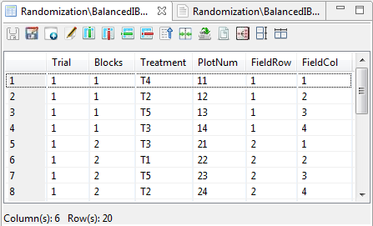

# Graphs

## Bar Graph

Bar graphs are useful for visualizing frequencies, sums, and statistics such as means and medians. The bar graphs that are created here can come from raw data or from pre-computed summary information.

The steps to create a bar graph are listed below:

* On the **Project Explorer** panel, double-click the file to be use to open it and view it in the Data Viewer tab.

For the example, using the project named *TrialProject*, select the data file *Year\_ReshapeToWide.csv.* The file was created in the **Reshaping data from long (serial) to wide (parallel)** sectionof this user’s manual.

* Click **Graphs | Bar Graph…**. The **Bar Graph** dialog box will appear.

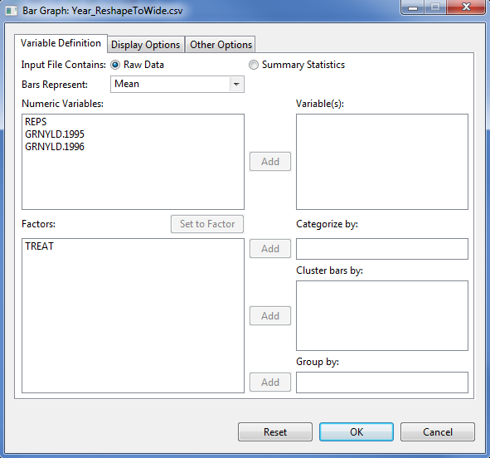

* Specify the inputs for the required fields and desired options.

**Variable Definition Tab**

**Input File Contains**

There are two options available, ***Raw Data***(default option) and ***Summary******Statistics***.

**Bars Represent**

This item is enabled if the **Input File Contains *Raw******Data***option is selected. Four options are available for creating the bars: ***Frequency****,* ***Mean****,* ***Median****,* and***Sum****.*

**Variable(s)**

At least one entry should be specified for the graph to be created. Entries should come from the **Numeric Variables** dialog box.

**Categorize by**

This field is required. The factor specified will define the labels for the bars and, if input file contains raw data, the categories for which values are computed.

**Cluster bars by**

This field is optional. For this, up to three factors can be specified. A group of bars is going to be generated for each level of the factors combined. Entries should come from the **Factors** list box.

**Group by**

This field is optional. If a factor is specified, a graph is going to be generated per category of the factor. Entry should come from the **Factors** list box.

**Display Options** **Tab**

**Main Title**

This field will contain the title for the graph.

**Category Axis Label**

This field will contain the label for the factor. If a factor is specified in the **Cluster bars by** field, the button **Display levels** will be enabled and checking it will add the levels of the combined factors onto the category axis.

**Value Axis**

The label and limits for the numeric variable(s) can be edited here. Default axis label is the name of the numeric variable(s). Lower and upper limits, if not specified, are determined from the data.

**Axis Label Orientation**

This option will determine how axis labels are displayed: *parallel to axis*, *horizontal*, *vertical*, and *perpendicular to axis*.

**Draw box around plot**

If checked, the graph will be enclosed in a box.

**Show legend**

If checked, a legend will be added to the graph. It may or may not have a title. The legend may be placed in any of nine positions within the graph: *bottom, bottom-left, bottom-right, center, left, right, top, top-left, top-right*. The items on the legend can be listed in one or more columns, the maximum of which is the number of levels of the category variable.

**Display multiple graphs in a page**

If checked, several graphs will be displayed on a single page, based on the specified number of rows and columns and orientation. At most 5 rows and 5 columns of graphs can be fitted into a single page, arranged either from *Top-to-bottom* or *Left-to-right*.

**Other Options** **Tab**

**Orientation**

Bars can either be drawn vertically or horizontally.

**Style**

This option is useful if several numeric variables are selected. Bars can be clustered (side-by-side) or stacked.

**Color and Fill**

Colors and fill patterns for the bars may be changed in this section.

**Display Error Bars**

If the bars represent means to be computed from raw data, error bars may be added based on one of three options: **confidence level** (default: 95%), **standard error** (with multiplier 1, 2, or 3), and **standard deviation** (with multiplier 1, 2, or 3).

For the example, suppose we want to create a bar graph for the means of *GRNYLD.1995* and *GRNYLD.Y1996* with error bars, the completed **Variable Definition** tab should appear as shown below:

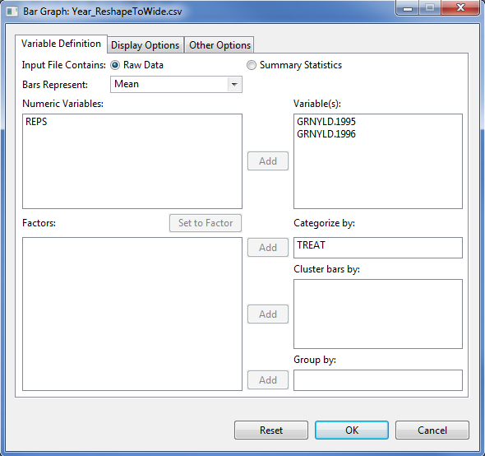

Items in the Display Options tab may be supplied as illustrated:

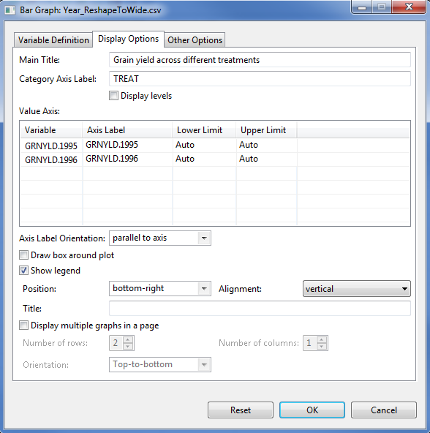

Items in the **Other Options** tab may be supplied as illustrated:

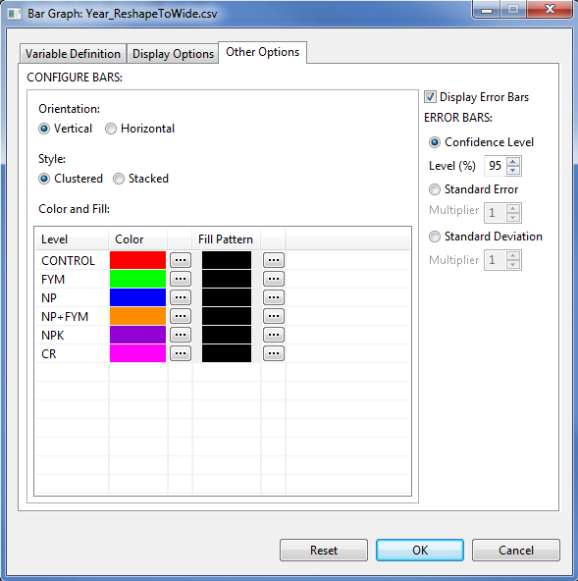

* Click the **OK** button to create the graph. The **Bar Graph** dialog box will be minimized and the **Result Viewer** tab will be activated.

Sample graphs as displayed in two pages in the *Graph* page of the Result Viewer:

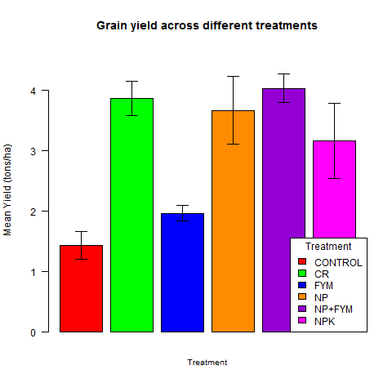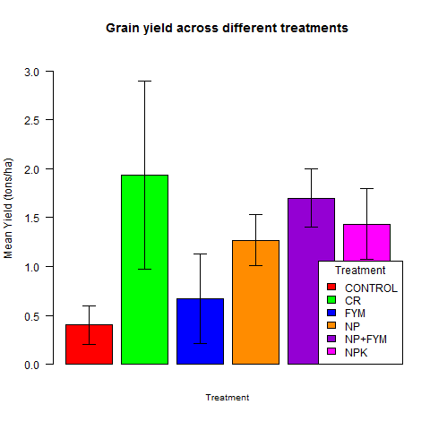

## Box Plot

Box plots are useful for displaying distributional properties of data.

The steps to create a box plot are listed below:

* On the **Project Explorer**, double-click the file to be used for the analysis to open and view it in the Data Viewer tab.

For the example, using the project named *MyProject*,import the data *Gerua* from STAR Package. See the *Importing Data from Package* sectionof this user’s manual for instructions on how to do this.

* Click **Graphs | Box Plot…**. The **Box Plot** (or Box-and-Whiskers Plot) dialog box will appear.

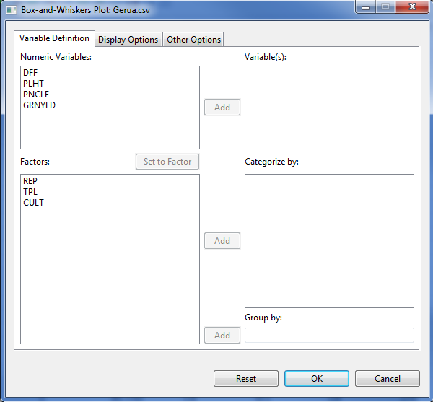

* Specify the inputs for the required fields and desired options.

**Variable Definition Tab**

**Variable(s)**

At least one entry should be specified for the graph to be created. Entries should come from the **Numeric Variables** dialog box.

**Categorize by**

This field, if specified, will define the labels and sub-grouping for the box plots.

**Group by**

This field is optional. If a factor is specified, a graph is going to be generated per category of the factor. Entry should come from the **Factors** list box.

**Display Options** **Tab**

**Main Title**

This field will contain the title for the graph.

**Category Axis Label**

This field will contain the label for the factor.

**Value Axis**

The label and limits for the numeric variable(s) can be edited here. Default axis label is the name of the numeric variable(s). Lower and upper limits, if not specified, are determined from the data.

**Axis Label Orientation**

This option will determine how axis labels are displayed: *parallel to axis*, *horizontal*, *vertical*, and *perpendicular to axis*.

**Orientation**

Plots can be displayed vertically (default) or horizontally.

**Draw box around plot**

If checked, the graph will be enclosed in a box.

**Display multiple graphs in a page**

If checked, several graphs will be displayed on a single page, based on the specified number of rows and columns and orientation. At most 5 rows and 5 columns of graphs can be fitted into a single page, arranged either from *Top-to-bottom* or *Left-to-right*.

**Other Options** **Tab**

**BOX**

Color for the box outline and fill, as well as the size of the line used for the box may be edited here.

**WHISKERS**

Color, type and width for the line representing the whiskers may be edited here.

**MEDIAN**

Color, type and width for the line representing the median may be edited here.

**OUTLIERS**

Color, symbol and size for the representing the outliers may be edited here.

For the example, suppose we want to create box plots for the plant height (*PLHT*) and grain yield (*GRNYLD*) variables, categorized based on transplanting method (TPL). The completed **Variable Definition** tab should appear as shown below:

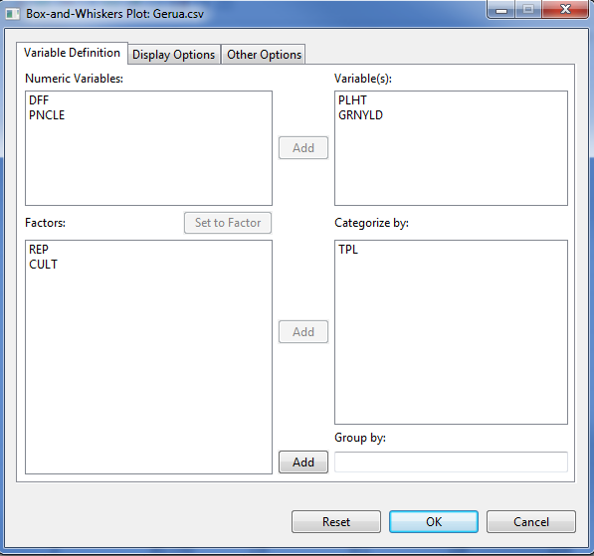

Items in the **Display Options** tab may be supplied as illustrated:

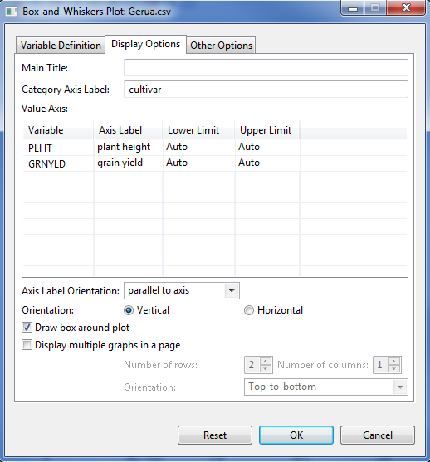

Items in the **Other Options** tab may be supplied as illustrated:

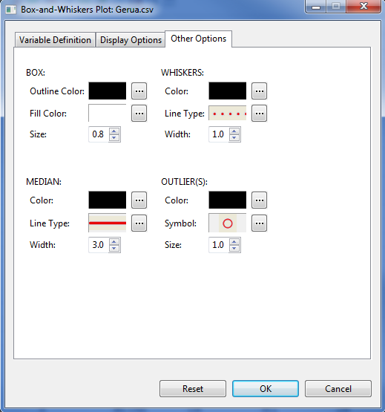

* Click the **OK** button to create the graph. The **Box Plot** dialog box will be minimized and the Result Viewer will be activated.

Sample graph as displayed in the *Graph* page of the Result Viewer:

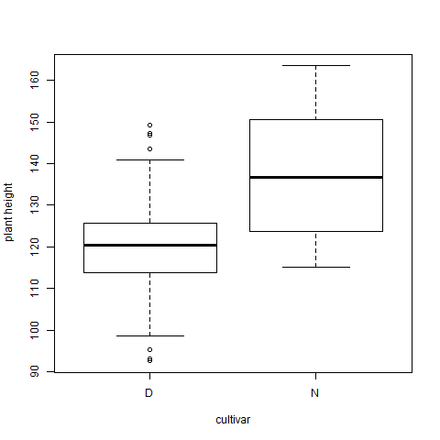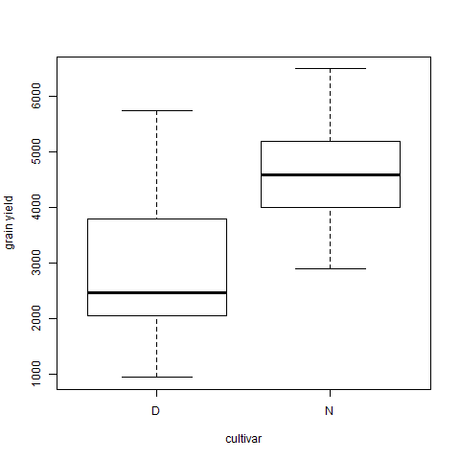

## Histogram

Histograms are useful for displaying distributional properties of data.

The steps to create a histogram are listed below:

* On the **Project Explorer**, double-click the file to be used for the analysis to open and view it in the Data Viewer tab.

For the example, using the project named *MyProject*,import the data *Gerua* from STAR Package. See the *Importing Data from Package* sectionof this user’s manual for instructions on how to do this.

* Click **Graphs | Histogram…**. The **Histogram** dialog box will appear.

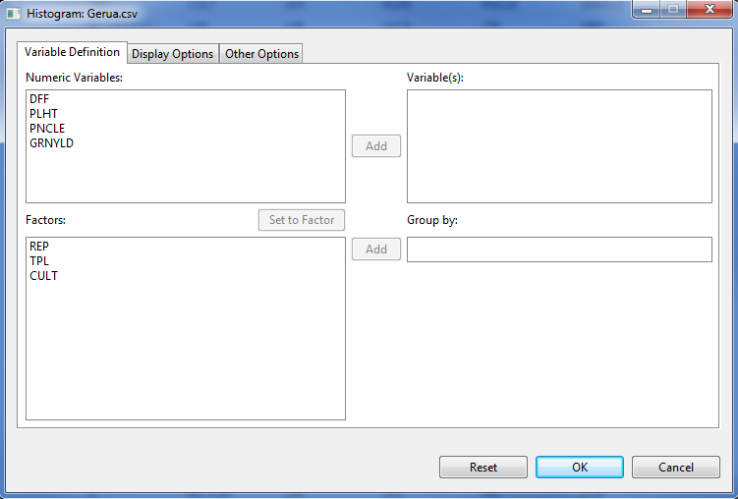

* Specify the inputs for the required fields and desired options.

**Variable Definition Tab**

**Variable(s)**

At least one entry should be specified for the graph to be created. Entries should come from the **Numeric Variables** dialog box.

**Group by**

This field is optional. If a factor is specified, a graph is going to be generated per category of the factor. Entry should come from the **Factors** list box.

**Display Options** **Tab**

**Main Title**

This field will contain the title for the graph.

**Use**

This is used for determining whether frequencies or probability densities will be used in the y-axis.

**X-Axis**

The label and limits for the numeric variable(s) can be edited here. Default axis label is the name of the numeric variable(s). Lower and upper limits, if not specified, are determined from the data.

**Y-Axis**

The label and limits for the y-axis can be edited here. Default axis label is *Frequency* or *Probability*, depending the option chosen in the **Use** subsection above. Lower and upper limits, if not specified, are determined from the data.

**Axis Label Orientation**

This option will determine how axis labels are displayed: *parallel to axis*, *horizontal*, *vertical*, and *perpendicular to axis*.

**Draw box around plot**

If checked, the graph will be enclosed in a box.

**Display multiple graphs in a page**

If checked, several graphs will be displayed on a single page, based on the specified number of rows and columns and orientation. At most 5 rows and 5 columns of graphs can be fitted into a single page, arranged either from *Top-to-bottom* or *Left-to-right*.

**Other Options** **Tab**

**Number of bars**

A suggested number of bars to be used for distributing the data can be specified here. The actual number of bars used by STAR may vary. If not specified, STAR determines this automatically.

**Overlay kernel density estimates**

If this option is checked, kernel density estimates are plotted over the bars. Option used in the **Use** subsection above will be automatically set to *probabilities*.

**Format Components**

Color for the bars can be edited here. If **Overlay kernel density estimates** option is checked, type of line, line color, and width for the curve can also be edited.

For the example, suppose we want to create histograms for plant height (*PLHT*) and grain yield (*GRNYLD*) variables. The completed **Variable Definition** tab should appear as shown below:

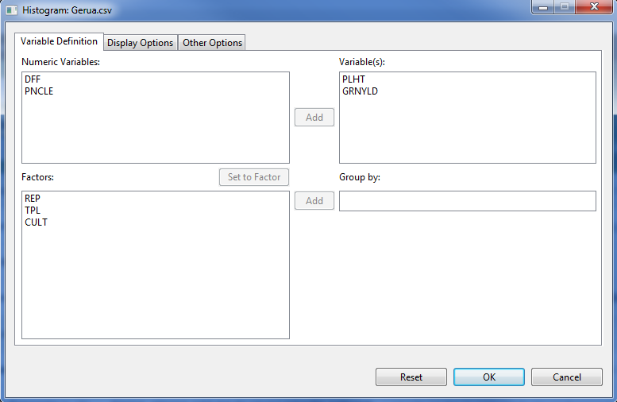

Items in the **Display Options** tab may be supplied as illustrated:

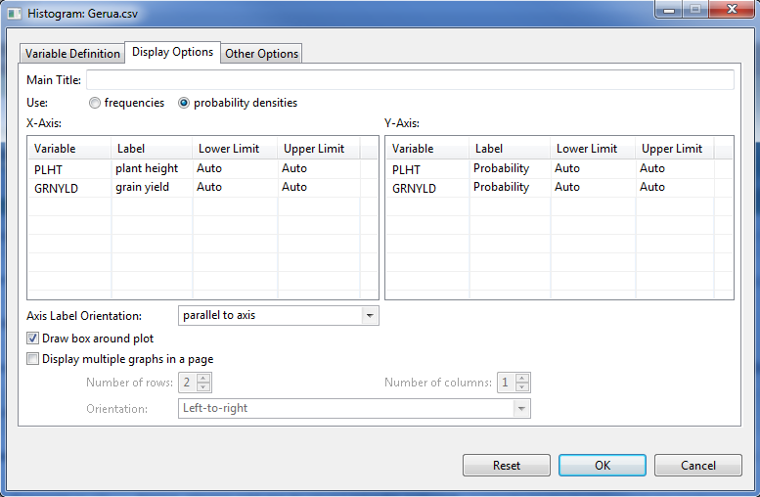

Items in the **Other Options** tab may be supplied as illustrated:

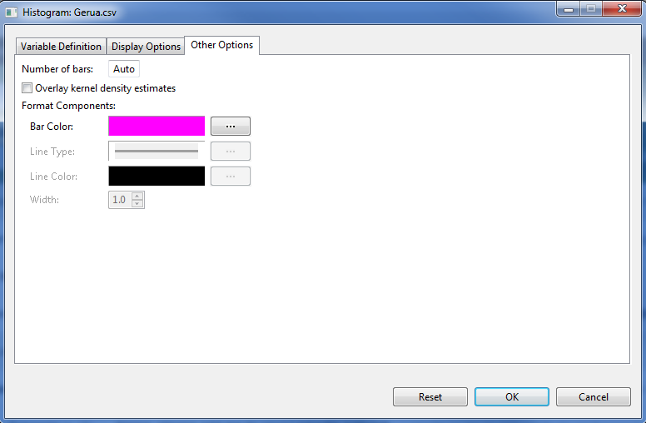

* Click the **OK** button to create the graph. The **Histogram** dialog box will be minimized and the Result Viewer will be activated.

Sample graph as displayed in the *Graph* page of the Result Viewer:

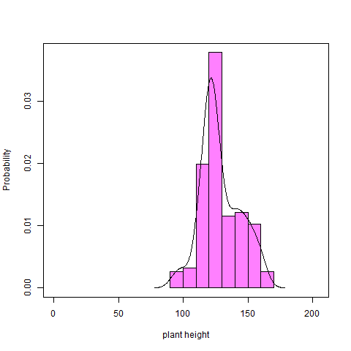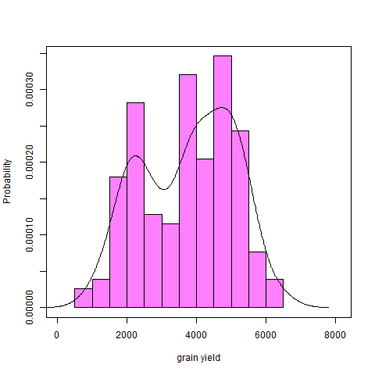

## Line Graph

Line graphs are useful for displaying trends using either raw data or statistics.

The steps to create a line graph are listed below:

* On the **Project Explorer**, double-click the file to be used for the analysis to open and view it in the Data Viewer tab.

For the example, using the project named *MyProject*,import the data *soil\_redox* from STAR Package. See the *Importing Data from Package* sectionof this user’s manual for instructions on how to do this.

* Click **Graphs | Line Graph…**. The **Line Graph** dialog box will appear.

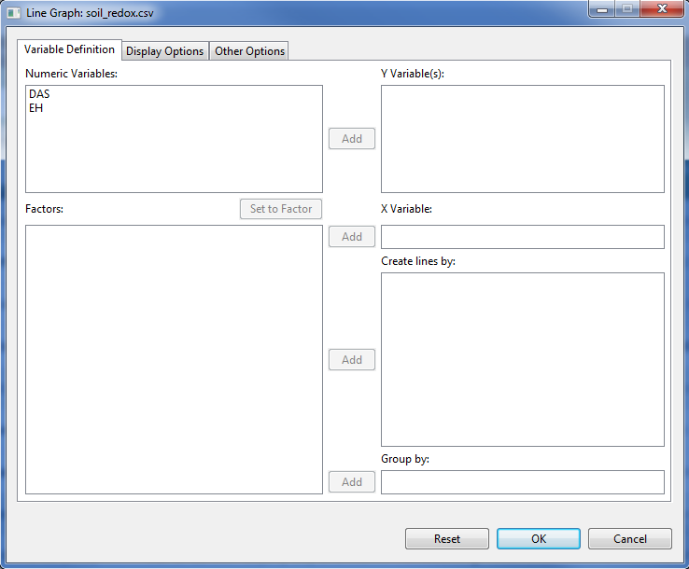

* Specify the inputs for the required fields and desired options.

**Variable Definition Tab**

**Y Variable(s)**

At least one entry should be specified for the graph to be created. Entries should come from the **Numeric Variables** dialog box.

**X Variable(s)**

This determines the levels for which means are computed. Entry should come from the **Factors** dialog box.

**Create lines by**

This field is optional. For this, up to three factors can be specified. Lines will be created for each of the levels of the factors combined. Entries should come from the **Factors** list box.

**Group by**

This field is optional. If a factor is specified, a line graph is going to be generated per category of the factor. Entry should come from the **Factors** list box.

**Display Options** **Tab**

**Main Title**

This field will contain the title for the graph.

**Horizontal Axis Label**

This field will contain the label for the factor.

**Vertical Axis**

The label and limits for the vertical axis can be edited here. Default axis label is the name of the variable. Lower and upper limits, if not specified, are determined from the data.

**Axis Label Orientation**

This option will determine how axis labels are displayed: *parallel to axis*, *horizontal*, *vertical*, and *perpendicular to axis*.

**Draw box around plot**

If checked, the graph will be enclosed in a box.

**Display line labels**

If checked, the name(s) of the numeric variable(s) are displayed on the right side of the corresponding line(s).

This option is useful if there are two or more lines displayed in the graph. If this option is used, **Show legend** is disabled.

**Show legend**

If checked, a legend will be added to the graph. It may or may not have a title. The legend may be placed in any of nine positions within the graph: bottom, bottom-left, bottom-right, center, left, right, top, top-left, top-right. The items on the legend can be listed in one or more columns, the maximum of which is the number lines displayed in the graph.

**Display multiple graphs in a page**

If checked, several graphs will be displayed on a single page, based on the specified number of rows and columns and orientation. At most 5 rows and 5 columns of graphs can be fitted into a single page, arranged either from *Top-to-bottom* or *Left-to-right*.

**Other Options** **Tab**

**Format Components (lines and points)**

Formats of lines and points (if any) can be edited here. Under *Type*, available options are *lines only*, *overplot* (overlapping lines and points), or *both* (non-overlapping lines and points)*.* Default color, width and type for lines, as well as symbol and size for points can be changed.

**Display Error Bars**

Error bars may be added based on one of two options: **confidence level** (default: 95%) and **standard error** (with multiplier 1, 2, or 3).

For the example, the **Variable Definition** tab should appear as:

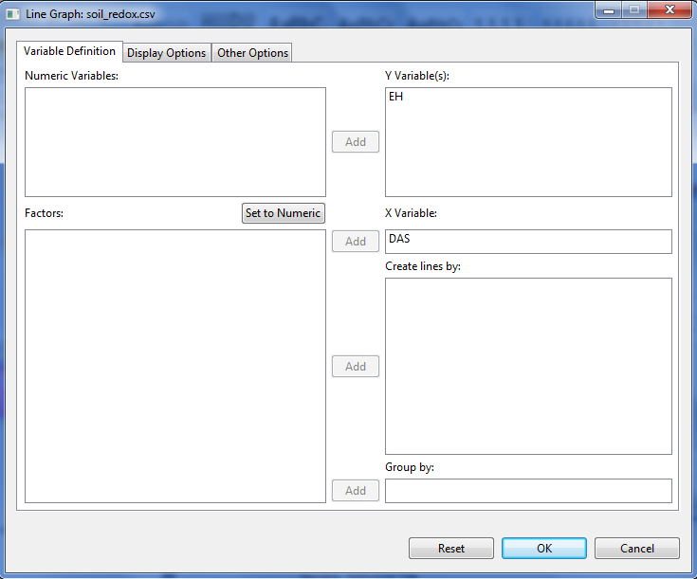

Items in the **Display Options** tab may be supplied as:

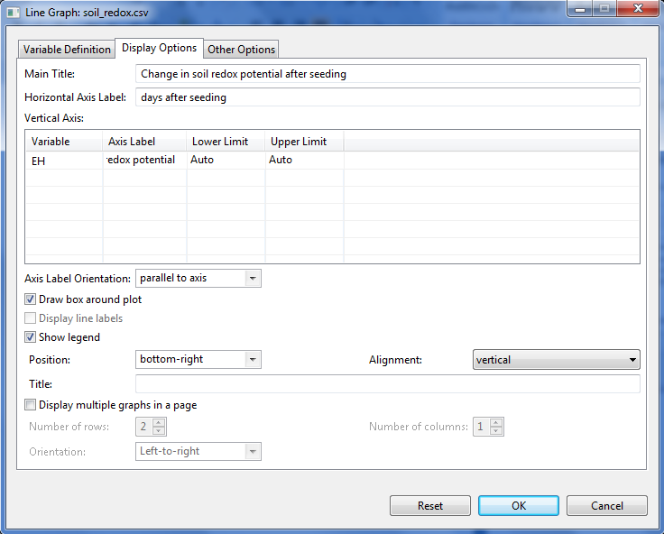

Components in the **Other Options** tab may be edited:

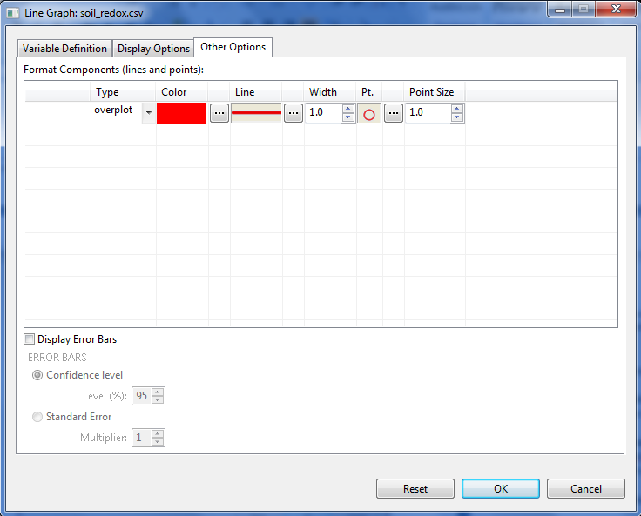

* Click the **OK** button to create the graph. The **Histogram** dialog box will be minimized and the Result Viewer will be activated.

Sample graph as displayed in the *Graph* page of the Result Viewer:

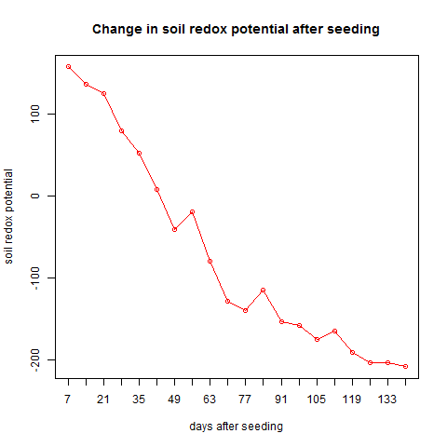

## Pie Chart

Pie charts are useful for presenting how a data set is divided into different sections or groups. In STAR, pie charts can be created from raw data or summaries (containing frequencies).

The steps to create a pie chart are listed below:

* On the **Project Explorer**, double-click the file to be used for the analysis to open and view it in the Data Viewer tab.

For the example, using the project named *MyProject*,import the data *GomezMaizeCross* from STAR Package. See the *Importing Data from Package* sectionof this user’s manual for instructions on how to do this.

* Click **Graphs | Pie Chart…**. The **Pie Chart** dialog box will appear.

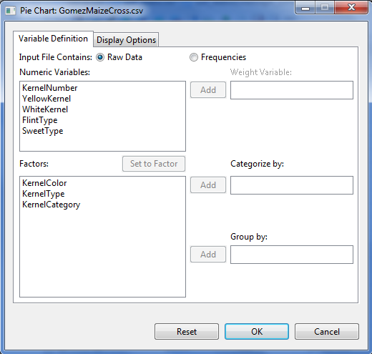

* Specify the inputs for the required fields and desired options.

**Variable Definition Tab**

**Input file contains**

There are two options available, ***Raw Data***(default option) and ***Frequencies***. If the default option is used, the percentages (or frequencies) are determined for the category variable, otherwise, values from the frequencies are plotted directly.

**Weight Variable**

This item is enabled if ***Input file contains Frequencies***is selected. This will contain the frequencies variable.

**Categorize by**

This will determine the sections for partitioning the pie. This field is required.

**Group by**

This field is optional. If a factor is specified, a pie chart is going to be generated per category of the factor. Entries should come from the **Factors** list box.

**Display Options** **Tab**

**Main Title**

This field will contain the title for the graph.

**Format slices**

In this section, changes to the formats (color and fill pattern) of the slices may be made.

Under ***Labels***, available options are: none, counts, percentages, levels, both counts and levels and both levels and percentages.

**Draw box around plot**

If checked, the graph will be enclosed in a box.

**Show legend**

If checked, a legend will be added to the graph. It may or may not have a title. The legend may be placed in any of nine positions within the graph: bottom, bottom-left, bottom-right, center, left, right, top, top-left, top-right. The items on the legend can be listed in one or more columns, the maximum of which is the number of levels of the category variable.

**Display multiple graphs in a page**

If checked, several graphs will be displayed on a single page, based on the specified number of rows and columns and orientation. At most 5 rows and 5 columns of graphs can be fitted into a single page, arranged either from *Top-to-bottom* or *Left-to-right*.

For the example, the **Variable Definition** tab should appear as illustrated:

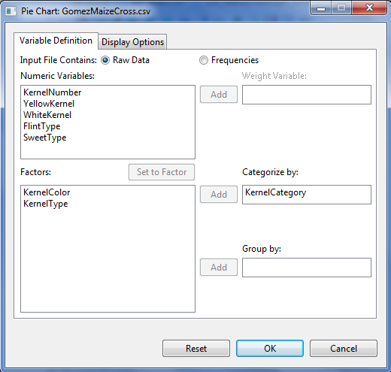

The **Display Options** Tabmay be edited:

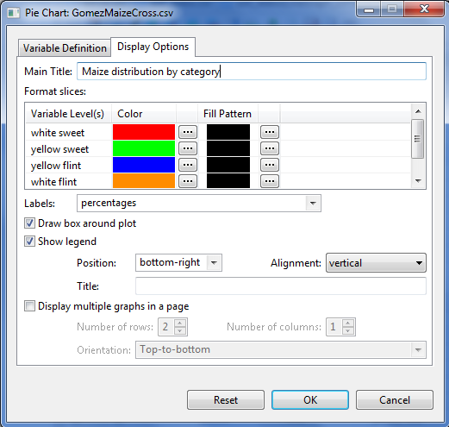

Sample graph as displayed in the *Graph* page of the Result Viewer:

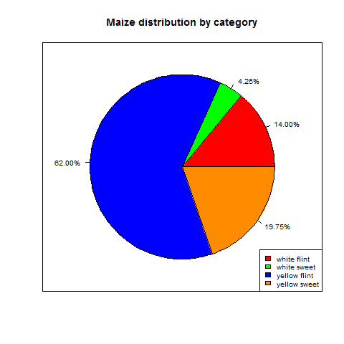

## Scatter Plot

Scatter plots are useful for describing relationship between a pair of variables.

The steps to create a scatter plot are listed below:

* On the **Project Explorer**, double-click the file to be used for the analysis to open and view it in the Data Viewer tab.

For the example, using the project named *MyProject*,import the data *Gerua* from STAR Package. See the *Importing Data from Package* sectionof this user’s manual for instructions on how to do this.

* Click **Graphs | Scatter Plot…**. The **Scatter Plot** dialog box will appear.

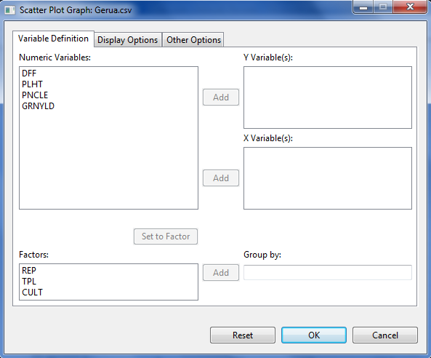

* Specify the inputs for the required fields and desired options.

**Variable Definition Tab**

**Y Variable(s)**

At least one entry should be specified for the graph to be created. Entries should come from the **Numeric Variables** dialog box.

**X Variable(s)**

At least one entry should be specified for the graph to be created. Entries should come from the **Numeric Variables** dialog box.

**Group by**

This field is optional. If a factor is specified, a graph is going to be generated per category of the factor. Entry should come from the **Factors** list box.

**Display Options** **Tab**

**Main Title**

This field will contain the title for the graph.

**Format Axes**

The label and limits for the numeric variable(s) can be edited here. Default axis label is the name of the numeric variable. Lower and upper limits, if not specified, are determined from the data.

**Axis Label Orientation**

This option will determine how axis labels are displayed: *parallel to axis*, *horizontal*, *vertical*, and *perpendicular to axis*.

**Format Points**

In this section, changes to the formats (symbol, size, and color) of the points may be made.

**Draw box around plot**

If checked, the graph will be enclosed in a box.

**Display multiple graphs in a page**

If checked, several graphs will be displayed on a single page, based on the specified number of rows and columns and orientation. At most 5 rows and 5 columns of graphs can be fitted into a single page, arranged either from *Top-to-bottom* or *Left-to-right*.

**Other Options** **Tab**

**Plot regression line**

If this option is checked, an estimated regression line is plotted over the points. If checked, type, width, and color of line may be edited. In addition, the *R-squared* and *p-value* may also be displayed (*bottom, bottom-left, bottom-right, center, left, right, top, top-left,* or *top-right* position).

For the example, suppose we want to create a scatter plot for plant height (*PLHT*) and grain yield (*GRNYLD*). The completed **Variable Definition** tab should appear as shown below:

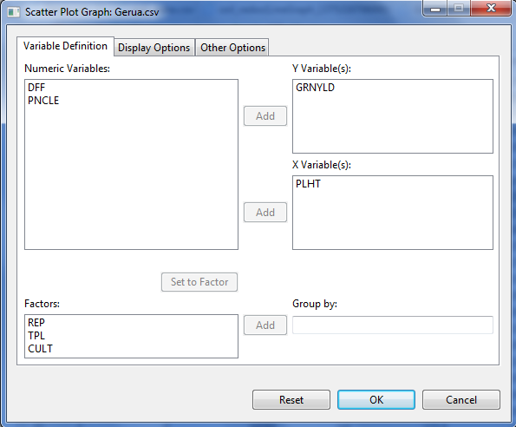

Items in the **Display Options** tab may be supplied as illustrated:

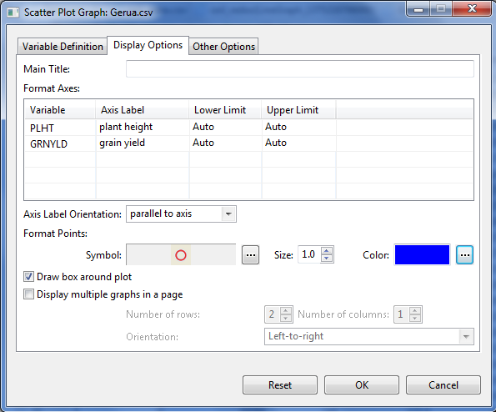

Items in the **Other Options** tab may be supplied as illustrated:

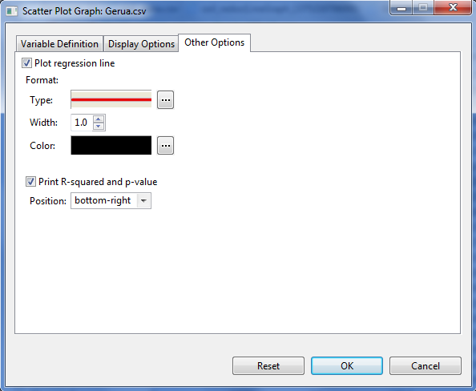

* Click the **OK** button to create the graph. The **Scatter Plot** dialog box will be minimized and the Result Viewer will be activated.

Sample graph as displayed in the **Graph** tab of the **Result Viewer**:

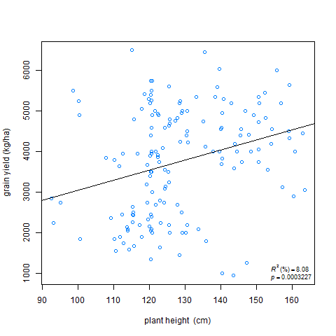

# Descriptive Statistics

The **Descriptive** procedureperforms univariate summary statistics for several variables and/or per levels of grouping variable(s).

The steps to obtain numerical descriptive measures are listed below:

* On the **Project Explorer** panel, double-click the file to be used for the analysis to open it and view it in the Data Viewer tab.

For the example, using the project named *MyProject*, import the data *MasterData.csv* from the *Data* folder of the project named *SampleProject*. To import data from the *SampleProject*, see *Importing Data from Other Project* sectionof this user’s manual.

Opening the data for the first time, *REP* field is regarded by STAR as numerical variable. To change its type, choose the variable *REP* and click on the **Set to Factor** button.

* Click **Analyze | Descriptive Statistics | Descriptive…**. The **Descriptive Statistics** dialog box will appear.

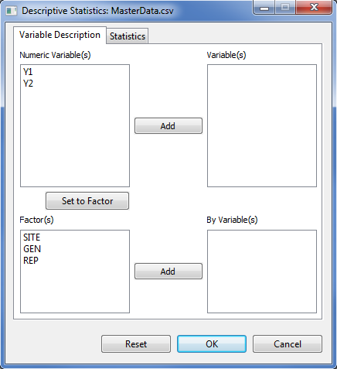

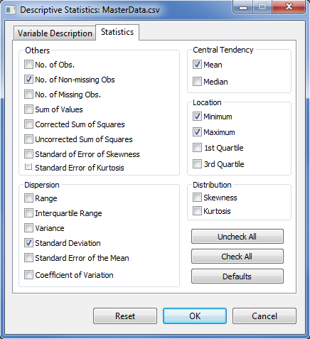

* Specify the required field and appropriate options for the analysis.

**Variable Description** **Tab**

This tab lets the user identify the variables and grouping variable(s) where descriptive statistics will be computed.

**Variable(s)**

At least one entry is needed for the analysis to proceed. Entries should come from the **Numeric Variable(s)** list box.

**By Variable(s)**

This field is optional. If a **By Variable(s)** is specified, it will generate descriptive statistic per category of the **By Variable**. Entries should come from the **Factor(s)** list box.

**Statistics Tab**

This tab lets the user identify the numerical descriptive measures to be displayed. By default, the procedure will display five statistics, namely: number of non-missing observations (NNMissObs), minimum (min), maximum (max), mean, and standard deviation (stdDev). To request for all statistics, click the **Check All** button of the **Statistics** tab. User may click on the **Uncheck All** button to remove previously selected items and start with a new selection.At least one statistics should be check to the analysis to proceed.

For the example, suppose we want to compute the descriptive statistics of variables *Y1* and *Y2*. The completed **Variable Description** tab and **Statistics** tab should appear as shown:

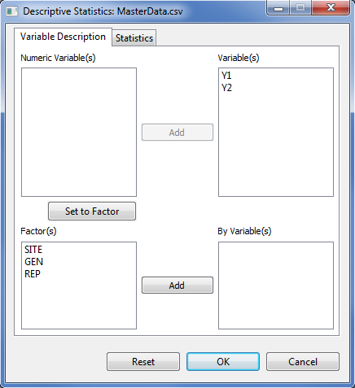



* Click the **OK** button to generate the summary statistics. The **Descriptive Statistics** dialog box will be minimize and STAR activates the **Output** page of the **Result Viewer** tab. Sample output displayed in the **Output** page is shown below:

Descriptive Statistics

------------------------------------------------------

Variable N\_NonMissObs Min Max Mean StdDev

------------------------------------------------------

Y1 96 14.00 151.00 130.43 16.05

Y2 96 92.60 163.50 124.50 15.05

------------------------------------------------------

Suppose we want to compute the descriptive statistics for variables *Y1* and *Y2* per level of *GEN*. The completed **Variable Description** tab should appear as shown below:

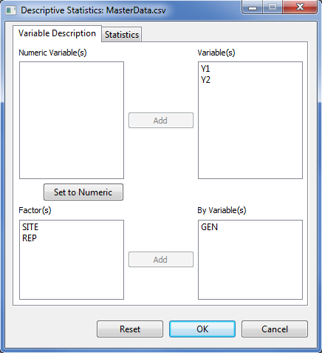

* Click the **OK** button to generate the summary statistics. Sample output is shown below:

Descriptive Statistics

-------------------------------------------------------------

Variable GEN N\_NonMissObs Min Max Mean StdDev

-------------------------------------------------------------

Y1 Gen1 12 113.00 144.00 132.33 10.50

Y1 Gen2 12 106.00 150.00 134.17 11.07

Y1 Gen3 12 116.00 148.00 132.42 9.46

Y1 Gen4 12 14.00 151.00 122.92 36.36

Y1 Gen5 12 106.00 145.00 129.42 11.84

Y1 Gen6 12 121.00 143.00 133.25 6.84

Y1 Gen7 12 109.00 149.00 130.00 12.05

Y1 Gen8 12 106.00 144.00 128.92 12.26

Y2 Gen1 12 92.60 163.50 128.87 20.06

Y2 Gen2 12 95.20 149.30 119.24 14.21

Y2 Gen3 12 93.10 148.40 120.09 15.03

Y2 Gen4 12 100.50 150.70 124.54 16.45

Y2 Gen5 12 98.60 160.70 125.22 16.83

Y2 Gen6 12 110.20 130.60 119.24 5.54

Y2 Gen7 12 117.90 159.30 130.05 13.78

Y2 Gen8 12 111.70 150.90 128.72 13.98

-------------------------------------------------------------

# 

# Cross Tabulation

The cross tabulation forms two-way tables. By default, the observed frequency is displayed.

The steps to perform Cross Tabulation are listed below:

* On the **Project Explorer** panel, double-click the file to be used for analysis to open it and view it in the Data Viewer tab.

For the example, using the project named *MyProject*, import the data *GomezMaizeCross.csv* from the package. To import data from the package, see *Importing Data from Package* sectionof this user’s manual.

* To generate cross table, from the main window click **Analyze | Descriptive Statistics | Cross Tabulation…**. The **Cross Tabulation** dialog box will appear.

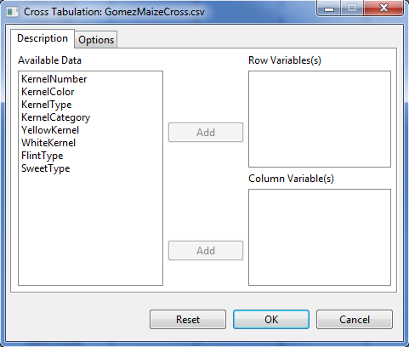

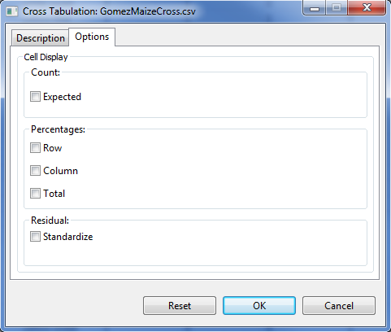

* Specify the required field and the appropriate options for the analysis.

**Description** **Tab**

This tab lets the user identify the variables where cross tabulation will be performed.

**Row Variable(s)**

At least one entry is need for the analysis to proceed.

**Column Variable(s)**

At least one entry is need for the analysis to proceed.

**Options Tab**

This tab lets the user identify the additional output that will be displayed.

**Expected Count**

If this option is selected, the expected frequency will be displayed.

**Row Percentages**

If this option is selected, the row percentage will be displayed.

**Column Percentages**

If this option is selected, the column percentage will be displayed.

**Total Percentages**

If this option is selected, the total percentage will be displayed.

**Standardize Residual**

If this option is selected, the standardize residual will be displayed.

For the example, the completed **Variable Description** tab and **Options** tab should appear as shown below:

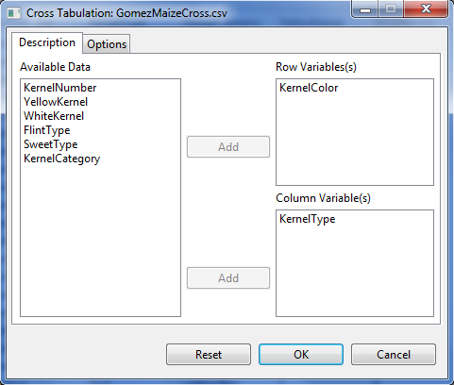

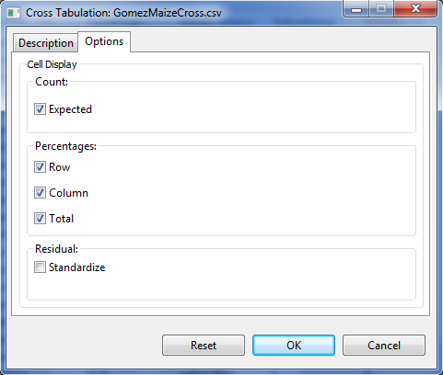

* Click the **OK** button. The **Cross Tabulation** dialog box will be minimized and STAR actives the **Output** page of the **Result Viewer** tab. Sample output of the analysis is shown below:

CROSS TABULATION

Table of KernelColor by KernelType

|KernelType

-----------------------------------+-----------+-----------+-----------+

KernelColor |flint |sweet |Total |

-----------------------------------+-----------+-----------+-----------+

white |Obs Freq | 112| 34| 146|

|Expected Freq | 110.9600| 35.0400| 146.0000|

|% within KernelColor | 76.7123| 23.2877| 100.0000|

|% within KernelType | 18.4211| 17.7083| |

|% of Total | 14.0000| 4.2500| 18.2500|

-----------------------------------+-----------+-----------+-----------+

yellow |Obs Freq | 496| 158| 654|

|Expected Freq | 497.0400| 156.9600| 654.0000|

|% within KernelColor | 75.8410| 24.1590| 100.0000|

|% within KernelType | 81.5789| 82.2917| |

|% of Total | 62.0000| 19.7500| 81.7500|

-----------------------------------+-----------+-----------+-----------+

Total |Obs Freq | 608| 192| 800|

|Expected Freq | 608.0000| 192.0000| 800.0000|

|% within KernelType | 100.0000| 100.0000| |

|% of Total | 76.0000| 24.0000| 100.0000|

-----------------------------------+-----------+-----------+-----------+

# Normality Test

The Test for Normality menu display normality test for at least one numeric variable. There are five procedures available in this menu, namely: Shapiro-Wilk, Shapiro-Francia, Lilliefors (Kolmogorov-Smirnov), Cramer-Von Mises and the Anderson-Darling test for normality.

The Shapiro-Wilk test for normality can be used if the number of non-missing observations is between 3 and 5000. While the Shapiro-Francia test for normality can be used if the number of non-missing observations is between 5 and 5000. The Lilliefors test for normality can be used if the number of non-missing observations is greater than 4. The Cramer-Von Mises and the Anderson-Darling test for normality can both be used if the number of non-missing observations is greater than 7.

The steps to perform test for normality are listed below:

* On the **Project Explorer** panel, double-click the file to be used for the analysis to open it and view it in the Data Viewer tab.

For the example, using the project named *MyProject*, import the data *MasterData.csv* from the *Data* folder of the project named *SampleProject*. To import data from the *SampleProject*, see *Importing Data from Other Project* sectionof this user’s manual.

Opening the data for the first time, *REP* field is regarded by STAR as numerical variable. To change its type, choose the variable *REP* and click on the **Set to Factor** button.

* Click **Analyze | Descriptive Statistics | Normality Test…**. The **Normality Test** dialog box will appear.

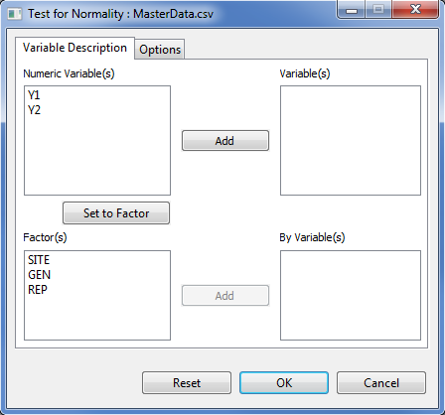

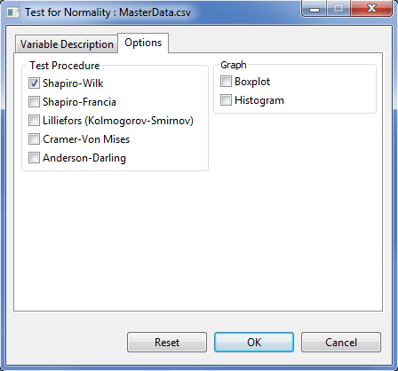

* Specify the required field and appropriate options for the analysis.

**Variable Description Tab**

This tab lets the user identify the variables and grouping variable(s) where test for normality will be performed.

**Variables**

At least one entry should be specified for the analysis to proceed. Entries for this list box should come from the **Numeric Variable(s)** list box.

**By Variables**

This field is optional. If a by variable(s) is specified, it will perform test for normality per level of the **By Variable(s)**. Entries for this list box should come from the **Factor(s)** list box.

**Options Tab**

**Test Procedure**

This option is required. At least one test procedure should be selected for the analysis to proceed. By default, the Shapiro-Wilk test is selected.

**Graph**

The user has the option to display the box plot and the histogram.

For the example, suppose we want to perform normality test using Shapiro-Wilk test for variables *Y1* and *Y2* per level of *GEN*. The completed **Variable Description** tab and **Option** tab should appear as shown:

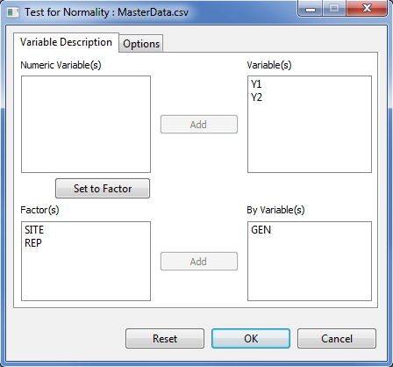



* Click the **OK** button to perform the test. The **Normality Test** dialog box will be minimized and STAR activates the **Output** page of the **Result Viewer** tab.

Sample text output displayed in the **Output** page is shown below:

Test for Normality

-----------------------------------------------------

Grp Level Variable Method W Value Pr(< W)

-----------------------------------------------------

GEN Gen1 Y1 Shapiro-Wilk 0.8914 0.1228

GEN Gen2 Y1 Shapiro-Wilk 0.8947 0.1353

GEN Gen3 Y1 Shapiro-Wilk 0.9560 0.7259

GEN Gen4 Y1 Shapiro-Wilk 0.6460 0.0003

GEN Gen5 Y1 Shapiro-Wilk 0.9268 0.3474

GEN Gen6 Y1 Shapiro-Wilk 0.9645 0.8454

GEN Gen7 Y1 Shapiro-Wilk 0.9618 0.8097

GEN Gen8 Y1 Shapiro-Wilk 0.9020 0.1681

GEN Gen1 Y2 Shapiro-Wilk 0.9700 0.9107

GEN Gen2 Y2 Shapiro-Wilk 0.9341 0.4251

GEN Gen3 Y2 Shapiro-Wilk 0.9811 0.9876

GEN Gen4 Y2 Shapiro-Wilk 0.9200 0.2860

GEN Gen5 Y2 Shapiro-Wilk 0.9314 0.3956

GEN Gen6 Y2 Shapiro-Wilk 0.9450 0.5658

GEN Gen7 Y2 Shapiro-Wilk 0.8047 0.0106

GEN Gen8 Y2 Shapiro-Wilk 0.8613 0.0508

-----------------------------------------------------

Sample graphical output displayed in the **Graph** page is shown below:

|  |  |
| --- | --- |
| E:\Applications\STAR\Projects\My Project\Output\NormalityStatistic_1361383487648\Boxplot__Y1.png | E:\Applications\STAR\Projects\My Project\Output\NormalityStatistic_1361383487648\Boxplot__Y2.png |
| E:\Applications\STAR\Projects\My Project\Output\NormalityStatistic_1361383487648\Histogram__Y1.png | E:\Applications\STAR\Projects\My Project\Output\NormalityStatistic_1361383487648\Histogram__Y2.png |

Suppose we want to perform normality test using Shapiro-Wilk and Kolmogorov-Smirnov for variables *Y1* and *Y2*. The completed **Variable Description** and **Option** tab should appear as shown below:

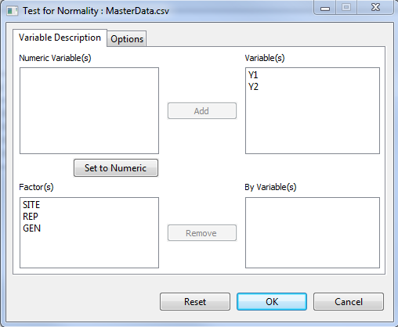

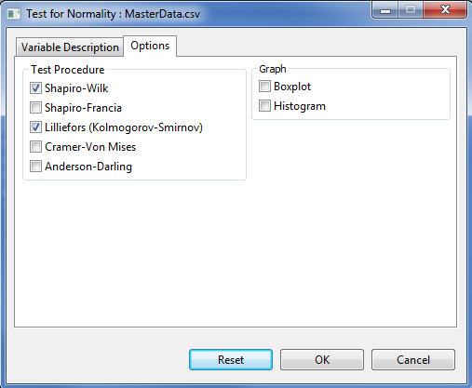

Sample text output that will be displayed in the **Output** page is shown below:

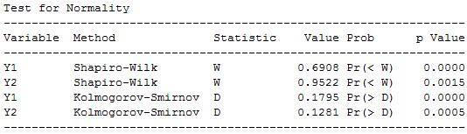

# Homogeneity of Variances

The Homogeneity of Variances menu perform test for equally of variances across groups. There are two procedures available in this menu, namely: Bartlett’s test and the Levene’s test.

The steps to perform the test are listed below:

* On the **Project Explorer** panel, double-click the file to be used for the analysis to open it and view it in the Data Viewer tab.

For the example, using the project named *MyProject*, import the data *MasterData.csv* from the *Data* folder of the project named *SampleProject*. To import data from the *SampleProject*, see *Importing Data from Other Project* sectionof this user’s manual.

Opening the data for the first time, *REP* field is regarded by STAR as numerical variable. To change its type, choose the variable *REP* and click on the **Set to Factor** button.

* Click **Analyze | Descriptive Statistics | Homogeneity of Variance…**. The **Homogeneity of Variance** dialog box will appear.

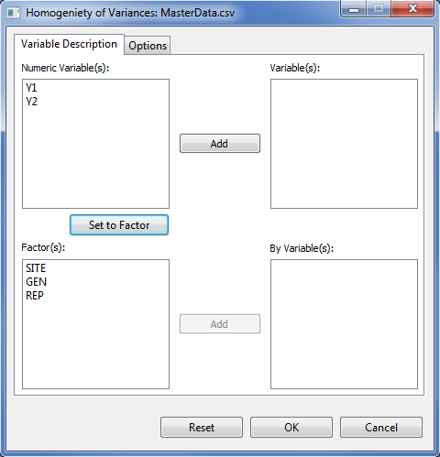

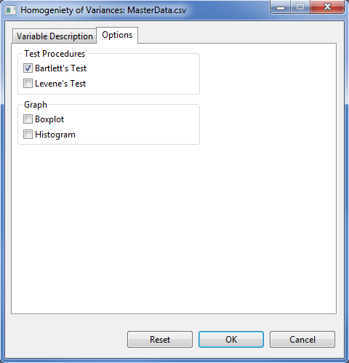

* Specify the required field and appropriate options for the analysis.

**Variable Description Tab**

This tab lets the user identify the variables and grouping variable(s) where test for homogeneity of variances will be performed.

**Variables**

At least one entry should be specified for the analysis to proceed. Entries must come from the **Numeric Variable(s)** list box.

**By Variables**

At least one entry should be specified for the analysis to proceed. Entries specified here should contain two or more levels and must come from the **Factor(s)** list box.

**Options Tab**

**Test Procedure**

At least one test procedure should be selected for the analysis to proceed. By default, the Bartlett’s test for homogeneity of variances is selected.

**Graph**

The user has the option to display the box plot and the histogram.

For the example, suppose we want to determine whether the variances are equal among the levels of *GEN* for variables *Y1* and *Y2*. The completed **Variable Description** tab and completed **Option** tab should appear as below:

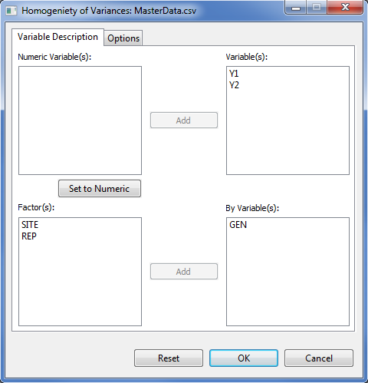

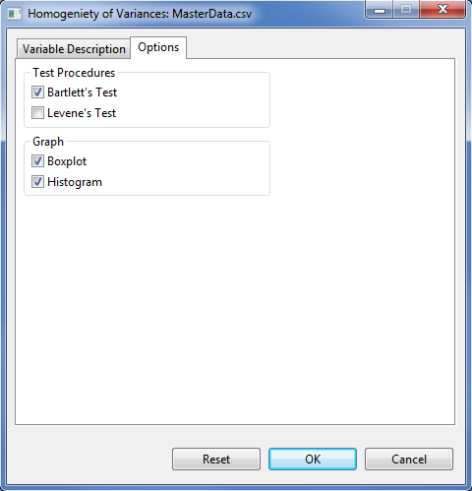

* Click the **OK** button to perform the test. The **Homogeneity of Variances** dialog box will be minimized and STAR activates the **Output** page of the **Result Viewer** tab.

Sample text output as displayed in the **Output** page:

Test for Homogeneity of Variances

------------------------------------------------------

Grp Variable Method DF Chisq Value Pr(>Chisq)

------------------------------------------------------

GEN Y1 Bartlett 7 49.91 0.0000

GEN Y2 Bartlett 7 15.00 0.0359

------------------------------------------------------

Sample graphical output displayed in the **Graph** page:

|  |  |
| --- | --- |
| E:\Applications\STAR\Projects\My Project\Output\NormalityStatistic_1361383487648\Boxplot__Y1.png | E:\Applications\STAR\Projects\My Project\Output\NormalityStatistic_1361383487648\Boxplot__Y2.png |
| E:\Applications\STAR\Projects\My Project\Output\NormalityStatistic_1361383487648\Histogram__Y1.png | E:\Applications\STAR\Projects\My Project\Output\NormalityStatistic_1361383487648\Histogram__Y2.png |
|  |  |

Suppose we want to determine whether the variances are equal among the levels of *GEN* for variables *Y1* and *Y2* using Bartlett’s and Levene’s test. The completed **Variable Description** tab and completed **Option** tab should appear as below:

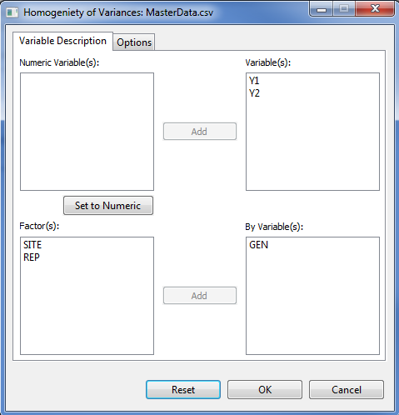

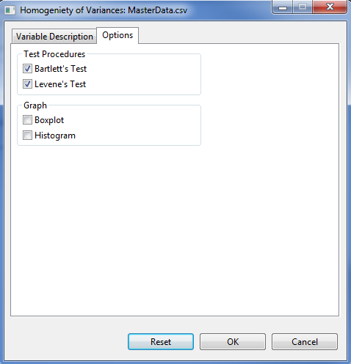

Sample output as displayed in the **Output page** tab is displayed below:

Test for Homogeneity of Variances

--------------------------------------------------------------------

Grp Variable Method DF Statistic Value Prob p Value

--------------------------------------------------------------------

GEN Y1 Bartlett 7 Chisq 49.91 Pr(>Chisq) 0.0000

GEN Y1 Levene 7 F 1.17 Pr(>F) 0.3275

GEN Y2 Bartlett 7 Chisq 15.00 Pr(>Chisq) 0.0359

GEN Y2 Levene 7 F 1.25 Pr(>F) 0.2861

--------------------------------------------------------------------

# Fitting Distributions

The steps to fit a distribution are listed below:

* On the **Project Explorer** panel, double-click the file to be used for the analysis to open it and view it in the Data Viewer tab.

For the example, using the project named *MyProject*, import the data *Gerua* from the package. To import data from the package, see *Importing Data from package* sectionof this user’s manual.

* Click **Analyze | Fit Distributions…**. The **Fit Distributions** dialog box will appear.

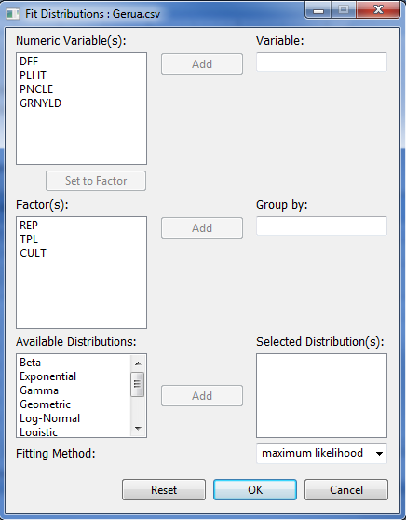

* Specify the required field and appropriate options for the analysis.

**Variable**

This field is required. Entry should come from the **Numeric Variable(s)** list box.

**Group by**

This field is optional. If a factor is specified, analysis is going to be done per category of the factor. Entry should come from the **Factor(s)** list box.

**Selected Distribution(s)**

This field is required. One or more entries should be selected from the **Available Distributions** list box.

**Fitting Method**

Available methods for fitting are: maximum likelihood, moment matching, and maximum goodness-of-fit.

For the example, the completed dialog box should appear as below:

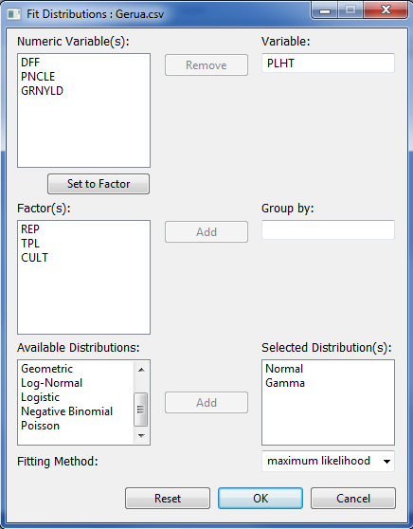

* Click the **OK** button to fit the distributions. The **Fit Distributions** dialog box will be minimized and STAR activates the **Output** page of the **Result Viewer** tab.

Sample text output as displayed in the **Output** page.

DISTRIBUTION FITTING

METHOD: maximum likelihood estimation

VARIABLE: PLHT

DISTRIBUTION: Normal

Fitting of the distribution 'norm' by maximum likelihood

Parameters:

estimate Std. Error

mean 128.47756 1.2203140

sd 15.24172 0.8628923

Goodness-of-fit

Statistic Decision

Cramer-von Mises 0.5887 NULL

Anderson-Darling 2.9911 NULL

Kolmogorov-Smirnov 0.1364 rejected

DISTRIBUTION: Gamma

Fitting of the distribution 'gamma' by maximum likelihood

Parameters:

estimate Std. Error

shape 71.8758920 8.11707165

rate 0.5594382 0.06339853

Goodness-of-fit

Statistic Decision

Cramer-von Mises 0.4672 rejected

Anderson-Darling 2.4234 rejected

Kolmogorov-Smirnov 0.1219 rejected

Sample graphical output as displayed in the **Graph** page.

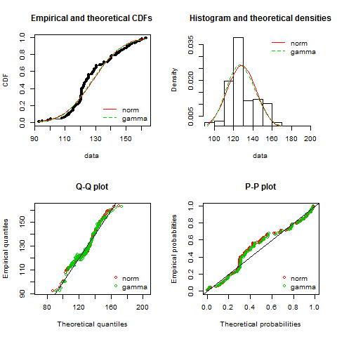

# t-Test

## One Sample *t*-test

The One Sample *t*-test procedure determine whether the mean of one variable differ from the hypothesized value. It assumes that the samples are randomly taken from the population of interest and that the observations are obtained from a normal distribution.

The steps to perform the one sample t-test are listed below:

* On the **Project Explorer** panel, double-click the file to be used for the analysis to open it and view it in the Data Viewer tab.

For the example, using the project named *MyProject*, import the data *MasterData.csv* from the *Data* folder of the project named *SampleProject*. To import data from the *SampleProject*, see *Importing Data from Other Project* sectionof this user’s manual.

Opening the data for the first time, *REP* field is regarded by STAR as numerical variable. To change its type, choose the variable *REP* and click on the **Set to Factor** button.

* Click **Analyze | t-Test | One Sample…**. The **One Sample** dialog box will appear.

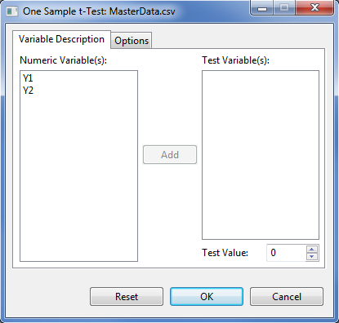

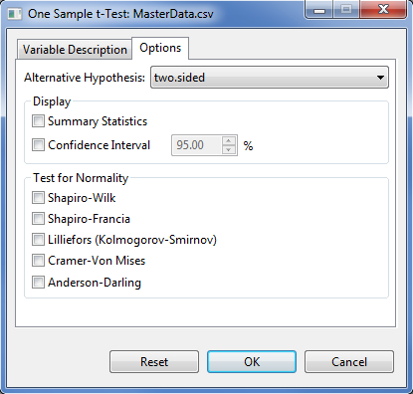

* Specify the required field and appropriate options for the analysis.

**Variable Description Tab**

**Test Variable(s)**

At least one entry should be specified for the analysis to proceed. Entries should come from the **Numeric Variable(s)** list box.

**Test Value**

This field is required and will only accept one entry at a time. The default value is 0. User can change the value by typing a value inside the spin box or by pressing the up-arrow key to increment the value, down-arrow key, otherwise.

**Options** **Tab**

**Alternative Hypothesis**

User can select a one-tailed or two-tailed test. The default alternative hypothesis used is that for the two-sided test.

**Summary Statistics**

If this option is selected, a summary table with number of observations, minimum, maximum, mean and standard deviation will be displayed.

**Confidence Interval**

If this option is selected, a confidence interval of the mean will be displayed. If this is selected, by default, a 95% confidence interval is displayed.

**Test for Normality**

If at least one option is selected, if display the test for normality test for each level of the **Grouping Variable**. There are five available tests for normality procedure.

For the example, suppose we want to determine whether the mean of *Y1* is significantly different from 125. The completed **Variable Description** tab and **Option** tab should appear as shown below:

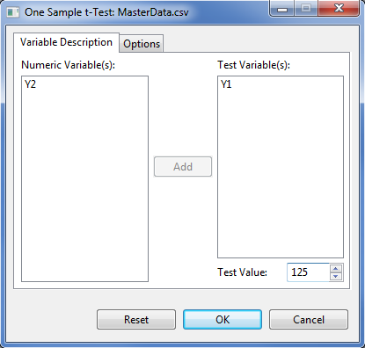

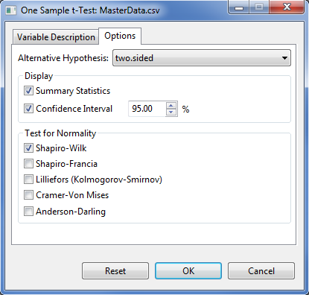

* Click the **OK** button to perform the test. The **One Sample t-Test** dialog box will be minimized and STAR activates the **Output** page of the **Result Viewer** tab.

Sample output as displayed in the **Output**page.

Test for Normality

-----------------------------------------

Variable Method W Value Pr(< W)

-----------------------------------------

Y1 Shapiro-Wilk 0.6908 0.0000

-----------------------------------------

Descriptive Statistics

-------------------------------------------------------------

Variable N Lower CI\* Mean Upper CI\* StdDev SE\_Mean

-------------------------------------------------------------

Y1 96 127.18 130.43 133.68 16.05 1.64

-------------------------------------------------------------

\* At 95% Confidence Level.

One Sample t-Test, h0: mean = 125

---------------------------------

Variable DF t Value Pr(>|t|)

---------------------------------

Y1 95 3.31 0.0013

---------------------------------

## Paired Sample *t*-tests

The paired sample *t*-test is used to compares the means of paired or related samples. It assumes that the samples are randomly taken from the population of interest and the population of differences is normally distributed.

The steps to perform paired t-test are listed below:

* On the **Project Explorer** panel, double-click the file to be used for the analysis to open it and view it in the Data Viewer tab.

For the example, using the project named *My Project*, import the data *Sensors* from the package. To import data from thepackage, see *Importing Data from the Package* sectionof this user’s manual.

* Click **Analyze | t-Tests | Paired Samples…** from the main window. The **Paired Samples t-Test** dialog box will appear.

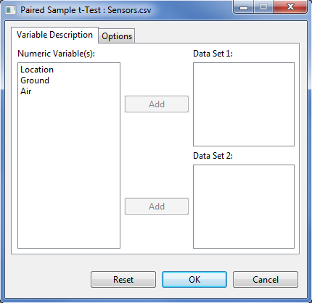

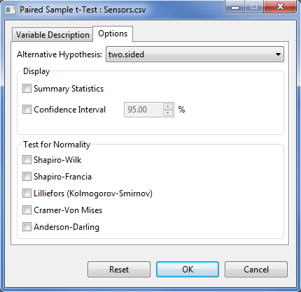

* Specify the required field and appropriate options for the analysis.

**Variable Description Tab**

**Data Set 1**

This field needs at least one entry for the analysis to proceed and must have the same number of entries as **Data Set 2**.

**Data Set 2**

This field needs at least one entry for the analysis to proceed and must have the same number of entries as **Data Set 1**.

**Options** **Tab**

**Alternative Hypothesis**

User can select a one-tailed or two-tailed test. The default alternative hypothesis used is that for the two-sided test.

**Summary Statistics**

If this option is selected, a summary table with number of observations, minimum, maximum, mean and standard deviation will be displayed.

**Confidence Interval**

If this option is selected, a confidence interval of the mean will be displayed. If this is selected, by default, a 95% confidence interval is displayed.

**Test for Normality**

If at least one option is selected, if display the test for normality test for the difference between each pair of variables. There are five available tests for normality procedure.

For the example, the completed **Variable Description** tab and **Options** tab should appear as shown below:

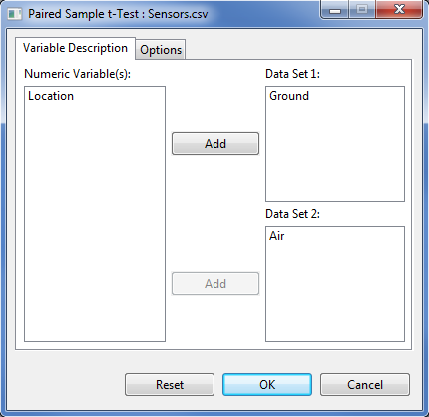

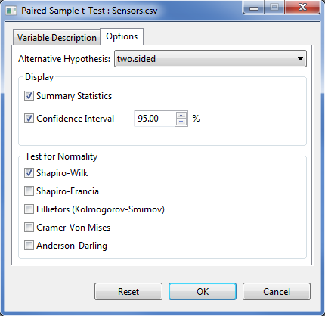

* Click the **OK** button to perform the analysis. The **Paired Sample t-Test** dialog box will be minimized and STAR activates the **Output** page of the **Result Viewer** tab.

Sample output of the analysis as shown in the Output page is displayed below:

Test for Normality

---------------------------------------------

Difference Method W Value Pr(< W)

---------------------------------------------

Ground - Air Shapiro-Wilk 0.9403 0.5562

---------------------------------------------

Descriptive Statistics

----------------------------------------------------------------

Difference N Lower CI\* Mean Upper CI\* StdDev SE\_Mean

----------------------------------------------------------------

Ground - Air 10 -2.10 -1.55 -0.9987 0.7706 0.2437

----------------------------------------------------------------

\* At 95% Confidence Level.

Paired Sample t-Test, h0: mean diff = 0

-------------------------------------

Difference DF t Value Pr(>|t|)

-------------------------------------

Ground - Air 9 -6.36 0.0001

-------------------------------------

## Independent Sample *t*-tests

The independent sample *t*-test is used to determine whether the means between two groups or populations are equal. It assumes that (i) the samples are drawn independently from each population; (ii) the samples from each population are randomly taken; and (iii) the observations from each population are obtained from a normal distribution.

Default output of the t-test for two independent samples in STAR includes the test for equality of variances. Depending on the result of the equality of variances, pooled t-test or a t-test with satterwaite adjustment is computed.

The steps to perform *t*-Test for two independent samples are listed below:

* On the **Project Explorer**, double-click the file to be used for the analysis to open and view it in the Data Viewer.

For the example, using the project named *My Project*,import the data *Fertilizer* from package. To import that data from package*, s*ee *Importing from Package* section of this user’s manual.

* Click **Analyze | t-test | Independent Sample…** from the main window. The **Two Independent Sample t-Test** dialog box will appear.

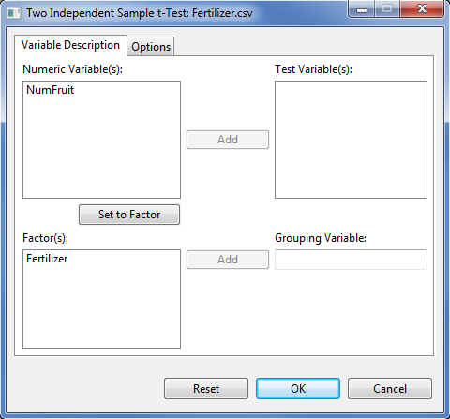

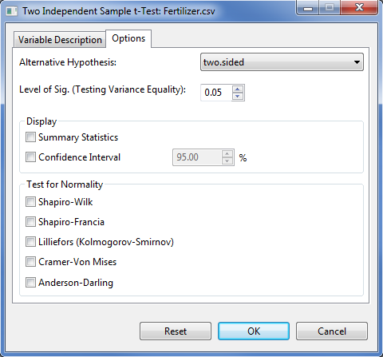

* Specify the required field and appropriate options for the analysis.

**Variable Description Tab**

**Test Variable(s)**

This field need at least one entry for the analysis to proceed and should come from the **Numeric Variable(s)** list box.

**Grouping Variable**

This field accepts one entry at a time and needs an entry for the analysis to proceed. The entry must come from the **Factor(s)** list box. The entry should have only two levels.

**Options** **Tab**

**Alternative Hypothesis**

User can select a one-tailed or two-tailed test. The default alternative hypothesis used is that for the two-sided test.

**Level of Significance**

This will be used to determine if the two groups have equal variance. Its default value is 0.05. The user can change this value by specifying a numeric value from zero to 1.

**Summary Statistics**

If this option is selected, a summary table with number of observations, minimum, maximum, mean and standard deviation will be displayed.

**Confidence Interval**

If this option is selected, a confidence interval of the mean will be displayed. If this is selected, by default, a 95% confidence interval is displayed.

**Test for Normality**

If at least one option is selected, if display the test for normality test for each level of the **Grouping Variable**. There are five available tests for normality procedure.

For the example, suppose we want to test the hypothesis that the mean number of fruits from trees sprayed by the two fertilizers are the same. The completed **Variable Description** tab and **Option** tab should appear as shown below:

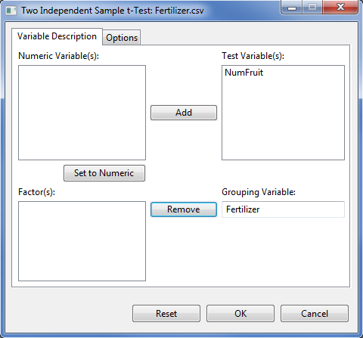

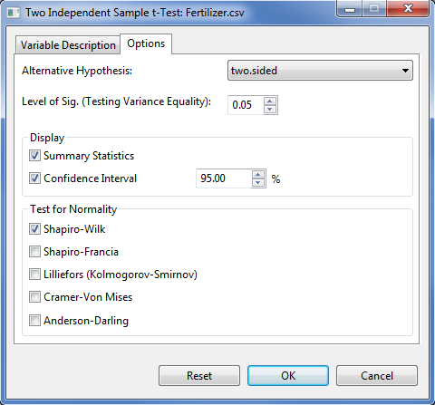

* Click the **OK** button to perform the analysis. The **Two** **Independent Sample** **t-test** dialog box will be minimized and STAR actives the **Output** page of the **Result Viewer** tab.

Sample output of the analysis as shown in the Output page is displayed below.

Test for Normality

------------------------------------------------------------

Grp Level Variable Method W Value Pr(< W)

------------------------------------------------------------

Fertilizer A NumFruit Shapiro-Wilk 0.9726 0.8950

Fertilizer B NumFruit Shapiro-Wilk 0.9198 0.1916

------------------------------------------------------------

Descriptive Statistics

------------------------------------------------------------------------

Variable Fertilizer N Lower CI\* Mean Upper CI\* StdDev SE\_Mean

------------------------------------------------------------------------

NumFruit A 15 21.51 23.13 24.75 2.92 0.76

NumFruit B 15 19.25 20.87 22.49 3.54 0.91

NumFruit Diff(A-B) -0.16 2.27 4.70 3.25 1.19

------------------------------------------------------------------------

\* At 95% Confidence Level.

Homogeneity of Variances

-----------------------------------------------------

Variable Method Num DF Den DF F Value Pr(> F)

-----------------------------------------------------

NumFruit Folded F 14 14 1.47 0.4820

-----------------------------------------------------

Two Independent Sample t-Test, h0: mean diff = 0

-----------------------------------------------------

Variable Method\* Variances DF t Value Pr(>|t|)

-----------------------------------------------------

NumFruit Pooled Equal 28 1.91 0.0663

-----------------------------------------------------

\* At 0.05 level of significance.

# Chi-Square Test

## Goodness of fit Test

The steps to perform chi-square goodness of fit test are listed below:

* On the **Project Explorer**, double-click the file to be used for the analysis to open and view it in the Data Viewer tab.

For the example, using the project named *MyProject*,import the data *GomezMaizeCross* from the package. To import the data from the package*, s*ee *Importing from Package* section of this user’s manual.

* Click **Analyze | Chi-Square | Goodness of Fit…** from the main window. The **Goodness of Fit Test** dialog box will appear as shown below:

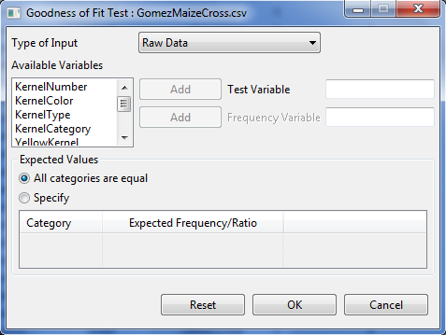

* Specify the required field and appropriate options for the analysis.

**Type of Input**

There are two options available, *Raw Data* (default option) and *Summary Data*.

**Test Variable**

This variable is required.

**Frequency Variable**

If the *Summary Data* is chosen as type of input, this variable is required.

**Expected Values**

There are two options available, *All categories are equal* (default option) and *specify*. If *specify* option is selected, table will be enable wherein user need to indicate the expected frequency/ratio for each of the unique categories of the test variable. The default and minimum expected frequency/ratio for each category is 1.

For the example, the completed dialog box should appear as shown below:

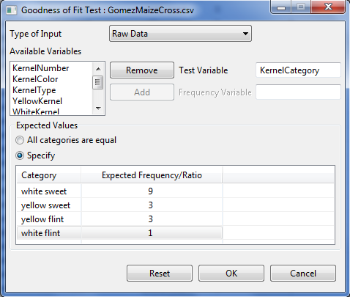

* Click **OK** button to perform the analysis. The **Goodness of Fit Test** dialog box will be minimized and STAR activates the **Output** page of the **Result Viewer** tab.

Sample text output is shown below.

Frequency Table:

-----------------------------------

KernelCategory Obs Freq Exp Freq

-----------------------------------

white flint 112 50

white sweet 34 150

yellow flint 496 450

yellow sweet 158 150

-----------------------------------

Chi-Square Goodness of Fit Test

------------------------------

Chi-Square 171.7156

DF 3

Pr > Chi-Square 0.0000

------------------------------

## Test of Independence

The steps to perform Chi-Square test of independence are listed below:

* On the **Project Explorer**, double-click the file to be used for the analysis to open and view it in the Data Viewer tab.

For the example, using the project named *MyProject*,import the data *GomezMaizeCross* from the package. To import the data the package*, s*ee *Importing from Package* section of this user’s manual.

* Click **Analyze | Chi-Square | Test of Independence…** from the main window. The **Test of Independence** dialog box will appear as shown below:

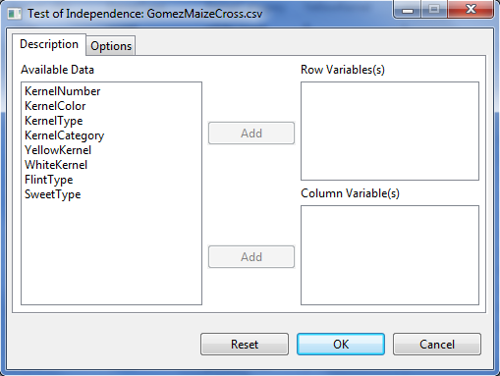

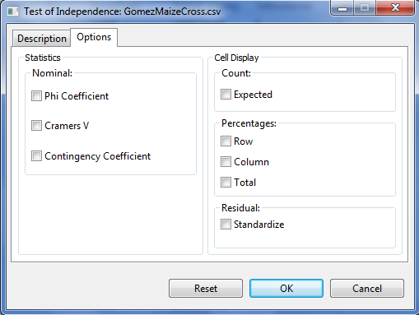

* Specify the required field and appropriate options for the analysis.

**Description** **Tab**

**Type of Input**

There are two options available,*Raw Data* (default option) and *Summary Data*.

**Row Variable(s)**

If *Raw Data* is selected as **Type of Input**, at least one entry is need for the analysis to proceed. If *Summary Data* is selected, only one entry should be entered in the list box.

**Column Variable(s)**

If *Raw Data* is selected as **Type of Input**, at least one entry is need for the analysis to proceed. If *Summary Data* is selected, only one entry should be entered in the list box.

**ID Variable(s)**

This field is required and visible if *Summary Data* is chosen as **Type of Input**. Only one entry should be entered in this entry box Entries for this entry box should be a numeric variable.

**Options Tab**

**Phi Coefficient**

If this option is selected, the phi coefficient will be displayed.

**Cramer’s V**

If this option is selected, the cramer’s v coefficient will be displayed.

**Contingency Coefficient**

If this option is selected, the contingency coefficient will be displayed.

**Expected Count**

If this option is selected, the expected frequency will be displayed.

**Row Percentages**

If this option is selected, the row percentage will be displayed.

**Column Percentages**

If this option is selected, the column percentage will be displayed.

**Total Percentages**

If this option is selected, the total percentage will be displayed.

**Standardize Residual**

If this option is selected, the standardize residual will be displayed.

For the example, the completed dialog box is shown below:

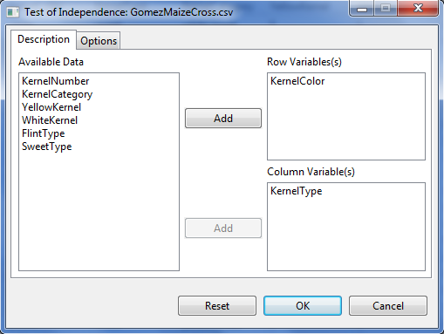

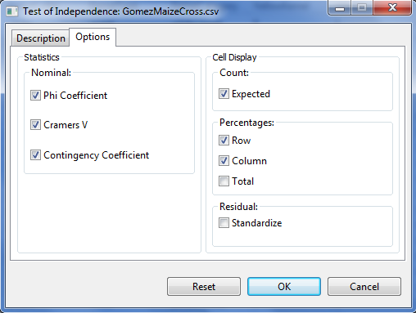

* Click the **OK** button to perform the analysis. The **Test of Independent** dialog box will be minimized and STAR actives the **Output** page of the **Result Viewer** tab.

Sample text output as displayed in the **Output** page is shown below:

Table of KernelColor by KernelType

|KernelType

-----------------------------------+-----------+-----------+-----------+

KernelColor |flint |sweet |Total |

-----------------------------------+-----------+-----------+-----------+

white |Obs Freq | 112| 34| 146|

|Expected Freq | 110.9600| 35.0400| 146.0000|

|% within KernelColor | 76.7123| 23.2877| 100.0000|

|% within KernelType | 18.4211| 17.7083| |

|% of Total | 14.0000| 4.2500| 18.2500|

-----------------------------------+-----------+-----------+-----------+

yellow |Obs Freq | 496| 158| 654|

|Expected Freq | 497.0400| 156.9600| 654.0000|

|% within KernelColor | 75.8410| 24.1590| 100.0000|

|% within KernelType | 81.5789| 82.2917| |

|% of Total | 62.0000| 19.7500| 81.7500|

-----------------------------------+-----------+-----------+-----------+

Total |Obs Freq | 608| 192| 800|

|Expected Freq | 608.0000| 192.0000| 800.0000|

|% within KernelType | 100.0000| 100.0000| |

|% of Total | 76.0000| 24.0000| 100.0000|

-----------------------------------+-----------+-----------+-----------+

Statistics for Table KernelColor by KernelType

Statistics DF Value Prob

--------------------------------------------------

Pearson Chi-Square 1 0.0134 0.9079

Likelihood Ratio Chi-Square 1 0.0499 0.8232

Phi Coefficient 0.0482

Contingency Coefficient 0.0482

Cramer's V 0.0482

Fisher's Exact Test 0.9147

--------------------------------------------------

# Test on Proportion

The steps to perform test on proportion are listed below:

* On the **Project Explorer**, double-click the file to be used for the analysis to open and view it in the Data Viewer tab.

For the example, using the project named *MyProject*,import the data *GomezMaizeCross* from the package. To import the data*, s*ee *Importing from Package* section of this user’s manual.

* Click **Analyze | Test on Proportion …** from the main window. The **Test on Proportion** dialog box will appear as shown below:

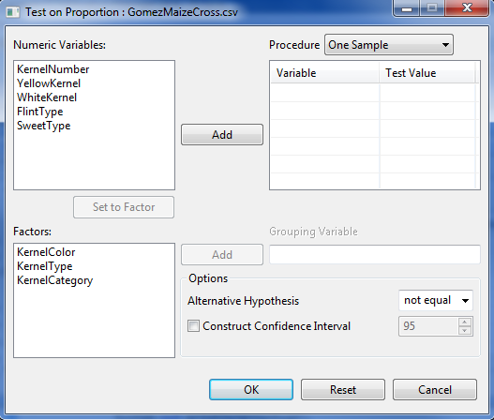

* Specify the required field and appropriate options for the analysis.

**Procedure**

There are three available procedures available: *One Sample* (default value), *Two Related Samples* and *Independent Sample*.

**Variable**

At least one entry is need for the analysis to proceed. Entries for this list box should come from the **Numeric Variable** list box.

**Test Value**

For every variable entered in the table, a default test value is specified. User can change the value by typing a value inside the spin box or by pressing the up-arrow key to increment the value, down-arrow key, otherwise. Valid value is between 0 to 1.

**Grouping Variable**

This field is required and visible if the procedure is *Independent Samples* is chosen. Entries for this list box should come from the **Factors** list box.

**Alternative hypothesis**

There are three available options: *less*, *greater* and *not equal* (default value).

**Construct Confidence Interval**

This option is available only if the procedure chosen is either *One Sample* or *Independent Sample*. If this option is selected, a confidence interval will be constructed.

For the example, the completed dialog box is shown below:

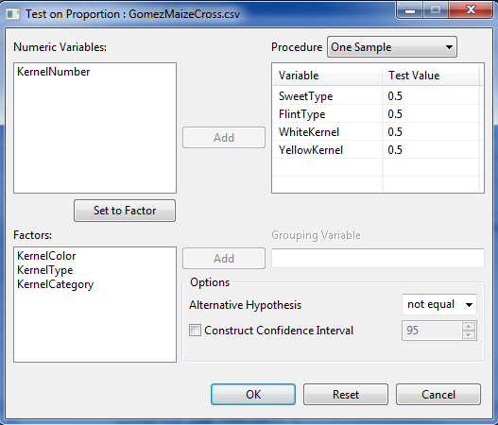

* Click the **OK** button to perform the analysis. The **Test on Proportion** dialog box will be minimized and STAR actives the **Output** page of the **Result Viewer** tab.

Sample output of the analysis as displayed in the Output page is shown below.

Summary

-------------------------------------------------

Variable Num Success Num Trial Proportion

-------------------------------------------------

SweetType 192 800 0.2400

FlintType 608 800 0.7600

WhiteKernel 146 800 0.1825

YellowKernel 654 800 0.8175

-------------------------------------------------

Test on One Proportion

------------------------------------------------------------

Variable Procedure TestValue Statistics Prob

------------------------------------------------------------

SweetType Chi-Square 0.5000 216.32 0.0000

SweetType Exact Binomial 0.5000 192.00 0.0000

SweetType Approx Z 0.5000 -14.71 0.0000

FlintType Chi-Square 0.5000 216.32 0.0000

FlintType Exact Binomial 0.5000 608.00 0.0000

FlintType Approx Z 0.5000 14.71 0.0000

WhiteKernel Chi-Square 0.5000 322.58 0.0000

WhiteKernel Exact Binomial 0.5000 146.00 0.0000

WhiteKernel Approx Z 0.5000 -17.96 0.0000

YellowKernel Chi-Square 0.5000 322.58 0.0000

YellowKernel Exact Binomial 0.5000 654.00 0.0000

YellowKernel Approx Z 0.5000 17.96 0.0000

------------------------------------------------------------

\* alternative hypothesis = 'two.sided'

# Analysis of Variance

The Analysis of Variance is a statistical technique which partitions the total variation into explained variation and unexplained variation.

The **Analysis of Variance submenu** can be use to perform analysis of variance for data from experimental designs with single error (e.g., RCB) and with 2 or more errors (e.g., Split Plot).

The Analysis of Variance in STAR uses fixed model and can be used for balanced data set. For data set with less than 10% missing observations, STAR can still perform the analysis of variance by first estimating the missing observations.

Treatment means or means of the treatment combination will be displayed depending on the result of the analysis of variance. If the analysis is performed on single factor and the treatment effect is not significant, the table of means is displayed. If the analysis is performed on multi-factor experiment and the highest interaction is not significant, the mean of the treatment combination are displayed.

Depending on the results of the analysis of variance, pairwise comparison means will be automatically generated for all effects that are significant using one applicable pairwise comparison procedure. If the factor being compared has at most 5 levels, the default pairwise comparison procedure used in STAR is the Least Significant Difference (LSD) test; otherwise the Honestly Significant Difference (HSD) or Tukey’s test is used. Aside from LSD and HSD, Duncan’s Multiple Range test, Student Newmann-Keul’s test and Scheffe’s test maybe also be requested.

Contrast analysis maybe requested in this menu. There are three available contrast analyses that maybe request for each factor, namely: compare with control, orthogonal polynomial contrast and user specified contrast.

Boxplot of the response variable and two diagnostic plots are automatically displayed in the *Graph* page of the **Result Viewer** tab. The *Residuals vs. Fitted* is for assessing the distribution of the residuals. An ideal plot should reveal that the points are distributed around 0. The residuals should not be affected by the size of the fitted values. Problematic data may result to a plot wherein the points increase as the fitted values increase, thus forming a “funnel-shaped” distribution. This will indicate a violation of the homogeneity of variances requirement for analysis of variance. The *Normal Q-Q* plot is used for assessing normality. The points should lie about the line.

A *csv* data named *residualData* is automatically created in the output folder that contains the original dataset, predicted and residual value of all response variable used in the analysis.

## Completely Randomized Design

This submenu can be used to perform analysis of variance for single or multi factor experiment.

The steps to perform the analysis are listed below:

* On the **Project Explorer**, double-click the file to be used for the analysis to open and view it in the Data Viewer.

For the example, using the project named *MyProject*,import the data *Insecticides* from package. To import the data from the package*, s*ee *Importing from Package* section of this user’s manual.

* Click **Analyze | Analysis of Variance | Completely Randomized Design…** from the main window. The **Completely Randomized Design** dialog box will appear as below:

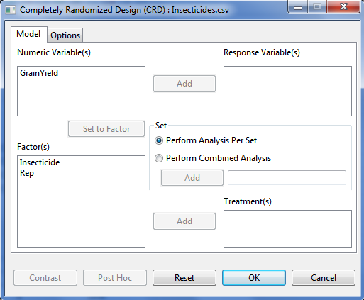

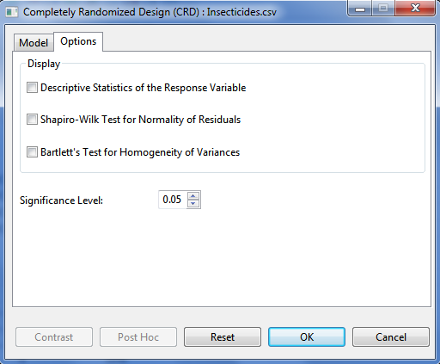

* Specify the required field and appropriate options for the analysis.

**Model Tab**

**Response Variable(s)**

For the analysis to proceed, at least one item should be entered in the list box. Only items from the **Numeric Variable(s)** can be added in this list box.

**Set**

There are two options available, *perform analysis per set* (default) and *perform combined analysis*. If default option is selected and a **Set** variable is specified, STAR will perform analysis for each level of the **Set** variable. If the default option is selected and no **Set** variable is specified, STAR will perform the analysis as if the entire data came from only one set variable. If *perform combined analysis* is selected, a **Set** variable with at least two levels must be specified. The item should come from the **Factor(s)** list box.

**Treatment(s)**

At least one item should be added in this list box and should come from the **Factor(s)** list box.

**Options Tab**

**Descriptive Statistics of the Response Variable**

If this option is selected, a summary table with number of non-missing observations, minimum, maximum, mean and standard deviation of the response variable will be displayed.

**Shapiro-Wilk Test for Normality of Residuals**

If this option is selected, test for normality of residuals using Shapiro-Wilk will be displayed, if the number of observation is between 3 and 5000.

**Bartlett’s Test for Homogeneity of Variances**

This option is visible if *perform analysis per set* is selected. If this option is selected, test for homogeneity of variances using Bartlett’s Test will be displayed.

**Significance Level**

This will be used to determine if the treatment effects and interaction effects are significant in the Analysis of Variance. This is also the level of significance to be used when pairwise mean comparison is performed. Its default value is 0.05. The user can change this value by specifying a numeric value from 0 to 1.

For the example, the completed **Model** tab and **Option** tab should appear as shown below:

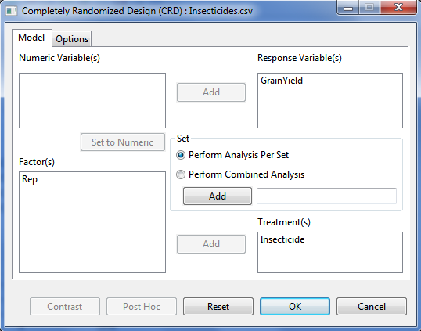

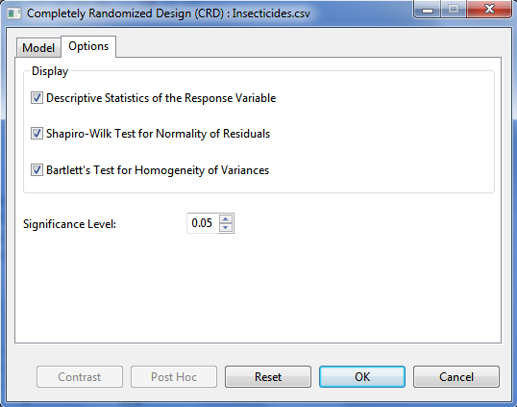

* Click **OK** button to perform the analysis. The **Completely Randomized Design** dialog box will be minimized and STAR activates the **Output** page of the **Result Viewer** tab.

Sample text output is shown below.

Analysis of Variance

Completely Randomized Design

===============================================

ANALYSIS FOR RESPONSE VARIABLE: GrainYield

===============================================

Summary Information

----------------------------------------------------------------

FACTOR NO. OF LEVELS LEVELS

----------------------------------------------------------------

Insecticide 7 Azodin, Control, ..., Dol-Mix (2kg)

----------------------------------------------------------------

Number of Observations Read and Used: 28

Descriptive Statistics

-----------------------------------------------

Variable N\_Obs Min Max Mean StdDev

-----------------------------------------------

GrainYield 28 1077 3366 2039.64 529.76

-----------------------------------------------

Test for Homogeneity of Variances

---------------------------------------

Method DF Chisq Value Pr(>Chisq)

---------------------------------------

Bartlett 6 5.56 0.4744

---------------------------------------

Test for Normality

-------------------------------------------------

Variable Method W Value Pr(< W)

-------------------------------------------------

GrainYield\_resid Shapiro-Wilk 0.9857 0.9587

-------------------------------------------------

ANOVA TABLE

Response Variable: GrainYield

--------------------------------------------------------------

Source DF Sum of Square Mean Square F Value Pr(> F)

--------------------------------------------------------------

Insecticide 6 5587174.9286 931195.8214 9.83 0.0000

Error 21 1990237.5000 94773.2143

Total 27 7577412.4286

--------------------------------------------------------------

Summary Statistics

-----------------------

CV(%) GrainYield Mean

-----------------------

15.09 2039.64

-----------------------

Standard Errors

--------------------

Effects StdErr

--------------------

Insecticide 217.68

--------------------

Pairwise Mean Comparison of Insecticide

Tukeys's Honest Significant Difference (HSD) Test

Alpha 0.05

Error Degrees of Freedom 21

Error Mean Square 94773.2143

Critical Value 4.5973

Test Statistics 707.6456

Summary of the Result:

-----------------------------------

Insecticide means N group

-----------------------------------

Azodin 2128.00 4 ab

Control 1316.00 4 c

DDT + phi-BHC 2551.75 4 a

Dimercon-Boom 1796.00 4 bc

Dimercon-Knap 1681.00 4 bc

Dol-Mix (1kg) 2126.75 4 ab

Dol-Mix (2kg) 2678.00 4 a

-----------------------------------

Means with the same letter are not significantly different.

Sample graphical output displayed in the **Graph** page.

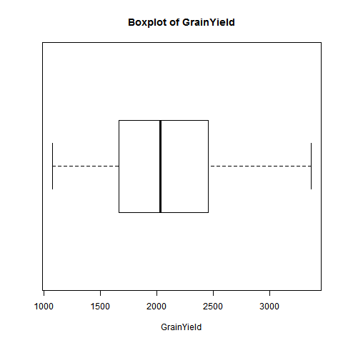

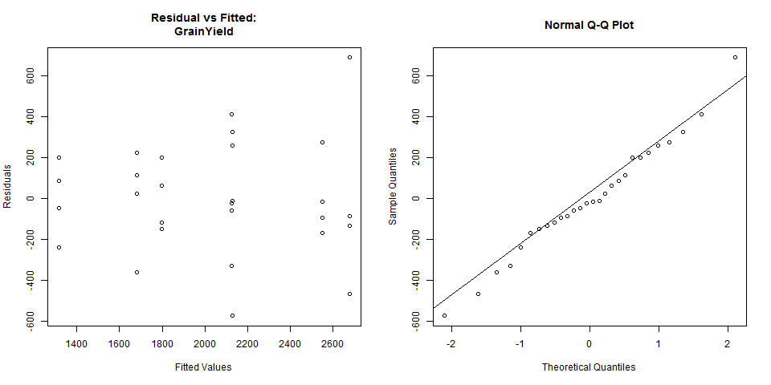

**Additional Options**

If there are still modifications to be made, the following option buttons may be used:

* **Post Hoc**

Use this option if other pairwise comparison procedures, other than what was presented in the **Output** page, are desired. There are five pairwise mean comparison procedure available, namely: Least Significant Difference Test, Duncan Multiple Range Test, Tukey’s Honest Significant Test, Student Newmann-Keul’s Test and the Scheffe’s Test. This button will be disabled if *F*-tests conducted using ANOVA yielded results that are not significant. Use of this button will be discussed in Pairwise Comparison section on this module.

* **Contrast**

This button will be enabled if there is at least one factor that has more than two levels. Use of this button will be discussed in Partitioning Sum of Squares section of this module.

## Randomized Complete Block Design

This submenu can be used to perform analysis of variance for single or multi factor experiment.

The steps to perform the analysis are listed below:

* On the **Project Explorer**, double-click the file to be used for the analysis to open and view it in the Data Viewer.

For the example, using the project named *MyProject*,import the data *SeedingRate* from package. To import that data*, s*ee *Importing from Project* section of this user’s manual.

* From the main window of STAR click **Analyze | Analysis of Variance | Randomized Complete Block Design…**. The **Randomized Complete Block Design** dialog box will appear.

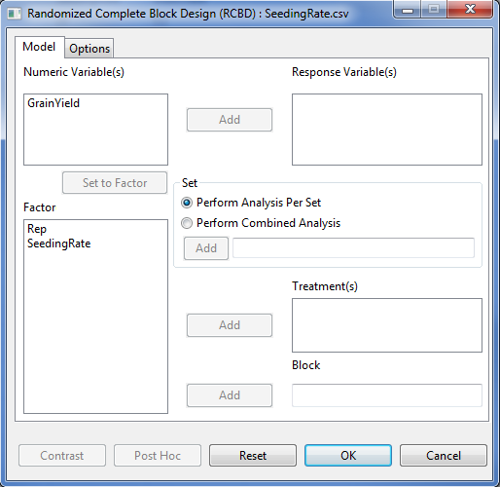

* Specify the required field and appropriate options for the analysis.

**Model Tab**

**Response Variable(s)**

For the analysis to proceed, at least one item should be entered in the list box. Only Items from the **Numeric Variable(s)** can be added in this list box.

**Set**

There are two options available, *perform analysis per set* (default option) and *perform combined analysis*. If default option is selected and a **Set** variable is specified, STAR will perform analysis for each level of the **Set** variable. If the default option is selected and no **Set** variable is specified, STAR will perform the analysis as if the entire data came from only one set variable. If *perform combined analysis* is selected, a **Set** variable with at least two levels must be specified. The item should come from the **Factor(s)** list box.

**Treatment(s)**

At least one item should be added in this list box and should come from the **Factor(s)** list box.

**Block**

Only one item can be added in this field and should come from the **Factor(s)** list box.

**Options Tab**

This tab lets the user identify additional output to be displayed and set the level of significance to be used. To know more about the options in detail, see the discussion under *Analysis of Variance > Completely Randomized Design > Options tab* of this user’s manual.

For the example, the completed **Model** tab should appear as shown below:

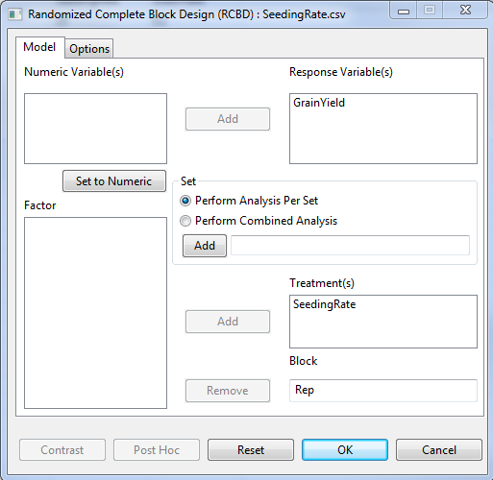

* Click **OK** button to perform the analysis. The **Randomized Complete Block Design (RCBD)** dialog box will be minimized and STAR activates the **Output Viewer** page of the **Result** **Viewer** tab.

Sample text output is shown below:

Analysis of Variance

Randomized Complete Block Design

===============================================

ANALYSIS FOR RESPONSE VARIABLE: GrainYield

===============================================

Summary Information

---------------------------------------------

FACTOR NO. OF LEVELS LEVELS

---------------------------------------------

SeedingRate 6 25, 50, ..., 150

Rep 4 1, 2, 3, 4

---------------------------------------------

Number of Observations Read and Used: 24

Descriptive Statistics

-------------------------------------------

Variable N\_Obs Min Max Mean StdDev

-------------------------------------------

GrainYield 24 2.80 6 4.65 0.7735

-------------------------------------------

Test for Homogeneity of Variances

---------------------------------------

Method DF Chisq Value Pr(>Chisq)

---------------------------------------

Bartlett 5 4.76 0.4462

---------------------------------------

Test for Normality

-------------------------------------------------

Variable Method W Value Pr(< W)

-------------------------------------------------

GrainYield\_resid Shapiro-Wilk 0.9346 0.1235

-------------------------------------------------

ANOVA TABLE

Response Variable: GrainYield

--------------------------------------------------------------

Source DF Sum of Square Mean Square F Value Pr(> F)

--------------------------------------------------------------

Rep 3 1.7667 0.5889 4.87 0.0147

SeedingRate 5 10.1800 2.0360 16.84 0.0000

Error 15 1.8133 0.1209

Total 23 13.7600

--------------------------------------------------------------

Summary Statistics

-----------------------

CV(%) GrainYield Mean

-----------------------

7.48 4.65

-----------------------

Standard Errors

--------------------

Effects StdErr

--------------------

Rep 0.2007

SeedingRate 0.2459

--------------------

Pairwise Mean Comparison of SeedingRate

Tukeys's Honest Significant Difference (HSD) Test

Alpha 0.05

Error Degrees of Freedom 15

Error Mean Square 0.1209

Critical Value 4.5947

Test Statistics 0.7988

Summary of the Result:

-------------------------------

SeedingRate means N group

-------------------------------

25 5.12 4 ab

50 5.08 4 ab

75 5.30 4 a

100 4.35 4 b

125 4.67 4 ab

150 3.38 4 c

-------------------------------

Means with the same letter are not significantly different.

Sample graphical output of the analysis displayed in the Graph Viewer tab is shown below:

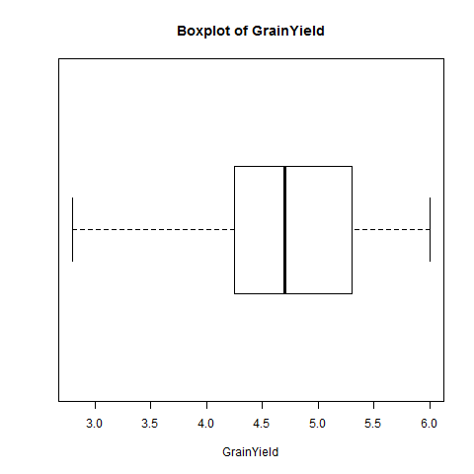

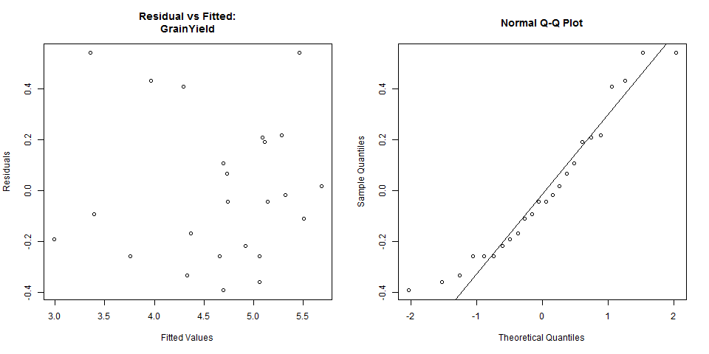

Modifications can still be made on the analysis submitted. To know more about the modification that can be made, see the discussion under *Analysis of Variance > Completely Randomized Design > Additional Options* of this user’s manual.

## Latin Square Design

This submenu can be used to perform analysis of variance for single or multi factor experiment.

The steps to perform the analysis are listed below:

* On the **Project Explorer**, double-click the file to be used for the analysis to open and view it in the Data Viewer.

For the example, using the project named *MyProject*,import the data *Maize* from package. To import that data*, s*ee *Importing from Package* section of this user’s manual.

* From the main window of STAR click **Analyze | Analysis of Variance | Latin Square Design…**. The **Latin Square Design** dialog box will appear.

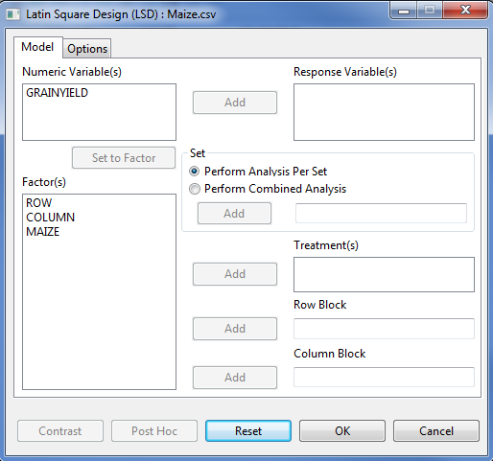

* Specify the required field and appropriate options for the analysis.

**Model Tab**

**Response Variable(s)**

For the analysis to proceed, at least one item should be entered in the list box. Only Items from the **Numeric Variable(s)** can be added in this list box.

**Set**

There are two options available, *perform analysis per set* (default option) and *perform combined analysis*. If default option is selected and a **Set** variable is specified, STAR will perform analysis for each level of the **Set** variable. If the default option is selected and no **Set** variable is specified, STAR will perform the analysis as if the entire data came from only one set variable. If *perform combined analysis* is selected, a **Set** variable with at least two levels must be specified. The item should come from the **Factor(s)** list box.

**Treatment(s)**

At least one item should be added in this list box and should come from the **Factor(s)** list box.

**Row Block**

Only one item can be added in this field and should come from the **Factor(s)** list box.

**Column Block**

Only one item can be added in this field and should come from the **Factor(s)** list box.

**Options Tab**

This tab lets the user identify additional output to be displayed and set the level of significance to be used. To know more about the options in detail, see the discussion under *Analysis of Variance > Completely Randomized Design > Options tab* of this user’s manual.

For the example, the completed **Model** tab should appear as illustrated below:

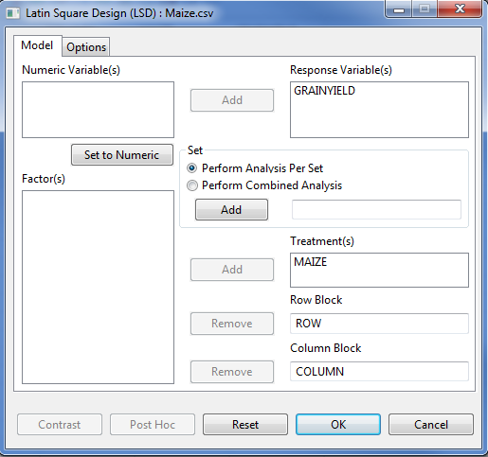

* Click **OK** button to perform the analysis. The **Latin Square Design** dialog box will be minimized and STAR activates the **Output Viewer** tab and the **Graph Viewer** tab.

Sample text output is shown below:

Analysis of Variance

Latin Square Design

===============================================

ANALYSIS FOR RESPONSE VARIABLE: GRAINYIELD

===============================================

Summary Information

----------------------------------

FACTOR NO. OF LEVELS LEVELS

----------------------------------

MAIZE 4 A, B, C, D

ROW 4 1, 2, 3, 4

COLUMN 4 1, 2, 3, 4

----------------------------------

Number of Observations Read and Used: 16

Descriptive Statistics

----------------------------------------------

Variable N\_Obs Min Max Mean StdDev

----------------------------------------------

GRAINYIELD 16 0.6600 1.67 1.34 0.3070

----------------------------------------------

Test for Homogeneity of Variances

---------------------------------------

Method DF Chisq Value Pr(>Chisq)

---------------------------------------

Bartlett 3 3.81 0.2825

---------------------------------------

Test for Normality

-------------------------------------------------

Variable Method W Value Pr(< W)

-------------------------------------------------

GRAINYIELD\_resid Shapiro-Wilk 0.9250 0.2026

-------------------------------------------------

ANOVA TABLE

Response Variable: GRAINYIELD

---------------------------------------------------------

Source DF Sum of Square Mean Square F Value Pr(> F)

---------------------------------------------------------

ROW 3 0.0302 0.0101 0.47 0.7170

COLUMN 3 0.8273 0.2758 12.77 0.0051

MAIZE 3 0.4268 0.1423 6.59 0.0251

Error 6 0.1296 0.0216

Total 15 1.4139

---------------------------------------------------------

Summary Statistics

-----------------------

CV(%) GRAINYIELD Mean

-----------------------

11.01 1.34

-----------------------

Standard Errors

----------------

Effects StdErr

----------------

ROW 0.1039

COLUMN 0.1039

MAIZE 0.1039

----------------

Pairwise Mean Comparison of MAIZE

Least Significant Difference (LSD) Test

Alpha 0.05

Error Degrees of Freedom 6

Error Mean Square 0.0216

Critical Value 2.4469

Test Statistics 0.2543

Summary of the Result:

-------------------------

MAIZE means N group

-------------------------

A 1.46 4 a

B 1.47 4 a

C 1.07 4 b

D 1.34 4 a

-------------------------

Means with the same letter are not significantly different.

Sample graphical output of the analysis displayed in the Graph Viewer tab is shown below:

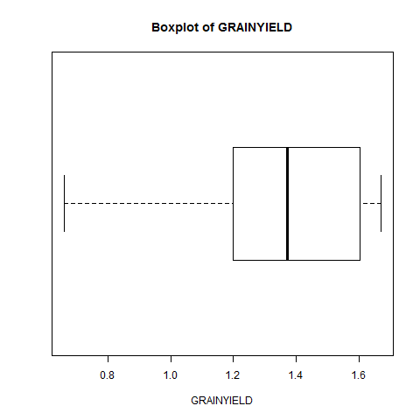

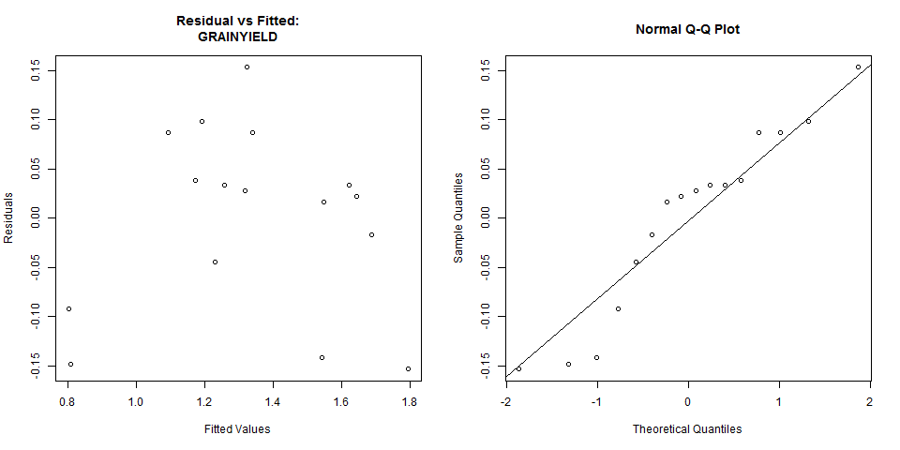

Modifications can still be made on the analysis submitted. To know more about the modification that can be made, see the discussion under *Analysis of Variance > Completely Randomized Design > Additional Options* of this user’s manual.

## Split Plot Design

This analysis can be performed for experiments where the main plot is arranged in completely randomized, randomized complete block or Latin square design.

The steps to perform the Analysis of Variance using Split Plot Design are listed below:

* On the **Project Explorer**, double-click the file to be used for the analysis to open and view it in the Data Viewer.

For the example, using the project named *My Project*,import the data *Nurul2012* from the package. To import the data from the package, see *Importing from Package* section of this user’s manual.

* From the main window of STAR click **Analyze | Analysis of Variance | Split Plot Design**. Choose the appropriate design for the main plot. The **Split Plot Design** dialog box will appear.

For the example, choose **Analyze | Analysis of Variance | Split Plot Design | Randomized Complete Block Design …** from the main window.

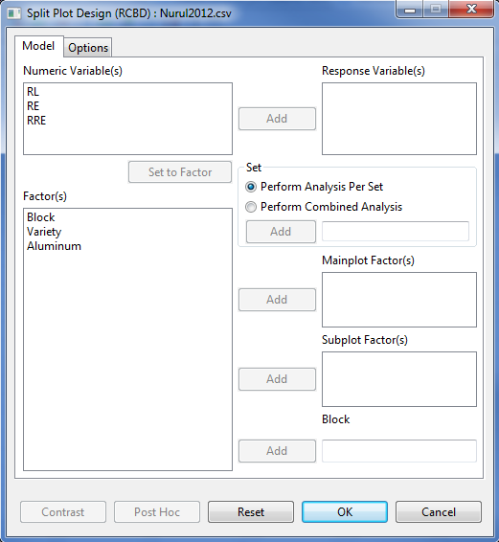

* Specify the required field and appropriate options for the analysis.

**Model Tab**

**Response Variable(s)**

For the analysis to proceed, at least one item should be entered in the list box. Only Items from the **Numeric Variable(s)** can be added in this list box.

**Set**

There are two options available, *perform analysis per set* (default) and *perform combined analysis*. If default option is selected and a **Set** variable is specified, STAR will perform analysis for each level of the **Set** variable. If the default option is selected and no **Set** variable is specified, STAR will perform the analysis as if the entire data came from only one set variable. If *perform combined analysis* is selected, a **Set** variable with at least two levels must be specified. The item should come from the **Factor(s)** list box.

**Mainplot Factor(s)**

At least one item should be added in this list box and should come from the **Factor(s)** list box.

**Subplot Factor(s)**

At least one item should be added in this list box and should come from the **Factor(s)** list box.

**Replicate**

Applicable only if completely randomized design is chosen. Only one item can be added in this field and should come from the **Factor(s)** list box.

**Block**

Applicable only if randomized complete block design is chosen. Only one item can be added in this field and should come from the **Factor(s)** list box.

**Row Block**

Applicable only if Latin square design is chosen. Only one item can be added in this field and should come from the **Factor(s)** list box.

**Column Block**

Applicable only if Latin square design is chosen. Only one item can be added in this field and should come from the **Factor(s)** list box.

**Options Tab**

This tab lets the user identify additional output to be displayed and set the level of significance to be used. To know more about the options in detail, see the discussion under *Analysis of Variance > Completely Randomized Design > Options tab* of this user’s manual.

For the example, the completed **Model** tab should appear as illustrated:

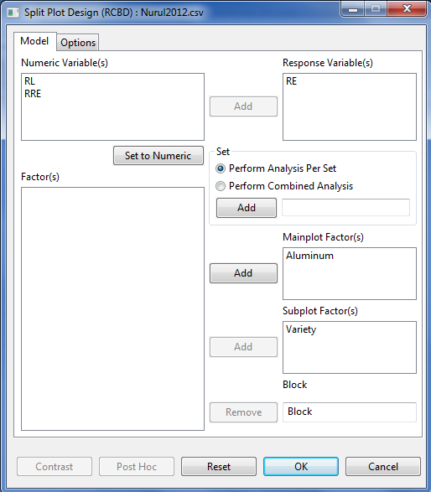

* Click **OK** button to perform the analysis. The **Split Plot Design** dialog box will be minimized and STAR activates the **Output Viewer** tab and the **Graph Viewer** tab.

Sample text output is shown below:

Analysis of Variance

Split Plot in Randomized Complete Block Design

=======================================

ANALYSIS FOR RESPONSE VARIABLE: RE

=======================================

Summary Information

-------------------------------------------------------------------

FACTOR NO. OF LEVELS LEVELS

-------------------------------------------------------------------

Aluminum 4 0, 540, 750, 1300

Variety 8 Azucena112854, Azucena47125, ..., Pokalli

Block 2 I, II

-------------------------------------------------------------------

Number of Observations Read and Used: 64

Descriptive Statistics

----------------------------------------------

Variable N\_Obs Min Max Mean StdDev

----------------------------------------------

RE 64 13.62 107.62 55.93 23.38

----------------------------------------------

Test for Homogeneity of Variances

---------------------------------------

Method DF Chisq Value Pr(>Chisq)

---------------------------------------

Bartlett 31 28.15 0.6136

---------------------------------------

Test for Normality

-----------------------------------------

Variable Method W Value Pr(< W)

-----------------------------------------

RE\_resid Shapiro-Wilk 0.9926 0.9675

-----------------------------------------

ANOVA TABLE

Response Variable: RE

-------------------------------------------------------------------

Source DF Sum of Square Mean Square F Value Pr(> F)

-------------------------------------------------------------------

Block 1 647.2572 647.2572 177.11 0.0009

Aluminum 3 11826.5606 3942.1869 1078.68 0.0000

Error(a) 3 10.9639 3.6546

Variety 7 17768.2497 2538.3214 64.04 0.0000

Aluminum:Variety 21 3085.8037 146.9430 3.71 0.0007

Error(b) 28 1109.9079 39.6396

Total 63 34448.7430

-------------------------------------------------------------------

Summary Statistics

------------------------

CV(a)% CV(b)% RE Mean

------------------------

3.42 11.26 55.93

------------------------

Comparison of Aluminum at each level of Variety

Least Significant Difference (LSD) Test

Alpha 0.05

Error Degrees of Freedom 28

Error Mean Square 35.1415

Critical Value 2.0462

Test Statistic 12.1297

Summary:

--------------------------------------------------------------------Aluminum N Variety = Azucena112854 group …

--------------------------------------------------------------------

0 2 65.1400 a …

540 2 54.9500 ab …

750 2 44.6000 b …

1300 2 23.0750 c …

--------------------------------------------------------------------

Means with the same letter are not significantly different

Comparison of Variety at each level of Aluminum

Tukeys's Honest Significant Difference (HSD) Test

Alpha 0.05

Error Degrees of Freedom 28

Error Mean Square 39.6396

Critical Value 4.6248

Test Statistic 20.5893

Summary:

--------------------------------------------------------------------Variety N Aluminum = 0 group Aluminum = 540 group …

--------------------------------------------------------------------

Azucena112854 2 65.1400 bc 54.9500 bc …

Azucena47125 2 79.6300 ab 82.3350 a …

Azucena52992 2 99.3100 a 86.0500 a …

Chadungda 2 54.8650 c 36.9400 c …

IR20 2 32.0500 d 40.0300 c …

IR64 2 56.9600 c 70.9350 ab …

IR74 2 67.3950 bc 83.8500 a …

Pokalli 2 91.1000 a 79.6000 a …

--------------------------------------------------------------------

Means with the same letter are not significantly different

Sample graphical output of the analysis displayed in the Graph Viewer tab is shown below:

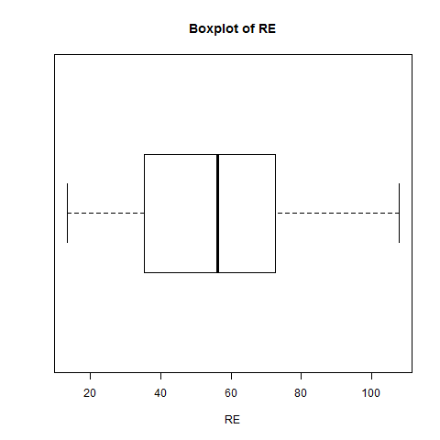

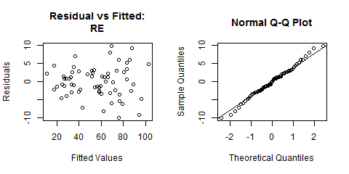

Modifications can still be made on the analysis submitted. To know more about the modification that can be made, see the discussion under *Analysis of Variance > Completely Randomized Design > Additional Options* of this user’s manual.

## Strip Plot Design

The steps to perform the Analysis of Variance in Strip Plot Design are listed below:

* On the **Project Explorer**, double-click the file to be used for the analysis to open and view it in the Data Viewer tab.

For the example, using the project named *MyProject*,import the data *GomezStrip* from package. To import the data from the package*, s*ee *Importing from Package* section of this user’s manual.

* From the main window of STAR click **Analyze | Analysis of Variance | Strip Plot Design**. The **Strip Plot** dialog box will appear.

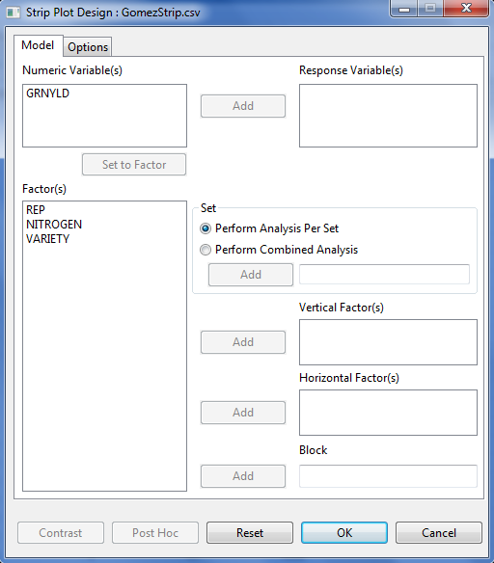

* Specify the required field and appropriate options for the analysis.

**Model Tab**

**Response Variable(s)**

For the analysis to proceed, at least one item should be entered in the list box. Only Items from the **Numeric Variable(s)** can be added in this list box.

**Set**

There are two options available, *perform analysis per set* (default option) and *perform combined analysis*. If default option is selected and a **Set** variable is specified, STAR will perform analysis for each level of the **Set** variable. If the default option is selected and the **Set** variable is not specified, STAR will perform the analysis as if the entire data came from only one site. If **perform combined analysis is selected**, a Set variable must be specified.

**Vertical Factor(s)**

At least one item should be added in this list box and should come from the **Factor(s)** list box.

**Horizontal Factor(s)**

At least one item should be added in this list box and should come from the **Factor(s)** list box.

**Block**

Only one item can be added in this field and should come from the **Factor(s)** list box.

**Options Tab**

This tab lets the user identify additional output to be displayed and set the level of significance to be used. To know more about the options in detail, see the discussion under *Analysis of Variance > Completely Randomized Design > Options tab* of this user’s manual.

For the example, the completed **Model** Specification tab should appear as shown below:

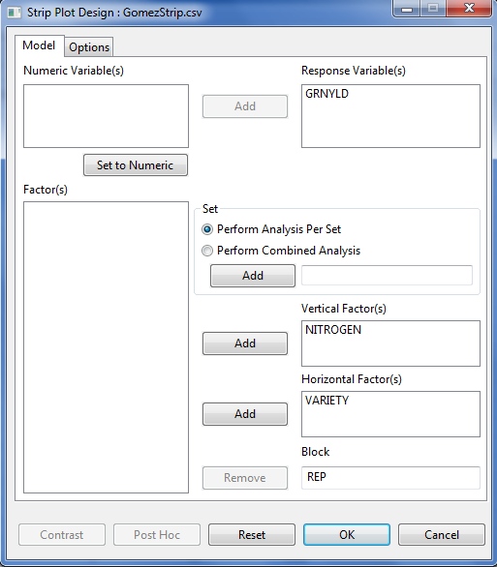

* Click **OK** button to perform the analysis. The **Strip Plot Design** dialog box will be minimized and STAR activates the **Output Viewer** tab and the **Graph Viewer** tab.

Sample text output is shown below:

Analysis of Variance

Strip Plot Design

===========================================

ANALYSIS FOR RESPONSE VARIABLE: GRNYLD

===========================================

Summary Information

-----------------------------------------

FACTOR NO. OF LEVELS LEVELS

-----------------------------------------

NITROGEN 3 0, 60, 120

VARIETY 6 V1, V2, ..., V6

REP 3 1, 2, 3

-----------------------------------------

Number of Observations Read and Used: 54

Descriptive Statistics

----------------------------------------------

Variable N\_Obs Min Max Mean StdDev

----------------------------------------------

GRNYLD 54 1556 8611 5289.94 1775.12

----------------------------------------------

Test for Homogeneity of Variances

---------------------------------------

Method DF Chisq Value Pr(>Chisq)

---------------------------------------

Bartlett 17 21.30 0.2130

---------------------------------------

Test for Normality

---------------------------------------------

Variable Method W Value Pr(< W)

---------------------------------------------

GRNYLD\_resid Shapiro-Wilk 0.9732 0.2665

---------------------------------------------

ANOVA TABLE

Response Variable: GRNYLD

----------------------------------------------------------------------

Source DF Sum of Square Mean Square F Value Pr(> F)

----------------------------------------------------------------------

REP 2 9220962.3333 4610481.1667 6.20 0.0595

NITROGEN 2 50676061.4444 25338030.7222 34.07 0.0031

Error(a) 4 2974907.8889 743726.9722

VARIETY 5 57100201.2778 11420040.2556 7.65 0.0034

Error(b) 10 14922619.2222 1492261.9222

NITROGEN:VARIETY 10 23877979.4444 2387797.9444 5.80 0.0004

Error(c) 20 8232917.2222 411645.8611

Total 53 167005648.8333

----------------------------------------------------------------------

Summary Statistics

------------------------------------

CV(a)% CV(b)% CV(c)% GRNYLD Mean

------------------------------------

16.30 23.09 12.13 5289.94

------------------------------------

Comparison of NITROGEN at each level of VARIETY

Least Significant Difference (LSD) Test

Alpha 0.05

Error Degrees of Freedom 22

Error Mean Square 466992.7130

Critical Value 2.0716

Test Statistic 1155.8848

Summary:

---------------------------------------------------------------------------------

NITROGEN N VARIETY = V1 group VARIETY = V2 group VARIETY = V3 group

---------------------------------------------------------------------------------

0 3 3571.6667 c 4934.3333 b 4249.6667 c …

60 3 5132.0000 b 6713.6667 a 6122.3333 b …

120 3 7548.0000 a 7211.3333 a 7868.3333 a …

---------------------------------------------------------------------------------

Means with the same letter are not significantly different

Comparison of VARIETY at each level of NITROGEN

Tukeys's Honest Significant Difference (HSD) Test

Alpha 0.05

Error Degrees of Freedom 10

Error Mean Square 1492261.9222

Critical Value 4.9120

Test Statistic 3464.3491

Summary:

-------------------------------------------------------------------------------

VARIETY N NITROGEN = 0 group NITROGEN = 60 group NITROGEN = 120 group

-------------------------------------------------------------------------------

V1 3 3571.6667 a 5132.0000 a 7548.0000 a

V2 3 4934.3333 a 6713.6667 a 7211.3333 a

V3 3 4249.6667 a 6122.3333 a 7868.3333 a

V4 3 4059.0000 a 5553.6667 a 7094.3333 a

V5 3 4101.6667 a 5633.3333 a 6012.0000 a

V6 3 3207.3333 a 3714.3333 a 2492.0000 b

-------------------------------------------------------------------------------

Means with the same letter are not significantly different

Sample graphical output of the analysis displayed in the Graph Viewer tab is shown below:

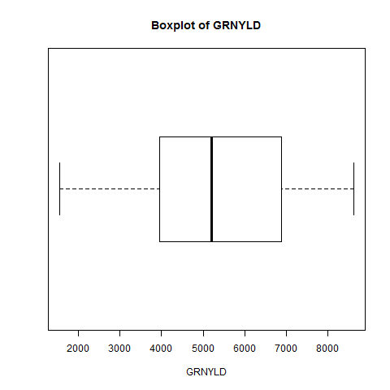

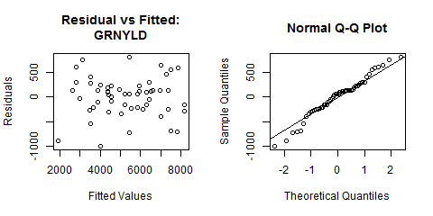

Modifications can still be made on the analysis submitted. To know more about the modification that can be made, see the discussion under *Analysis of Variance > Completely Randomized Design > Additional Options* of this user’s manual.

## Split-Split Plot Design

This analysis can be performed for experiments where the main plot is arranged in completely randomized, randomized complete block or Latin square design.

The steps to perform the Analysis of Variance using Split-Split Plot Design are listed below:

* On the **Project Explorer**, double-click the file to be used for the analysis to open and view it in the Data Viewer tab.

For the example, using the project named *MyProject*, import the data *GomezSplit2RCBD* from the package. To import the data from the package, see *Importing from Package* section of this user’s manual.

* From the main window of STAR click **Analyze | Analysis of Variance | Split-Split Plot Design**. Choose the appropriate design for the mainplot. The **Split-Split Plot Design** dialog box will appear.

For the example, choose **Analyze | Analysis of Variance | Split-Split Plot Design | Randomized Complete Block Design …** from the main window.

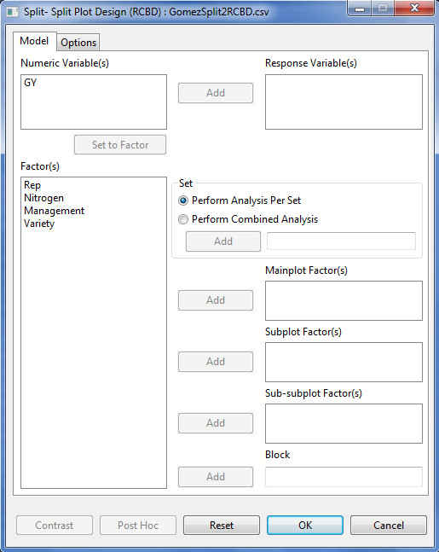

* Specify the required field and appropriate options for the analysis.

**Model Tab**

**Response Variable(s)**

For the analysis to proceed, at least one item should be entered in the list box. Only Items from the **Numeric Variable(s)** can be added in this list box.

**Set**

There are two options available, *perform analysis per set* (default) and *perform combined analysis*. If default option is selected and a **Set** variable is specified, STAR will perform analysis for each level of the **Set** variable. If the default option is selected and no **Set** variable is specified, STAR will perform the analysis as if the entire data came from only one set variable. If *perform combined analysis* is selected, a **Set** variable with at least two levels must be specified. The item should come from the **Factor(s)** list box.

**Mainplot Factor(s)**

At least one item should be added in this list box and should come from the **Factor(s)** list box.

**Subplot Factor(s)**

At least one item should be added in this list box and should come from the **Factor(s)** list box.

**Sub-subplot Factor(s)**

At least one item should be added in this list box and should come from the **Factor(s)** list box.

**Replicate**

Applicable only if completely randomized design is chosen. Only one item can be added in this field and should come from the **Factor(s)** list box.

**Block**

Applicable only if randomized complete block design is chosen. Only one item can be added in this field and should come from the **Factor(s)** list box.

**Row Block**

Applicable only if Latin square design is chosen. Only one item can be added in this field and should come from the **Factor(s)** list box.

**Column Block**

Applicable only if Latin square design is chosen. Only one item can be added in this field and should come from the **Factor(s)** list box.

**Options Tab**

This tab lets the user identify additional output to be displayed and set the level of significance to be used. To know more about the options in detail, see the discussion under *Analysis of Variance > Completely Randomized Design > Options tab* of this user’s manual.

For the example, the completed **Model** tab should appear as illustrated:

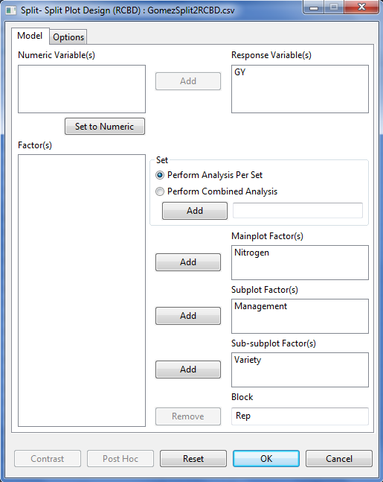

* Click **OK** button to perform the analysis. The **Split-Split Plot Design** dialog box will be minimized and STAR activates the **Output** page of the **Result Viewer** tab.

Sample text output is shown below:

Analysis of Variance

Split-Split Plot in Randomized Complete Block Design

=======================================

ANALYSIS FOR RESPONSE VARIABLE: GY

=======================================

Summary Information

----------------------------------------------

FACTOR NO. OF LEVELS LEVELS

----------------------------------------------

Nitrogen 5 N1, N2, N3, N4, N5

Management 3 M1, M2, M3

Variety 3 V1, V2, V3

Rep 3 1, 2, 3

----------------------------------------------

Number of Observations Read and Used: 135

Descriptive Statistics

-------------------------------------------

Variable N\_Obs Min Max Mean StdDev

-------------------------------------------

GY 135 3.13 10.36 6.55 1.67

-------------------------------------------

Test for Homogeneity of Variances

---------------------------------------

Method DF Chisq Value Pr(>Chisq)

---------------------------------------

Bartlett 44 44.66 0.4440

---------------------------------------

Test for Normality

-----------------------------------------

Variable Method W Value Pr(< W)

-----------------------------------------

GY\_resid Shapiro-Wilk 0.9951 0.9279

-----------------------------------------

ANOVA TABLE

Response Variable: GY

-------------------------------------------------------------------------------

Source DF Sum of Square Mean Square F Value Pr(> F)

-------------------------------------------------------------------------------

Rep 2 0.7320 0.3660 0.66 0.5439

Nitrogen 4 61.6408 15.4102 27.70 0.0001

Error(a) 8 4.4514 0.5564

Management 2 42.9361 21.4681 82.00 0.0000

Nitrogen:Management 8 1.1030 0.1379 0.53 0.8226

Error(b) 20 5.2363 0.2618

Variety 2 206.0132 103.0066 207.87 0.0000

Nitrogen:Variety 8 14.1445 1.7681 3.57 0.0019

Management:Variety 4 3.8518 0.9629 1.94 0.1149

Nitrogen:Management:Variety 16 3.6992 0.2312 0.47 0.9538

Error(c) 60 29.7325 0.4955

Total 134 373.5407

-------------------------------------------------------------------------------

Summary Statistics

--------------------------------

CV(a)% CV(b)% CV(c)% GY Mean

--------------------------------

11.38 7.81 10.74 6.55

--------------------------------

Table of Means

Nitrogen N1 N2 N3 N4 N5

Management Variety

M1 V1 3.897000 4.232000 5.226000 4.650333 4.061667

V2 5.346000 5.921667 5.979667 6.252000 6.775667

V3 5.378333 6.781333 7.933333 7.452667 8.618000

M2 V1 4.317333 4.576333 5.732333 5.447333 5.200000

V2 4.711667 5.815000 6.500000 7.004000 7.084333

V3 6.496000 7.816667 8.567333 8.624667 9.399333

M3 V1 5.325000 5.482667 6.546333 6.236333 5.971667

V2 5.431000 6.312000 7.286000 7.517667 8.005333

V3 7.560000 9.045333 9.190667 9.251333 9.989333

Comparison of Nitrogen at each level of Variety

Least Significant Difference (LSD) Test

Alpha 0.05

Error Degrees of Freedom 43

Error Mean Square 0.5158

Critical Value 2.0160

Test Statistic 0.6826

Summary:

-----------------------------------------------------------------------------

Nitrogen N Variety = V1 group Variety = V2 group Variety = V3 group

-----------------------------------------------------------------------------

N1 9 4.5131 c 5.1629 d 6.4781 d

N2 9 4.7637 bc 6.0162 c 7.8811 c

N3 9 5.8349 a 6.5886 bc 8.5638 b

N4 9 5.4447 ab 6.9246 ab 8.4429 bc

N5 9 5.0778 bc 7.2884 a 9.3356 a

-----------------------------------------------------------------------------

Means with the same letter are not significantly different

Comparison of Variety at each level of Nitrogen

Least Significant Difference (LSD) Test

Alpha 0.05

Error Degrees of Freedom 60

Error Mean Square 0.4955

Critical Value 2.0003

Test Statistic 0.6638

Summary:

---------------------------------------------------------------------------------

Variety N Nitrogen = N1 group Nitrogen = N2 group Nitrogen = N3 group …

---------------------------------------------------------------------------------

V1 9 4.5131 b 4.7637 c 5.8349 c …

V2 9 5.1629 b 6.0162 b 6.5886 b …

V3 9 6.4781 a 7.8811 a 8.5638 a …

---------------------------------------------------------------------------------

Means with the same letter are not significantly different

Pairwise Mean Comparison of Management

Least Significant Difference (LSD) Test

Alpha 0.05

Error Degrees of Freedom 20

Error Mean Square 0.2618

Critical Value 2.0860

Test Statistics 0.2250

Summary of the Result:

------------------------------

Management means N group

------------------------------

M1 5.90 45 c

M2 6.49 45 b

M3 7.28 45 a

------------------------------

Means with the same letter are not significantly different.

Sample graphical output of the analysis displayed in the Graph Viewer tab is shown below:

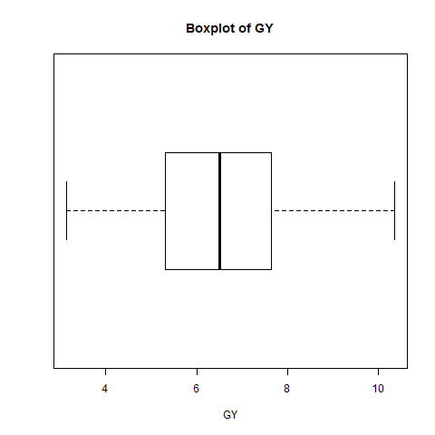

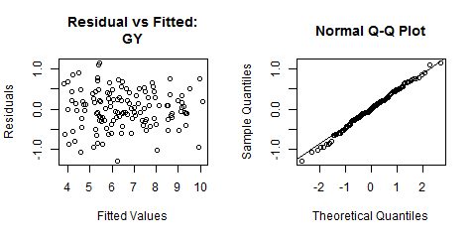

Modifications can still be made on the analysis submitted. To know more about the modification that can be made, see the discussion under *Analysis of Variance > Completely Randomized Design > Additional Options* of this user’s manual.

## Strip-Split Plot Design

The steps to perform the Analysis of Variance in Strip-Split Plot Design are listed below:

* On the **Project Explorer**, double-click the file to be used for the analysis to open and view it in the Data Viewer.

For the example, using the project named *MyProject*, import the data *GomezStripSplit* from the package. To import the data from the package, see *Importing from Package* section of this user’s manual.

* From the main window of STAR click **Analyze | Analysis of Variance | Strip-Split Plot Design**. The **Strip-Split Plot** dialog box will appear.

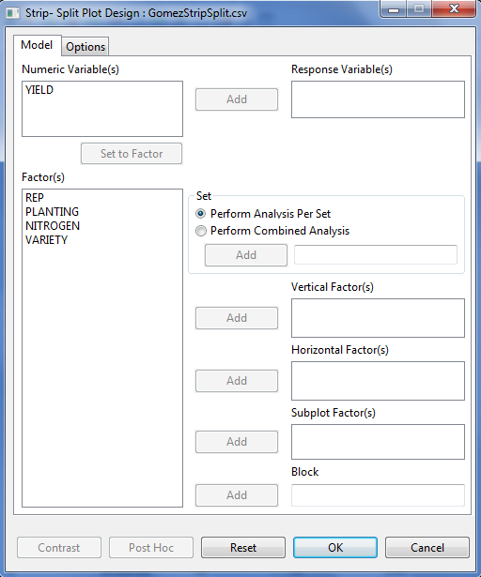

* Specify the required field and appropriate options for the analysis.

**Model Tab**

**Response Variable(s)**

For the analysis to proceed, at least one item should be entered in the list box. Only Items from the **Numeric Variable(s)** can be added in this list box.

**Set**

There are two options available, *perform analysis per set* (default option) and *perform combined analysis*. If default option is selected and a **Set** variable is specified, STAR will perform analysis for each level of the **Set** variable. If the default option is selected and the **Set** variable is not specified, STAR will perform the analysis as if the entire data came from only one site. If **perform combined analysis is selected**, a Set variable must be specified.

**Vertical Factor(s)**

At least one item should be added in this list box and should come from the **Factor(s)** list box.

**Horizontal Factor(s)**

At least one item should be added in this list box and should come from the **Factor(s)** list box.

**Subplot Factor(s)**

At least one item should be added in this list box and should come from the **Factor(s)** list box.

**Block**

Only one item can be added in this field and should come from the Factor(s) list box.

**Options Tab**

This tab lets the user identify additional output to be displayed and set the level of significance to be used. To know more about the options in detail, see the discussion under *Analysis of Variance > Completely Randomized Design > Options tab* of this user’s manual.

For the example, the completed Model tab is shown below:

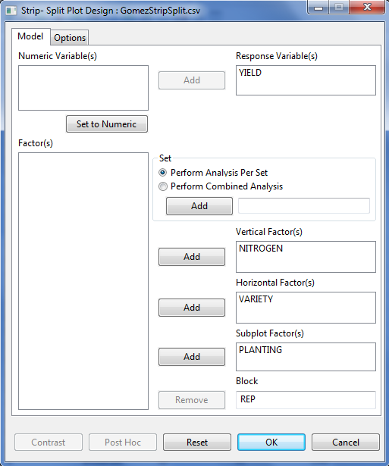

* Click **OK** button to perform the analysis. The **Strip-Split Plot Design** dialog box will be minimized and STAR activates the **Output** page of the **Result Viewer** tab.

Sample text output is shown below:

Analysis of Variance

Strip-Split Plot Design

==========================================

ANALYSIS FOR RESPONSE VARIABLE: YIELD

==========================================

Summary Information

-------------------------------------------------

FACTOR NO. OF LEVELS LEVELS

-------------------------------------------------

NITROGEN 3 0, 60, 120

VARIETY 6 V1, V2, ..., V6

PLANTING 2 Broadcast, Transplanted

REP 3 I, II, III

-------------------------------------------------

Number of Observations Read and Used: 108

Descriptive Statistics

----------------------------------------------

Variable N\_Obs Min Max Mean StdDev

----------------------------------------------

YIELD 108 1556 9838 5371.77 1694.76

----------------------------------------------

Test for Homogeneity of Variances

---------------------------------------

Method DF Chisq Value Pr(>Chisq)

---------------------------------------

Bartlett 35 57.79 0.0090

---------------------------------------

Test for Normality

--------------------------------------------

Variable Method W Value Pr(< W)

--------------------------------------------

YIELD\_resid Shapiro-Wilk 0.9938 0.9089

--------------------------------------------

ANOVA TABLE

Response Variable: YIELD

--------------------------------------------------------------------------------

Source DF Sum of Square Mean Square F Value Pr(> F)

--------------------------------------------------------------------------------

REP 2 15289498.1296 7644749.0648 4.81 0.0863

NITROGEN 2 116489166.1296 58244583.0648 36.62 0.0027

Error(a) 4 6361491.0370 1590372.7593

VARIETY 5 49119269.6019 9823853.9204 3.68 0.0379

Error(b) 10 26721827.9815 2672182.7981

NITROGEN:VARIETY 10 24595730.6481 2459573.0648 2.57 0.0344

Error(c) 20 19106733.1852 955336.6593

PLANTING 1 723079.3426 723079.3426 1.71 0.1986

NITROGEN:PLANTING 2 2468131.9074 1234065.9537 2.93 0.0664

VARIETY:PLANTING 5 23761441.3796 4752288.2759 11.27 0.0000

NITROGEN:VARIETY:PLANTING 10 7512072.2037 751207.2204 1.78 0.1000

Error(d) 36 15179353.6667 421648.7130

Total 107 307327795.2130

--------------------------------------------------------------------------------

Summary Statistics

-------------------------------------------

CV(a)% CV(b)% CV(c)% CV(d)% YIELD Mean

-------------------------------------------

23.48 30.43 18.20 12.09 5371.77

-------------------------------------------

Table of Means

VARIETY V1 V2 V3 V4 V5 V6

PLANTING NITROGEN

Broadcast 0 3571.667 4934.333 4249.667 4059.000 4101.667 3207.333

60 5132.000 6713.667 6122.333 5553.667 5633.333 3714.333

120 7548.000 7211.333 7868.333 7094.333 6012.000 2492.000

Transplanted 0 2786.333 4501.000 4340.333 5170.667 3730.000 4509.667

60 4983.000 5509.667 6233.000 5545.000 4772.667 4620.667

120 6924.333 6608.000 7716.333 7878.667 6015.000 6320.333

Comparison of NITROGEN at each level of VARIETY

Least Significant Difference (LSD) Test

Alpha 0.05

Error Degrees of Freedom 22

Error Mean Square 1061176.0093

Critical Value 2.0693

Test Statistic 1230.7388

Summary:

--------------------------------------------------------------------

NITROGEN N VARIETY = V1 group VARIETY = V2 group

--------------------------------------------------------------------

0 6 3179.0000 c 4717.6667 b …

60 6 5057.5000 b 6111.6667 a …

120 6 7236.1667 a 6909.6667 a …

--------------------------------------------------------------------

Means with the same letter are not significantly different

Comparison of VARIETY at each level of NITROGEN

Tukeys's Honest Significant Difference (HSD) Test

Alpha 0.05

Error Degrees of Freedom 10

Error Mean Square 2672182.7981

Critical Value 4.9120

Test Statistic 3278.0623

Summary:

-------------------------------------------------------------------------------

VARIETY N NITROGEN = 0 group NITROGEN = 60 group NITROGEN = 120 group

-------------------------------------------------------------------------------

V1 6 3179.0000 a 5057.5000 a 7236.1667 ab

V2 6 4717.6667 a 6111.6667 a 6909.6667 ab

V3 6 4295.0000 a 6177.6667 a 7792.3333 a

V4 6 4614.8333 a 5549.3333 a 7486.5000 ab

V5 6 3915.8333 a 5203.0000 a 6013.5000 ab

V6 6 3858.5000 a 4167.5000 a 4406.1667 b

-------------------------------------------------------------------------------

Means with the same letter are not significantly different

Comparison of VARIETY at each level of PLANTING

Tukeys's Honest Significant Difference (HSD) Test

Alpha 0.05

Error Degrees of Freedom 13

Error Mean Square 1546915.7556

Critical Value 4.6728

Test Statistic 1937.2651

Summary:

--------------------------------------------------------------------------

VARIETY N PLANTING = Broadcast group PLANTING = Transplanted group

--------------------------------------------------------------------------

V1 9 5417.2222 a 4897.8889 a

V2 9 6286.4444 a 5539.5556 a

V3 9 6080.1111 a 6096.5556 a

V4 9 5569.0000 a 6198.1111 a

V5 9 5249.0000 a 4839.2222 a

V6 9 3137.8889 b 5150.2222 a

--------------------------------------------------------------------------

Means with the same letter are not significantly different

Comparison of PLANTING at each level of VARIETY

Least Significant Difference (LSD) Test

Alpha 0.05

Error Degrees of Freedom 36

Error Mean Square 421648.7130

Critical Value 2.0281

Test Statistic 620.8079

Summary:

--------------------------------------------------------------------

PLANTING N VARIETY = V1 group VARIETY = V2 group

--------------------------------------------------------------------

Broadcast 9 5417.2222 a 6286.4444 a …

Transplanted 9 4897.8889 a 5539.5556 b …

--------------------------------------------------------------------

Means with the same letter are not significantly different

Sample graphical output displayed in the Graph Viewer page is shown below:

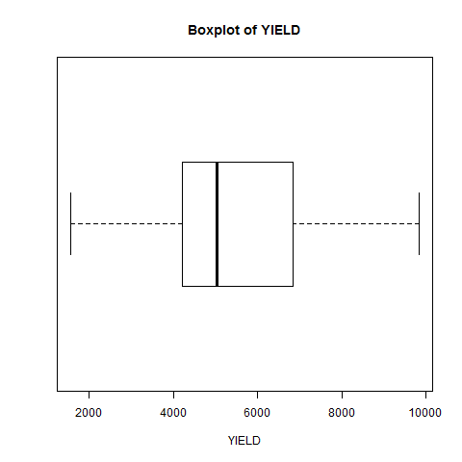

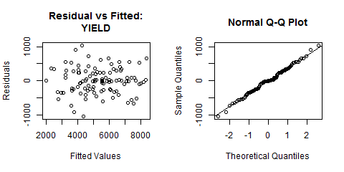

Modifications can still be made on the analysis submitted. To know more about the modification that can be made, see the discussion under *Analysis of Variance > Completely Randomized Design > Additional Options* of this user’s manual.

## Split-Split-Split Plot Design

This analysis can be performed for experiments where the main plot is arranged in completely randomized, randomized complete block or Latin square design.

The steps to perform the Analysis of Variance using Split-Split-Split Plot Design are listed below:

* On the **Project Explorer**, double-click the file to be used for the analysis to open and view it in the Data Viewer.
* From the main window of STAR click **Analyze | Analysis of Variance | Split-Split-Split Plot Design**. Choose the appropriate design for the mainplot. The **Split-Split-Split Plot Design** dialog box will appear.
* Specify the required field and appropriate options for the analysis.

**Model Tab**

**Response Variable(s)**

For the analysis to proceed, at least one item should be entered in the list box. Only items from the **Numeric Variable(s)** can be added in this list box.

**Set**

There are two options available, *perform analysis per set* (default option) and *perform combined analysis*. If default option is selected and a **Set** variable is specified, STAR will perform analysis for each level of the **Set** variable. If the default option is selected and the **Set** variable is not specified, STAR will perform the analysis as if the entire data came from only one site. If **perform combined analysis is selected**, a Set variable must be specified.

**Mainplot Factor(s)**

At least one item should be added in this list box and should come from the **Factor(s)** list box.

**Subplot Factor(s)**

At least one item should be added in this list box and should come from the **Factor(s)** list box.

**Sub-subplot Factor(s)**

At least one item should be added in this list box and should come from the **Factor(s)** list box.

**Sub-sub-subPlot Factor(s)**

At least one item should be added in this list box and should come from the **Factor(s)** list box.

**Replicate**

Applicable only if completely randomized design is chosen. Only one item can be added in this field and should come from the **Factor(s)** list box.

**Block**

Applicable only if randomized complete block design is chosen. Only one item can be added in this field and should come from the **Factor(s)** list box.

**Row Block**

Applicable only if Latin square design is chosen. Only one item can be added in this field and should come from the **Factor(s)** list box.

**Column Block**

Applicable only if Latin square design is chosen. Only one item can be added in this field and should come from the **Factor(s)** list box.

**Options Tab**

This tab lets the user identify additional output to be displayed and set the level of significance to be used. To know more about the options in detail, see the discussion under *Analysis of Variance > Completely Randomized Design > Options tab* of this user’s manual.

* Click **OK** button to perform the analysis. The **Split-Split-Split Plot Design (RCBD)** dialog box will be minimized and STAR activates the **Output** page of the **Result Viewer** tab.

Modifications can still be made on the analysis submitted. To know more about the modification that can be made, see the discussion under *Analysis of Variance > Completely Randomized Design > Additional Options* of this user’s manual.

## Strip-Split-Split Plot Design

The steps to perform the Analysis of Variance in Strip-Split-Split Plot Design are listed below:

* On the **Project Explorer**, double-click the file to be used for the analysis to open and view it in the Data Viewer.
* From the main window of STAR click **Analyze | Analysis of Variance | Strip-Split-Split Plot Design**. The **Strip-Split-Split Plot** dialog box will appear.
* Specify the required field and appropriate options for the analysis.

**Model Tab**

**Response Variable(s)**

For the analysis to proceed, at least one item should be entered in the list box. Only Items from the **Numeric Variable(s)** can be added in this list box.

**Set**

There are two options available, *perform analysis per set* (default option) and *perform combined analysis*. If default option is selected and a **Set** variable is specified, STAR will perform analysis for each level of the **Set** variable. If the default option is selected and the **Set** variable is not specified, STAR will perform the analysis as if the entire data came from only one site. If **perform combined analysis is selected**, a Set variable must be specified.

**Vertical Factor(s)**

At least one item should be added in this list box and should come from the **Factor(s)** list box.

**Horizontal Factor(s)**

At least one item should be added in this list box and should come from the **Factor(s)** list box.

**Subplot Factor(s)**

At least one item should be added in this list box and should come from the **Factor(s)** list box.

**Sub-subplot Factor(s)**

At least one item should be added in this list box and should come from the **Factor(s)** list box.

**Block**

Only one item can be added in this field and should come from the Factor(s) list box.

**Options Tab**

This tab lets the user identify additional output to be displayed and set the level of significance to be used. To know more about the options in detail, see the discussion under *Analysis of Variance > Completely Randomized Design > Options tab* of this user’s manual.

* Click **OK** button to perform the analysis. The **Strip-Split-Split Plot Design** dialog box will be minimized and STAR activates the **Output** page of the **Result Viewer** tab.

Modifications can still be made on the analysis submitted. To know more about the modification that can be made, see the discussion under *Analysis of Variance > Completely Randomized Design > Additional Options* of this user’s manual.

## Balanced Incomplete Block Design

The steps to perform analysis for balanced incomplete block design are listed below:

* On the **Project Explorer**, double-click the file to be used for the analysis to open and view it in the Data Viewer.

For the example, using the project named *MyProject*, import the data *CochranBIB* from the package. To import the data from the package, see *Importing from Package* section of this user’s manual.

* Choose **Analyze** | **Incomplete Block | Balanced Incomplete Block Design…** from the main window. The **Balanced Incomplete Block Design** dialog box will appear.

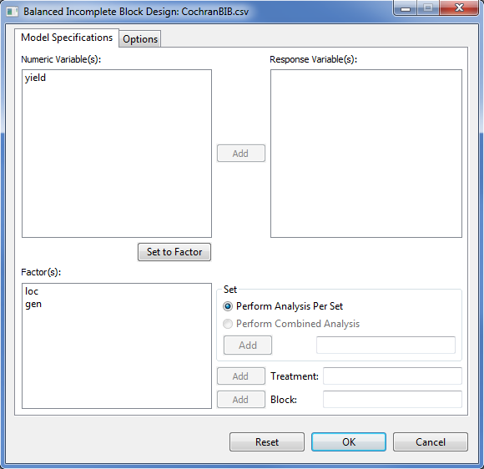

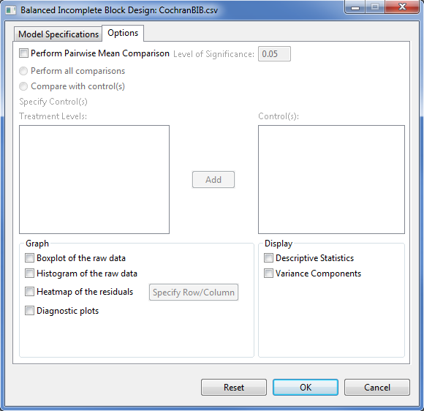

* Specify the required fields and appropriate options for the analysis.

**Model Specifications Tab**

**Response Variable(s)**

For the analysis to proceed, at least one item should be entered in the list box. The items to be entered should come from the **Numeric Variable(s)** list box.

**Set**

There are two options available, *perform analysis per set* (default) and *perform combined analysis*. If default option is selected and a **Set** variable is specified, STAR will perform analysis for each level of the **Set** variable. If the default option is selected and no **Set** variable is specified, STAR will perform the analysis as if the entire data came from only one set variable. If *perform combined analysis* is selected, a **Set** variable with at least two levels must be specified. Only one item can be added in this entry box and should come from the **Factor(s)** list box.

**Treatment**

This field is required. Only one item can be added in this entry box and should come from the **Factor(s)** list box.

**Block**

This field is required. Only one item can be added in this entry box and should come from the **Factor(s)** list box.

**Options Tab**

**Perform pairwise mean comparisons**

If this option is selected, user can either choose *Perform all comparisons* or *Compare with control(s)*. The option *Perform all comparisons* is not recommended when the number of treatment levels is very large. For now, STAR executes this option if the treatment levels is at most fifteen. If the treatment has more than 15 levels, user can only choose the option *Compare with control(s)*. If the option *Compare with control(s)* was selected, the user should specify the control levels to be compared with the rest of the treatment levels. This can be done by selecting the level(s) of the treatment that are considered as the control(s) then click the **Add** button.

**Level of Significance**

This will be enabled if *Perform pairwise mean comparison* is selected. This will be the level of significance to be used when pairwise mean comparison is performed. Its default value is 0.05.

**Display Descriptive Statistics**

If selected, a summary table with number of missing observations, mean and standard deviation will be displayed.

**Display Variance Components**

If selected, a table with the variance estimates of the some model components will be displayed.

**Graph**

Graphs like boxplot, histogram, heatmap and diagnostic plots can be generated as part of the output of the analysis. If heatmap is selected, user needs to specify a row and a column variable.

For the example, the completed **Model Specification** tab and **Options** tab should appear as shown:

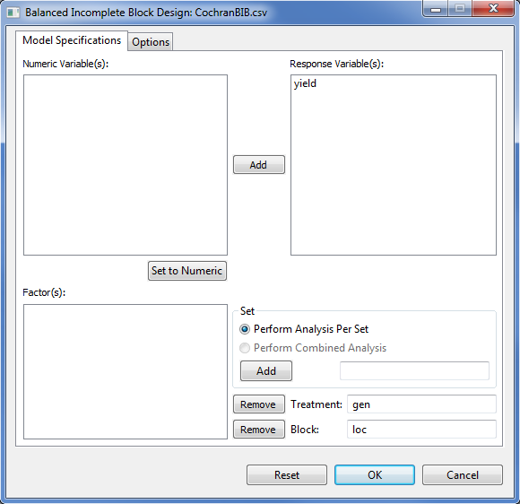

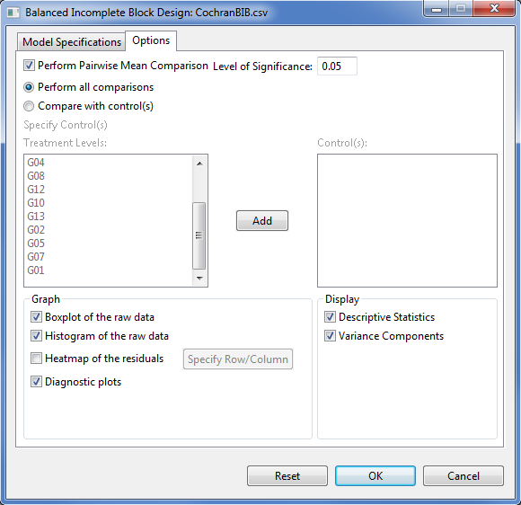

* Click **OK** button to perform the analysis. The **Augmented RCB** dialog box will be minimized and STAR activates the **Output** page of the **Result Viewer** tab.

Sample text output of the analysis is shown below:

DESIGN: Balanced Incomplete Block Design (BIBD)

==========================================

ANALYSIS FOR RESPONSE VARIABLE: yield

==========================================

Descriptive Statistics

--------------------------------------

Variable N\_NonMissObs Mean StdDev

--------------------------------------

yield 52 29.78 5.52

--------------------------------------

Summary Information

------------------------------------------

FACTOR NO. OF LEVELS LEVELS

------------------------------------------

loc 13 B01, B02, ..., B13

gen 13 G01, G02, ..., G13

------------------------------------------

Number of Observations Read and Used: 52

Estimates of Variance Components

---------------------------

Groups Variance StdDev

---------------------------

loc 6.0527 2.4602

Residual 19.9340 4.4647

---------------------------

Testing for the Significance of Genotypic Effect

Models:

model2: yield ~ 1 + (1|loc)

model1: yield ~ 1 + gen + (1|loc)

-----------------------------------------------------------------------

Source Df AIC BIC logLik Chisq Chi Df Pr(>Chisq)

-----------------------------------------------------------------------

model2 3 326.1376 331.9913 -160.0688

model1 15 328.4084 357.6770 -149.2042 21.73 12 0.0407

-----------------------------------------------------------------------

----------------------------------------------

Source Df Sum Sq Mean Sq F value Prob

----------------------------------------------

gen 12 400.63 33.39 1.67 0.0407

----------------------------------------------

gen LSMeans and Standard Error

------------------------

gen LSMean StdErrMean

------------------------

G01 34.17 2.44

G02 29.04 2.44

G03 30.11 2.44

G04 28.08 2.44

G05 30.34 2.44

G06 27.59 2.44

G07 30.76 2.44

G08 32.75 2.44

G09 28.56 2.44

G10 28.10 2.44

G11 23.47 2.44

G12 28.99 2.44

G13 35.18 2.44

------------------------

List of gen pairs that are significantly different using Tukey at alpha = 0.05

----------------------------------------

gen[i] gen[j] Estimate lwr upr

----------------------------------------

G13 G11 11.71 0.6738 22.74

----------------------------------------

Sample graphical output of the analysis is shown below:

|  |  |
| --- | --- |
| E:\AAGulles\BBI\PROGRAMS\ECLIPSE JUNO WORKSPACE\Star\Projects\Alaine Test Run\Output\CochranBIB.csv(BalancedIncompleteBlockDesign_1366939619140)\boxplotSEA_yield.png | E:\AAGulles\BBI\PROGRAMS\ECLIPSE JUNO WORKSPACE\Star\Projects\Alaine Test Run\Output\CochranBIB.csv(BalancedIncompleteBlockDesign_1366939619140)\diagPlotsSEA_yield.png |

|  |  |
| --- | --- |
| E:\AAGulles\BBI\PROGRAMS\ECLIPSE JUNO WORKSPACE\Star\Projects\Alaine Test Run\Output\CochranBIB.csv(BalancedIncompleteBlockDesign_1366939619140)\histSEA_yield.png |  |

## Pairwise Mean Comparison

The **Post Hoc** option is used to request for other pairwise comparison procedures. This button will be enabled if there is at least one effect that is significant.

The steps to request for other pairwise mean comparison are listed below:

* On the **Project Explorer**, double-click the file to be used for the analysis to open and view it in the Data Viewer tab.

For the example, using the project named *MyProject*, import the data *SeedingRate* from STAR package. To import the data from the package, see *Importing from Package* section of this user’s manual.

* Perform the Analysis of Variance.

For the example, follow the discussion in **Randomized Complete Block Design** of this module with *SeedingRate* as Factor and *Rep* as Block.

* After performing the Analysis of Variance, the **Post hoc** button will be enabled if there is at least one effect in the analysis that is significant at specified level.

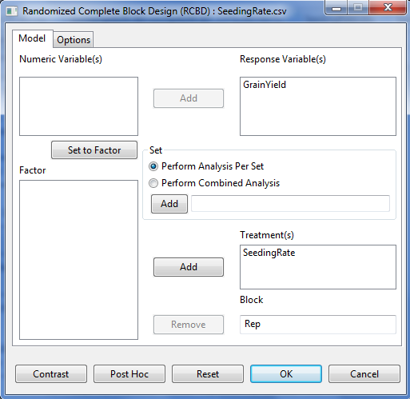

* Click the **Post Hoc** button. A dialog box will appear.

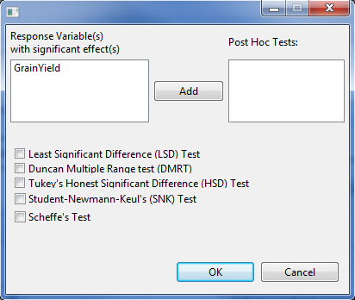

* Specify the required field and appropriate options for the analysis.

**Response Variable(s)**

This list box display all response variables with at least one significant effect. User need to select one item from this list and transfer to the **Post Hoc Test** list box to proceed with the analysis

**Post Hoc Tests**

This list box should contain at least one item that will come from the **Response Variable(s)** list box. STAR will perform the additional pairwise comparison procedure for all effects of the response variable(s) selected.

**Pairwise Comparison Procedure**

At least one of the checkbox should be ticked for the analysis to proceed.

For the example, the completed dialog should appear as illustrated below:

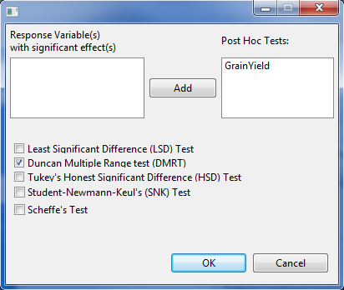

* Click the **OK** button to perform the pairwise mean comparison. The **Pairwise Comparison** dialog box will be closed. The *PairwiseOutput.txt* is created in the parent folder within the *Output* folder and STAR actives the **Result Viewer** tab.

Sample content of the *PairwiseOutput.txt* displayed in the **Result Viewer** tab is shown below:

Response Variable: GrainYield

Pairwise Mean Comparison of SeedingRate

Duncan's Multiple Range Test (DMRT)

Alpha 0.05

Error Degrees of Freedom 15

Error Mean Square 0.1209

---------------------------------------------------

Number of Means 2 3 4 5 6

---------------------------------------------------

Tabular Value 3.01 3.16 3.25 3.31 3.36

Test Statistics 0.52 0.55 0.57 0.58 0.58

---------------------------------------------------

Summary of the Result:

-----------------------------

SeedingRate means N group

-----------------------------

100 4.35 4 c

125 4.67 4 bc

150 3.38 4 d

25 5.12 4 ab

50 5.08 4 ab

75 5.30 4 a

-----------------------------

Means with the same letter are not significantly different.

* After performing the pairwise comparison test, user can click the **OK** button to embed the requested pairwise mean comparison procedure with the Analysis of Variance output.

Sample content of the text file when user clicks the **OK** button after performing the pairwise comparison.

Analysis of Variance

Randomized Complete Block Design

===============================================

ANALYSIS FOR RESPONSE VARIABLE: GrainYield

===============================================

Summary Information

---------------------------------------------

FACTOR NO. OF LEVELS LEVELS

---------------------------------------------

SeedingRate 6 25, 50, ..., 150

Rep 4 1, 2, 3, 4

---------------------------------------------

Number of Observations Read and Used: 24

ANOVA TABLE

Response Variable: GrainYield

--------------------------------------------------------------

Source DF Sum of Square Mean Square F Value Pr > F

--------------------------------------------------------------

Rep 3 1.7667 0.5889 4.87 0.0147

SeedingRate 5 10.1800 2.0360 16.84 0.0000

Error 15 1.8133 0.1209

Total 23 13.7600

--------------------------------------------------------------

Summary Statistics

-----------------------

CV(%) GrainYield Mean

-----------------------

7.48 4.65

-----------------------

Standard Errors

--------------------

Effects StdErr

--------------------

Rep 0.2007

SeedingRate 0.2459

--------------------

Pairwise Mean Comparison of SeedingRate

Duncan's Multiple Range Test (DMRT)

Alpha 0.05

Error Degrees of Freedom 15

Error Mean Square 0.1209

---------------------------------------------------

Number of Means 2 3 4 5 6

---------------------------------------------------

Tabular Value 3.0143 3.1598 3.2502 3.3118 3.3560

Test Statistics 0.5240 0.5493 0.5650 0.5757 0.5834

---------------------------------------------------

Summary of the Result:

-------------------------------

SeedingRate means N group

-------------------------------

25 5.12 4 ab

50 5.08 4 ab

75 5.30 4 a

100 4.35 4 c

125 4.67 4 bc

150 3.38 4 d

-------------------------------

Means with the same letter are not significantly different.

## Partitioning Sum of Squares

The **Contrast** option isused in partitioning sum of squares that decompose the variability of the response(s) into various components to have a better view of the nature of variability. There are different selections in partitioning sum of squares such as, “Compare with Control”, “User Specified Contrast (Group Comparison)” and “Orthogonal Polynomial Contrast”.

### Group Comparison

The steps to perform the Group Comparison are listed below:

* On the **Project Explorer**, double-click the file to use for the analysis to open and view it in the Data Viewer tab.

For the example, using the project named *MyProject*, import the data *grp\_pss* from STAR package. To import the data from the package, see *Importing from Package* section of this user’s manual.

* Perform the Analysis of Variance.

For the example, follow the discussion in **Randomized Complete Block Design** of this module with *VARIETY* as Factor and *REP* as Block.

* After performing the Analysis of Variance, the **Contrast** button will be enabled if there is at least one factor in the analysis with more than two levels.

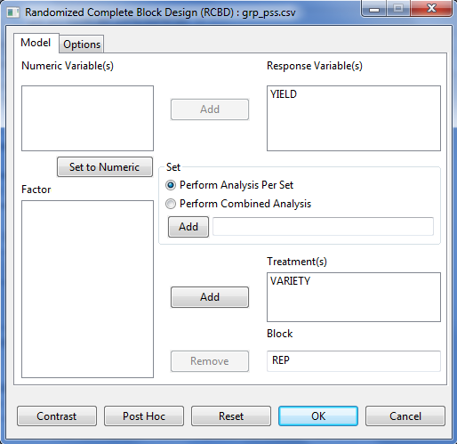

* Click the **Contrast** button. A dialog box will appear.

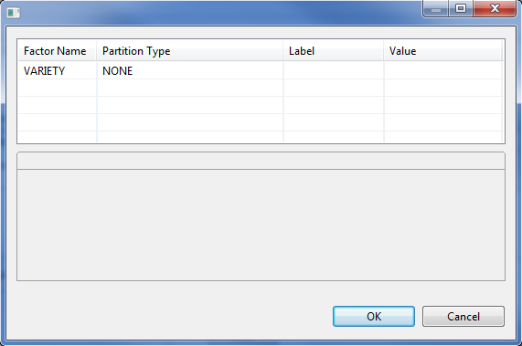

* Specify the required field and appropriate options for the analysis.

**Factor Name** column

All factors included in the analysis with more than two levels will be displayed in this column.

**Partition Type** column

Specify the type of partitioning to be performed by clicking the drop-down menu. If the levels of the factor are quantitative, the 3 choices are available, otherwise; only the choices *Compare with Control* and *User-Specified Contrast* will be available for that factor.

**Value** column

If *Compare with Control* is chosen, this column specifies which level of the factor is considered as control level. By default, the first level of the factor is considered the control. To change the control level, click the drop-down box to display the different levels of the factor.

If *User Specified Contrast* or *Orthogonal Polynomial Contrast* is chosen, this column specifies the number of contrast that will be used for the analysis. The default value is 1 while the maximum number is equal to the treatment degrees of freedom.

If *User Specified Contrast* is selected, a tab with the factor name as label will be displayed at the lower part of the **Contrast Analysis** dialog box to specify the coefficients for each contrast. The sum of each contrast should be equal to zero. If there are 2 or more contrasts, the sum of the cross product of each pair wise contrast should be equal to zero.

For the example, suppose we want to determine the following:

1. If the mean of the traditional variety (A) is significantly different from the new varieties (B and C).
2. If the mean of the new varieties (B and C) are significantly different.

The completed dialog box should appear as shown below:

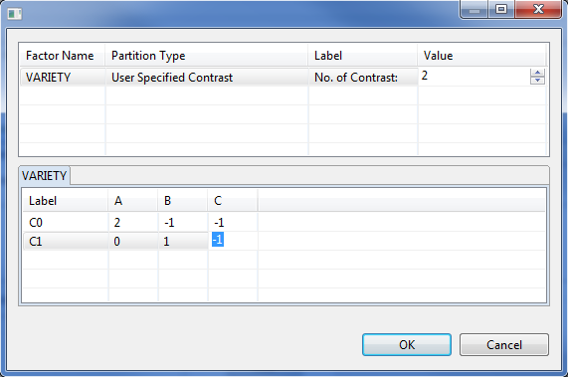

* Click the **OK** button to perform Group Comparison. The **Contrast Analysis** dialog box will be closed. The *ContrastAnalysisOutput.txt* is created in the parent folder within the *Output* folder and STAR actives the **Result Viewer** tab.

Sample content of the *ContrastAnalysisOutput.txt* displayed in the **Result Viewer** tab is shown below:

Result of Contrast Analysis

ANOVA TABLE

Response Variable: YIELD

----------------------------------------------------------------

Source DF Sum of Square Mean Square F Value Pr > F

----------------------------------------------------------------

REP 3 0.5867 0.1956 2.20 0.1889

VARIETY 2 1.0400 0.5200 5.85 0.0390

VARIETY: C0 1 0.9600 0.9600 10.80 0.0167

VARIETY: C1 1 0.0800 0.0800 0.90 0.3794

Error 6 0.5333 0.0889

Total 11 2.1600

----------------------------------------------------------------

### Trend Comparison

This procedure is applicable and available if the levels of the factor are quantitative. The steps to perform the Group Comparison are listed below:

* On the **Project Explorer**, double-click the file to be used for the analysis to open and view it in the Data Viewer tab.

For the example, using the project named *MyProject*, import the data *OP\_pss* from STAR package. To import the data from the package, see *Importing from Package* section of this user’s manual.

* Perform the Analysis of Variance.

For the example, follow the discussion in **Randomized Complete Block Design** of this module with *NITROGEN* as Factor and *REP* as Block.

* After performing the Analysis of Variance, the **Contrast** button will be enabled if there is at least one factor in the analysis with more than two levels.
* Click the **Contrast** button. A dialog box will appear.

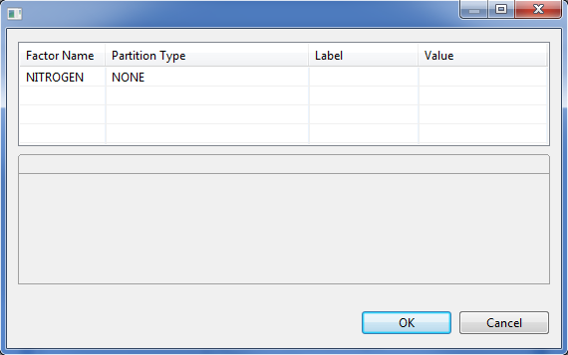

* Specify the required field and appropriate options for the analysis. To know more about the options in detail, see the discussion under *Analysis of Variance > Partitioning Sum of Squares > Group Comparison* of this user’s manual.

For the example, suppose we want to know the highest degree of relationship between the yield response and Nitrogen Rate. The completed dialog box should appear as illustrated below:

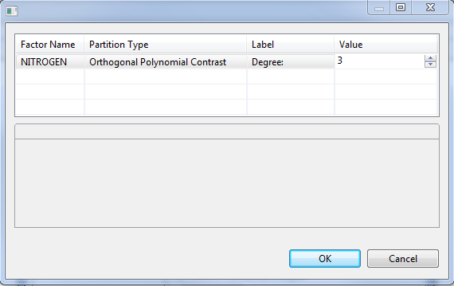

* Click the **OK** button to perform Group Comparison. The **Contrast Analysis** dialog box will be closed. The *ContrastAnalysisOutput.txt* is created in the parent folder within the *Output* folder and STAR actives the **Result Viewer** tab.

Sample text output of the analysis displayed in the Output Viewer tab is shown below:

ANOVA TABLE

Response Variable: YIELD

----------------------------------------------------------------

Source DF Sum of Square Mean Square F Value Pr > F

----------------------------------------------------------------

REP 2 0.4067 0.2033 0.65 0.5557

NITROGEN 3 11.0225 3.6742 11.73 0.0064

NITROGEN: 1 1 10.6562 10.6562 34.01 0.0011

NITROGEN: 2 1 0.1913 0.1913 0.61 0.4643

NITROGEN: 3 1 0.1750 0.1750 0.56 0.4831

Error 6 1.8800 0.3133

Total 11 13.3092

----------------------------------------------------------------

# Correlation Analysis

The **Correlation Analysis** is used to determine the strength of linear relationship between variables. The **Correlation Analysis** submenu performs bivariate correlation using the pearson’s correlation coefficient, spearman’s rho and kendall tau. By default, it uses the pearson’s correlation coefficient.

The steps to perform Correlation Analysis are listed below:

* On the **Project Explorer**, double-click the file to be used for the analysis open and view it in the Data Viewer tab.

For the example, using the project named *MyProject*,import the data *Corr* from the package. To import the data from the package, see *Importing from Package* section of this user’s manual.

* Click **Analyze | Correlation…** from the main window. The **Correlation Analysis** dialog box will appear.

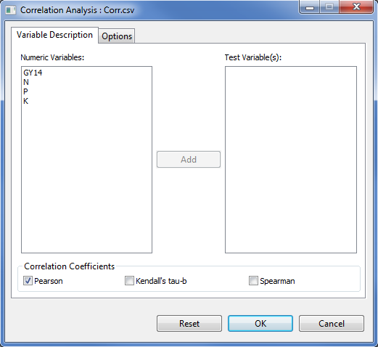

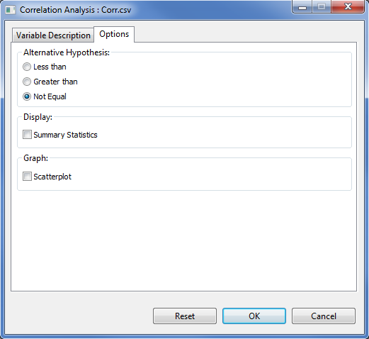

* Specify the required field and appropriate options for the analysis:

**Variable Description Tab**

**Test Variable(s)**

For the analysis to proceed, this list box should have at least two entries.

**Correlation Coefficient**

For the analysis to proceed, at least one method should be selected. By default, Pearson’s correlation coefficient is chosen. For quantitative and normally distributed variables, choose the Pearson correlation coefficient. If the data are not normally distributed or ordinal level, choose Kendall’s tau or Spearman, which measures the association between ranks. The correlation coefficient ranges from -1 to +1.

**Option Tab**

**Alternative Hypothesis**

User can select a one-tailed (less than or greater than) or two-tailed test (not equal). The default alternative hypothesis used is that for the two-sided test.

**Display Summary Statistics**

If this option is selected, a summary table with number of observations, minimum, maximum, mean and standard deviation will be displayed.

**Scatterplot**

If this option is selected, scatter plot for all pair of variables listed in the **Test Variable(s)** list box will be created.

For the example, the completed **Variable Description** tab and **Option** tab should appear as shown:

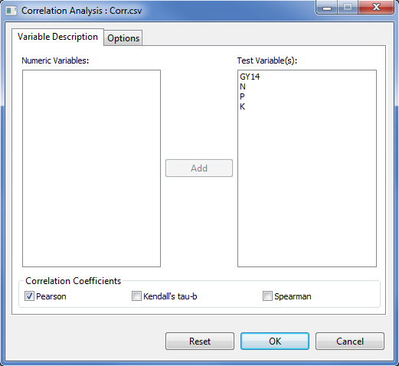

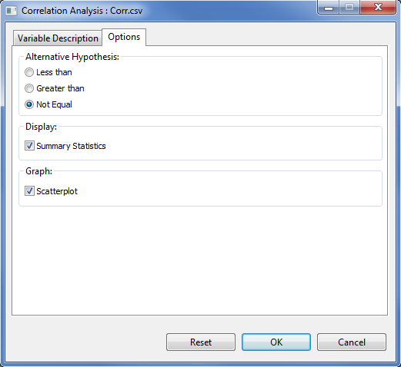

* Once all options have been specified, click the **OK** button. The **Correlation Analysis** dialog box will be minimized and STAR activates the **Result Viewer** tab which shows the results of the analysis.

Sample output of the Correlation Analysis using Pearson’s product-moment correlation is shown below.

Result of Correlation Analysis

DESCRIPTIVE STATISTICS

-----------------------------------------------------------

Variable N\_NonMissObs Min Max Mean StdDev

-----------------------------------------------------------

GY14 48 1678.00 7860.00 4788.67 1552.27

N 48 0.10 1.80 1.23 0.33

P 48 0.10 0.30 0.23 0.08

K 48 0.20 0.40 0.31 0.06

-----------------------------------------------------------

CORRELATION ANALYSIS

Pearson's product-moment correlation, Prob > |r|

GY14 N P K

GY14 coef 1.00 0.72 0.38 -0.40

p-value 0.0000 0.0080 0.0053

n 48 48 48 48

N coef 0.72 1.00 0.02 -0.34

p-value 0.0000 0.8686 0.0180

n 48 48 48 48

P coef 0.38 0.02 1.00 -0.35

p-value 0.0080 0.8686 0.0161

n 48 48 48 48

K coef -0.40 -0.34 -0.35 1.00

p-value 0.0053 0.0180 0.0161

n 48 48 48 48

If a scatter plot is requested, the graph can be viewed in the **Graph Viewer**. Sample generated graphs are shown below:

|  |  |
| --- | --- |
| scatterplot_K_GY14 | scatterplot_K_N |
| scatterplot_K_P | scatterplot_N_GY14 |
| scatterplot_P_GY14 | **scatterplot_P_N** |

# Regression Analysis

Regression Analysis is the statistical technique used to determine the strength of linear relationship between variables.

## Linear Regression

The steps to perform Linear Regression Analysis are listed below:

* On the **Project Explorer**, double-click the file to be used for the analysis to open and view it in the Data Viewer tab.

For the example, using the project named *My Project*,import the data C*arbonStock* from the package. To import the data from the package, see *Importing from Package* section of this user’s manual.

* Click **Analyze | Regression | Linear…** from the main window. The **Regression** **Analysis** dialog box will appear.

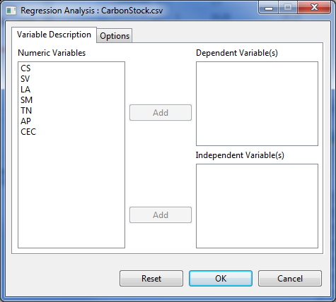

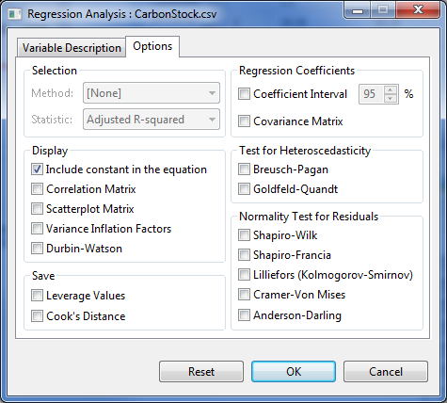

* Specify the required field and appropriate options for the analysis:

**Variable Description Tab**

**Dependent Variable(s)**

For the analysis to proceed, this list box should have at least one entry.

**Independent Variable(s)**

For the analysis to proceed, this list box should have at least one entry.

**Options Tab**

**Selection**

By default, no selection method is used for linear regression analysis in STAR. If at least two independent variables were specified, a selection method from one of the following can be selected: *All possible regression, Forward selection, Backward elimination, Stepwise regression*. If *all possible regression* is selected, user can choose one among *Adjusted R-squared*, *R-squared*, and *Mallow’s C(p)* as Statistic.

**Include constant in the equation**

By default, the regression model includes a constant term in the equation. Deselecting this option forces regression through the origin, this is rarely done.

**Correlation Matrix**

If this is selected, a matrix of correlation coefficients for all numeric variables will be displayed.

**Scatterplot Matrix**

If this is selected, a matrix of scatterplots for all numeric variables will be displayed. This option is disabled if all possible regression selection method is selected.

**Variance Inflation Factors**

If this is selected, it displays the variance inflation factors (VIF) which measures the Collinearity (or multicollinearity). This option is disabled if all possible regression selection method is selected.

**Durbin-Watson**

If this is selected, it displays the Durbin-Watson test for serial correlation of the residuals. This option is disabled if all possible regression selection method is selected.

**Leverage Values**

If this is selected, the leverage values will be computed and included in the output data file containing the raw data, residuals, and predicted values. This option is disabled if all possible regression selection method is selected.

**Cook’s Distance**

If this is selected, Cook’s distance will be computed and included in the output data file containing the raw data, residuals, and predicted values. This option is disabled if all possible regression selection method is selected.

**Regression Coefficients**

User can choose to display the confidence interval and the covariance matrix. If at least one of this is selected, the result is embedded in the table of parameter estimates. For the confidence interval, the default value is 95%. This option is disabled if all possible regression selection method is selected.

**Test for Heteroskedasticity**

There are two available procedures namely: Breusch-Pagan and Goldfeld-Quandt. This option is disabled if all possible regression selection method is selected.

**Normality Test**

This option will perform normality test for the residuals. There are five procedures available, namely: Shapiro-Wilk, Shapiro-Francia, Lilliefors, Cramer-Von Mises and Anderson-Darling. This option is disabled if all possible regression selection method is selected.

For the example, the completed **Variable Description** tab and **Option** tab should appear as shown:

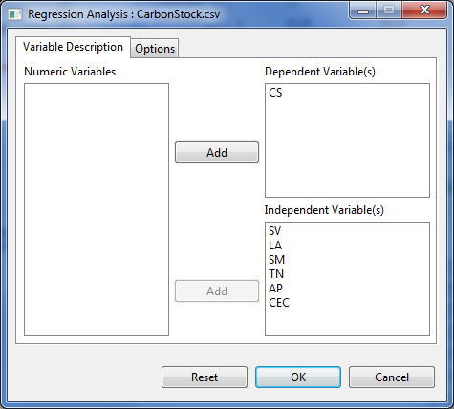

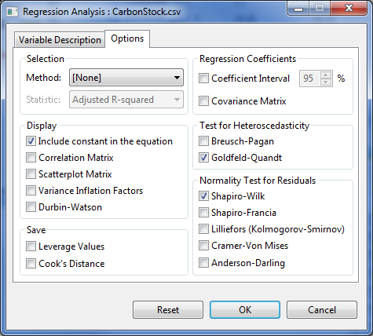

* Once all options have been specified, click the **OK** button. The **Regression Analysis** dialog box will be minimized and STAR activates the **Output** page of the **Result Viewer** tab.

The Linear Regression Analysis procedure in STAR saves all text output in the filename *LinearRegOutput.txt*. By default, the text output includes the descriptive statistics, Analysis of Variance table, a table of model summary and the parameter estimates:

Descriptive Statistics

----------------------------------------------------

Variable N\_NonMissObs Mean StdDev SE\_Mean

----------------------------------------------------

CS 50 20.28 3.99 0.56

SV 50 31.63 10.58 1.50

LA 50 7.75 0.35 0.05

SM 50 7.40 0.21 0.03

TN 50 0.16 0.04 0.01

AP 50 5.31 1.48 0.21

CEC 50 16.29 2.01 0.28

----------------------------------------------------

LINEAR REGRESSION ANALYSIS

Model Fitted: CS ~ SV + LA + SM + TN + AP + CEC

Analysis of Variance Table

---------------------------------------------------------

Source DF Sum of Square Mean Square F Value Pr(> F)

---------------------------------------------------------

Model 6 750.3633 125.0606 186.74 0.0000

Error 43 28.7975 0.6697

Total 49 779.1608

---------------------------------------------------------

Model Summary:

--------------------------------------------------

Root MSE CS Mean CV(%) R-Square Adj R-Sq

--------------------------------------------------

0.8184 20.28 19.67 0.9630 0.9579

--------------------------------------------------

Parameter Estimates:

--------------------------------------------------------

Variable Estimate Std. Error t value Pr(>|t|)

--------------------------------------------------------

Intercept -48.91 6.93 -7.06 0.0000

SV 0.04 0.02 2.73 0.0091

LA 0.79 0.53 1.48 0.1471

SM 6.41 1.11 5.75 0.0000

TN 33.23 7.75 4.29 0.0001

AP 0.16 0.08 1.90 0.0642

CEC 0.49 0.13 3.82 0.0004

--------------------------------------------------------

Test for Normality

---------------------------------------------

Variable Method W Value Pr(< W)

---------------------------------------------

residual Shapiro-Wilk 0.9792 0.5207

---------------------------------------------

Test for Heteroskedasticity

-------------------------------------------------------

Method DF1 DF2 GQ Value Pr(>GQ)

-------------------------------------------------------

Goldfeld-Quandt test 18 18 1.22 0.6797

-------------------------------------------------------

By default, a *png* file is created for each dependent variable used in the analysis. The file follows the filename format as: *<dependent variable>\_DiagPlot.png.* Each *png* file contains two diagnostics plots. The *Residuals vs. Fitted* plotis for assessing the distribution of the residuals. An ideal plot should reveal that the points are distributed around 0. The residuals should not be affected by the size of the fitted values. Problematic data may result to a plot wherein the points increase as the fitted values increase, thus forming a “funnel-shaped” distribution. This will indicate a violation of the homogeneity of variances requirement for analysis of variance. The *Normal Q-Q* plot is used for assessing normality. The points should lie about the line. Sample generated graphs are shown below:

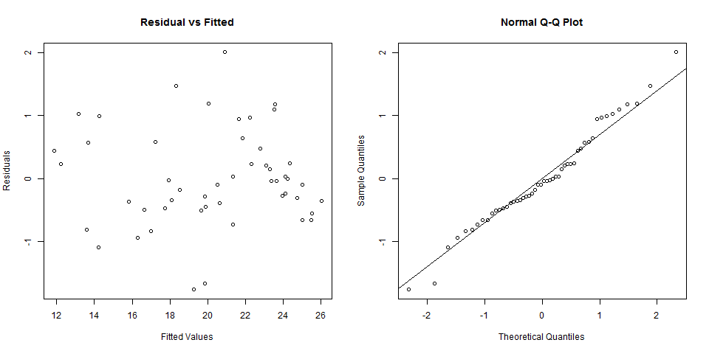

This procedure will also create the *LinearRegNewData.csv.* This file contains the original data with the residual and predicted values for each of the dependent variables used in the analysis. This file will also contain the *Leverage Values* and *Cooks’s Distance*, if user chose to save these values.

## Non-Linear Regression

The steps to perform Non-Linear Regression Analysis are listed below:

* On the **Project Explorer**, double-click the file to be used for the analysis to open and view it in the Data Viewer tab.

For the example, using the project named *My Project*,import the data *fishData* from the package. To import the data from the package, see *Importing from Package* section of this user’s manual.

* Click **Analyze | Regression | Non Linear…** from the main window. The **Nonlinear** **Regression** dialog box will appear.

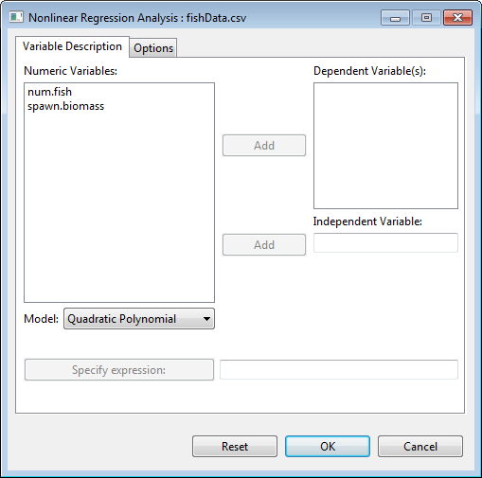

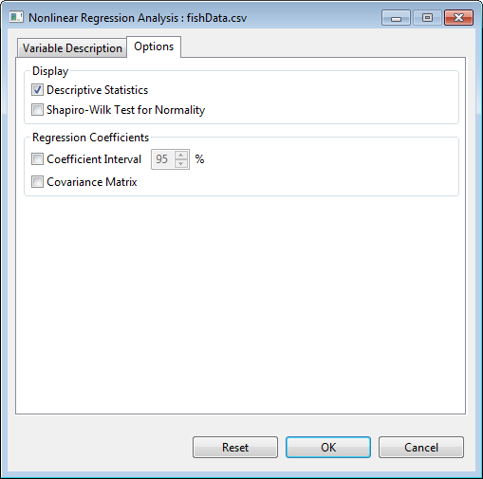

* Specify the required field and appropriate options for the analysis:

**Variable Description Tab**

**Dependent Variable(s)**

For the analysis to proceed, this list box should have at least one entry.

**Independent Variable(s)**

For the analysis to proceed, this list box should have one entry.

**Model**

The following models are available for performing the analysis: *Quadratic Polynomial, Cubic Polynomial, Logistic, Four-parameter logistic, Gompertz Growth, or Weibull Growth Curve*. If the user needs to use a model that is not listed above, the [Custom] option is selected. The user defines the model by clicking on the **Specify expression** button.

**Specify expression**

When the **Specify expression** button is pressed, the **Nonlinear Regression: Expression Building** dialog box appears. Prior to defining the expression, parameters need to be defined by clicking on the **Parameters** button.

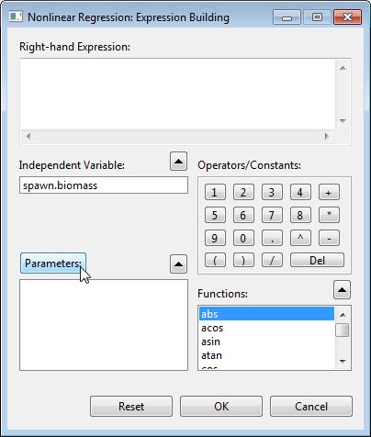

In the **Nonlinear Regression: Parameters** dialog box, user needs to indicate a name and starting value for each parameter. This is done by typing on the **Name** and **Starting value** text fields and clicking on the **Add** button for each parameter. When all parameters are specified, the **Ok** button is pressed to return to the **Nonlinear Regression: Expression Building** dialog box.

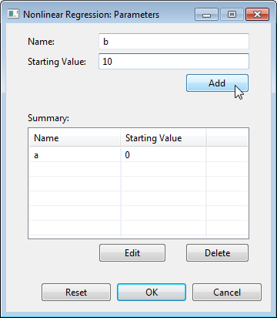

**In the Nonlinear Regression: Expression Building** dialog box, the **Right-hand Expression** is defined by pressing on the appropriate buttons/items for the independent variable, operator, constant, parameter, or function. The available functions are: abs, acos, asin, atan, cos, exp, log, log10, sin, sqrt and tan. When the expression is specified, the **Ok** button is pressed to return to the main dialog box.

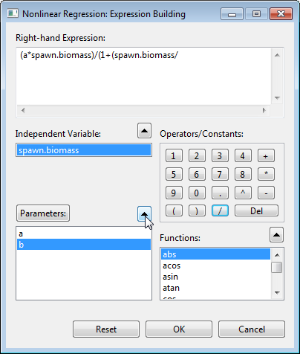

**Options Tab**

**Descriptive Statistics**

If this option is selected, a summary table with number of observations, minimum, maximum, mean and standard deviation of the variables is displayed.

**Shapiro-Wilk Test for Normality**

If this option is selected, Shapiro-Wilk Test for Normality will be performed.

**Regression Coefficients**

User can choose to display the confidence interval and the covariance matrix. If at least one of this is selected, the result is embedded in the table of parameter estimates. For the confidence interval, the default value is 95%.

For the example, the completed **Variable Description** tab and **Option** tab should appear as shown:

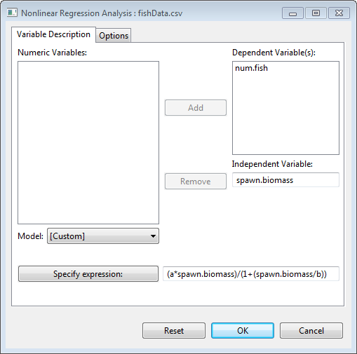

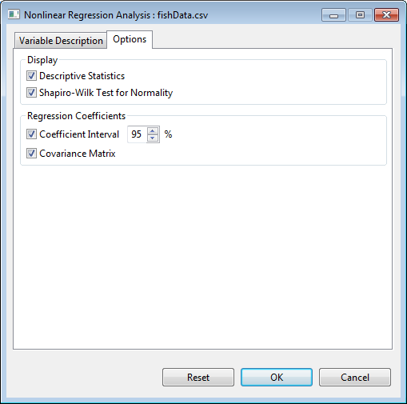

* Once all options have been specified, click the **OK** button. The **Nonlinear Regression Analysis** dialog box will be minimized and STAR activates the **Output** page of the **Result Viewer** tab.

The NonLinear Regression Analysis procedure in STAR saves all text output in the filename *NonLinearRegOutput.txt*.

Descriptive Statistics

---------------------------------------------------------

Variable N\_NonMissObs Mean StdDev SE\_Mean

---------------------------------------------------------

num.fish 15 84.53 27.55 7.11

spawn.biomass 15 29.90 16.96 4.38

---------------------------------------------------------

NONLINEAR REGRESSION ANALYSIS

Dependent Variable: num.fish

Test for Normality

---------------------------------------------

Variable Method W Value Pr(< W)

---------------------------------------------

residual Shapiro-Wilk 0.9550 0.6063

---------------------------------------------

Formula: num.fish ~ (a\*spawn.biomass)/(1+(spawn.biomass/b))

Parameter Estimates:

-------------------------------------------------------------------------

Variable Estimate Std. Error t value LL CI\* UL CI\* Pr(>|t|)

-------------------------------------------------------------------------

a 5.75 1.03 5.57 3.52 7.98 0.0001

b 33.16 11.41 2.91 8.52 57.80 0.0122

-------------------------------------------------------------------------

\* At 95% Confidence Interval

Residual Sum of Squares: 2809.0013

Coefficient Variance-Covariance Matrix

a b

a 1.0659 -11.428

b -11.4277 130.103

Sample generated graph is shown below:

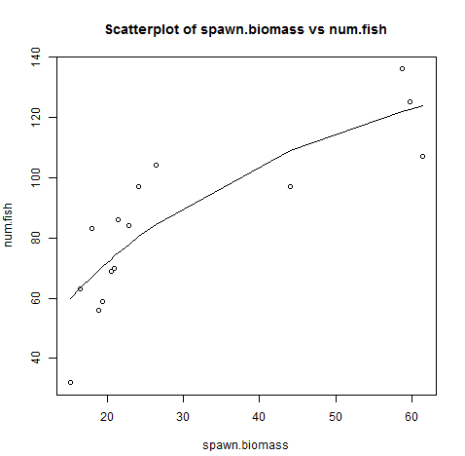

# 

# Nonparametric Tests

Nonparametric Tests procedure provides several tests that do not require assumptions about the shape of the underlying distribution.

## One Sample

The steps to perform one sample non-parametric test are listed below:

* On the **Project Explorer**, double-click the file to be used for the analysis to open and view it in the Data Viewer.

For the example, using the project named *MyProject*,import the data *MasterData* from the *Data* folder of the project named *SampleProject*. To import data from the *SampleProject*, see *Importing Data from Other Project* sectionof this user’s manual.

* From the main window of STAR, click **Analyze | Non-Parametric Test | One Sample**…. The **One Sample Non-Parametric** dialog box will appear.

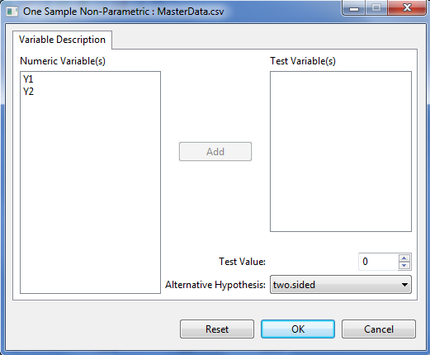

* Specify the required field and appropriate options for the analysis.

**Test Variable(s)**

For the analysis to proceed, at least one item should be entered in the list box. Only items from the **Numeric Variable(s)** can be added in this dialog box.

**Test Value**

This field is required and will only accept one entry at a time. The default value is 0. User can change the value by typing a value inside the spin box or by pressing the up-arrow key to increment the value, down-arrow key, otherwise.

**Alternative Hypothesis**

User can select a one-tailed or two-tailed test. The default alternative hypothesis used is that for the two-sided test.

For the example, the completed dialog box should appear as shown below:

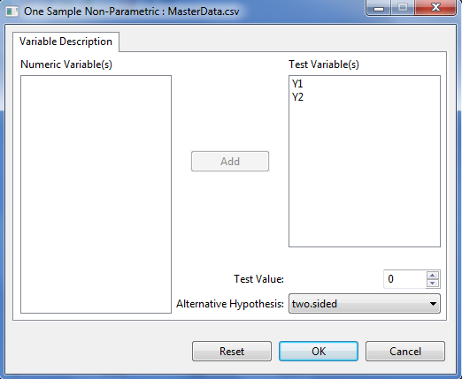

* Click **OK** button to perform the analysis. The **One Sample Non-Parametric** dialog box will be minimized and STAR activates the **Output Viewer** tab of the **Result Viewer** tab.

Sample output is shown below:

Sigh Test: Md = 0

-----------------------------------------------------------

Variable Statistics Prob > |V| LL\_CI \* Median UL\_CI \*

-----------------------------------------------------------

Y1 4656 0.0000 132.00 132.00 132.00

Y2 4656 0.0000 122.95 122.99 123.00

-----------------------------------------------------------

\* 95% Confidence Interval

## Two Related Samples

The steps to perform Kruskal Wallis test are listed below:

* On the **Project Explorer**, double-click the file to be used for the analysis to open and view it in the Data Viewer.

For the example, using the project named *MyProject*,import the data *Sensors* from package. To import the data from the package, see *Importing from Package* section of this user’s manual.

* From the main window of STAR, click **Analyze | Non-Parametric Test | Two Related Samples**…. The **Two Related Samples** dialog box will appear.

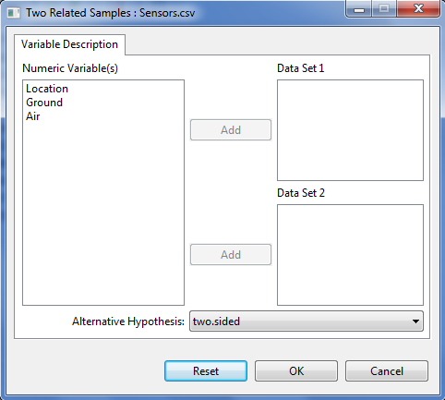

* Specify the required field and appropriate options for the analysis.

**Data Set 1**

This field needs at least one entry for the analysis to proceed and must have the same number of entry as **Data Set 2**.

**Data Set 2**

This field needs at least one entry for the analysis to proceed and must have the same number of entry as **Data Set 1**.

**Alternative Hypothesis**

User can select a one-tailed or two-tailed test. The default alternative hypothesis used is that for the two-sided test.

For the example, the completed dialog box should appear as shown below:

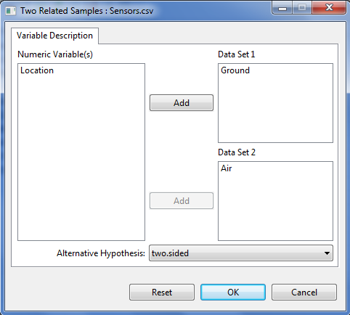

* Click **OK** button to perform the analysis. The **Two Related Samples** dialog box will be minimized and STAR activates the **Output Viewer** tab of the **Result Viewer** tab.

Sample output is shown below:

Wilcoxon Signed Rank Test

---------------------------------------------

Variable Statistics Prob > |V| Median

---------------------------------------------

Ground - Air 0.0000 0.0020 -1.60

---------------------------------------------

## Two Independent Samples

The steps to perform Kruskal Wallis test are listed below:

* On the **Project Explorer**, double-click the file to be used for the analysis to open and view it in the Data Viewer.

For the example, using the project named *MyProject*,import the data *Fertilizer* from package. To import the data from the package, see *Importing from Package* section of this user’s manual.

* From the main window of STAR, click **Analyze | Non-Parametric Test | Test for Two Independent Samples**…. The **Test for Two Independent Samples** dialog box will appear.

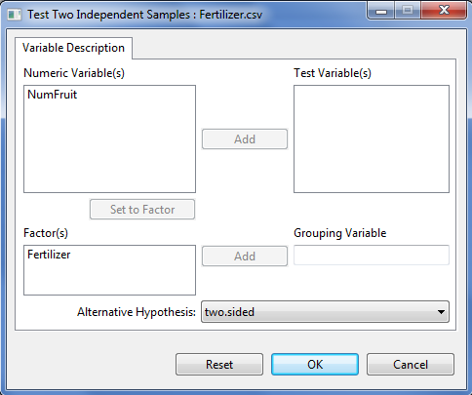

* Specify the required field and appropriate options for the analysis.

**Test Variable(s)**

For the analysis to proceed, at least one item should be entered in the list box. Only items from the **Numeric Variable(s)** can be added in this dialog box.

**Grouping Variable**

Only one item can be added in this field and should come from the **Factor(s)** list box.

**Alternative Hypothesis**

User can select a one-tailed or two-tailed test. The default alternative hypothesis used is that for the two-sided test.

For the example, the completed dialog box should appear as shown below:

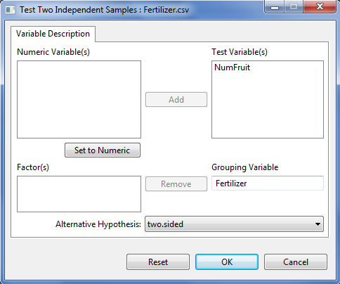

* Click **OK** button to perform the analysis. The **Test for Two Independent Samples** dialog box will be minimized and STAR activates the **Output Viewer** tab of the **Result Viewer** tab.

Sample output is shown below:

Mann-Whitney (Wilcoxon Rank Sum) Test

-----------------------------------------------------------

Variable Statistics Prob > |W| LL\_CI \* Median UL\_CI \*

-----------------------------------------------------------

NumFruit 163 0.0371 0.0000 3.00 5.00

-----------------------------------------------------------

\* 95% Confidence Interval

## Test for Several Related Samples

The steps to perform Kruskal Wallis test are listed below:

* On the **Project Explorer**, double-click the file to be used for the analysis to open and view it in the Data Viewer.

For the example, using the project named *MyProject*,import the data *Insecticides* from package. To import the data from the package, see *Importing from Package* section of this user’s manual.

* From the main window of STAR, click **Analyze | Non-Parametric Test | Test for Several Independent Samples**…. The **Test for Several Independent Samples** dialog box will appear.

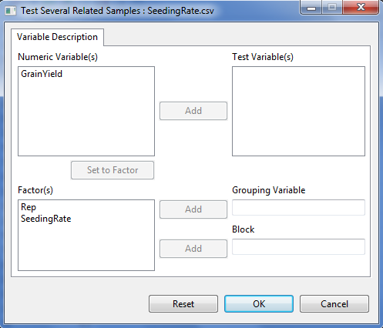

* Specify the required field and appropriate options for the analysis.

**Test Variable(s)**

For the analysis to proceed, at least one item should be entered in the list box. Only items from the **Numeric Variable(s)** can be added in this dialog box.

**Grouping Variable**

Only one item can be added in this field and should come from the **Factor(s)** list box.

**Block**

Only one item can be added in this field and should come from the **Factor(s)** list box.

For the example, the completed dialog box should appear as:

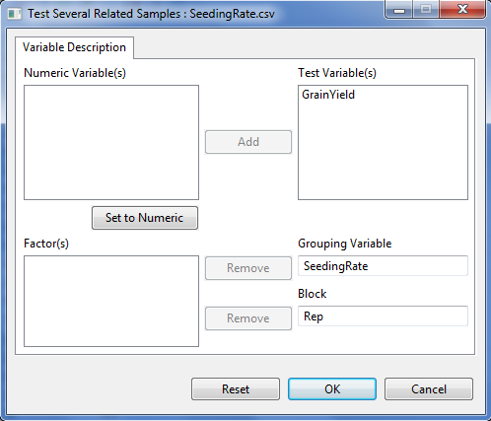

* Click **OK** button to perform the analysis. The **Test for Several Independent Samples** dialog box will be minimized and STAR activates the **Output Viewer** tab of the **Result Viewer** tab.

Sample output is shown below:

Rank Sums for Variable GrainYield

Classified by SeedingRate

----------------------------------------------

SeedingRate N Sum of Ranks Mean of Ranks

----------------------------------------------

25 4 20.50 5.12

50 4 20.30 5.08

75 4 21.20 5.30

100 4 17.40 4.35

125 4 18.70 4.67

150 4 13.50 3.38

----------------------------------------------

\* Average scores are used for ties.

Friedman rank sum test

-----------------------------

Chi-Square 15.2985

DF 5

Pr > Chi-Square 0.0092

-----------------------------

## Test for Several Independent Samples

The steps to perform Kruskal Wallis test are listed below:

* On the **Project Explorer**, double-click the file to be used for the analysis to open and view it in the Data Viewer.

For the example, using the project named *MyProject*,import the data *Insecticides* from package. To import the data from the package, see *Importing from Package* section of this user’s manual.

* From the main window of STAR, click **Analyze | Non-Parametric Test | Test for Several Independent Samples**…. The **Test for Several Independent Samples** dialog box will appear.

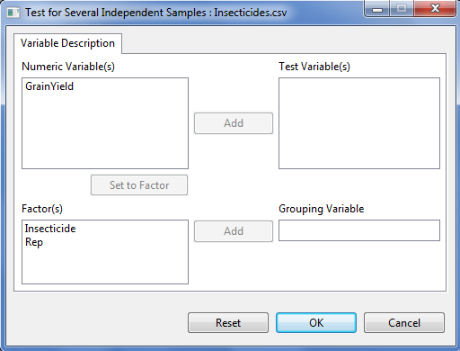

* Specify the required field and appropriate options for the analysis.

**Test Variable(s)**

For the analysis to proceed, at least one item should be entered in the list box. Only items from the **Numeric Variable(s)** can be added in this dialog box.

**Grouping Variable**

Only one item can be added in this field and should come from the **Factor(s)** list box.

For the example, the completed dialog box should appear as shown below:

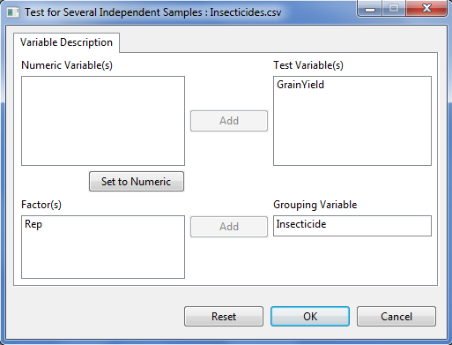

* Click **OK** button to perform the analysis. The **Test for Several Independent Samples** dialog box will be minimized and STAR activates the **Output Viewer** tab of the **Result Viewer** tab.

Sample output is shown below:

Rank Sums for Variable YIELD

Classified by Variable TREATMENT

----------------------------------------------

TREATMENT N Sum of Ranks Mean of Ranks

----------------------------------------------

Azodin 4 64 16.00

Control 4 12 3.00

DDT + phi-BHC 4 91 22.75

Dimercon-Boom 4 41 10.25

Dimercon-Knap 4 35 8.75

Dol-Mix (1kg) 4 66 16.50

Dol-Mix (2kg) 4 97 24.25

----------------------------------------------

\* Average scores are used for ties.

Kruskal-Wallis rank sum test

-----------------------------

Chi-Square 20.8522

DF 6

Pr > Chi-Square 0.0020

-----------------------------

# 

# Multivariate Analysis

## Principal Component Analysis

The steps to perform Multivariate Analysis of Variance are listed below:

* On the **Project Explorer**, double-click the file to be used for the analysis to open and view it in the Data Viewer.

For the example, using the project named *MyProject*,import the data *InjuryProfile* from package. To import data from the package, see *Importing Data from Package* sectionof this user’s manual.

* From the main window of STAR, click **Analyze | Multivariate Analysis | Principal Component Analysis**…. The **Principal Component Analysis** dialog box will appear.

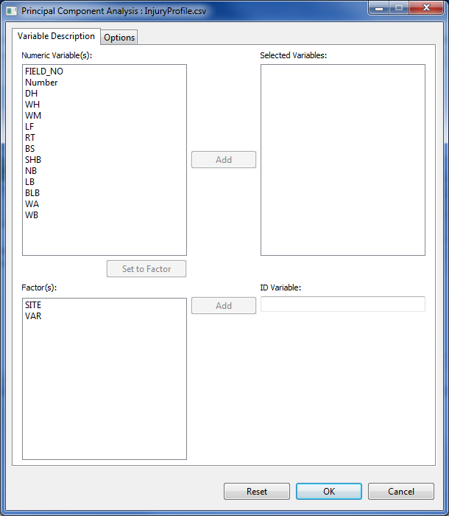

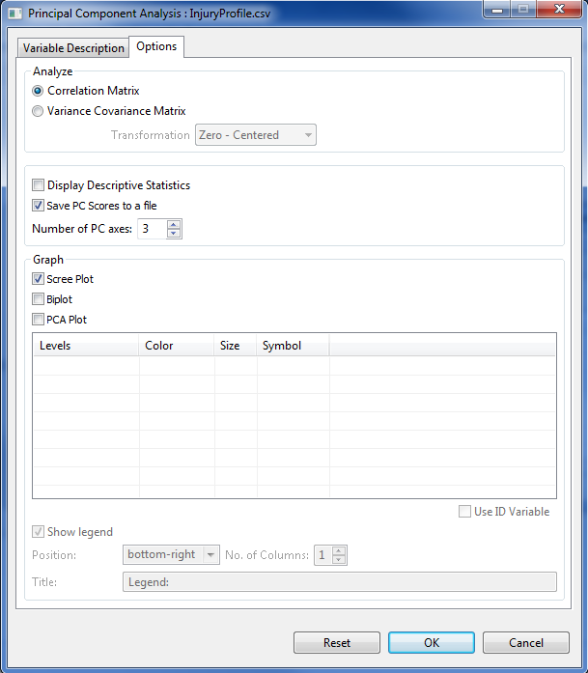

* Specify the required field and appropriate options for the analysis.

**Variable Description Tab**

**Selected Variables:**

For the analysis to proceed, at least one item should be entered in the list box. Only items from the **Numeric Variable(s)** can be added in this dialog box.

**ID Variable**

Only one item can be entered in this entry box and should come from the **Factor(s)** list box.

**Options Tab**

**Analyze**

The user has the option to use Correlation matrix and Variance Covariance matrix for the analysis. By default, Correlation matrix is selected. If the user choose Variance Covariance matrix, the transformation field will be enabled. The user has the option to choose whether the transformation to be used is Zero-Centered, Unit Variance or no transformation. By default, Zero-centered is selected.

**Display Descriptive Statistics**

If checked, the Descriptive Statistics of the selected variables will be displayed.

**Save PC Scores to a file**

The user has the option to save PC scores to a file. By default, this option is selected.

**Number of PC Axes**

The user has the option to specify the number of PCs to be displayed in the PC scores and graphs. By default, the number of PC axes is 3.

**Scree Plot**

If checked, Scree plot will be displayed. By default, this option is selected.

**Biplot**

If checked, Biplot will be displayed.

**PCA Plot**

The user has the option to display PCA plot. If the user specified an ID Variable and also selected PCA Plot, the levels of the ID variable will be automatically displayed on the format table. In this table, user can modify the PCA plot by changing the color, size and symbol.

**Use ID Variable**

This option will use the levels of the ID variable as points in the PCA plot. This option will only be enabled if the user specifies an ID variable.

**Show legend**

If checked, a legend will be added to the graph. By default the title is *Legend*. The legend may be placed in any of nine positions within the graph: *bottom, bottom-left, bottom-right, center, left, right, top, top-left, top-right*. The items on the legend can be listed in one or more columns, the maximum of which is the number of levels of the category variable.

For the example, the completed dialog box should appear as shown below:

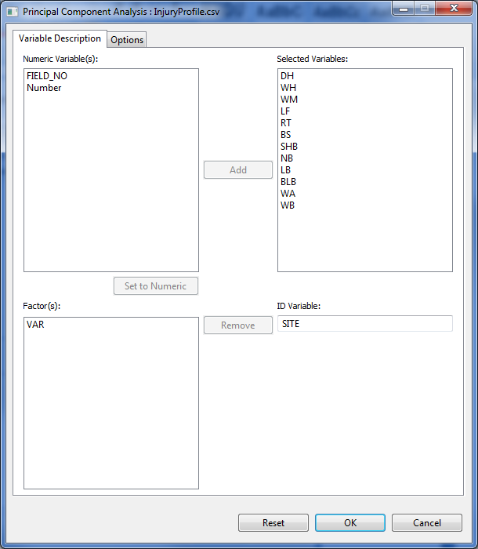

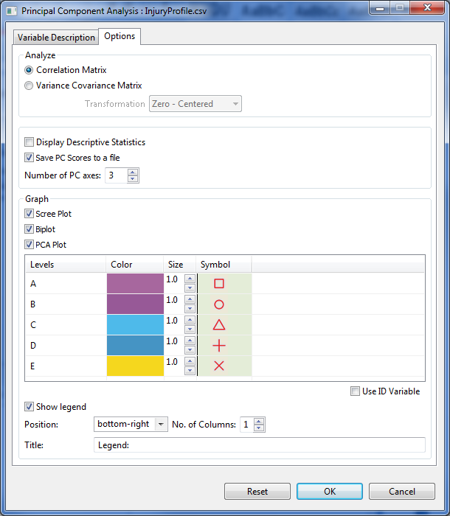

* Click **OK** button to perform the analysis. The **Principal Component Analysis** dialog box will be minimized and STAR activates the **Output Viewer** tab of the **Result Viewer** tab.

Sample output is shown below:

Number of Observations: 200

PRINCIPAL COMPONENT ANALYSIS

-------------------------------------------------------------------

Statistics PC1 PC2 PC3 ... PC12

-------------------------------------------------------------------

Standard deviation 2.1013 1.5853 1.1604 ... 0.1885

Proportion of Variance 0.3680 0.2094 0.1122 ... 0.0030

Cumulative Proportion 0.3680 0.5774 0.6896 ... 1.0000

EigenValues 4.4155 2.5131 1.3466 ... 0.0355

-------------------------------------------------------------------

EIGENVECTORS

---------------------------------------------------------

Variables PC1 PC2 PC3 ... PC12

---------------------------------------------------------

DH 0.2339 0.1939 -0.2837 ... 0.0123

WH 0.3061 0.0842 0.1799 ... -0.1294

WM 0.4030 -0.0838 0.1610 ... -0.2288

LF 0.4498 -0.0142 0.2328 ... 0.8264

RT 0.0846 0.2345 -0.5976 ... 0.0673

BS -0.1302 -0.5115 -0.1688 ... 0.0078

SHB 0.3306 0.1190 -0.1340 ... -0.1195

NB 0.0294 -0.5701 -0.1607 ... -0.0285

LB 0.2036 -0.5350 0.0086 ... 0.0383

BLB 0.4348 -0.0133 0.2524 ... -0.4755

WA -0.2021 0.0634 0.4050 ... 0.0051

WB -0.2850 0.0439 0.3871 ... 0.0251

---------------------------------------------------------

Sample graphical output of the analysis is shown below:

**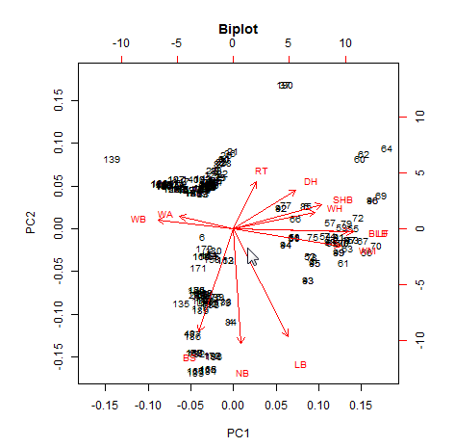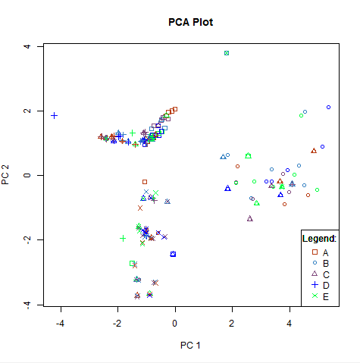**

**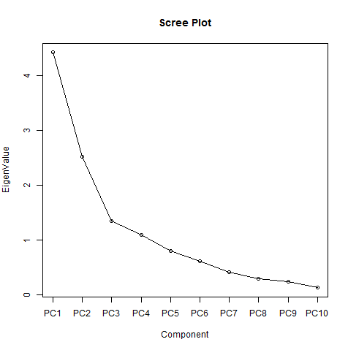**

## Cluster Analysis

The steps to perform Multivariate Analysis of Variance are listed below:

* On the **Project Explorer**, double-click the file to be used for the analysis to open and view it in the Data Viewer.

For the example, using the project named *MyProject*,import the data *Sevilla2012Cluster* from the package. To import data from the package, see *Importing Data from Package* sectionof this user’s manual.

* From the main window of STAR, click **Analyze | Multivariate Analysis | Cluster Analysis**…. The **Cluster Analysis** dialog box will appear.

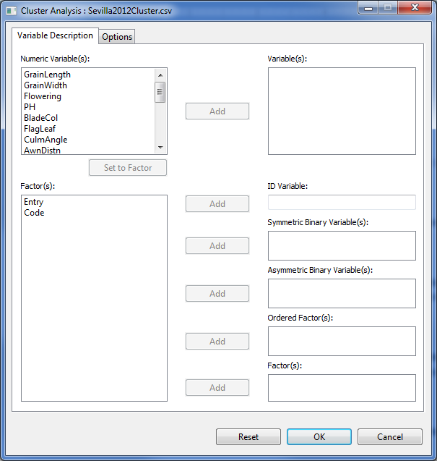

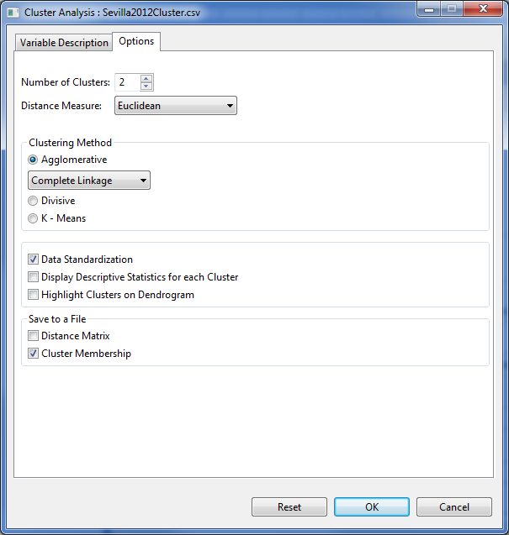

* Specify the required field and appropriate options for the analysis.

**Variable Description Tab**

**Variable(s):**

For the analysis to proceed, at least one item should be entered in the list box. Only items from the **Numeric Variable(s)** can be added in this list box.

**ID Variable**

Only one item can be added in this field and should come from the **Factor(s)** entry box. ID Variable must have unique observations.

**Symmetric Binary Variable(s)**

At least one item can be entered in the list box. Only items from the **Factors(s)** list box can be added in this list box. The items should have only two levels denoted by 0 and 1.

**Asymmetric Binary Variable(s)**

At least one item can be entered in the list box. Only items from the **Factors(s)** list box can be added in this list box. The items should have only two levels denoted by 0 and 1.

**Ordered Factor(s)**

At least one item can be entered in the list box. Only items from the **Factors(s)** list box can be added in this list box.

**Factors(s)**

At least one item can be entered in the list box. Only items from the **Factors(s)** list box can be added in this list box.

**Options Tab**

**Number of Clusters**

This option will determine the number of clusters to be used in the analysis. By default the number of clusters is 2.

**Distance Measure**

The distance measure procedures will depend on the type of variables that will be used in the analysis. If the variables are numeric only, the available distance measures are *Euclidean, Maximum, Manhattan, Minkowski and Canberra*. If the variables are symmetric binary, the available distance measures are *Simple Matching, Sokal & Sneath and Hamann Coefficient*. For asymmetric binary variables, *Jaccard and Dice* are the available distance measures. If the variables selected are of different levels or data type, the *Gower* distance measure procedure will be used.

**Clustering Method**

There are three available types of method. The user can choose Agglomerative, Divisive or K – means. If Agglomerative is selected, the user has the option to choose the clustering method. The available methods are *Single Linkage, Complete Linkage, Average Linkage, Ward’s method and Centroid method*. For K – means procedure, this will only be used if the variables are numeric only.

**Data Standardization**

If checked, the data to be used in the analysis will be standardized. This option is available for numeric variables only.

**Display Descriptive Statistics for each Cluster**

If checked, the Descriptive Statistics of the selected variables will be displayed. This option is available for numeric variables only.

**Highlight Clusters on Dendogram**

If checked, the clusters will be highlighted in the Dendrogram.

**Distance Matrix**

If checked, the Distance Matrix will be saved to a file.

**Cluster Membership**

If checked, the Cluster Membership will be saved to a file. By default, this option is selected.

For the example, the completed dialog box should appear as shown below:

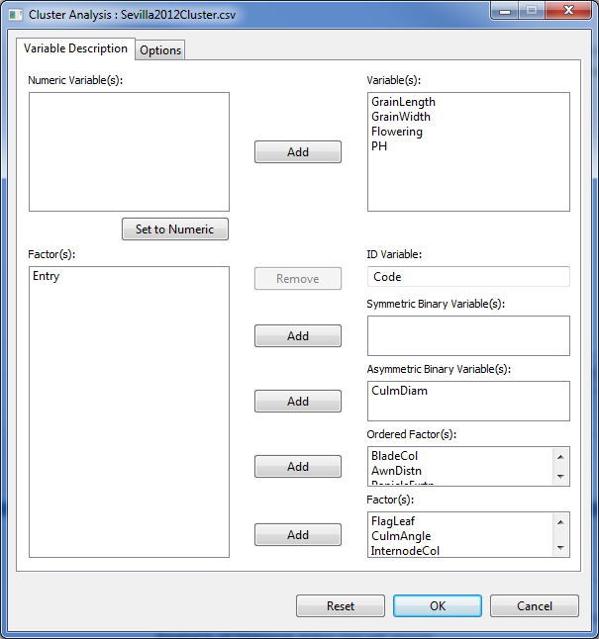

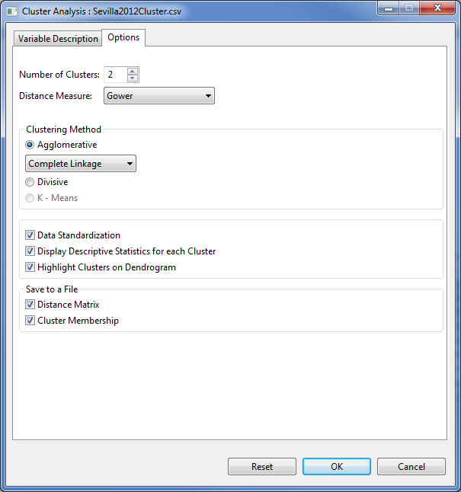

* Click **OK** button to perform the analysis. The **Multivariate Analysis of Variance** dialog box will be minimized and STAR activates the **Output Viewer** tab of the **Result Viewer** tab.

Sample text output displayed in the Output Viewer tab is shown below:

Number of Observations: 74

AGGLOMERATIVE CLUSTER ANALYSIS

SPECIFICATIONS:

Distance Method: Gower

Clustering Method: Single

Number of Clusters: 2

Descriptive Statistics

---------------------------------------------------------

Variable Cluster Min Max Mean StdDev

---------------------------------------------------------

GrainLength 1 7.90 10.40 9.59 0.65

GrainLength 2 2.20 10.40 9.43 1.07

GrainWidth 1 2.40 3.00 2.77 0.15

GrainWidth 2 1.90 2.70 2.11 0.15

Flowering 1 82.00 92.00 85.21 3.12

Flowering 2 82.00 96.00 89.20 3.56

PH 1 79.20 101.20 92.27 6.49

PH 2 76.00 116.20 98.52 7.88

---------------------------------------------------------

CLUSTER MEMBERSHIP SUMMARY

Member of Cluster 1

1 2 3 64 65 66 67 68 69 70 71 72 73 74

Member of Cluster 2

4 5 6 7 8 9 10 11 12 13 14 15 16 17 18

19 20 21 22 23 24 25 26 27 28 29 30 31 32 33

34 35 36 37 38 39 40 41 42 43 44 45 46 47 48

49 50 51 52 53 54 55 56 57 58 59 60 61 62 63

Number of members in each cluster

----------------

Cluster Size

----------------

1 14

2 60

----------------

COPHENETIC CORRELATION COEFFICIENT = 0.882

Sample graphical output displayed in the Graphical Viewer tab is shown below:

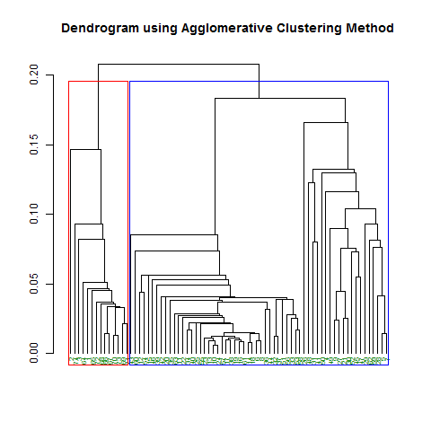

## Multivariate Analysis of Variance

The steps to perform Multivariate Analysis of Variance are listed below:

* On the **Project Explorer**, double-click the file to be used for the analysis to open and view it in the Data Viewer.

For the example, using the project named *MyProject*,import the data *ManovaData1* from package. To import data from the package, see *Importing Data from Package* sectionof this user’s manual.

* From the main window of STAR, click **Analyze | MANOVA**…. The **Multivariate Analysis of Variance** dialog box will appear.

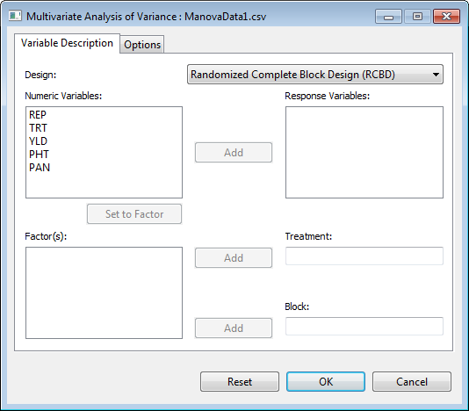

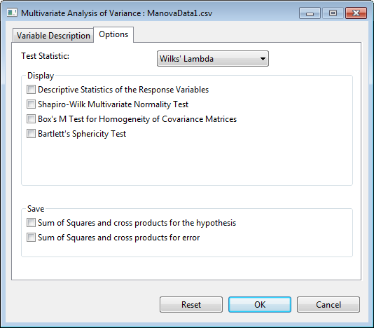

* Specify the required field and appropriate options for the analysis.

**Variable Description Tab**

**Response Variable:**

For the analysis to proceed, at least two items should be entered in the list box. Only items from the **Numeric Variable(s)** can be added in this dialog box.

**Treatment**

For the analysis to proceed, one item from the **Factor(s)** list should be entered into this field.

**Block**

For the analysis to proceed, one item from the **Factor(s)** list should be entered into this field.

**Options Tab**

**Test Statistic**

By default, the test statistic used in the analysis is Wilks’ Lambda. This can be changed into Pillai’s Trace, Hotelling-Lawley Trace, or Roy’s maximum-root.

**Descriptive Statistics of the Response Variables**

If this option is selected, a summary table with number of observations, minimum, maximum, mean and standard deviation of all selected numeric variables is displayed.

**Shapiro-Wilk Multivariate Normality Test**

If this option is selected, Shapiro-Wilk Test for Multivariate Normality will be performed.

**Box’s M Test for Homogeneity of Covariance Matrices**

If this option is selected, Box’s M Test for Homogeneity of Covariance Matrices will be performed.

**Bartlett’s Sphericity Test**

If this option is selected, Bartlett’s Sphericity Test will be performed.

**Sum of Squares and cross products for the hypothesis**

If this option is selected, sum of squares and cross products for the hypothesis will be saved to a csv file.

**Sum of Squares and cross products for error**

If this option is selected, error sum of squares and cross products will be saved to a csv file.

For the example, the completed dialog box should appear as shown below:

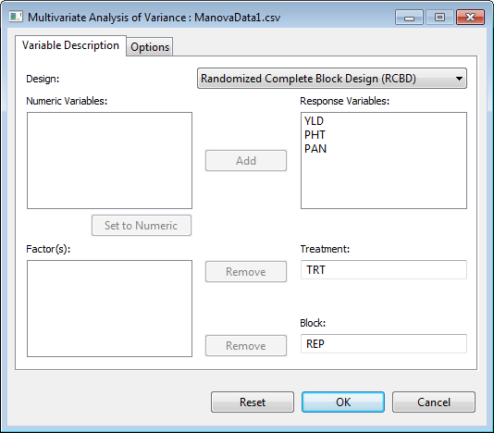

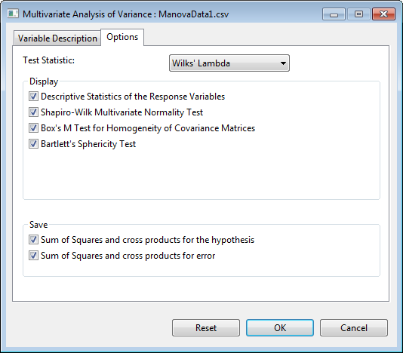

* Click **OK** button to perform the analysis. The **Multivariate Analysis of Variance** dialog box will be minimized and STAR activates the **Output Viewer** tab of the **Result Viewer** tab.

Sample output is shown below:

Summary Information

-------------------------------------

FACTOR NO. OF LEVELS LEVELS

-------------------------------------

TRT 4 1, 2, 3, 4

REP 4 1, 2, 3, 4

-------------------------------------

Number of Observations: 16

Descriptive Statistics

------------------------------------------------------

Variable N\_Obs Min Max Mean StdDev

------------------------------------------------------

YLD 16 3.52 7.85 5.37 1.19

PHT 16 107.30 137.50 119.09 9.58

PAN 16 21.80 26.40 24.32 1.52

------------------------------------------------------

MULTIVARIATE NORMALITY TEST

---------------------------

Statistic Value Prob

Wilk-Shapiro 0.9729 0.8825

BOX'S M TEST FOR HOMOGENEITY OF COVARIANCE MATRICES

---------------------------------------------------

Box M F df1 df2 Prob

24.9723 0.7120 18 508 0.8001

BARTLETT'S SPHERICITY TEST

--------------------------

Statistic Value Df Prob

Chi-Square 5.9049 3 0.1163

SUM OF SQUARES AND CROSS PRODUCTS FOR THE HYPOTHESIS

----------------------------------------------

TERM: TRT

YLD PHT PAN

YLD 9.32182 42.2462 4.3300

PHT 42.24619 318.6969 35.9675

PAN 4.33000 35.9675 4.9850

TERM: REP

YLD PHT PAN

YLD 9.71707 -52.5421 10.5915

PHT -52.54206 733.0869 -137.3950

PAN 10.59150 -137.3950 26.6350

SUM OF SQUARES AND CROSS PRODUCTS FOR ERROR

-------------------------------------

YLD PHT PAN

YLD 2.18436 -6.84594 -1.90325

PHT -6.84594 324.72562 14.89000

PAN -1.90325 14.89000 2.83000

MULTIVARIATE ANALYSIS OF VARIANCE IN RCBD

-----------------------------------------

Df Wilks approx F num Df den Df Pr(>F)

REP 3 0.004461 15.742 9 17.19 1.25e-06 \*\*\*

TRT 3 0.025898 6.659 9 17.19 0.000409 \*\*\*

Residuals 9

---

Signif. codes: 0 '\*\*\*' 0.001 '\*\*' 0.01 '\*' 0.05 '.' 0.1 ' ' 1

## Multidimensional Scaling

The steps to perform Multidimensional Scaling (MDS) are listed below:

* On the **Project Explorer**, double-click the file to be used for the analysis to open and view it in the Data Viewer.

For the example, using the project named *MyProject*,import the data *GeneticDistMatrix* from the package. To import data from thepackage, see *Importing Data from Package* sectionof this user’s manual.

* From the main window of STAR, click **Analyze | MDS**…. The **Multidimensional Scaling** dialog box will appear.

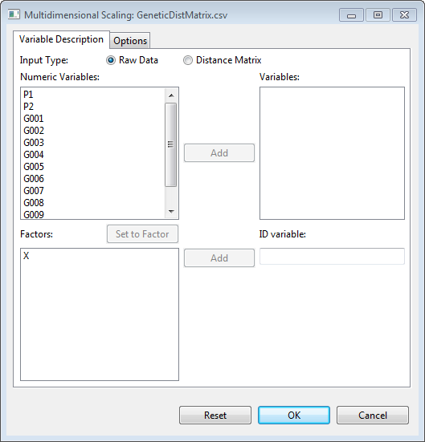

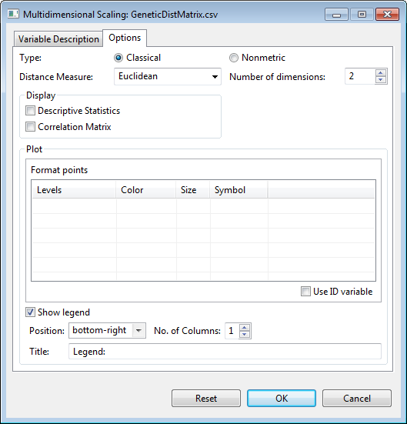

* Specify the required field and appropriate options for the analysis.

**Variable Description Tab**

**Input Type**

By default, the type of input data for MDS is raw data. If a symmetric matrix containing distances is used, the second option is selected.

**Variable(s)**

If input type is raw data, at least two items from the **Numeric Variable(s)** should be entered in this list box, for the analysis to proceed. Otherwise, this part is left blank.

**ID Variable**

If input type is raw data, an item from the **Factors** list should be entered in this list box, for the analysis to proceed. Otherwise, the levels of the ID variable are obtained automatically from the first column.

**Options Tab**

**Type**

The user can perform classical (metric) or nonmetric MDS. The default type is classical MDS.

**Distance Measure**

The available distance measures are: *Euclidean, Maximum, Manhattan, Canberra,* and *Minkowski* for both classical and nonmetric MDS. In addition, *Bray* is available for nonmetric MDS. This option is disabled if input type is distance matrix.

**Number of dimensions**

The allowable number of dimensions for the analysis is from two to five. By default, the number of dimensions used is 2.

**Descriptive Statistics**

If this option is selected, a summary table with number of observations, minimum, maximum, mean and standard deviation of all selected numeric variables is displayed. This option is disabled if input type is distance matrix.

**Correlation Matrix**

If this option is selected, a matrix of correlation coefficients, together with *p-*value and number of observations, of all selected numeric variables is displayed This option is disabled if input type is distance matrix.

**Plot**

Formats of the points corresponding to the levels of the ID variable can be edited for color, size, and symbol. If the options **Use ID variable** is checked, the symbol column is disabled.

**Show legend**

If checked, a legend will be added to the graph. Its default title is “Legend.” It may be placed in any of nine positions within the graph: bottom, bottom-left, bottom-right, center, left, right, top, top-left, top-right. The items on the legend can be listed in one to five columns.

For the example, the completed dialog box should appear as shown below:

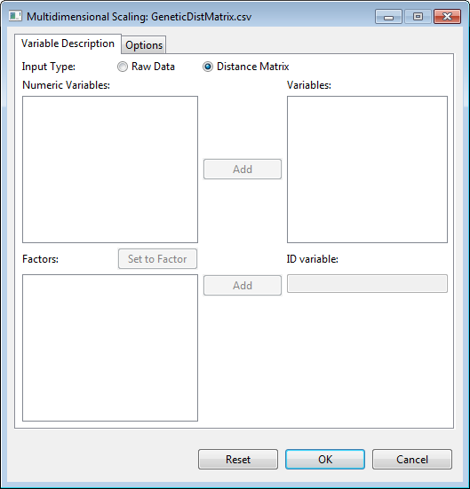

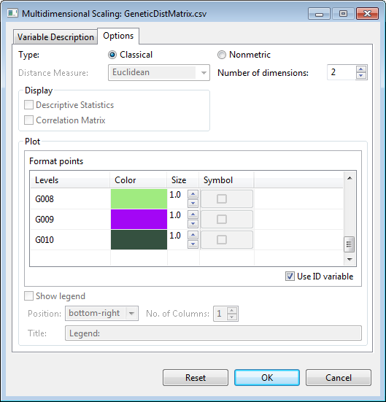

* Click **OK** button to perform the analysis. The **Multidimensional Scaling** dialog box will be minimized and STAR activates the **Output Viewer** tab of the **Result Viewer** tab.

Sample text output displayed in the Output Viewer is shown below:

CLASSICAL MULTIDIMENSIONAL SCALING

POINTS

MDS1 MDS2

1 0.63530755 0.00731054

2 -0.36151720 0.03349883

3 -0.01483443 0.06890020

4 -0.02852569 -0.17409966

5 -0.00402664 0.24548248

6 -0.02019590 0.08630418

7 0.02762699 -0.07304992

8 -0.00976805 -0.04107086

9 -0.04048116 -0.11783893

10 -0.10213215 0.00081293

11 -0.02093113 0.02498110

12 -0.06052219 -0.06123087

P\_2 criterion: 0.7472

Sample graphical output displayed in the **Graph** Viewer is displayed below:

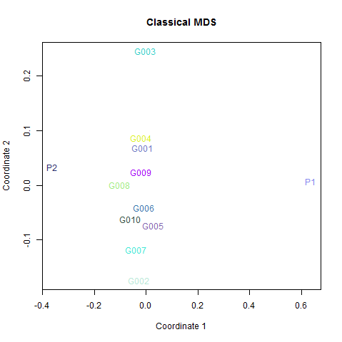 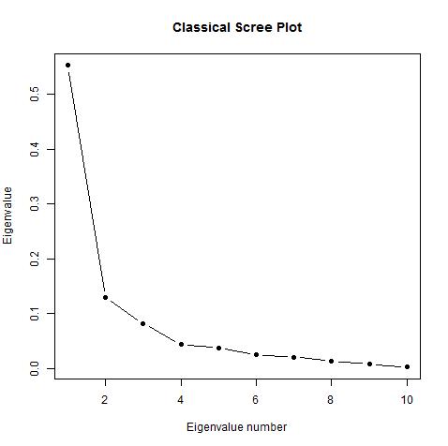

## Discriminant Analysis

The steps to perform Discriminant Analysis are listed below:

* On the **Project Explorer**, double-click the file to be used for the analysis to open and view it in the Data Viewer.

For the example, using the project named *MyProject*,import the data files *AgroData1* and *AgroData2* from the package. To import data from the package, see *Importing Data from Package* sectionof this user’s manual.

* From the main window of STAR, click **Analyze | Discriminant Analysis**…. The **Discriminant Analysis** dialog box will appear.

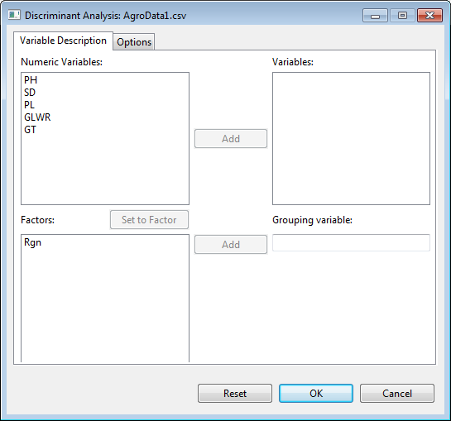

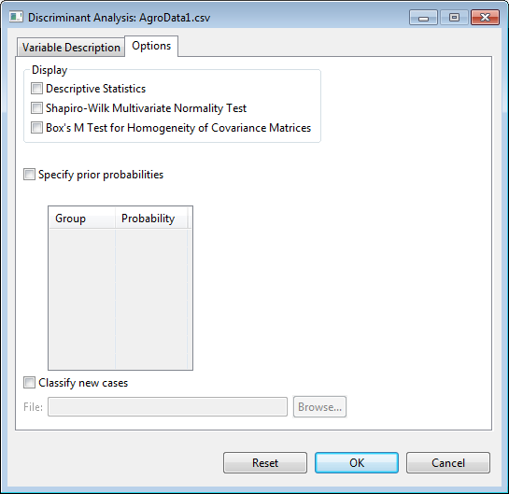

* Specify the required field and appropriate options for the analysis.

**Variable Description Tab**

**Variable(s)**

For the analysis to proceed, at least two items should be entered in the list box. Only items from the **Numeric Variable(s)** can be added into this dialog box.

**Grouping Variable**

For the analysis to proceed, one item from the **Factors** list should be entered into this list box.

**Options Tab**

**Descriptive Statistics**

If this option is selected, a summary table with number of observations, minimum, maximum, mean and standard deviation of all selected numeric variables is displayed.

**Shapiro-Wilk Multivariate Normality Test**

If this option is selected, Shapiro-Wilk Test for Multivariate Normality will be performed.

**Box’s M Test for Homogeneity of Covariance Matrices**

If this option is selected, Box’s M Test for Homogeneity of Covariance Matrices will be performed.

**Specify prior probabilities**

By default prior probabilities are based on the observed distribution of the grouping variable. The user can change this by selecting this option and specifying the corresponding probabilities (fraction or decimal form) in the table. By default, the prior probabilities are all equal.

**Classify new cases**

If the user wants to classify other cases, this option is selected. The file specified in the field should contain cases with those variables specified in the **Variable(s)** list.

For the example, the completed dialog box should appear as shown below:

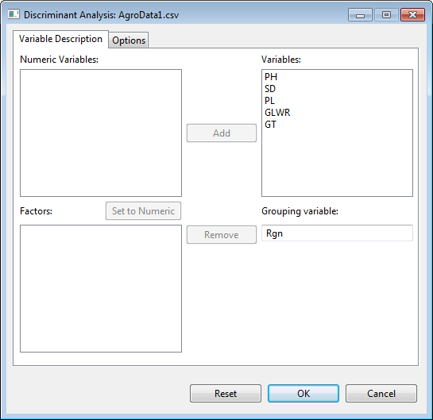

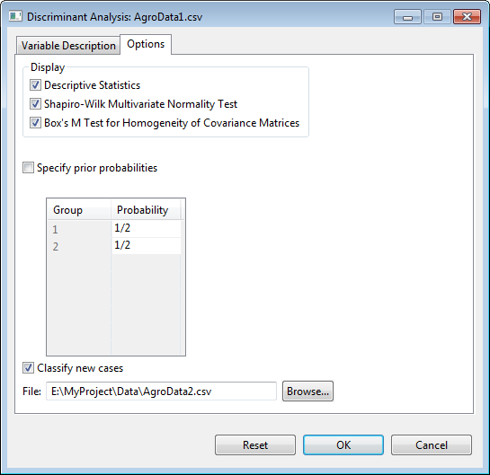

* Click **OK** button to perform the analysis. The **Discriminant Analysis** dialog box will be minimized and STAR activates the **Output Viewer** tab of the **Result Viewer** tab.

Sample text output displayed in the Output Viewer is shown below:

Descriptive Statistics

-----------------------------------------------------

Variable N\_Obs Min Max Mean StdDev

-----------------------------------------------------

PH 38 82.80 145.30 106.98 14.92

SD 38 3.27 8.10 5.23 1.09

PL 38 15.84 28.99 23.26 3.12

GLWR 38 2.24 4.50 3.32 0.48

GT 38 1.77 2.46 2.08 0.16

-----------------------------------------------------

MULTIVARIATE NORMALITY TEST

---------------------------

Statistic Value Prob

Wilk-Shapiro 0.9662 0.2988

BOX'S M TEST FOR HOMOGENEITY OF COVARIANCE MATRICES

---------------------------------------------------

Box's M Chi-Square df Prob

27.3195 23.2555 15 0.9211

DISCRIMINANT ANALYSIS

SUBGROUP MEANS

PH SD PL GLWR GT

1 98.0333 5.0311 23.7872 3.3583 2.0433

2 115.0250 5.4160 22.7850 3.2800 2.1180

TEST OF SIGNIFICANCE OF THE DISCRIMINANT FUNCTION(S)

Df Wilks approx F num Df den Df Pr(>F)

Rgn 1 0.5883 4.48 5 32 0.00331 \*\*

Residuals 36

---

Signif. codes: 0 '\*\*\*' 0.001 '\*\*' 0.01 '\*' 0.05 '.' 0.1 ' ' 1

DISCRIMINANT FUNCTION COEFFICIENTS

LD1

PH 0.0806

SD 0.4547

PL -0.0403

GLWR -0.4968

GT 0.1055

CLASSIFICATION RESULTS

Original\Predicted (Counts)

1 2 Total

1 14 4 18

2 6 14 20

Original\Predicted (%)

1 2 Total

1 77.78 22.22 100

2 30.00 70.00 100

73.68% of original cases correctly classified

# Appendix

## Data from STAR Package

### AgroData1

**Description**

This file contains hypothetical data on some agronomic traits of 38 rice lines coming from two regions.

**Formats**

This data contains the following columns:

Rgn a factor with two levels (1, 2)

PH a numeric vector denoting plant height in cm

SD a numeric vector denoting stem diameter in mm

PL a numeric vector denoting panicle length in cm

GLWR a numeric vector denoting grain length/width ratio

GT a numeric vector denoting grain thickness in mm

### AgroData2

**Description**

This file contains hypothetical data on some agronomic traits of nine rice lines.

**Formats**

This data contains the following columns:

PH a numeric vector denoting plant height in cm

SD a numeric vector denoting stem diameter in mm

PL a numeric vector denoting panicle length in cm

GLWR a numeric vector denoting grain length/width ratio

GT a numeric vector denoting grain thickness in mm

### CarbonStock

**Description**

This file contains ecological data collected from 125 sampling locations in Eastern Region of Ghana. The objective of the study was to identify explanatory variables of carbon stocks in fallow vegetation aged 3 to 8 years, using ecological parameters that are known to influence primary productivity.

**Formats**

This data contains the following columns:

CS a numeric vector of carbon stock (MgCha-1)

SV a numeric vector of stem volume (m3ha-1)

LA a numeric vector of leaf area (m2kg-1)

SM a numeric vector of soil moisture (%)

TN a numeric vector of total nitrogen (%)

AP a numeric vector of available phosphorus (mgkg-1)

CEC a numeric vector of cation exchange capacity (Cmolckg-1)

**Source**

Attua, E. M.

### AugLS

**Description**

**Formats**

This data contains the following columns:

Row a factor with 15 levels (1 to 15) denoting the row

Column a factor with 5 levels (1, 2, 3, 4, 5) denoting the column

Entry a factor with 55 levels (1 to 55) denoting the treatment with levels 1 to 50 as the unreplicated entries and levels 51 to 55 as the replicated entries

Yield a numeric vector of grain yield

**Source**

### AugRCB

**Description**

**Formats**

This data contains the following columns:

BLOCK a factor with 4 levels (1, 2, 3, 4) denoting the block

ENTRY a factor with 55 levels (1, 2, …, and 66) denoting the treatment with levels 1 to 60 as the unreplicated entries and levels 61 to 66 as the replicated entries

YIELD a numeric vector of grain yield

**Source**

### CochranBIB

**Description**

This file contains data of corn from an experiment conducted in 1943 in North Carolina Agricultural Experiment Station, United States Department of Agriculture which uses balanced incomplete block design. Each location or block has 4 genotypes. The blocks are planted at different location.

**Formats**

This data contains the following columns:

loc a factor with 13 levels denoting the location or the block

gen a factor with 13 levels (G01, G02, G03, G04, G05, G06, G07, G08, G09, G10, G11, G12 and G13) denoting the genotype

yield a numeric vector of grain yield (pounds per plot)

**Source**

Cochran, W.G. and Cox, G.M. (1957), Experimental Designs, 2nd ed., Wiley and Sons, New York, p. 448.

### Corr

**Description**

The data is from an experiment that was conducted to investigate the relationship between grain yield (*GY14*, in kg/ha), the grain’s nitrogen (*N*), phosphorus (*P*) and potassium (*K*) content in percent. The data were collected from 48 experimental plots with grain yield adjusted to 14% moisture content.

**Formats**

This data contains the following columns:

GY14 a numeric vector of grain yields in kg/ha adjusted to 14% moisture continent

N a numeric vector of grain’s nitrogen

P a numeric vector of grain’s phosphorus

K a numeric vector of grain’s potassium content in percent

**Source**

BEDDA Training

### CropStatRCBDOverSite

**Description**

**Formats**

This data contains the following columns:

NTRT a factor with 6 levels (1, 2, 3, 4, 5, 6) denoting the nitrogen

SITE a factor with 3 levels (1, 2, 3) denoting the site

REP a factor with 3 levels (1, 2, 3) denoting the block

YIELD a numeric vector denoting the grain yield

**Source**

CropStat Manual

#### 

### Dule\_AlphaGxE

**Description**

**Formats**

This data contains the following columns:

Env a factor with 6 levels (A01WSCM, A03WS-0, A03WS-1, AWS01-D, UWS02-2, UWS02-8) denoting the environment

Rep a factor with 3 levels (1, 2, 3) denoting the replication

Block a factor with 5 levels (1, 2, 3, 4, 5) denoting the block

Plot a numeric vector denoting the plot number

Geno a factor with 40 levels (AUS196, AZUCENA, B6144F-MR-6-0-0, C22, CT13370-12-2-M, CT13377-4-2-M, CT13382-8-3-M, CT6510-24-1-2, CT6516-24-3-2, DINORADO, IR47686-30-3-2, IR55419-04, IR55423-01, IR60080-46A, IR65261-09-1-B, IR65907-116-1-B, IR66417-18-1-1-1, IR66421-062-1-1-2, IR66424-1-2-1-5, IR68702-072-1-4-B, IR70358-84-1-1, IR70360-38-1-B-1, IR71524-44-1-1, IR71525-19-1-1, IR72768-15-1-1, IRAT170, IRAT177, IRAT212, IRAT216, MARAVILHA, PALAWAN, PRIMAVERA, UPLRI-5, UPLRI-7, VANDANA, WAB181-18, WAB56-125, WAB638-1, WAB96-1-1, WAYRAREM)

FLOWER a numeric vector

Duration a numeric vector

PlantHt a numeric vector

CropBF a numeric vector

HI a numeric vector

YLD a numeric vector

**Source**

### Dune

**Description**

This file contains 20 rows and 31 columns.

**Formats**

This data contains the following columns:

Species a numeric vector of

Belper a numeric vector of

Empnig a numeric vector of

Junbuf a numeric vector of

Junart a numeric vector of

Airpra a numeric vector of

Elepa a numeric vector of

Rumace a numeric vector of

Viclat a numeric vector of

Brarut a numeric vector of

Ranfla a numeric vector of

Cirarv a numeric vector of

Hyprad a numeric vector of

Leoaut a numeric vector of

Potpal a numeric vector of

Poapra a numeric vector of

Calcus a numeric vector of

Tripra a numeric vector of

Trirep a numeric vector of

Antodo a numeric vector of

Salrep a numeric vector of

Achmil a numeric vector of

Poatri a numeric vector of

Chealb a numeric vector of

Elyrep a numeric vector of

Sagpro a numeric vector of

Plalan a numeric vector of

Agrsto a numeric vector of

Lolper a numeric vector of

Alogen a numeric vector of

Brohor a numeric vector of

**Source**

### Fertilizer

**Description**

**Formats**

This data contains the following columns:

Fertilizer a factor with two levels (A and B) denoting the fertilizer used

NumFruit a numeric vector of number of fruits

**Source**

### fishData

**Description**

The file contains stock-recruitment data of hake (Merluccius merluccius) for 15 years.

**Formats**

This data contains the following columns:

num.fish a numeric vector of the number of fish in millions

spawn.biomass a numeric vector of spawning biomass in thousand tonnes

**Source**

*M.merluccius* data of the *nlrwr* package in R

### GeneticDistMatrix

**Description**

This file contains a genetic distance matrix for genotypes *P1, P2, G001, G002, …, G010*

**Formats**

This is a symmetric matrix containing genetic distances for genotypes *P1, P2, G001, G002, …, G010*. First column contains the labels for the rows (*P1, P2, G001, G002, …, G010*). Columns 2 to 13 have these labels as headings in the same order.

**Source**

Introduction to Multivariate Analysis Training

### Gerua

**Description**

An experiment was conducted to determine the effect of two transplanting method using 26 cultivars on the grain yield, plant height and panicle number. The experiment was conducted using split plot design with transplanting method as the mainplot factor and cultivar as the subplot factor, replicated three times.

**Formats**

This data contains the following columns:

REP a factor with three levels (1, 2 and 3) denoting the blocks

TPL a factor with two levels (D and N) denoting the transplanting method; considered as the main plot factor

CULT a factor with 26 levels denoting the cultivar; considered as the subplot factor

DFF a numeric vector denoting the number of days after flowering

PLHT a numeric vector denoting the plant height in cm

PNCLE a numeric vector denoting the panicle number

GRNYLD a numeric vector denoting the grain yield in kg/ha

**Source**

BEDDA Training

### GomezMaizeCross

**Description**

“A plant breeder is studying a cross between a sweet maize inbred line with yellow kernels and a flint maize inbred line with white kernels. He would like to know whether the ratio of kernel type and color in the F2 population follows the normal di-hybrid ratio of 9:3:3:1. From the F1 plants produced by crossing the two inbred lines, he obtain F2 kernels and classifies them into four categories according to kernel color (yellow or white) and kernel type (flint or sweet) as follows: yellow flint, yellow sweet, white flint and white sweet.” -- Gomez, Kwanchai A. and Arturo A. Gomez. (1984) *Statistical Procedures for Agricultural Research 2nd Edition*. John Wiley & Sons, Inc. Page 460.

**Formats**

This data contains the following columns:

KernelNumber a numeric vector denoting the kernel id number

KernelColor a factor with 2 levels (white and yellow) denoting the color of the kernel

KernelType a factor with 2 levels (flint and sweet) denoting the kernel type

KernelCategory a factor with 4 levels (white flint, white sweet, yellow flint, and yellow sweet) denoting the kernel type and color

YellowKernel a numeric vector of values 0 and 1, with 1 denoting that the kernel is of color yellow

WhiteKernel a numeric vector of values 0 and 1, with 1 denoting that the kernel is of color white

FlintType a numeric vector of values 0 and 1, with 1 denoting that the kernel is of type flint

SweetType a numeric vector of values 0 and 1, with 1 denoting that the kernel is of type sweet

**Source**

Gomez, Kwanchai A. and Arturo A. Gomez. (1984) *Statistical Procedures for Agricultural Research 2nd Edition*. John Wiley & Sons, Inc. Page 460.

### GomezMaizeCrossSummary

**Description**

This data is a summary of *GomezMaizeCross*.

**Formats**

This data contains the following columns:

KernelCategory a factor with 4 levels (white flint, white sweet, yellow flint, and yellow sweet) denoting the kernel type and color

Frequency a numeric vector denoting the number of observation in that follows in that kernel category

**Source**

Gomez, Kwanchai A. and Arturo A. Gomez. (1984) *Statistical Procedures for Agricultural Research 2nd Edition*. John Wiley & Sons, Inc. Page 460.

### GomezSplitRCBD

**Description**

Grain Yield of Data of Four Rice Varietues Grown in Six Levels of Nitrogen in a Split-Plot Design with three replications.

**Formats**

This data contains the following columns:

Rep a factor with 3 levels (1 to 3) denoting the blocks

Nitrogen main plot factor with 6 levels (0, 60, 90, 120, 150 and 180, in kg N/ha) denoting the Nitrogen Levels

Variety subplot factor with 4 levels (C4-63, IR5, IR8 and Peta) denoting the Rice Variety

Yield a numeric vector of grain yield in kg/ha

**Source**

Gomez, Kwanchai A. and Arturo A. Gomez. (1984) *Statistical Procedures for Agricultural Research 2nd Edition*. John Wiley & Sons, Inc. Page 102.

### GomezSplit2RCBD

**Description**

Grain Yield of Three Rice Varieties Grown under Three Management Practices and Five Nitrogen Levels; in a split-split plot design in RCBD with three replications.

**Formats**

This data contains the following columns:

Rep a factor with 3 levels (1 to 3) denoting the blocks

Nitrogen main plot factor with 5 levels (N1, N2, N3, N4, and N5) denoting the Nitrogen Levels

N1 0 kg N/ha

N2 50 kg N/ha

N3 80 kg N/ha

N4 110 kg N/ha

N5 140 kg N/ha

Management subplot factor with 3 levels (M1, M2 and M3) denoting the Management Practices

M1 Minimum

M2 Optimum

M3 Intensive

Variety sub-subplot factor with 3 levels (V1, V2 and V3) denoting the Rice Variety

GY a numeric vector of grain yield in t/ha

**Source**

Gomez, Kwanchai A. and Arturo A. Gomez. (1984) *Statistical Procedures for Agricultural Research 2nd Edition*. John Wiley & Sons, Inc. Page 143.

### GomezStrip

**Description**

Grain Yield of Six Varieties of Rice, Broadcast Seeded and Grown with Three Nitrogen Rates in a Strip-plot Design with Three Replications

**Formats**

This data contains the following columns:

REP a factor with 3 levels (1 to 3) denoting the blocks

NITROGEN vertical factor with 3 levels (0, 60 and 120, kg N/ha) denoting the Nitrogen Levels

VARIETY horizontal factor with 6 levels (V1, V2, V3, V4, V5 and V6) denoting the Rice Variety

V1 IR8

V2 IR127-80

V3 IR305-4-12

V4 IR400-2-5

V5 IR665-58

V6 Peta

GRNYLD a numeric vector of grain yield in kg/ha

**Source**

Gomez, Kwanchai A. and Arturo A. Gomez. (1984) *Statistical Procedures for Agricultural Research 2nd Edition*. John Wiley & Sons, Inc. Page 110.

### GomezStripSplit

**Description**

Grain yield of six rice varieties tested under two planting methods and three nitrogen rates in a Strip-Split plot Design with three replicates.

**Formats**

This data contains the following columns:

REP a factor with 3 levels (1 to 3) denoting the blocks

NITROGEN vertical factor with 3 levels (0, 60 and 120, kg N/ha) denoting the Nitrogen Levels

VARIETY horizontal factor with 6 levels (V1, V2, V3, V4, V5 and V6) denoting the Rice Variety

V1 IR8

V2 IR127-80

V3 IR305-4-12

V4 IR400-2-5

V5 IR665-58

V6 Peta

PLANTING subplot factor with two levels (Broadcast and Transplanted) denoting the planting methods

YIELD a numeric vector of grain yield in kg/ha

**Source**

Gomez, Kwanchai A. and Arturo A. Gomez. (1984) *Statistical Procedures for Agricultural Research 2nd Edition*. John Wiley & Sons, Inc. Page 155.

### GomezTenureStatus

**Description**

“An agricultural economist studying factors affecting the adoption of the newly introduced high-yielding rice varieties wishes to know if adoption is affected by the tenure status of farmers. With three distinct classes of tenure status (the first classification criterion) – owner operator, share-rent farmer, and fixed-rent farmer – and two classes of adoption status (the second classification criterion) – adopter and nonadopter – the resulting data form a 3 x 2 contingency table.” -- Gomez, Kwanchai A. and Arturo A. Gomez. (1984) *Statistical Procedures for Agricultural Research 2nd Edition*. John Wiley & Sons, Inc. Page 462.

**Formats**

This data contains the following columns:

TenureStatus a factor with 3 levels (fixed-rent, owner, and share-rent)

FarmerClassif a factor with 2 levels (adopter and nonadopter)

**Source**

Gomez, Kwanchai A. and Arturo A. Gomez. (1984) *Statistical Procedures for Agricultural Research 2nd Edition*. John Wiley & Sons, Inc. Page 463.

### GomezTwoCropSeasonRCB

**Description**

Grain yield of rice tested with five rates of nitrogen in two crop seasons.

**Formats**

This data contains the following columns:

Season a factor with 2 levels (Dry and Wet) denoting the season

Rep a factor with 3 levels (I, II and III) denoting the block

NitrogenRate a factor with 5 levels (0, 60, 90, 120 and 150 kg/ha) denoting the Nitrogen Rate

GrainYield a numeric vector of grain yield, t/ha

**Source**

Gomez, Kwanchai A. and Arturo A. Gomez. (1984) *Statistical Procedures for Agricultural Research 2nd Edition*. John Wiley & Sons, Inc. Page 318.

### grp\_pss

**Description**

Three (3) varieties, a traditional variety (A) and two new varieties B and C, were tested to determine if their yield means are equal. Analysis of variance showed that difference among the varieties exists. The researcher would like to know the nature of the differences among the groups.

**Formats**

This data contains the following columns:

VARIETY a factor with three levels denoting the variety

REP a factor with four levels (1 to 4) denoting block

YIELD a numeric vector of grain yield

**Source**

### IASRICorrReg

**Description**

The data was collected through a pilot survey on Hybrid Jowar crop on yield and biometrical characters.

**Formats**

This data contains the following columns:

sampleNum a numeric vector denoting the identification number of the sample

PP a numeric vector denoting the average plant population

PH a numeric vector denoting the average plant height

NGL a numeric vector denoting the average number of green leaves

Yield a numeric vector denoting the yield (kg/plot)

**Source**

Design Resources Server. *Indian Agricultural Statistics Research Institute (ICAR), New Delhi 110 012, India*. [www.iasri.res.in/design](http://www.iasri.res.in/design) (accessed lastly on December 20, 2012).

### IASRILSD

**Description**

An experiment was conducted at Agricultural Research Station, Kopurgaon, Maharashtra on cotton during the year 1969 – 1970 using a Latin Square design to study the effects of foliear application of urea in combination with insecticidal sprays on the cotton yield.

**Formats**

This data contains the following columns:

row a factor with six levels (1 to 6) denoting the row

col a factor with six levels (1 to 6) denoting the column

trt a factor with six levels denoting the treatment

T1 Control (No nitrogen and no insecticides)

T2 100 kg N/ha as urea (half at final thinning and half at flowering as top dressing)

T3 100 kg N/ha as urea (80 kg N/ha in 4 equal split does as spray and 20 kg N/ha at final thinning)

T4 100 kg N/ha as CAN (half at final thinning and half at flowering as top dressing)

T5 T2 + six insecticidal sprays

T6 T4 + six insecticidal sprays

yield a numeric vector denoting the yield in kg

**Source**

Design Resources Server. *Indian Agricultural Statistics Research Institute (ICAR), New Delhi 110 012, India*. [www.iasri.res.in/design](http://www.iasri.res.in/design) (accessed lastly on December 20, 2012).

### IASRITomar

**Description**

An experiment was conducted to study compare the effect of natural pollination and hand pollination under open field conditions.

**Formats**

This data contains the following columns:

group a factor with two levels (1 and 2) denoting the type of pollination used

1. natural pollination
2. hand pollination

fs45 a numeric vector of number of fruit set for the period of 45 days

fw a numeric vector of fruit weight in kilograms (kg)

syp a numeric vector of seed yield per plant in grams

sl a numeric vector of seedling length in cm

**Source**

Tomar, B.S. Descriptive Statistics: Design Resources Server. *Indian Agricultural Statistics Research Institute (ICAR), New Delhi 110 012, India*. [www.iasri.res.in/design](http://www.iasri.res.in/design) (accessed lastly on December 20, 2012).

### IASRITomar2

**Description**

An experiment was conducted to study compare the effect of hand pollination on hybrid of seed production in bottle gourd under open field and poly house conditions.

**Formats**

This data contains the following columns:

Group a factor with two levels (2 and 3) denoting the type of conditions

2 hand pollination in open field condition

1. hand pollination in poly house condition

nmfp a numeric vector of total number of male flowers per plant

fs45 a numeric vector of number of fruit set for the period of 45 days

fweight a numeric vector of fruit weight in kilograms (kg)

flength a numeric vector of fruit length in centimeter (cm)

slyp a numeric vector of seed yield per plant in grams

sl a numeric vector of seedling length in centimeter

**Source**

Tomar, B.S. Descriptive Statistics: Design Resources Server. *Indian Agricultural Statistics Research Institute (ICAR), New Delhi 110 012, India*. [www.iasri.res.in/design](http://www.iasri.res.in/design) (accessed lastly on December 20, 2012).

### InjuryProfile

**Description**

A study was conducted to assess harmful effects of pests termed as injury variables. The primary concern of the study is to determine the possibility of yield-reducing effects.

**Formats**

This data contains the following columns:

SITE a factor with 5 levels (A, B, C, D and E) denoting the site

FIELD\_NO a numeric vector of field number

Number a numeric vector of field number

VAR a factor with 4 levels (HYB1, HYB2, MV1 and MV2) denoting the varieyt

DH a numeric vector of deadheart

WH a numeric vector of whitehead

WM a numeric vector of whorl maggot

LF a numeric vector of leaffolder

RT a numeric vector of rice tungro disease

BS a numeric vector of brown spot

SHB a numeric vector of sheath blight

NB a numeric vector of neck blast

LB a numeric vector of leaf blast

BLB a numeric vector of bacterial leaf blast

WA a numeric vector of weeds above canopy

WB a numeric vector of weeds below canopy

**Source**

### Inoculation

**Description**

An experiment was conducted on the effect of 6 times of inoculation of *S. linicola* on the oil content of Redwing Flaxseed. The experiment was conducted using an RCB design with 4 replications.

**Formats**

This data contains the following columns:

Rep a factor with three levels (1, 2 and 3) denoting the blocks

InoculationTime a factor with six levels (Seedling, Early Bloom, Full Bloom, Full Bloom (1/100), Ripening and Uninoculated) denoting the time of inoculation

OilContent a numeric vector denoting the oil content

**Source**

Steel, R.G.D., J.H. Torrie, and D.A. Dickey. Principles and Procedures of Statistics: A Biometrical Approach.

### Insecticides

**Description**

Grain yield of rice resulting from use of different foliar and granular insecticides for the control of brown planthoppers and stem borers from a Completely Randomized Design Experiment with Four Replicates and 7 treatments. The data contains 28 rows and 3 columns.

**Formats**

This data contains the following columns:

Treatment a factor with 7 levels (Azodin, DDT + γ-BHC, Dimercon-Boom, Dimercon-Knap, Dol-Mix (1 kg), Dol-Mix (2 kg) and Control) denoting the Different Foliar and Granular Insecticides

Rep a factor with 4 levels (1 to 4) denoting the replicates

GrainYield a numeric vector of grain yield in kg/ha

**Source**

Gomez, Kwanchai A. and Arturo A. Gomez. (1984) *Statistical Procedures for Agricultural Research 2nd Edition*. John Wiley & Sons, Inc. Page 14.

### JohnAlpha

**Description**

A spring oats trial grown in Craibstone, near Aberdeen was conducted with 24 varieties in 3 replicates, each consisting of 6 blocks of 4 plots. The objective is to determine the performance of the 24 new varieties.

**Formats**

This data contains the following columns:

plot plot number

rep a factor with 3 levels (R1, R2, R3) denoting the replicate

block a factor with 6 levels (B1, B2, B3, B4, B5 and B6) denoting the block

gen a factor with 24 levels (G01, G02, G03, G04, G05, G06, G07, G08, G09, G10, G11, G12, G13, G14, G15, G16, G17, G18, G19, G20, G21, G22, G23, G24) denoting the genotype (variety)

yield a numeric vector denoting the dry matter yield in tones/ha

**Source**

John JA, Williams ER. (1995) Cyclic and computer generated designs, Chapman and Hall, London. Page 146.

R agridat package

### KemptonRowCol

**Description**

Wheat yields of 35 genotypes, 2 reps, planted in a row-column design. Two plots are missing.

**Formats**

This data contains the following columns:

rep a factor with 2 levels (R1 and R2) denoting the replicate

row a factor with 5 levels (1 to 5) denoting the row

col a factor with 7 levels (1 to 7) denoting the column

gen a factor with 35 levels (G01, G02, G03, G04, G05, G06, G07, G08, G09, G10, G11, G12, G13, G14, G15, G16, G17, G18, G19, G20, G21, G22, G23, G24, G25, G26, G27, G28, G29, G30, G31, G32, G33, G34, G35) denoting the genotype

yield a numeric vector denoting the yield

**Source**

R A Kempton and P N Fox, Statistical Methods for Plant Variety Evaluation, Chapman and Hall, 1997.

R agridat package.

### KijojiDS2010Cluster

**Description**

Trait means of the 201 genotypes from an experiment conducted in IRRI upland during dry season of 2010.

**Formats**

This data contains the following columns:

GENO a factor with 202 levels denoting the genotype

DTF a numeric vector of days after flowering

YIELD a numeric vector of mean grain yield in g/m2

PK a numeric vector of in %

SBM a numeric vector of in g/m2

HI a numeric vector of harvest index

PH a numeric vector of plant height

TILLER a numeric vector of grain yield in kg/ha

**Source**

Kijoji, Abubakari

### Maize

**Description**

Grain yield of three promising maize hybrids and a check variety from an experiment using Latin Square design. The data contains 24 rows and 3 columns.

**Formats**

This data contains the following columns:

Maize a factor with 4 levels denoting the Maize Hybrids (A, B, and D) and a Check Variety (C)

Row a factor with 4 levels (1 to 4) denoting the row blocking factor

Column a factor with 4 levels (1 to 4) denoting the column blocking factor

GrainYield a numeric vector of grain yield in kg/ha

**Source**

Gomez, Kwanchai A. and Arturo A. Gomez. (1984) *Statistical Procedures for Agricultural Research 2nd Edition*. John Wiley & Sons, Inc. Page 33.

### ManovaData1

**Description**

Yield and other characteristics obtained from an experiment using Randomized Complete Block design. The data contains 16 rows and 5 columns.

**Formats**

This data contains the following columns:

REP a factor with four levels (1, 2, 3 and 4) denoting the blocks

TRT a factor with four levels (1, 2, 3 and 4) denoting the treatment

YLD a numeric vector denoting yield in tons/ha

PHT a numeric vector denoting plant height in cm

PAN a numeric vector denoting panicle length in cm

**Source**

Introduction to Multivariate Analysis Training

### Nurul2012

**Description**

**Formats**

This data contains the following columns:

Block a factor with levels I II

Variety a factor with levels Azucena112854 Azucena47125 Azucena52992 Chadungda IR20 IR64 IR74 Pokalli

Aluminum a factor with levels 0 540 750 1300

RL a numeric vector

RE a numeric vector

RRE a numeric vector

**Source**

### OP\_pss

**Description**

Grain yield of three promising maize hybrids and a check variety from an experiment using Latin Square design. The data contains 24 rows and 3 columns.

**Formats**

This data contains the following columns:

NITROGEN a factor with levels 0 60 90 120

REP a factor with levels 1 2 3

YIELD a numeric vector

**Source**

### PGTYPIC

**Description**

**Formats**

This data contains the following columns:

Block a factor with levels 1 2 3 4

Geno a factor with levels 1 2 3 4 5 6 7 8

X1 a numeric vector

X2 a numeric vector

X3 a numeric vector

X4 a numeric vector

**Source**

### SeedingRate

**Description**

A hypothetical data of grain yield in Randomized Complete Block Design.

**Formats**

This data contains the following columns:

Rep a factor with levels 1 2 3 4

SeedingRate a factor with levels 25 50 75 100 125 150

GrainYield a numeric vector

**Source**

#### 

### Sensors

**Description**

**Formats**

This data contains the following columns:

REP a factor with three levels (1, 2 and B) denoting the blocks

GRNYLD a numeric vector denoting the grain yield in kg/ha

**Source**

BEDDA Training

### 

### Sevilla2012Cluster

**Description**

A multivariate data gathered from the entries of the Green Super Rice (GSR) nursery trials that underwent seed increase before distribution to target countries. Each entry were characterized based on agromorphological traits using the new rice descriptors published by the Bioversity International. The data contains 74 rows and 21 columns.

**Formats**

This data contains the following columns:

Entry a factor with 202 levels denoting the genotype

Code a numeric vector of \_\_

Grain\_Length a numeric vector of grain length

Grain\_Width a numeric vector of grain width

Flowering a numeric vector of \_\_

PH a numeric vector of \_\_

Blade\_Col a numeric vector of \_\_

Flag\_Leaf a numeric vector of \_\_

Culm\_Angle a numeric vector of \_\_

Awn\_Distn a numeric vector of \_\_

Panicle\_Exrtn a numeric vector of \_\_

Panicle\_Axis a numeric vector of \_\_

Internode\_Col a numeric vector of \_\_

Lodging\_Resist a numeric vector of \_\_

Shattering a numeric vector of \_\_

Leaf\_Senscene a numeric vector of \_\_

Leaf\_Length a numeric vector of leaf length

Leaf\_Width a numeric vector of leaf width in \_\_

Culm\_Length a numeric vector of \_\_

Culm\_Diam a numeric vector of \_\_

Panicle\_Length a numeric vector of panicle length in \_\_\_

**Source**

Sevilla, Maria Anna Lyn  *<verify from lei>*

### soil\_redox

**Description**

The file contains the data of number of days after seeding (DAS) as independent variable and soil redox potential (EH) as dependent variable. Based on this data, simple linear regression analysis is to be conducted to assess how the days after seeding linearly affects soil redox potential, on the average.

**Formats**

This data contains the following columns:

DAS a numeric vector denoting the number of days after seeding

EH a numeric vector denoting the soil redox potential

**Source**

BEDDA Training

### soil\_var

**Description**

**Formats**

This data contains the following columns:

REP a factor with three levels (1, 2 and B) denoting the blocks

GRNYLD a numeric vector denoting the grain yield in kg/ha

**Source**

BEDDA Training

### Survival

**Description**

**Formats**

This data contains the following columns:

REP a factor with three levels (1, 2 and B) denoting the blocks

GRNYLD a numeric vector denoting the grain yield in kg/ha

**Source**

BEDDA Training

### tf\_rcb

**Description**

**Formats**

This data contains the following columns:

REP a factor with three levels (1, 2 and B) denoting the blocks

GRNYLD a numeric vector denoting the grain yield in kg/ha

**Source**

BEDDA Training

### upland

**Description**

**Formats**

This data contains the following columns:

Env a factor with three levels (UDSO2-14, UDSO2-6 and UDSO2-6) denoting the environments

Rep a factor with three levels (1, 2 and 3) denoting the replicate

Block a factor with four levels (1, 2, 3 and 4) denoting the blocks

Plot a numeric vector denoting the plots

Geno a factor with 44 levels (1, 2 and B) denoting the genotypes

Yield a numeric vector denoting the grain yield

**Source**

BEDDA Training

### White\_heads

**Description**

**Formats**

This data contains the following columns:

REP a factor with three levels (1, 2 and B) denoting the blocks

GRNYLD a numeric vector denoting the grain yield in kg/ha

**Source**

BEDDA Training

### Year

**Description**

**Formats**

This data contains the following columns:

REP a factor with three levels (1, 2 and B) denoting the blocks

GRNYLD a numeric vector denoting the grain yield in kg/ha

**Source**

BEDDA Training

### Yield94

**Description**

**Formats**

This data contains the following columns:

REP a factor with three levels (1, 2 and B) denoting the blocks

GRNYLD a numeric vector denoting the grain yield in kg/ha

**Source**

BEDDA Training

**Description**

**Formats**

This data contains the following columns:

REP a factor with three levels (1, 2 and B) denoting the blocks

GRNYLD a numeric vector denoting the grain yield in kg/ha

**Source**

BEDDA Training